|  |  |  |  |
| --- | --- | --- | --- |
| |  |  | | --- | --- | | **Logo_FPT_University_doc** | **MINISTRY OF EDUCATION AND TRAINING** |   **FPT UNIVERSITY**   |  | | --- | | Capstone Project | |
|  |
| Cooking Recipes Sharing Website |
| |  |  | | --- | --- | | **Master Chefs team** | | | **Group Members** | Trần Trung Kiên - 01017  Đặng Xuân Toàn - 01143  Trần Sỹ Tùng - 01302  Bùi Trung Kiên - 01359  Ngô Thị Việt Anh – 01286 | | **Supervisor** | Huỳnh Anh Dũng | | **Ext Supervisor** | Nguyễn Tất Trung | | **Capstone Project code** | CRS\_v1.0 | |
|  |

- Hanoi, 5/2012 –

**Record of Changes**

|  |  |  |  |  |
| --- | --- | --- | --- | --- |
| **Date** | **Change Item** | **Description** | **By** | **Version** |
| 10/08/2012 | All | Create the document | ToanDX | 0.1 |
| 12/08/2012 | All | Edit format document | ToanDX | 0.2 |
| 15/08/2012 | SRS | Add content  Edit format document | ToanDX | 0.3 |
| 16/08/2011 | SDD | Edit content | ToanDX | 0.4 |
| 17/04/2011 | Database design | Update some database field definitions | ToanDX | 1.0 |
|  | Test Document | Add content  Edit format document |

Contents

[Contents 2](#_Toc332982208)

[PART I: INTRODUCTION 10](#_Toc332982209)

[I. Introduction 10](#_Toc332982210)

[1. Project Information 10](#_Toc332982211)

[2. Purposes 10](#_Toc332982212)

[3. The People 10](#_Toc332982213)

[4. Background 11](#_Toc332982214)

[4.1 Vietnamese cuisine 11](#_Toc332982215)

[4.2 Richness and diversity of the Vietnamese dishes 11](#_Toc332982216)

[II. Literature Review 12](#_Toc332982217)

[III. Idea Proposal 16](#_Toc332982218)

[1. Problem 16](#_Toc332982219)

[2. Solution 17](#_Toc332982220)

[2.1 Advantages 17](#_Toc332982221)

[2.2 Disadvantages 17](#_Toc332982222)

[2.3 Global picture 18](#_Toc332982223)

[PART II: SOFTWARE PROJECT MANAGEMENT PLAN 19](#_Toc332982224)

[I. Problem Definition 19](#_Toc332982225)

[1. Project Overview 19](#_Toc332982226)

[3.1 The Current System 19](#_Toc332982227)

[3.2 The Proposed System 19](#_Toc332982228)

[3.3 Development Environment 20](#_Toc332982229)

[II. Project Organization 21](#_Toc332982230)

[1. Software Project Model 21](#_Toc332982231)

[2. Roles and Responsibilities 22](#_Toc332982232)

[III. Project Management Plan 23](#_Toc332982233)

[1. Tasks 23](#_Toc332982234)

[Initial idea 23](#_Toc332982235)

[2. Task Sheet: Assignments and Timetable 24](#_Toc332982236)

[3. Meeting Minutes 24](#_Toc332982237)

[IV. Coding Conventions 27](#_Toc332982238)

[1. Naming Conventions 27](#_Toc332982239)

[2. Coding Styles 31](#_Toc332982240)

[3. Comments 35](#_Toc332982241)

[V. Risk Management Plan 35](#_Toc332982242)

[VI. Project Success Criteria 36](#_Toc332982243)

[VII. Communication and Reporting 37](#_Toc332982244)

[PART III: SOFTWARE REQUIREMENTS SPECIFICATIONS 37](#_Toc332982245)

[I. User Requirement Specification 37](#_Toc332982246)

[1. User Requirements 37](#_Toc332982247)

[2. Administration Requirements 38](#_Toc332982248)

[3. Ranking Requirements 39](#_Toc332982249)

[4. Comment/Answer Requirements 39](#_Toc332982250)

[5. Cooking Recipe Requirements 39](#_Toc332982251)

[6. Cooking Tip Requirements 40](#_Toc332982252)

[7. News Requirements 40](#_Toc332982253)

[8. Question Requirements 40](#_Toc332982254)

[9. Search Requirements 40](#_Toc332982255)

[II. System Requirement Specification 41](#_Toc332982256)

[1. External Interface Requirements 41](#_Toc332982257)

[1.1 User Interfaces 41](#_Toc332982258)

[1.2 Hardware Interfaces 41](#_Toc332982259)

[1.3 Software Interfaces 41](#_Toc332982260)

[1.4 Communications Protocol 42](#_Toc332982261)

[2. System Features 42](#_Toc332982262)

[2.1 Back–end 42](#_Toc332982263)

[2.2 Front–end 72](#_Toc332982264)

[**3.** Software System Attributes 96](#_Toc332982265)

[3.1 Usability 96](#_Toc332982266)

[3.2 Reliability 97](#_Toc332982267)

[3.3 Availability 97](#_Toc332982268)

[3.4 Security 97](#_Toc332982269)

[3.5 Maintainability 98](#_Toc332982270)

[3.6 Portability 98](#_Toc332982271)

[3.7 Performance 98](#_Toc332982272)

[PART IV: SOFTWARE DESIGN DESCRIPTION 99](#_Toc332982273)

[I. Design Overview 99](#_Toc332982274)

[II. System Architectural Design 99](#_Toc332982275)

[1. Overall System Architecture 99](#_Toc332982276)

[2. Web Application Architecture 101](#_Toc332982277)

[2.1 CRS.Common Component 101](#_Toc332982278)

[2.2 CRS.Resources Component 102](#_Toc332982279)

[2.3 CRS.Business Component 102](#_Toc332982280)

[2.4 CRS.Web Component 103](#_Toc332982281)

[III. Detailed Description of Component 104](#_Toc332982282)

[1. Comment 104](#_Toc332982283)

[1.1 Class Diagram 105](#_Toc332982284)

[1.2 Class Explanations 105](#_Toc332982285)

[1.3 Sequence Diagrams 107](#_Toc332982286)

[2. Search Content 110](#_Toc332982287)

[2.1 Class Diagram 111](#_Toc332982288)

[2.2 Class Explanations 111](#_Toc332982289)

[2.3 Sequence Diagrams 112](#_Toc332982290)

[3. Statistics 112](#_Toc332982291)

[3.1 Class Diagram 113](#_Toc332982292)

[3.2 Class Explanations 113](#_Toc332982293)

[3.3 Sequence Diagrams 115](#_Toc332982294)

[4. Question 116](#_Toc332982295)

[4.1. Class Diagram 117](#_Toc332982296)

[4.2. Class Explanations 117](#_Toc332982297)

[4.3. Sequence Diagrams 119](#_Toc332982298)

[5. Answer 124](#_Toc332982299)

[5.1 Class Diagram 125](#_Toc332982300)

[5.2 Class Explanations 127](#_Toc332982301)

[5.3 Sequence Diagrams 128](#_Toc332982302)

[6. Manage Categories 131](#_Toc332982303)

[6.1 Class Diagram 132](#_Toc332982304)

[6.2 Class Explanations 132](#_Toc332982305)

[6.3 Sequence Diagrams 134](#_Toc332982306)

[7. Manage Spam Contents 137](#_Toc332982307)

[7.1 Class Diagram 138](#_Toc332982308)

[7.2 Class Explanations 138](#_Toc332982309)

[7.3 Sequence Diagrams 140](#_Toc332982310)

[8. Manage Spam Comments 142](#_Toc332982311)

[8.1 Class Diagram 143](#_Toc332982312)

[8.2 Class Explanations 143](#_Toc332982313)

[8.3 Sequence Diagrams 145](#_Toc332982314)

[9. Manage Spam Answers 147](#_Toc332982315)

[9.1 Class Diagram 148](#_Toc332982316)

[9.2 Class Explanations 148](#_Toc332982317)

[9.3 Sequence Diagrams 150](#_Toc332982318)

[10. Manager Users 152](#_Toc332982319)

[10.1 Class Diagram 153](#_Toc332982336)

[10.2 Class Explanations 153](#_Toc332982337)

[10.3 Sequence Diagrams 155](#_Toc332982338)

[11. Contents 157](#_Toc332982339)

[11.1 Class Diagram 157](#_Toc332982340)

[11.2 Class Explanations 159](#_Toc332982341)

[11.3 Sequence Diagrams 160](#_Toc332982342)

[12. Manage Spam Questions 164](#_Toc332982343)

[12.1 Class Diagram 165](#_Toc332982344)

[12.2 Class Explanations 165](#_Toc332982345)

[12.3 Sequence Diagrams 167](#_Toc332982346)

[IV. Database Design 169](#_Toc332982347)

[1. Database Design 169](#_Toc332982348)

[2. Tables 169](#_Toc332982349)

[2.1 Answers table 171](#_Toc332982350)

[2.2 FavoriteRecipes table 172](#_Toc332982351)

[2.3 Locations table 172](#_Toc332982352)

[2.4 News table 172](#_Toc332982353)

[2.5 NewsComments table 173](#_Toc332982354)

[2.6 Permissions table 174](#_Toc332982355)

[2.7 PointConfigs table 174](#_Toc332982356)

[2.8 Questions table 174](#_Toc332982357)

[2.9 RatedRecipes table 175](#_Toc332982358)

[2.10 RecipeCategories table 176](#_Toc332982359)

[2.11 RecipeCategoryMapping table 176](#_Toc332982360)

[2.12 RecipeComments table 176](#_Toc332982361)

[2.13 Recipes table 177](#_Toc332982362)

[2.14 RecipeSmallCategories table 178](#_Toc332982363)

[2.15 ReportedAnswers table 179](#_Toc332982364)

[2.16 ReportedNews table 179](#_Toc332982365)

[2.17 ReportedNewsComments table 180](#_Toc332982366)

[2.18 ReportedQuestions table 180](#_Toc332982367)

[2.19 ReportedRecipeComments table 181](#_Toc332982368)

[2.20 ReportedRecipes table 181](#_Toc332982369)

[2.21 ReportedTipComments table 182](#_Toc332982370)

[2.22 ReportedTips table 182](#_Toc332982371)

[2.23 RolePermissions table 183](#_Toc332982372)

[2.24 Roles table 183](#_Toc332982373)

[2.25 TipCategories table 183](#_Toc332982374)

[2.26 TipComments table 184](#_Toc332982375)

[2.27 Tips table 184](#_Toc332982376)

[2.28 Titles table 185](#_Toc332982377)

[2.29 UpdateWords table 186](#_Toc332982378)

[2.30 UserRoles table 186](#_Toc332982379)

[2.31 Users table 187](#_Toc332982380)

[2.32 UserStates table 188](#_Toc332982381)

[2.33 VisitorNumbers table 188](#_Toc332982382)

[2.34 VotedAnswers table 188](#_Toc332982383)

[2.35 VotedNewsComments table 189](#_Toc332982384)

[2.36 VotedRecipeComments table 189](#_Toc332982385)

[2.37 VotedTipComments table 190](#_Toc332982386)

[2.38 VotedTips table 190](#_Toc332982387)

[2.39 Words table 191](#_Toc332982388)

[PART V: SOFTWARE TEST DOCUMENT 191](#_Toc332982389)

[I. Introduction 191](#_Toc332982390)

[II. Test Plan 192](#_Toc332982391)

[1. Features to be tested 192](#_Toc332982392)

[1.1 Admin – Contents 192](#_Toc332982393)

[1.2 Admin – User 192](#_Toc332982394)

[1.3 Admin – Categories 192](#_Toc332982395)

[1.4 Admin – Approval 192](#_Toc332982396)

[1.5 Admin – Dictionary 192](#_Toc332982397)

[1.6 Admin – Spam 192](#_Toc332982398)

[1.7 Users 193](#_Toc332982399)

[1.8 Homepage 193](#_Toc332982400)

[1.9 Search 193](#_Toc332982401)

[1.10 News 193](#_Toc332982402)

[1.11 Recipes 193](#_Toc332982403)

[1.12 Tips 193](#_Toc332982404)

[1.13 Dictionary 193](#_Toc332982405)

[1.14 Q&A 193](#_Toc332982406)

[2. Features not to be tested 193](#_Toc332982407)

[2.1 Admin – Statistics 194](#_Toc332982410)

[2.2 Network Connection & Security 194](#_Toc332982411)

[2.3 Performance 194](#_Toc332982412)

[3. Test Cases 195](#_Toc332982413)

[3.1 Admin – Contents 195](#_Toc332982417)

[3.2 Admin – Users 198](#_Toc332982418)

[3.3 Admin – Categories 201](#_Toc332982419)

[3.4 Admin – Approval 210](#_Toc332982420)

[3.5 Admin – Dictionary 212](#_Toc332982421)

[3.6 Admin – Spam 214](#_Toc332982422)

[3.7 Users 242](#_Toc332982423)

[3.8 Home page 251](#_Toc332982424)

[3.9 News 253](#_Toc332982425)

[3.10 Recipes 265](#_Toc332982426)

[3.11 Tips 279](#_Toc332982427)

[3.12 Search 289](#_Toc332982428)

[3.13 Dictionary 290](#_Toc332982429)

[3.14 Q&A 292](#_Toc332982430)

[4. Checklists 301](#_Toc332982431)

[4.1 Checklist of Validation 301](#_Toc332982433)

[4.2 Submission Checklist 302](#_Toc332982434)

[III. Test Result 304](#_Toc332982435)

[PART VI: SOFTWARE USER’S MANUAL 305](#_Toc332982436)

[I. Installation Guide 305](#_Toc332982437)

[1. Setting up the environment at server side 305](#_Toc332982438)

[2. Deployment at server side 305](#_Toc332982439)

[2.1 Prepare deployment package 305](#_Toc332982440)

[2.2 Deploy Database 305](#_Toc332982441)

[2.3 Deploy web application 307](#_Toc332982442)

[2.4 Change Configurations 311](#_Toc332982443)

[II. User’s Guide 312](#_Toc332982444)

[1. Register 312](#_Toc332982445)

[2. Login 313](#_Toc332982446)

[3. Forgot Password 314](#_Toc332982447)

[4. View Profile 315](#_Toc332982448)

[4.1 Method 1 315](#_Toc332982449)

[4.2 Method 2 315](#_Toc332982450)

[5. Menu bar 316](#_Toc332982451)

[6. Sort bar 317](#_Toc332982452)

[6.1 Recipes 317](#_Toc332982453)

[6.2 News 317](#_Toc332982454)

[6.3 Tips 317](#_Toc332982455)

[7. View detail 317](#_Toc332982456)

[7.1 Recipe 318](#_Toc332982457)

[7.2 Tips 321](#_Toc332982458)

[7.3 Question/Answer 322](#_Toc332982459)

[8. Search 323](#_Toc332982460)

[9. Right Menu 324](#_Toc332982461)

[10. Create 325](#_Toc332982462)

[11. Dictionary 327](#_Toc332982463)

[III. Administrator’s Guide 330](#_Toc332982464)

[1. Manage Contents 330](#_Toc332982465)

[2. Manage Spam 333](#_Toc332982466)

[3. User 333](#_Toc332982467)

[3.1 Manage User 333](#_Toc332982468)

[3.2 Manage Roles 335](#_Toc332982469)

[4. Categories 337](#_Toc332982470)

[4.1 Manage Tip Categories & Recipe Categories 337](#_Toc332982471)

[4.1 Create new Tip & Recipe categories 339](#_Toc332982472)

[4.2 Manage Small Recipe category 339](#_Toc332982473)

[4.3 Create Small Recipe Categories 340](#_Toc332982474)

[5. Approval 341](#_Toc332982475)

[5.1 Approve recipes 341](#_Toc332982476)

[5.2 Unapprove recipes 342](#_Toc332982477)

[6. Dictionary 342](#_Toc332982478)

[PART VII: REFERENCE 344](#_Toc332982479)

List of Acronyms

|  |  |
| --- | --- |
| **Acronyms** | **Meaning** |
| CRS | Cooking recipe sharing |
| SRS | Software Requirements Specification |
| SDD | Software Design Description |

# PART I: INTRODUCTION

# Introduction

## Project Information

* Project name: Cooking recipe sharing website
* Project code: CRS
* Product type: Website
* Timeline: from May 2012 to August 2012

## Purposes

This project is registered and implemented as the capstone project for the team members. The first purpose is to fulfill the studying program of FPT University. The second purpose is to create a complete product for going live if the project is appreciated by the capstone project’s council.

## The People

Supervisors:

|  |  |  |  |  |
| --- | --- | --- | --- | --- |
|  | **Full name** | **Phone** | **E-Mail** | **Title** |
| Supervisor 1 | Huỳnh Anh Dũng | 094.493.7974 | [dungha@fpt.edu.vn](mailto:dungha@fpt.edu.vn) | Lecturer |
| Supervisor 2 | Nguyễn Tất Trung | 090.439.9139 | [trungnt@fpt.edu.vn](mailto:trungnt@fpt.edu.vn) | Lecturer |

Team members:

|  |  |  |  |  |  |
| --- | --- | --- | --- | --- | --- |
|  | **Full name** | **Roll no** | **Phone** | **E-mail** | **Role** |
| 1 | Trần Trung Kiên | 01017 | 0165.656.2025 | [kientt01017@fpt.edu.vn](mailto:kientt01017@fpt.edu.vn) | Leader |
| 2 | Đặng Xuân Toàn | 01143 | 0165.610.7275 | [toandx01143@fpt.edu.vn](mailto:toandx01143@fpt.edu.vn) | Member |
| 3 | Trần Sỹ Tùng | 01302 | 0166.477.3113 | [tungts01302@fpt.edu.vn](mailto:tungts01302@fpt.edu.vn) | Member |
| 4 | Bùi Trung Kiên | 01359 | 090.401.1376 | [kienbt01359@fpt.edu.vn](mailto:kienbt01359@fpt.edu.vn) | Member |
| 5 | Ngô Thị Việt Anh | 01286 | 098.792.5675 | [anhntv01286@fpt.edu.vn](mailto:anhntv01286@fpt.edu.vn) | Member |

## Background

### Vietnamese cuisine

Eating represents the level of civilization of a people. Each nation, region, domain, country has customs, its own taste. It comes from the living process, economic conditions, traditions, geographical conditions, climate, social conditions, with the outside world and developing. Eastern countries including Vietnam attaches great importance to the eating, it is not simply a meal to provide energy for the body, it reflects the traditional culture of a family, of a country.

The mainstream culinary traditions of Vietnam are:

* Freshness of food: Most meats are only briefly cooked to preserve their original textures and colors. Vegetables are eaten fresh; if they are cooked, they are boiled or only briefly stir-fried.
* Presence of herbs and vegetables: Herbs and vegetables are essential to many Vietnamese dishes and are often abundantly used.
* Broths or soup-based dishes are common in all three regions
* Presentation: The condiments that accompany Vietnamese meals are usually colorful and arranged in eye-pleasing manners.

### Richness and diversity of the Vietnamese dishes

While sharing some key features, Vietnamese culinary tradition differs from region to region.

* In Northern Vietnam, colder climate limits the production and availability of spices. As a result, the foods here are often less spicy than those in other regions. Most Northern Vietnamese foods feature light and balanced flavors that result from subtle combinations of many different flavoring ingredients. Being the cradle of Vietnamese civilization, Northern Vietnam produces many signature dishes of Vietnam, such as “phở”, “bún riêu”, “bánh cuốn”…
* The abundance of spices produced by Central Vietnam's mountainous terrain makes this region's cuisine notable for its spicy food, which sets it apart from the two other regions of Vietnam where foods are mostly non-spicy. The region's cuisine is also notable for its sophisticated meals constituted by many complex dishes served in small portions. Chili peppers and shrimp sauces are among the frequently used ingredients. Some Vietnamese signature dishes produced in Central Vietnam are “bún bò Huế” and “bánh xèo”.
* The warm weather and fertile soil of Southern Vietnam create an ideal condition for growing a wide variety of fruits, vegetables, and livestock. As a result, foods in Southern Vietnam are often vibrant and flavorful with liberal uses of garlic, shallots, and fresh herbs. Sugar is added to food more than in the other regions. The preference for sweetness in Southern Vietnam can also be seen through the widespread use of coconut milk in Southern Vietnamese cuisine.[[1]](http://en.wikipedia.org/wiki/Vietnamese_cuisine#cite_note-2)

Vietnamese dishes are made from many different materials by various methods, specific to regions and areas: fried, roasted, fried, dried, boiled, steamed, cooked…

# Literature Review

Up to now, people always want to improve cooking skills to make better dishes not only for special holidays but also for regular meals. Understood this situation, some websites are developed to be satisfied people who have cooking favorite.

1. Cẩm nang nấu nướng (http://camnangnaunuong.com):

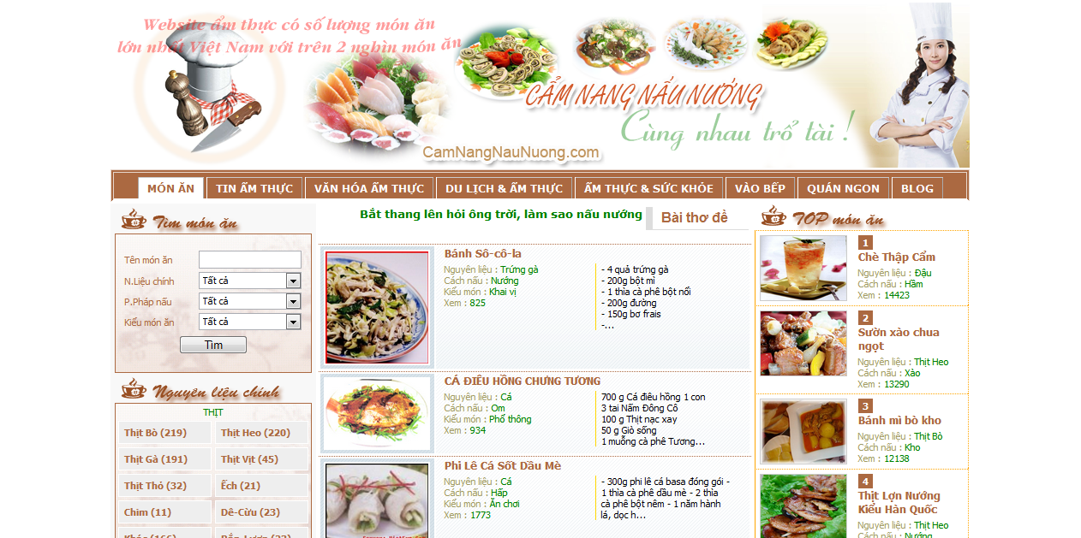

It is a Vietnamese website provides all cooking information not only cooking guides or recipes; it has tips for choosing better materials, cooking better than regular and suggesting some good restaurants. This page has the most recipes in Vietnamese cooking websites with approximate 2000 recipes. All the recipes are posted by the administrator. Users can view but can’t comment because it doesn’t have this function. The search function is very detailed. Users can search by name, main ingredients, cooking manners, or kinds of food. The content of a recipe contains mainly text and just one picture.

1. Delish (<http://www.delish.com>):

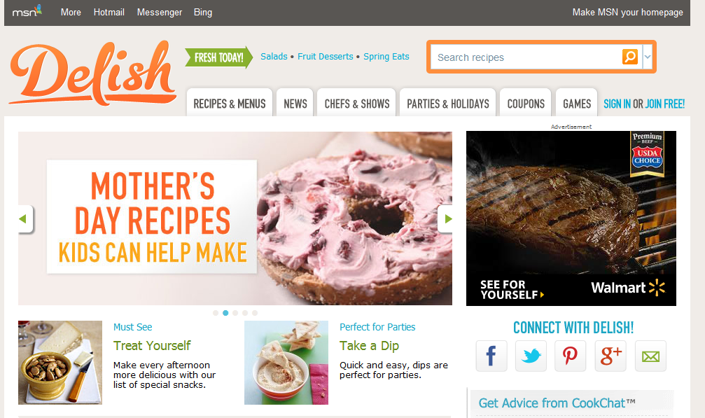

This English website is a part of media social network. It allows readers comment and rate after logging in. Each user has their profile page, and they can ask others about cooking. It also has step-by-step guides and readers can follow the instructions. Most of the recipes are written by professional chefs. The administrator collects them from some websites such as countryliving.com or eatingwell.com… Authorized users can write a recipe or make another version of the existing ones; they also can comment on each recipe but it’s very seldom to see users’ recipes. Even if it has one, the recipe is just “another version” of the main recipe. Although all of the recipes have only one picture, the content of them is quite detailed. Most have nutritional information (per serving). Some have time measurement to complete a dish. The recipes are categorized into kinds of food (cookies, chicken, pasta…), kinds of meals (desserts, lunch, dinner…), time to complete (under 30 minutes), quantities of calories (low calorie) … Recipes are not only viewable, authorized users can also save them to their computers or add them to their accounts to view later without searching again. Moreover, they can share it on their social networks such as twitter, facebook, google+, send emails to friends or print directly through their browsers.

1. Afamily (<http://afamily.vn/an-ngon>):

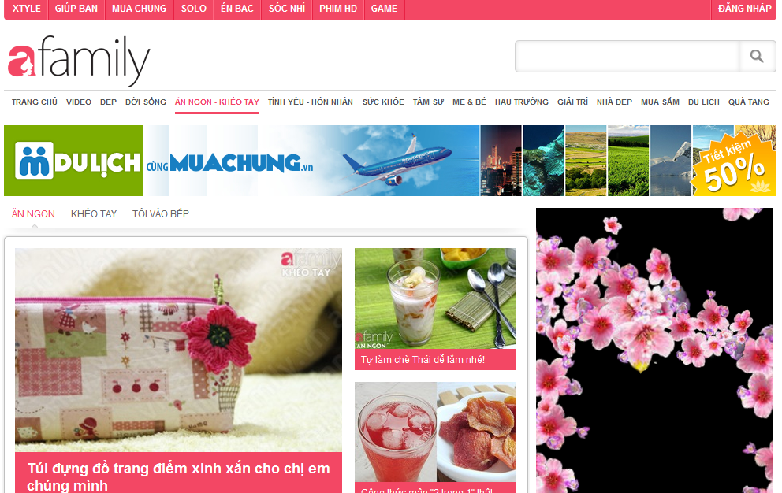

This is a sub-page of Vietnamese website afamily.vn. Its guides are divided into steps for readers to follow. Each step has its own picture. So it is clear and easy for everyone to learn and follow. Pictures of ingredients and dishes are adequate and visual. Maybe recipes are written not only by chefs, but also by users but must pass through the checking process before be posted. Users can comment after logging in. Like delish, users can share it on their social networks and print through their browsers.

1. Epicurious (http://www.epicurious.com):

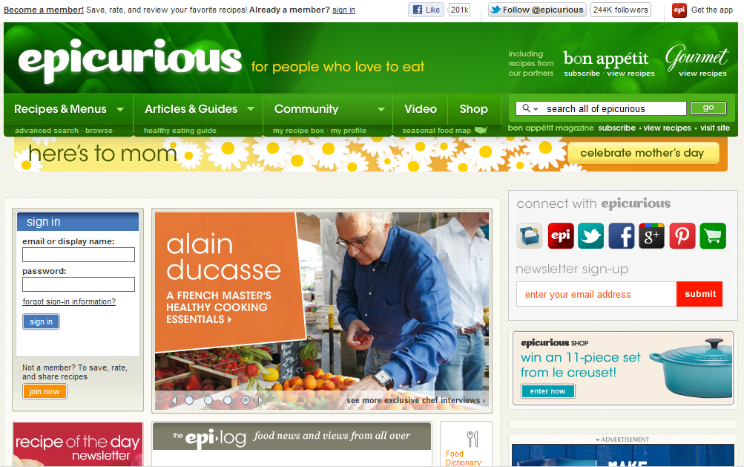

This English website is rated as top 10 cooking guide websites over the world. Its functions are much similar to delish except it has video guides. The point is that it separates member recipes and chef recipes. It also has food dictionary. User can search the same ingredients or tools or dishes but in other names or other languages. It’s much easy to understand if you meet a strange ingredients or dishes…

1. All Recipes (http://allrecipes.com):

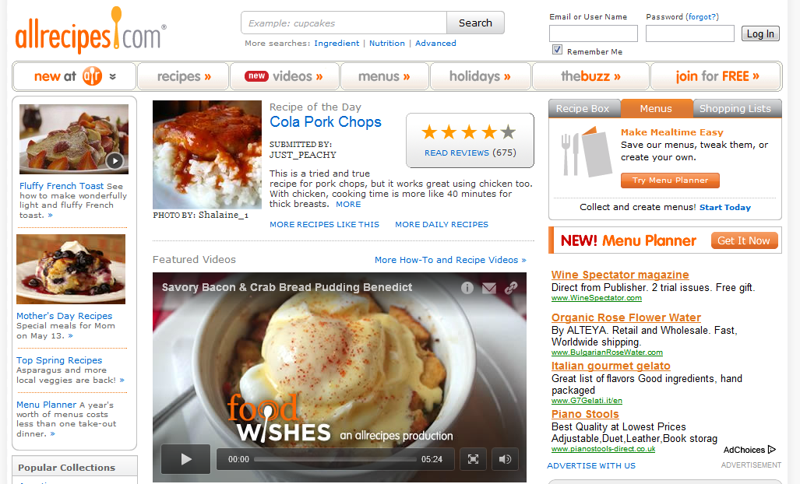

Its functions are similar to other cooking websites (delish, epicurious). But the point of this page is to support other languages, so it is easy for foreigners to understand what the recipes are “saying”. Thus, their job is to focus on how to follow recipes themselves. It also suggests a suitable drink to make a meal more delicious.

# Idea Proposal

## Problem

* Because of the richness and diversity of the Vietnamese dishes, possibly not everyone is aware of the dishes of the other regions, areas, so learning how to cook, how to eat is more and more difficult.
* Busy life makes people accidentally or intentionally forgets the taste of family meals. Many young people now cannot cook or just know how to cook simple dishes. For example, if you want to cook some delicious for your family, lovers… but you do not know what dish to cook or how to cook the dish you want.

Many people in above situations will ask their friends, their relatives, who has experience to know how to cook this, how to cook that… but if they do not know either or if you want to make them surprised, what will you do? You will spend time a lot of time “asking” Google. With huge amount of information, Google will return millions of results. Most of the results are cooking recipes which are written in English. If you can find some recipes in Vietnamese, there are no guarantees that you have enough food ingredients because these recipes are written by professional chefs who are always supplied with adequate ingredients .We are sure that you cannot easily determine what guide is good and suitable for you. You can follow a guide and spend much effort for this but finally fail because you cannot understand one step of this guide or the final dish followed this guide is not suitable for your taste. It is unavoidable.

## Solution

We will build a centralized website where people can go to and share cooking recipes, search for recipes in need, share and learn experience to cook better. They can comment, rate, mark… a recipe to make the information about that is most valuable to others. By providing cooking guides step by step with picture for each, it is easy to understand, remember and follow. We want to save your time, your money, your “happy cooking” moments with delicious dishes are done by yourself to share with your relatives, family, friends… and also help you know more about richness and diversity of Vietnamese dishes.

### 2.1 Advantages

The idea of ​​creating a specific website that provides cooking recipes and experience is not new. The above websites still exist and develop, but all of them do not have all the features and advantages of website we are building.

By implementing a user-oriented website for Vietnamese users, our product will have the following advantages:

* Specialized for Vietnamese users and Vietnamese dishes.
* Each cooking guide is reviewed, evaluated, rated... by other users, so we will give users the best information they need.
* Utilized newest technologies to make the system user-friendly and have best performance. We provide picture-guides step by step, easy to understand, remember and follow, so you will save time, money…
* With the contribution and opinion from all users, the interaction among users is increased. Our website can be the place that connects people who have common cooking interest.

### 2.2 Disadvantages

On the other hand, our website also remains some disadvantages.

* As users contribute contents and share their experiences, the contents totally depend on the users, so we must consider the content management carefully.
* Administrator also cannot control the qualities of articles; it depends on registered users by rating, commenting and numbers of view… Each step of cooking guide has a picture and a description, it requires users’ efforts.

The above problems are the direction that we will continue to learn to troubleshoot and develop in the future.

### 2.3 Global picture

**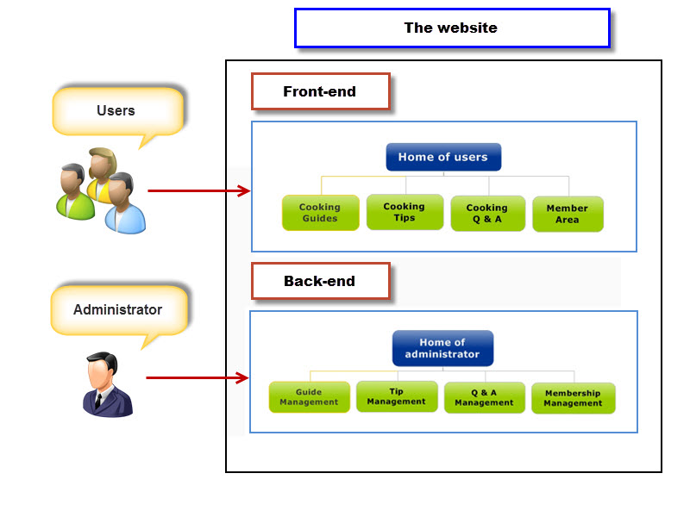**

**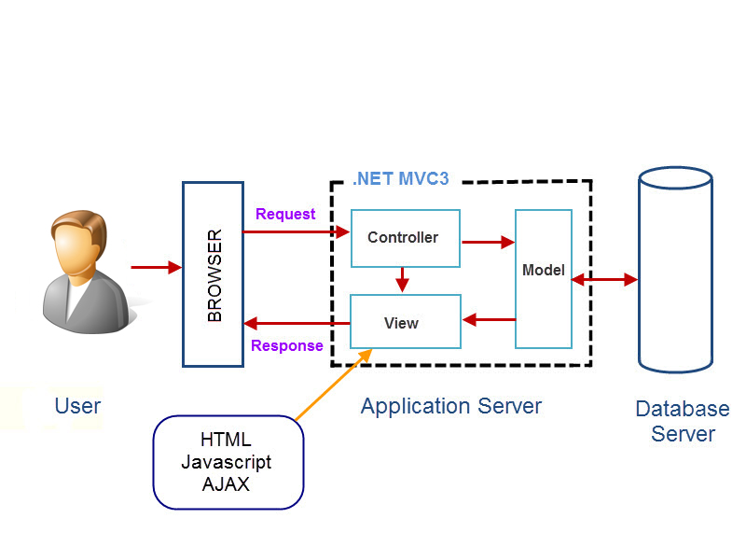**

# PART II: SOFTWARE PROJECT MANAGEMENT PLAN

# Problem Definition

## Project Overview

### The Current System

The content of the current websites are taken up mainly by professional chefs or collectors. Interaction among users is not high. Furthermore, the content is often not intuitive, vivid and easy to understand for novices to cooking. The recipes are usually expressed by text makes readers difficult to follow. Some websites have pictures but do not specific for sharing cooking experience.

### The Proposed System

The website will contain 2 main parts: front-end and back-end.

Front-end:

|  |  |  |
| --- | --- | --- |
| No | User | Permission |
| 1 | Everyone | * Visit the site and see the cooking recipes and cooking tips, most rated recipes, latest recipes and most shared recipes. * Search for recipes, word in dictionary |
| 2 | Authenticated users | * Post new recipes, new word for dictionary. * Post comments, rate. * Can report bad contents. * Have a profile page which displays, their personal information, their recipes or recipes of people they followed. * Integrate with some other popular networks (Facebook, Google plus). |

Back-end:

|  |  |  |
| --- | --- | --- |
| No | User | Permission |
| 1 | Administrators | * View, search, view details, edit and approve contents. * View, search, add or edit categories. * View, search, ban or delete users. * Process reported bad contents, users. |
| 2 | Power users | * Edit the information of recipes to make it more interesting, clearer. * Delete recipes, comments. |

### Development Environment

Below is the list of hardware and software requirements needed for development environment:

Hardware requirements:

* Computer that has a 1.6 GHz or faster processor.
* 1GB (32 Bit) or 2GB (64 Bit) RAM (Add 512 MB if running in a virtual machine).
* 3GB of available hard disk space.
* 5400 RPM hard disk drive.
* DirectX 9 capable video card running at 1024 x 768 or higher-resolution display
* DVD-ROM Drive

Software requirements:

* Front-end technologies: ASP.NET MVC 3.0, jQuery, AJAX, HTML, CSS, Javascript.
* ORM: Entity Framework.
* Architecture and design patterns: MVC 3.0.
* Programming Language: C#.
* Database: SQL Server 2008 R2
* Development tools: Visual Studio 2010, SQL Server 2008, Notepad++,
* Communication tools: Yahoo Messenger, Skype, Google Mail.
* Other tools: Microsoft Office 2010, Microsoft Project 2010, Microsoft Visio 2010.

# Project Organization

## Software Project Model

We choose iterative model to implement because of following reasons:

* This model is suitable for small and medium projects like our project.
* It is difficult to complete this project (especially requirement specification and implementation phases) for a short time.
* The iterative lifecycle model does not attempt to start with a full specification of requirements. Instead, development begins by specifying and implementing just part of the software, which can then be reviewed in order to identify further requirements. Our project doesn’t have clear requirements at the beginning. Therefore we choose this process model, in order to help project team run this project easier and get the best quality.

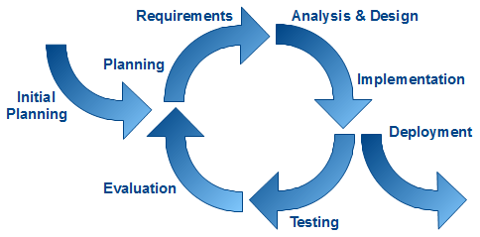

Iterative Model

## Roles and Responsibilities

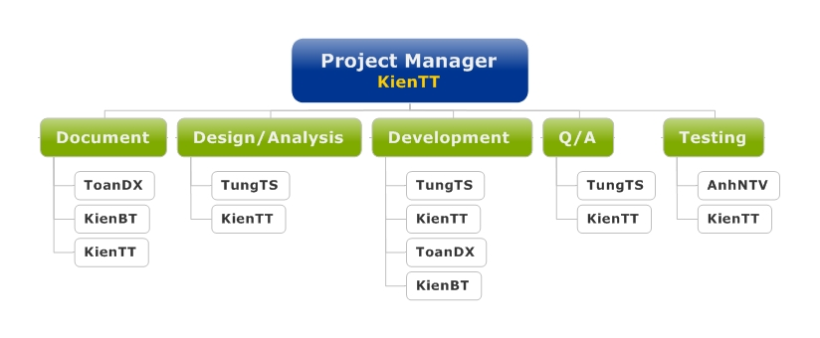

|  |  |  |
| --- | --- | --- |
| No | Role in Group | Responsibilities |
| 1 | KienTT  Project Manager/ Technical Leader | * Manage the project. * Plan, control and monitor processes, and also manage the assigned project resources to meet project objectives. * Identify, monitor, and respond to risk. * Identify needed resource and assign individual responsibilities. * Design Database. * Design high-level architecture and develop framework. * Training technique for team members. * Resolve technique problems. |
| 2 | TungTS  Risk Manager/Configuration Manager | * Define risks and solutions at starting, mitigate and monitor risks during this project’s lifetime. * Ensure that directories and files in the SVN repository have correct, perform daily and weekly backups of the team’s directory. structure and permissions |
| 3 | KienBT  Business Analysis | * Understand clearly and deeply the project requirements and write SRS. * Assist other team members when they have unclear comprehension of business and project requirements * Report to manager about requirements and related problems. |
| 4 | ToanDX  Quality Assurance | * Control quality and managerial processes, control quality of reports after reviewed by PM. * Review SRS * Send daily emails for team members about current status of processes. If a process isn’t finished on time, QA must raise this issue in the next team meeting. |
| 6 | KienTT, TungTS, ToanDX, KienBT  Developer | * Code and execute unit tests. * Provide coding assistance for other members. |
| 7 | AnhNTV  Tester | * Create Test Plan and Test Scenarios * Write test reports. * Take part in all testing phases. * Take part in test team’s meetings. * Test the system, create testing reports. |

# Project Management Plan

## Tasks

|  |  |  |  |  |
| --- | --- | --- | --- | --- |
| **Milestones** | **Description** | **Output** | **Deliverables** | **Resources Needed** |
| Initial idea | Start discussing about topic of capstone project | Topic of capstone project | Deliver initiator idea before 07/05/2012 | 5 people for 2 weeks |
| Create Project plan | Create project plan | Project plan | Deliver project plan before 22/05/2012 | 2 people for 1 weeks |
| Create Software Requirements Specification | Create Software Requirements Specification | Software Requirements Specification (SRS) document | Deliver SRS document before 26/06/2012 | 4 people for 4 weeks |
| Design Database | Create logical and physical database design | Database design and database script | Deliver database design and database script before 05/06/2012 | 2 people for 2 days |
| Create Soft Design Description  (SDD) | Design the system in OOP manner | Architecture design, detailed design, diagrams and design specification | Deliver SDD before 10/07/2012 | 3 people for 2 weeks |
| Layout Design | Create the main GUI for layout, and create global styles that will be applied to the GUI | HTML layout and CSS files | None | 1 person for 4 days |
| Create Coding Framework | Map the architecture design into source code, create the project solution files and common classes, and implement common functions | Visual Studio project and solution files containing coding framework | Deliver coding framework before 11/06/2012 | 1 person for 4 days |
| Coding | Implement the system to reflect the requirements | Source code of the project, unit test reports | Executable programs and source code before 15/08/2012 | 4 people for 4 weeks |
| System Test | Perform system test for the system | System test report | Deliver Software Test Documentation before 17/08/2012 | 5 people for 1.5 weeks |
| Input initial data | Input Initial data | Initial data | Deliver before 17/08/2012 | 5 people for 1 weeks |
| Deployment | Deploy the system to the internet | Running website with domain and hosting | None | 2 people for 3 days |

## Task Sheet: Assignments and Timetable

Refer to Master\_Plan in attached file.

## Meeting Minutes

We use the following meeting minute template:

At the end of each meeting, scribe collect all information write a meeting minute document.

Weekly meeting minute 1

|  |  |  |  |
| --- | --- | --- | --- |
| **Subject** | Meeting minute | **Date** | 07/05/2012 |
| **Facilitator** | Detech Building | **Time** | 9:00 – 10:00 |
| **Location** | FPT University – 8th Ton That Thuyet Str – Tu Liem – Ha Noi | **Scribe** | KienBT |
| **Attendees** | DungHA (Supervisor),TrungNT(Supervisor), KienTT (Team Lead), KienBT, ToanDX, TungTS, AnhNTV | | |
| **Absent** |  | | |

| **Key Points Discussed** | | |
| --- | --- | --- |
| No. | Topic | Description |
| 1. | Set up team, project | Naming team, project |
| 2. | Make schedule for meeting | Time: Everyday Monday: 8h to 11h  Place: 2nd floor, Detech building |
| 3. | Define project objectives |  |
| 4. | Discuss report 1 |  |

| **Action Plan** | | | |
| --- | --- | --- | --- |
| No. | Action Item(s) | People | Deadline |
| 1. | Writing Report 1: Introduction | KienBT, ToanDX | 15/05/2012 |
| 2. | Research existing system and their limitation | KienBT, ToanDX | 15/05/2012 |
| 3. | Draw briefly proposed system | KienTT, TungTS | 15/05/2012 |
| 4. | Start learning tutorial .NET MVC 3, HTML, Javascript, AJAX | KienTT, TungTS |  |
| 5. | Start learning Web design | KienTT |  |

Kick-off meeting minute

|  |  |  |  |
| --- | --- | --- | --- |
| **Subject** | Kick-off Meeting | **Date** | 10/05/2012 |
| **Facilitator** | Detech Building | **Time** | 9:00 – 10:00 |
| **Location** | FPT University – 8th Ton That Thuyet Str – Tu Liem – Ha Noi | **Scribe** | KienBT |
| **Attendees** | DungHA (Supervisor),TrungNT(Supervisor), KienTT (Team Lead), KienBT, ToanDX, TungTS, AnhNTV | | |
| **Absent** |  | | |

| **Key Points Discussed** | | |
| --- | --- | --- |
| No. | Topic | Description |
| 1. | Team member introduction | Introduce all members of team to supervisor |
| 2. | Project introduction | Introduce briefly about the project |
| 3. | Talk about project | SMARTER structure, slides, report 1… |

| **Action Plan** | | | |
| --- | --- | --- | --- |
| No. | Action Item(s) | People | Deadline |
| 1. | Writing Report 1: Introduction | KienBT, ToanDX | 15/05/2012 |

Weekly meeting minute 2

|  |  |  |  |
| --- | --- | --- | --- |
| **Subject** | Meeting minute | **Date** | 14/05/2012 |
| **Facilitator** | Detech Building | **Time** | 9:00 – 10:00 |
| **Location** | FPT University – 8th Ton That Thuyet Str – Tu Liem – Ha Noi | **Scribe** | KienBT |
| **Attendees** | DungHA (Supervisor),TrungNT(Supervisor), KienTT (Team Lead), KienBT, ToanDX, TungTS, AnhNTV | | |
| **Absent** |  | | |

| **Key Points Discussed** | | |
| --- | --- | --- |
| No. | Topic | Description |
| 1. | Check working process | Check assigned tasks last week |
| 2. | Discuss detail proposed system | Define main features and set priority |
| 3. | Review and update report 1 |  |

| **Action Plan** | | | |
| --- | --- | --- | --- |
| No. | Action Item(s) | People | Deadline |
| 1. | Prepare slide presentation and project Plan, learning MVC and JavaScript LinQ to SQL, Ajax | KienBT, ToanDX | 15/05/2012 |
| 2. | Continue learning technology and make demo | KienTT, TungTS |  |

Weekly meeting minute 3

|  |  |  |  |
| --- | --- | --- | --- |
| **Subject** | Meeting minute | **Date** | 21/05/2012 |
| **Facilitator** | Detech Building | **Time** | 9:00 – 10:00 |
| **Location** | FPT University – 8th Ton That Thuyet Str – Tu Liem – Ha Noi | **Scribe** | KienBT |
| **Attendees** | DungHA (Supervisor),TrungNT(Supervisor), KienTT (Team Lead), KienBT, ToanDX, TungTS, AnhNTV | | |
| **Absent** |  | | |

| **Key Points Discussed** | | |
| --- | --- | --- |
| No. | Topic | Description |
| 1. | Complete Master Plan | Make the schedule, ands milestones more detailed. |
| 2. | Review and update report 2 |  |

| **Action Plan** | | | |
| --- | --- | --- | --- |
| No. | Action Item(s) | People | Deadline |
| 1. | Prepare slide presentation | ToanDX | 23/05/2012 |
| 2. | Continue learning technology and make demo | KienTT, TungTS, ToanDX, KienBT |  |

# Coding Conventions

The following rules follow the standard rules for developing applications using .NET and C#.

## Naming Conventions

The following terms describe different ways to case identifiers.

Pascal Casing

The first letter in the identifier and the first letter of each subsequent concatenated word are capitalized. You can use Pascal case for identifiers of three or more characters. For example:

BackColor

Camel Casing

The first letter of an identifier is lowercase and the first letter of each subsequent concatenated word is capitalized. For example:

BackColor

Uppercase

All letters in the identifier are capitalized. For example:

IO

Naming rules

* Use Pascal casing for Class names.

public class HelloWorld

{

...

}

* Use Pascal casing for Method names

void SayHello(string name)

{

...

}

* Use Camel casing for variables and method parameters

void SayHello(string name)

{

string fullMessage = "Hello " + name;

...

}

* All private member variables must be prefixed with underscore (\_) so that they can be identified from other local variables.

public class HelloWorld

{

private int \_count;

}

* Use Meaningful, descriptive words to name variables. Do not use abbreviations.

string address (not addr)

int salary (not sal)

* Do not use variable names that resemble keywords.
* Prefix boolean variables, properties and methods with “is” or similar prefixes.

private bool \_isFinished;

* Namespace names should follow the standard pattern.

*<company name>.<product name>.<top level module>.<bottom level module>*

* Use appropriate prefix for the UI elements to identify them from the rest of the variables.

|  |  |
| --- | --- |
| Control | Prefix |
| Label | lbl |
| TextBox | txt |
| DataGrid | dtg |
| Button | btn |
| ImageButton | imb |
| Hyperlink | hlk |
| DropDownList | ddl |
| ListBox | lst |
| DataList | dtl |
| Repeater | rep |
| Checkbox | chk |
| CheckBoxList | cbl |
| RadioButton | rdo |
| RadioButtonList | rbl |
| Image | img |
| Panel | pnl |
| PlaceHolder | phd |
| Table | tbl |
| Validators | val |

* File name should match with class name.

*For the class* HelloWorld*, the file name should be HelloWorld.cs*

* Use #region to group related pieces of code together. If you use proper grouping using #region, the page should like this when all definitions are collapsed.
* Keep private member variables, properties and methods in the top of the file and public members in the bottom.



* Compound words should be cased correctly (FxCop Microsoft.Naming CA1702)

Avoid creating compound words from terms which exist in the dictionary as discrete terms. Do not create a compound word such as *'StopWatch'* or *'PopUp'*. These terms are recognized in the dictionary and should be cased as *'Stopwatch'* and *'Popup'.*

* Identifiers should differ by more than case. (FxCop Microsoft.Naming CA1708)

Do not use names that require case sensitivity for uniqueness. Components must be fully usable from both case-sensitive and case-insensitive languages. Since case-insensitive languages cannot distinguish between two names within the same context that differ only by case, components must avoid this situation.

* Identifiers should have correct prefix (FxCop Microsoft.Naming CA1715)

Prefix interface names with the letter 'I' to indicate that the type is an interface, as in IFormattable. Prefix generic type parameter names with the letter 'T' and provide them with descriptive names, as in Dictionary<TKey, TValue>, unless a single 'T' is completely self-explanatory, as in Collection<T>. Use Pascal casing for both interface and type parameter names. Use abbreviations sparingly. Do not use the underscore character. Do use similar names when defining a class/interface pair where the class is a standard implementation of the interface. The names should differ only by the letter I prefixed on the interface name, as with Component and IComponent.

* Identifiers should have correct suffix (FxCop Microsoft.Naming CA1710) Types that extend certain base types have specified name suffixes. Types that extend Attribute, for example, should be suffixed in 'Attribute', as in ObsoleteAttribute. This rules checks types that extend several base types, including Attribute, Exception, EventArgs, IMembershipPermission, Stream, and others.
* Identifiers should not match keywords (FxCop Microsoft.Naming CA1716)

Identifiers which conflict with reserved language keywords should be avoided. Using a reserved keyword as an identifier makes it harder for consumers in other languages to use your API.

* Parameter names should not match member names (FxCop Microsoft.Naming CA1719)

Parameter names should be distinct from member names.

public class HelloWorld

{

private int \_count;

public HelloWorld(int count)

{

\_count = count; //Should not change the parameter name to \_count

}

}

* Property names should not match get methods (FxCop Microsoft.Naming CA1721)

A Get method was found with the same name as a property. Get methods and properties should have names that clearly distinguish their function. See the design guidelines for information regarding choosing properties over methods.

* Type names should not match namespaces (FxCop Microsoft.Naming A1724)

Identifiers which conflict in whole or in part with namespace names should be avoided. Names that describe the purpose or contents of a type are preferred.

## Coding Styles

* Avoid writing very long methods. A method should typically have 1~50 lines of code. If a method has more than 50 lines of code, you must consider re factoring into separate methods.
* Do not hardcode configuration data. Configuration data should be put into configuration file or database.
* Avoid using member variables. Declare local variables wherever necessary and pass it to other methods instead of sharing a member variable between methods. When sharing a member variable between methods, it will be difficult to track which method changed the value and when.
* Do not make the member variables public or protected. Keep them private and expose public/protected Properties.
* Do not have more than one class in a single file.
* Avoid public methods and properties, unless they really need to be accessed from outside the class. Use “internal” if they are accessed only within the same assembly.
* Declare variables as close as possible to where it is first used. Use one variable declaration per line.
* Use StringBuilder class instead of String when manipulating string objects in a loop. The String object works in weird way in .NET. Each time a string is appended, it is actually discarding the old string object and recreating a new object, which is a relatively expensive operations.
* Never do a 'catch exception and do nothing'. If hiding an exception, there is no way to notice the exception happened or not. Lot of developers uses this handy method to ignore non significant errors. Best practices are to avoid exceptions by checking all the error conditions programmatically. In any case, catching an exception and doing nothing is not allowed. In the worst case, exceptions should be logged for later investigation and system should not be halted.
* When you re throw an exception, use the throw statement without specifying the original exception. This way, the original call stack is preserved.
* Write your own custom exception classes if required in your application. Do not derive your custom exceptions from the base class SystemException. Instead, inherit from ApplicationException.
* A class should be declared as sealed if there is no further inheritance.
* Abstract types should not have constructors (FxCop Microsoft.Design CA1012). Public constructors for abstract types do not make sense because you cannot create instances of abstract types.
* Avoid empty interfaces (FxCop Microsoft.Design CA1040). Interfaces are meant to contain members that specify a set of behaviors. To mark or label a class, use an attribute instead of an empty interface.
* Avoid excessive parameters on generic types (FxCop Microsoft.Design CA1005). Avoid generic types with more than two type parameters as users have difficulties understanding what type parameters represent in types with long type parameter lists.
* Avoid out parameters (FxCop Microsoft.Design CA1021). Using out parameters might indicate a design flaw. Although there are legitimate times to use out parameters, their use frequently indicates a design that does not conform to the design guidelines for managed code.
* Declare types in namespaces (FxCop Microsoft.Design CA1050). A type should be defined inside a namespace to avoid duplication.
* Do not declare static members on generic types (FxCop Microsoft.Design CA1000). The syntax for calling static members on generic types is complex as the type parameter has to be specified for each call.
* Do not declare protected members in sealed types (FxCop Microsoft.Design CA1047). Sealed types cannot be extended, and protected members are only useful if you can extend the declaring type. Sealed types should not declare protected members.
* Do not declare virtual members in sealed types (FxCop Microsoft.Design CA1048). Sealed types cannot be extended, and virtual members are only useful if you can extend the declaring type.
* Do not expose generic lists (FxCop Microsoft.Design CA1002). Do not expose List<T> in object models. Use Collection<T>, ReadOnlyCollection<T> or KeyedCollection<K,V> instead. List<T> is meant to be used from implementation, not in object model API. List<T> is optimized for performance at the cost of long term versioning. For example, if you return List<T> to the client code, you will not ever be able to receive notifications when client code modifies the collection.
* Do not hide base class methods (FxCop Microsoft.Design CA1061). Defining a method in a derived class with the same name and parameters that are more weakly typed as one that is defined in the base class will obstruct access to the method defined in the base class.
* Do not overload operator equals on reference types (FxCop Microsoft.Design CA1046). Most reference types, including those that override System.Object.Equals, do not override the equality operator (==). Most languages provide a default implementation of this operator.
* Do not pass types by reference (FxCop Microsoft.Design CA1045). Although there are legitimate times to use reference parameters, such use frequently indicates a design that does not conform to the design guidelines for managed code.
* Enumerators should be strongly typed (FxCop Microsoft.Design CA1038). Types that implement IEnumerator should also provide a version of the Current property that returns a type other than Object. Implement the interface member explicitly and make the strongly typed version public.
* Exceptions should be public (FxCop Microsoft.Design CA1064). Exception classes should either be public, or have a non-generic public ancestor.
* Implement standard exception constructors (FxCop Microsoft.Design CA1032). Multiple constructors are required to correctly implement a custom exception. Missing constructors can make your exception unusable in certain scenarios. For example, the serialization constructor is required for handling exceptions in XML Web services.
* Lists are strongly typed (FxCop Microsoft.Design CA1039). IList implementations should also provide versions of the IList members that are strongly typed, namely they should specify types other than Object for method and property parameter and return types. Implement the interface members explicitly and make the strongly typed versions public. It is safe to ignore violations of this rule when you are implementing a new object-based collection, such as a linked list, where types based on your collection will determine what the strong type is. These types should expose strongly typed members.
* Override methods on comparable types (FxCop Microsoft.Design CA1036). Types that implement IComparable should redefine Equals and comparison operators to keep the meanings of less than, greater than, and equals consistent throughout the type.
* Replace repetitive arguments with params array (FxCop Microsoft.Design CA1025). Several instances of same-type arguments can be better implemented as a parameter array argument. Generally, if a member declares three or more arguments of the same type, consider using a parameter array.
* Static holder types should be sealed (FxCop Microsoft.Design CA1052). Static holder types do not provide functionality that derived instances can extend. Inheriting from such a type indicates a flawed design.
* Use events where appropriate (FxCop Microsoft.Design CA1030). A method name suggestive of event functionality was encountered.
* Use generic event handler instances (FxCop Microsoft.Design CA1007). Do not declare new delegates to be used as event handlers when targeting a version of the .NET Framework that supports generics. Use an instance EventHandler<T> instead.
* Use properties where appropriate (FxCop Microsoft.Design CA1024). Properties should be used instead of Get/Set methods in most situations. Methods are preferable to properties in the following situations: the operation is a conversion, is expensive or has an observable side-effect; the order of execution is important; calling the member twice in succession creates different results; a member is static but returns a mutable value; or the member returns an array.
* Do not hardcode locale specific strings (FxCop Microsoft.Globalization CA1302). Do not use string literals for system items that have locale-specific designations. Special system locations should be retrieved using provided API such as GetFolderPath. See the System.Environment.SpecialFolder enumeration for more information.
* Set locale for data types (FxCop Microsoft.Globalization CA1306). In most cases, Locale should be explicitly set to CultureInfo.InvariantCulture on DataSet and DataTable instances. Upon creation of a DataSet or DataTable instance, the Locale is set to the current culture. In most cases, the Locale should be set to CultureInfo.InvariantCulture to guarantee proper sorting behavior in all cultures.
* Specify CultureInfo (FxCop Microsoft.Globalization CA1304). If an overload exists that takes a CultureInfo argument, it should always be called in favor of an overload that does not. The CultureInfo type contains culture-specific information required for performing numeric and string operations, such as casing, formatting, and string comparisons. In scenarios where conversion and parsing behavior should never change between cultures, specify CultureInfo.InvariantCulture, otherwise, specify CultureInfo.CurrentCulture.
* Specify IFormatProvider (FxCop Microsoft.Globalization CA1305). If an overload exists that takes an IFormatProvider argument, it should always be called in favour of an overload that does not. Some methods in the runtime convert a value to or from a string representation and take a string parameter that contains one or more characters, called format specifies, which indicate how the value is to be converted. If the meaning of the format specified varies by culture, a formatting object supplies the actual characters used in the string representation. In scenarios where sorting and comparison behavior should never change between cultures, specify CultureInfo.InvariantCulture, otherwise, specify CultureInfo.CurrentCulture.
* Specify StringComparison (FxCop Microsoft.Globalization CA1307). If an overload exists that takes a StringComparison argument, it should always be called in favour of an overload that does not.
* Use ordinal StringComparison (FxCop Microsoft.Globalization CA1309). For non-linguistic comparisons, StringComparison.Ordinal or StringComparison. OrdinalIgnoreCase should be used instead of the linguistically-sensitive StringComparison.InvariantCulture.

## Comments

* + Comments should be written in order to make code understandable and maintainable.
  + Only write comments when necessary, do not write comments for every line of code and every variable declared.
  + Use **//** or **///** for comments. Avoid using **/\* … \*/**
  + Do not write comments if the code is easily understandable without comment. The drawback of having lot of comments is that if you change the code and forget to change the comment, it will lead to more confusion.
  + Fewer lines of comments will make the code more elegant. But if the code is not clean/readable and there are less comments, that is worse.
  + Writes clean, readable code such a way that it doesn't need any comments or very little to understand.

Perform spelling check on comments and also make sure proper grammar and punctuation is used.

# Risk Management Plan

|  |  |  |  |  |  |
| --- | --- | --- | --- | --- | --- |
| Risk Description | Risk type | Prob-ability  (1-5) | Effect  (1- 5) | Risk Strategy | Resolution |
| Member’ illness | People | 2 | 4 | Build a reasonable working schedule. | - PTL and PM monitor other members’ tasks and always ready to do these tasks instead of them if can  - Using buffer time to recover works |
| Bad attitude of team member: in-cohesive with team, breach of discipline | People | 3 | 5 | - Engage teamwork.  - Team-building | Create team’s policies: rewarding and punishment |
| Working productivity is not high | Technical | 4 | 4 | - Define standards to be followed to meet the performance criteria  - Training technology seriously and research all related problem | - Using buffer time to recover works  - Cross-review tasks to track working process |
| Working progress is not meeting schedule | Time | 3 | 3 | Create buffer in plan | Using buffer time to recover works |

# Project Success Criteria

|  |  |  |
| --- | --- | --- |
| Project success criteria | Measurement | Weight |
| All high-priority functions defined in the requirement specification must be finished at the end of project (31/8/2012) | All high-priority functions are tested and released on time | 40 |
| Complete all tasks within the predetermined time | All team member’s tasks have to meet the deadline | 30 |
| Team working | Team members can support and help each other. Software process must be carried out correctly. | 15 |
| Number of defects per function is acceptable | Number of defects per function is not exceed 10 | 15 |

# Communication and Reporting

|  |  |  |  |  |
| --- | --- | --- | --- | --- |
| Type of Communication | Method / Tool | Frequency / Schedule | Information | Participants / Responsible |
| **Internal Communication:** | | | | |
| Project Meetings | Face to face | Weekly and when required | Project status, problems, risks, changed requirements | Team Members |
| Sharing of project data | Shared Project Server | When available | All project documents and reports | Team Members |
| Milestone Meetings | Face to face | Before milestones | Project status | Team Members |
| Final Project | Face to face | End of project | Project result, lessons | Supervisor |
| **External Communication and Reporting:** | | | | |
| Project Report | Excel sheet | On event | 5 reports | Project Team |
| Meetings with Supervisor | Face to face | 2 times / week | Project status, problems, risks, change requirements, schedules | Supervisor, Team Members |

# PART III: SOFTWARE REQUIREMENTS SPECIFICATIONS

# User Requirement Specification

## User Requirements

* User can create accounts on the website. Email address and password are required for registering an account on the website. 1 email address can only be used once for registering.
* User can edit his/her account information: Display Name, Avatar, and Password. But he/she can’t change his/her email address which was used for registering.
* User can change his/her password through his/her User Profile page.
* User can see his/her account information and other’s.
* User can see other user’s statistic like: Display Name, Registered Date, number of created recipes, number of posted comments, questions and answers.
* User can search for contents by using Search functiơn.
* User can view information of recipes, rate the recipes, add it to favorites list, share it on social networks (Twitter and Facebook) or report it as spam.
* User can upload images for recipes.
* User can view information tips, rate the tips, add it to favorites list, share it on social networks (Twitter and Facebook) or report it as spam.
* User can upload images for tips.
* User can view information of news, rate the news, add it to favorites list, share it on social networks (Twitter and Facebook) or report it as spam.
* User can upload images for news.
* User can view his/her favorites list and remove recipes from the list at his/her profile page.
* User can see list of questions, recipes, tips, news he/she posted at his/her profile page.
* User can write comments for recipes, tips, news or delete it.
* User can thumb up, thumb down or report comments of other users but his/her comments
* User can create recipes, tips, news and edit his/her them.
* User can approve and edit recipes, tips, news of other users when they rank up in ranking system their account will be more prestige.
* User can view and post questions on Question & Answer page.
* User can answer to questions, thumb up, thumb down or report as it as spam.
* User can vote up, vote down or report other user’s answers.
* User can delete his/her answers.
* User can view words from dictionary function.
* User can create or contribute meaning of word.

## Administration Requirements

* Admin can view a list of all categories in the system, add new categories, edit categories and delete categories.
* Admin can view a list of all users in the system, view and edit user information, active users on the system or delete users.
* Admin can view a list of spam reports, decide they are spam or not. Spam reports include reports about recipes, tips and news, reports about comments, reports about questions, reports about answers and reports about recipes, tips and news.
* Admin can use all functions in the system.
* Admin can view a list of all recipes, tips, news, questions in the system, edit or delete these them.
* Admin can see statistics on the whole system: Registered User number, Activated User number, Comment number, Question number, Answer number, All the Time Visitor number, Today Visitor number, Online Visitor number, Recipe number, Tip number, Question number,…
* Admin users can approve a recipe is editor choice’s recipe.
* Admin users can remove approved recipe
* Admin users can approve word, update word.
* Admin can remove unapproved word from waiting list.
* Admin can delete word from dictionary.

## Ranking Requirements

* User Point will be used in user ranking system of the website
* User Point is calculated as follow:

|  |  |
| --- | --- |
| Title | Points |
| Phụ bếp | 0 |
| Đầu bếp tập sự | >100 |
| Đầu bếp chính thức | >500 |
| Đầu bếp trứ danh | >1000 |
| Bếp phó | >2000 |
| Bếp trưởng | >3500 |
| Siêu đầu bếp | >6000 |
| Vua đầu bếp | >10000 |

* + - * Starter point for every user is 10
      * Create a recipes: +30
      * Create a tip: +20
      * Create a news: +15
      * Max point per day: < 120
* CP will be used to set rank for user:
* 10 user who post most answers will be in on Most Contributors list in Q&A page
* There is a list for 20 Newest Questions at Q&A page and Home page.
* A list of 5 newest recipes, news and tips is displayed at home page by default.
* Every list is updated each 10 minutes.

## Comment/Answer Requirements

* A comment/answer can’t be blank and must be less than 4000 characters.
* When the number of comments/answers is big, the comments/replies will be displayed each time 10 comments/answers. To see more comments/answers users need click to “Xem thêm”.
* 2 most voted up comments/answers will be highlighted and put on top of Comment Area/Answer Area. These highlighted comments/answers still can be treated as normal comments/answers.
* Each user can only post 1 comment for a recipe or 1 answer for a question each 3 minutes.

## Cooking Recipe Requirements

A cooking recipe has following information:

* Name (required)
* Main ingredient (required)
* Method (required)
* Description
* Number of view
* Rating
* Dish Images: include a main image displayed as the dish and other images display steps of recipe (1 image for 1 step).
* Steps: include steps from ingredient preparation to dish completion
* Suggestion List: 5 highest popularity recipes in the same category, 10 latest recipes.

## Cooking Tip Requirements

A cooking tip has following information:

* Name (required)
* Method (required)
* Description
* Number of view
* Rating
* Images: images for tip
* Suggestion List: 5 highest popularity tips in the same category, 10 latest tips

## News Requirements

Cooking news has following information:

* Name (required)
* Description
* Number of view
* Rating
* Images: images for news
* Suggestion List: 10 latest news

## Question Requirements

Question has following information:

* Title (required)
* Question content
* Number of view
* Rating
* Suggestion List: 10 latest news

## Search Requirements

There is a kind of search in the website:

This function provides users more options search. These options are:

* Search by keyword
* Search by category

# System Requirement Specification

## External Interface Requirements

### 1.1 User Interfaces

* Interface need to attract the attention of users to the product image. Products are things having a lot of colors and diversity combination in order to attract users. Website should have the background simple, less color, less attention but that also shows clear boundaries between each section: photos with text, photos with photos, and photos with the background…So color choices should be pleasing to the eye and should stimulate the user's interest.
* Page layout and navigation should be as intuitive and easy as possible.
* The overuse of product images should not increase the time in which a page downloads, which has a negative impact on usability.

### Hardware Interfaces

Our website needs to run are the peripheral devices mouse and keyboard. System can display many image formats, such as: jpg, jpeg.

### Software Interfaces

* Products run on web application, it requires the use of programming languages supported on the browser.
* Outside, the system should use the program to manage resources data, this program can be combined with the system, can change and update from the system. Data products will be exchanged between systems and external data through data management software

|  |  |  |
| --- | --- | --- |
| Software name | Version | Source |
| .NET Framework | 4.0 | Microsoft |
| SQL Server | R2 | Microsoft |
| Visual Studio | 2010 | Microsoft |
| MVC | 3.0 | Microsoft |
| Enterprise Library |  | Microsoft |

### Communications Protocol

* System implemented on the browser, using standard protocols to communicate between users and server.
* In the process of communication, some important information of the user system will use the protocol https to transfer data.
* The system should produce nicely formatted HTML that popular social network such as Face book, Google+ can share information.

## System Features

### 2.1 Back–end



#### Account Management

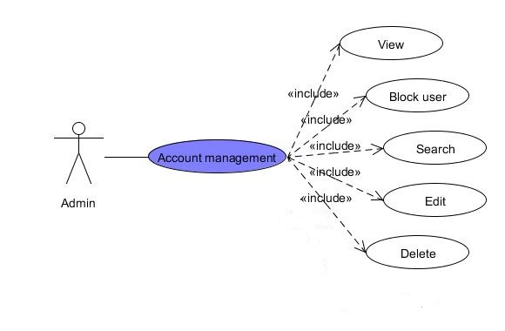

* + - 1. View Users

|  |  |  |  |  |
| --- | --- | --- | --- | --- |
| **USE CASE – View Users SPECIFICATION** | | | | |
| **Use-case No.** | UC001 | **Use-case Version** | | 1.0 |
| **Use-case Name** | View Users | | | |
| **Author** | ToanDX | | | |
| **Date** | 03/06/2012 | **Priority** | High | |
| **Actor:**  Administrator  **Summary:**  Administrator can view all member and their detail information  **Goal:**  Allow administrator to list all users in website  **Triggers**  Click to “Users” menu then click to “Manage Users” sub menu  **Preconditions:**  Logged into the system with admin role and go to Admin page  **Post Conditions:**  Open manage user page  **Main Success Scenario:**   |  |  |  | | --- | --- | --- | | Step | Actor Action | System Response | | 1 | Click to “Users” menu then click to “Manage Users” sub menu | Display Manage User page with all user in the system | | 2 | Click to username hyperlink at Manage User page | Redirect to User Detail page |   **Alternative Scenario:**  N/A  **Exceptions:**  N/A  **Relationships:**  N/A  **Business Rules:**  N/A | | | | |

* + - 1. Ban An User

|  |  |  |  |  |
| --- | --- | --- | --- | --- |
| **USE CASE – Ban An User SPECIFICATION** | | | | |
| **Use-case No.** | UC002 | **Use-case Version** | | 1.0 |
| **Use-case Name** | Ban An User | | | |
| **Author** | ToanDX | | | |
| **Date** | 03/06/2012 | **Priority** | High | |
| **Actor:**  Administrator  **Summary:**  Administrator can ban user.  **Goal:**  Allow administrator to ban spam user or who have bad behavior in website  **Triggers**  Click to “Ban” from dropdown list  **Preconditions:**  Logged into the system with admin role and open User Detail page  **Post Conditions:**  Redirect back to Manage User page  **Main Success Scenario:**   |  |  |  | | --- | --- | --- | | Step | Actor Action | System Response | | 1 | Click to “Banned” from User state dropdown list |  | | 2 | Click to “Save” button | Redirect back to Manage User page. |   **Alternative Scenario:**   |  |  |  | | --- | --- | --- | | Step | Actor Action | System Response | | 1 | Click to “Banned” from User state dropdown list |  | | 3 | Click to “Cancel” button | Redirect back to Manage User page. |   **Exceptions:**  N/A  **Relationships:**  List of user use case  **Business Rules:**  N/A | | | | |

* + - 1. Edit An User

|  |  |  |  |  |
| --- | --- | --- | --- | --- |
| **USE CASE – Edit An User SPECIFICATION** | | | | |
| **Use-case No.** | UC003 | **Use-case Version** | | 1.0 |
| **Use-case Name** | Edit An User | | | |
| **Author** | ToanDX | | | |
| **Date** | 03/06/2012 | **Priority** | High | |
| **Actor:**  Administrator  **Summary:**  Administrator can edit existing member in system such as point, change user state or assign role.  **Goal:**  Allow administrator to update user profile.  **Triggers**  Click to “Edit” button  **Preconditions:**  Logged into the system with admin role and open User Detail page  **Post Conditions:**  Redirect back to manage user page  **Main Success Scenario:**   |  |  |  | | --- | --- | --- | | Step | Actor Action | System Response | | 1 | Click to “Edit” button | Redirect to Edit User page | | 2 | Change some information |  | | 3 | Click to “Save” button | Redirect to Manage User page |   **Alternative Scenario:**  N/A  **Exceptions:**   |  |  |  | | --- | --- | --- | | Step | Actor Action | System Response | | 1 | Click to “Edit” button | Redirect to Edit User page | | 2 | Leave required fields blank |  | | 3 | Click to “Save” button | Displayed error message inform admin can’t leave required fields blank |   **Relationships:**  View User Detail use case  **Business Rules:** | | | | |

* + - 1. Delete An User

|  |  |  |  |  |
| --- | --- | --- | --- | --- |
| **USE CASE – Delete An User SPECIFICATION** | | | | |
| **Use-case No.** | UC004 | **Use-case Version** | | 1.0 |
| **Use-case Name** | Delete An User | | | |
| **Author** | ToanDX | | | |
| **Date** | 03/06/2012 | **Priority** | High | |
| **Actor:**  Administrator  **Summary:**  Administrator can delete an user  **Goal:**  Allow administrator to delete spam user or who have bad behavior in website  **Triggers**  Click to “Delete” button  **Preconditions:**  Logged into the system with admin role and open User Detail page  **Post Conditions:**  Redirect back to Manage User page  **Main Success Scenario:**   |  |  |  | | --- | --- | --- | | Step | Actor Action | System Response | | 1 | Click to “Delete” button | Pop up confirm message “Are you sure you want to delete this User?” | | 2 | Click to “Ok” button | Popup close, redirect back to Manage User page, display message “User has been deleted successfully” |   **Alternative Scenario:**  N/A  **Exceptions:**  N/A  **Relationships:**  List of user use case  **Business Rules:**  N/A | | | | |

#### Category Management

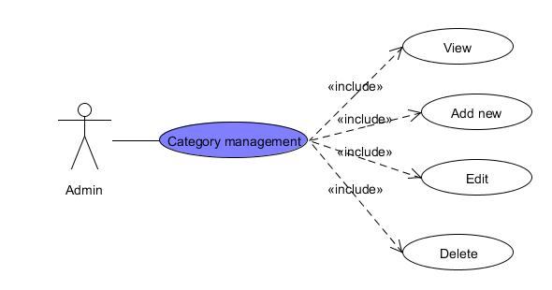

* + - 1. View Categories

|  |  |  |  |  |
| --- | --- | --- | --- | --- |
| **USE CASE – View Categories SPECIFICATION** | | | | |
| **Use-case No.** | UC005 | **Use-case Version** | | 1.0 |
| **Use-case Name** | View Categories | | | |
| **Author** | ToanDX | | | |
| **Date** | 03/06/2012 | **Priority** | High | |
| **Actor:**  Administrator  **Summary:**  Category is only be managed by administrator. A list of all categories in the system will be listed.  **Goal:**  Admin can view existed category list.  **Triggers**  Click to “Categories” menu then click to “Manage Categories” sub menu  **Preconditions:**  Successfully logged into the system with Admin role and go to Admin page  **Post Conditions:**  Categories List page will be displayed with all existed categories  **Main Success Scenario:**   |  |  |  | | --- | --- | --- | | Step | Actor Action | System Response | | 1 | Click to “Categories” menu then click to “Manage Categories” sub menu | Categories List page will be displayed with all existed categories |   **Alternative Scenario:**  N/A  **Exceptions:**  N/A  **Relationships:**  N/A  **Business Rules:**  N/A | | | | |

* + - 1. Create New Category

|  |  |  |  |  |
| --- | --- | --- | --- | --- |
| **USE CASE – Create new category SPECIFICATION** | | | | |
| **Use-case No.** | UC006 | **Use-case Version** | | 1.0 |
| **Use-case Name** | Create New Category | | | |
| **Author** | ToanDX | | | |
| **Date** | 03/06/2012 | **Priority** | High | |
| **Actor:**  Administrator  **Summary:**  Admin can create a new category in the system  **Goal:**  Create a new category in database.  **Triggers**  Click to “Categories” menu then click to “Create a new category” sub menu  **Preconditions:**  Successfully logged into the system with Admin role and go to admin page.  **Post Conditions:**  New category is added to database and displayed in Manage Category page.  **Main Success Scenario:**   |  |  |  | | --- | --- | --- | | Step | Actor Action | System Response | | 1 | Click to “Categories” menu then click to “Create a new category” sub menu | Redirect to Create Category page | | 2 | Enter needed information |  | | 3 | Click to “Save” button | Redirect to Manage Category page with new category was added and display message “Category has been inserted successfully” |   **Alternative Scenario:**  N/A  **Exceptions:**   |  |  |  | | --- | --- | --- | | Step | Actor Action | System Response | | 1 | Click to “Categories” menu then click to “Create a new category” sub menu | Redirect to Create Category page | | 2 | Leave Category name blank |  | | 3 | Click to “Save” button | Display message “Name is required.” |   **Relationships:**  Login use case  **Business Rules:**  N/A | | | | |

* + - 1. Edit Category

|  |  |  |  |  |
| --- | --- | --- | --- | --- |
| **USE CASE – Edit Category SPECIFICATION** | | | | |
| **Use-case No.** | UC007 | **Use-case Version** | | 1.0 |
| **Use-case Name** | Edit Category | | | |
| **Author** | ToanDX | | | |
| **Date** | 03/06/2012 | **Priority** | High | |
| **Actor:**  Administrator  **Summary:**  The admin can make a mistake when creating a new category. So he/she want to correct it. The admin can edit a category.  **Goal:**  Edit a category  **Triggers**  Click to “Edit” button  **Preconditions:**  Successfully logged into the system with Admin role and accessed to Manage Category page.  **Post Conditions:**  Redirect back to Manage Category page  **Main Success Scenario:**   |  |  |  | | --- | --- | --- | | Step | Actor Action | System Response | | 1 | Click to “Edit” button | Redirect to Edit Category page | | 2 | Edit information |  | | 3 | Click to “Save” button | Redirect back to Manage Category page and display message “Category has been updated successfully” |   **Alternative Scenario:**  N/A  **Exceptions:**   |  |  |  | | --- | --- | --- | | Step | Actor Action | System Response | | 1 | Click to “Edit” button | Redirect to Edit Category page | | 2 | Leave Name blank |  | | 3 | Click to “Save” button | Display message “Có lỗi xảy ra. Thực hiện tác vụ không thành công.” |   **Relationships:**  Login use case, List all category use case  **Business Rules:**  N/A | | | | |

* + - 1. Delete Category

|  |  |  |  |  |
| --- | --- | --- | --- | --- |
| **USE CASE – Delete Category SPECIFICATION** | | | | |
| **Use-case No.** | UC008 | **Use-case Version** | | 1.0 |
| **Use-case Name** | Delete Category | | | |
| **Author** | ToanDX | | | |
| **Date** | 03/06/2012 | **Priority** | High | |
| **Actor:**  Administrator  **Summary:**  When the admin see a category which category is useless, they can want to delete it.  **Goal:**  Delete categories in database.  **Triggers**  Click to “Delete” button.  **Preconditions:**  Successfully logged into the system with Admin role and accessed to Manage Category page.  **Post Conditions:**  Stay remains at Manage Category page and selected category will be deleted from category list.  **Main Success Scenario:**   |  |  |  | | --- | --- | --- | | Step | Actor Action | System Response | | 1 | Click to “Delete” button | Pop up a window to confirm if the admin really want to delete the category. | | 3 | Click to “OK” button | Redirect to Manage Categories page with selected category was removed from the list and display message “Category has been deleted successfully” |   **Alternative Scenario:**  N/A  **Exceptions:**  N/A  **Relationships:**  Login use case  **Business Rules:**  N/A | | | | |

#### Recipe Management

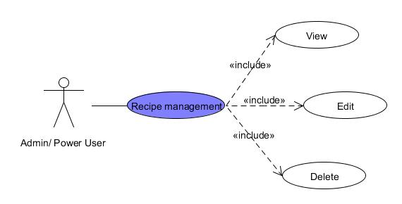

* + - 1. View recipe

|  |  |  |  |  |
| --- | --- | --- | --- | --- |
| **USE CASE – View Recipe SPECIFICATION** | | | | |
| Use-case No. | UC009 | Use-case Version | | 1.0 |
| Use-case Name | View recipe | | | |
| Author | KienBT | | | |
| Date | 02/06/2012 | Priority | Normal | |
| **Actor:**  Admin/Power user  **Summary:**  When Admin or Power user wants to view posted recipes  **Goal**  Admin or power user can view posted recipes  **Triggers**  Click to “Recipe Management” menu then click to “View” sub menu  **Preconditions:**  Logged into website with Admin or Power user role successfully.  **Post Conditions:**  N/A  **Main Success Scenario:**   |  |  |  | | --- | --- | --- | | Step | Actor Action | System Response | | 1 | Click to “Recipe Management” menu then click to “View” sub menu | Navigate user to the page with list of existed recipes |   **Alternative Scenario:**  N/A  **Exceptions:**  N/A  **Relationships:**  Login use case  **Business Rules:**  Must be admin or power user to view recipe management | | | | |

* + - 1. Edit recipe

|  |  |  |  |  |
| --- | --- | --- | --- | --- |
| **USE CASE – Edit Recipe SPECIFICATION** | | | | |
| Use-case No. | UC010 | Use-case Version | | 1.0 |
| Use-case Name | Edit recipe | | | |
| Author | KienBT | | | |
| Date | 02/06/2012 | Priority | High | |
| **Actor:**  Admin / Power user  **Summary:**  When Admin or Power User finds something wrong in a recipe, such as misspellings, missing tags. They edit the recipe for better.  **Goal**  Admin or power user can edit posted recipes  **Triggers**  Click to “Recipe Management” menu then click to “View” sub menu  **Preconditions:**  Logged into website with Admin or Power user role successfully.  **Post Conditions:**  N/A  **Main Success Scenario:**   |  |  |  | | --- | --- | --- | | Step | Actor Action | System Response | | 1 | Click to “Recipe Management” menu then click to “View” sub menu | Navigate admin to the page with list of existed recipes | | 2 | Click to the recipe admin wants to edit | Navigate admin to the page with corresponding detailed recipe. | | 3 | Click to “Edit” button at the bottom of post | Change post to edit form | | 4 | Click to textboxes, combo boxes and type to edit. |  | | 5 | Click to “Save” button at the bottom of form | Display message “Recipe edited successfully” |   **Alternative Scenario:**  N/A  **Exceptions:**   |  |  |  | | --- | --- | --- | | Step | Actor Action | System Response | | 1 | Click to “Recipe Management” menu then click to “View” sub menu | Navigate admin to the page with list of existed recipes | | 2 | Click to the recipe admin wants to edit | Navigate admin to the page with corresponding detailed recipe. | | 3 | Click to “Edit” button at the bottom of post | Change post to edit form | | 4 | Click to textboxes, combo boxes… and delete all text. |  | | 5 | Click to “Save” button at the bottom of form | Display message “Please fill all information” |   **Relationships:**  Login use case  **Business Rules:**  Must be admin or power user to edit recipe management | | | | |

* + - 1. Delete recipe

|  |  |  |  |  |
| --- | --- | --- | --- | --- |
| **USE CASE – Delete Recipe SPECIFICATION** | | | | |
| Use-case No. | UC011 | Use-case Version | | 1.0 |
| Use-case Name | Delete recipe | | | |
| Author | KienBT | | | |
| Date | 02/06/2012 | Priority | Normal | |
| **Actor:**  Admin / Power user  **Summary:**  When Admin or Power User finds bad content or spam recipe. They delete the recipe for better and more professional website.  **Goal**  Admin or power user can delete posted recipes  **Triggers**  Click to “Recipe Management” menu then click to “View” sub menu  **Preconditions:**  Logged into website with Admin or Power user role successfully.  **Post Conditions:**  N/A  **Main Success Scenario:**   |  |  |  | | --- | --- | --- | | Step | Actor Action | System Response | | 1 | Click to “Recipe Management” menu then click to “View” sub menu | Navigate admin to the page with list of existed recipes | | 2 | Click to the recipe admin wants to edit | Navigate admin to the page with corresponding detailed recipe. | | 3 | Click to “Delete” button at the bottom of post | Display message “Are you sure to delete this recipe” | | 4 | Click to “Yes” button at the bottom of form | Display message “Recipe deleted successfully” |   **Alternative Scenario:**  N/A  **Exceptions:**   |  |  |  | | --- | --- | --- | | Step | Actor Action | System Response | | 1 | Click to “Recipe Management” menu then click to “View” sub menu | Navigate admin to the page with list of existed recipes | | 2 | Click to the recipe admin wants to edit | Navigate admin to the page with corresponding detailed recipe. | | 3 | Click to “Delete” button at the bottom of post | Display message “Are you sure to delete this recipe” | | 4 | Click to “No” button at the bottom of form | Pop-up message is closed and stay remains current page with detailed recipe. |   **Relationships:**  Login use case  **Business Rules:**  Must be admin or power user to delete recipe management | | | | |

#### Report Management

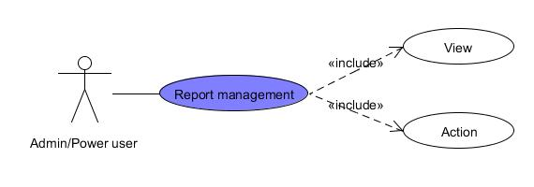

* + - 1. View report

|  |  |  |  |  |
| --- | --- | --- | --- | --- |
| **USE CASE – View report SPECIFICATION** | | | | |
| Use-case No. | UC012 | Use-case Version | | 1.0 |
| Use-case Name | View report | | | |
| Author | KienBT | | | |
| Date | 02/06/2012 | Priority | High | |
| **Actor:**  Admin / Power user  **Summary:**  When user see bad content or spam recipe, comment or recipe. He/she can report bad content to Admin. And Admin or Power User will view all reports to make a decision for a better website.  **Goal**  Admin or power user can view report  **Triggers**  Click to “Report Management” menu then click to “View” sub menu  **Preconditions:**  Logged into website with Admin or Power user role successfully.  **Post Conditions:**  N/A  **Main Success Scenario:**   |  |  |  | | --- | --- | --- | | Step | Actor Action | System Response | | 1 | Click to “Report Management” menu then click to “View” sub menu | Navigate admin to the page with list of existed report |   **Alternative Scenario:**  N/A  **Exceptions:**  N/A  **Relationships:**  Login use case  **Business Rules:**  Must be admin or power user to view all reports | | | | |

* + - 1. Action

|  |  |  |  |  |
| --- | --- | --- | --- | --- |
| **USE CASE - Action SPECIFICATION** | | | | |
| Use-case No. | UC013 | Use-case Version | | 1.0 |
| Use-case Name | Action | | | |
| Author | KienBT | | | |
| Date | 02/06/2012 | Priority | High | |
| **Actor:**  Admin / Power user  **Summary:**  When user see bad content or spam recipe, comment or recipe. He/she can report bad content to Admin. And Admin or Power User will view all reports to make a decision for a better website.  **Goal**  Admin or power user can view report  **Triggers**  Click to “Report Management” menu then click to “View” sub menu  **Preconditions:**  Logged into website with Admin or Power user role successfully.  **Post Conditions:**  N/A  **Main Success Scenario:**   |  |  |  | | --- | --- | --- | | Step | Actor Action | System Response | | 1 | Click to “Report Management” menu then click to categories report sub menu | Navigate admin to the page with list of existed report with corresponding category. | | 2 | Click to “Delete” button | Pop-up window show to confirm delete this report | | 3 | Click to “Yes” button | Comment will be deleted and display message “Spam content and attached reports has been successfully” |   **Alternative Scenario:**   |  |  |  | | --- | --- | --- | | Step | Actor Action | System Response | | 1 | Click to “Report Management” menu then click to categories report sub menu | Navigate admin to the page with list of existed report with corresponding category. | | 2 | Click to “Not spam” button | The report will be deleted and display message “Reports attached to chosen Comment has been deleted successfully” |   **Exceptions:**  N/A  **Relationships:**  Login use case  **Business Rules:**  Must be admin or power user to view all reports | | | | |

#### Approval

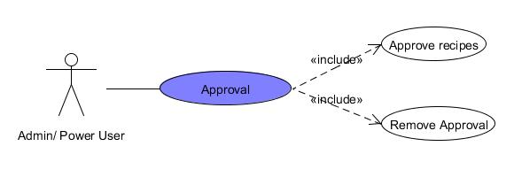

* + - 1. Approve Recipes

|  |  |  |  |  |
| --- | --- | --- | --- | --- |
| **USE CASE – Approve recipes SPECIFICATION** | | | | |
| Use-case No. | UC014 | Use-case Version | | 1.0 |
| Use-case Name | Approve recipe | | | |
| Author | KienBT | | | |
| Date | 02/06/2012 | Priority | High | |
| **Actor:**  Admin / Power user  **Summary:**  When user posts a recipe, it will be showed to the website immediately; However, that is user’s opinion or knowledge. Admin or Power User wants to view posted recipes and approve it with agreement of famous chefs or cooking experts. Recipes were approved that it is high quality recipe and star as “Editor choice”  **Goal**  Admin or power user can approve posted recipes  **Triggers**  Click to “Recipe Management” menu then click to “View” sub menu  **Preconditions:**  Logged into website with Admin or Power user role successfully.  **Post Conditions:**  N/A  **Main Success Scenario:**   |  |  |  | | --- | --- | --- | | Step | Actor Action | System Response | | 1 | Click to “Recipe Management” menu then click to “View” sub menu | Navigate user to the page with list of existed recipes | | 2 | Click recipe want to approve. | Navigate user to the page with corresponding recipe | | 3 | Click “Approve” button | Display message “Recipe approved” |   **Alternative Scenario:**  N/A  **Exceptions:**  N/A  **Relationships:**  Login use case  **Business Rules:**  Must be admin or power user to view for experts and chefs to approve | | | | |

* + - 1. Remove Recipes

|  |  |  |  |  |
| --- | --- | --- | --- | --- |
| **USE CASE – Remove recipes SPECIFICATION** | | | | |
| Use-case No. | UC015 | Use-case Version | | 1.0 |
| Use-case Name | Remove recipes | | | |
| Author | KienBT | | | |
| Date | 02/06/2012 | Priority | High | |
| **Actor:**  Admin / Power user  **Summary:**  Admin or Power User wants to remove approved recipes to unapproved recipes.  **Goal**  Admin or power user can approve posted recipes  **Triggers**  Click to “Recipe Management” menu then click to “View” sub menu  **Preconditions:**  Logged into website with Admin or Power user role successfully.  **Post Conditions:**  N/A  **Main Success Scenario:**   |  |  |  | | --- | --- | --- | | Step | Actor Action | System Response | | 1 | Click to “Recipe Management” menu then click to “View” sub menu | Navigate user to the page with list of existed recipes | | 2 | Click recipe want to approve. | Navigate user to the page with corresponding recipe | | 3 | Click “Remove” button | Display message “Recipe unapproved.” |   **Alternative Scenario:**  N/A  **Exceptions:**  N/A  **Relationships:**  Login use case  **Business Rules:**  Must be admin or power user to view for experts and chefs to remove | | | | |

#### Dictionary Management

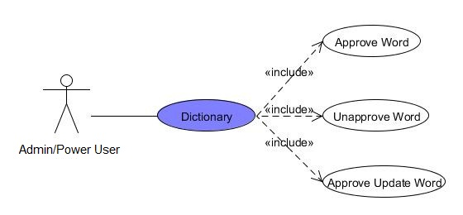

* + - 1. Approve Word

|  |  |  |  |  |
| --- | --- | --- | --- | --- |
| **USE CASE – Approve Word SPECIFICATION** | | | | |
| Use-case No. | UC016 | Use-case Version | | 1.0 |
| Use-case Name | Approve Word | | | |
| Author | KienBT | | | |
| Date | 02/06/2012 | Priority | High | |
| **Actor:**  Admin / Power User  **Summary:**  Admin can approve word and its meaning to show in website.  **Goal**  Only approved word can show in website for user’s searching.  **Triggers**  Click to “Approve Words” hyperlink in Dictionary button on Admin menu bar.  **Preconditions:**  Logged into website successfully with Admin or Power account  **Post Conditions:**  N/A  **Main Success Scenario:**   |  |  |  | | --- | --- | --- | | Step | Actor Action | System Response | | 1 | Click to “Approve” button | System will ask to confirm | | 2 | Click “Yes” | Record will be deleted and display message “Word has been approved successfully” |   **Alternative Scenario:**  N/A  **Exceptions:**   |  |  |  | | --- | --- | --- | | Step | Actor Action | System Response | | 1 | Click to “Approve” button | System will ask you to confirm | | 2 | Click “No” | Navigate to current page with waiting words list for approval. |   **Relationships:**  Login function  **Business Rules:**  Must be Admin/Power User to perform this task. | | | | |

* + - 1. Unapprove Word

|  |  |  |  |  |
| --- | --- | --- | --- | --- |
| **USE CASE – Unapprove Word SPECIFICATION** | | | | |
| Use-case No. | UC017 | Use-case Version | | 1.0 |
| Use-case Name | Unapprove Word | | | |
| Author | KienBT | | | |
| Date | 02/06/2012 | Priority | High | |
| **Actor:**  Admin / Power User  **Summary:**  Admin can unapprove word and its meaning to appear in website.  **Goal**  Uapproved words no longer appear in website for user’s searching.  **Triggers**  Click to “Unpprove Words” hyperlink in Dictionary button on Admin menu bar.  **Preconditions:**  Logged into website successfully with Admin or Power account  **Post Conditions:**  N/A  **Main Success Scenario:**   |  |  |  | | --- | --- | --- | | Step | Actor Action | System Response | | 1 | Click to “Unapprove” button | System will ask to confirm | | 2 | Click “Yes” | Record will be deleted and display message “Word has been unapproved successfully” and move word to approve word page. |   **Alternative Scenario:**  N/A  **Exceptions:**   |  |  |  | | --- | --- | --- | | Step | Actor Action | System Response | | 1 | Click to “Unapprove” button | System will ask you to confirm | | 2 | Click “No” | Navigate to current page with words has been approved. |   **Relationships:**  Login function  **Business Rules:**  Must be Admin/Power User to perform this task. | | | | |

* + - 1. Approve Update Word

|  |  |  |  |  |
| --- | --- | --- | --- | --- |
| **USE CASE – Approve Update Word SPECIFICATION** | | | | |
| Use-case No. | UC018 | Use-case Version | | 1.0 |
| Use-case Name | Approve Update Word | | | |
| Author | KienBT | | | |
| Date | 02/06/2012 | Priority | High | |
| **Actor:**  Admin / Power User  **Summary:**  Admin can approve updating word and its meaning to show in website.  **Goal**  Updating words and meaning for more correctly satisfy user’s searching.  **Triggers**  Click to “Approve Update Words” hyperlink in Dictionary button on Admin menu bar.  **Preconditions:**  Logged into website successfully with Admin or Power account  **Post Conditions:**  N/A  **Main Success Scenario:**   |  |  |  | | --- | --- | --- | | Step | Actor Action | System Response | | 1 | Click to “Approve” button | System will ask to confirm | | 2 | Click “Yes” | Record will be deleted and display message “Word has been approved successfully” |   **Alternative Scenario:**  N/A  **Exceptions:**   |  |  |  | | --- | --- | --- | | Step | Actor Action | System Response | | 1 | Click to “Approve” button | System will ask you to confirm | | 2 | Click “No” | Navigate to current page with waiting words list for approval. |   **Relationships:**  Login function  **Business Rules:**  Must be Admin/Power User to perform this task. | | | | |

### 2.2 Front–end



#### Comment

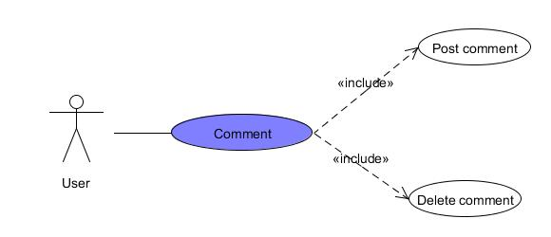

* + - 1. Post comment

|  |  |  |  |  |
| --- | --- | --- | --- | --- |
| **USE CASE – Post comment SPECIFICATION** | | | | |
| Use-case No. | UC024 | Use-case Version | | 1.0 |
| Use-case Name | Post comment | | | |
| Author | KienBT | | | |
| Date | 02/06/2012 | Priority | High | |
| **Actor:**  Authenticated User  **Summary:**  When users want to express his/her opinion about recipes or tips.  **Goal**  User post comment successfully.  **Triggers**  Click “bình luận” textbox  **Preconditions:**  Logged into website successfully.  **Post Conditions:**  Stay remain at current recipe page with a comment was added.  **Main Success Scenario:**   |  |  |  | | --- | --- | --- | | Step | Actor Action | System Response | | 1 | Click to “bình luận” textbox and type comment |  | | 2 | Click “Bình luận” button | Stay remains current page with new comment is posted |   **Alternative Scenario:**  N/A  **Exceptions:**   |  |  |  | | --- | --- | --- | | Step | Actor Action | System Response | | 1 | Click to “bình luận” textbox and type comment |  | | 2 | Click “Bình luận” button | Display a message “Bình luận không hợp lệ.” |   **Relationships:**  N/A  **Business Rules:**  Comment must be greater than 0 characters. | | | | |

* + - 1. Delete comment

|  |  |  |  |  |
| --- | --- | --- | --- | --- |
| **USE CASE – Delete comment SPECIFICATION** | | | | |
| Use-case No. | UC025 | Use-case Version | | 1.0 |
| Use-case Name | Delete comment | | | |
| Author | KienBT | | | |
| Date | 02/06/2012 | Priority | Normal | |
| **Actor:**  Authenticated User  **Summary:**  When users want to delete his/her comments.  **Goal**  User deletes comments.  **Triggers**  Click to posted comments.  **Preconditions:**  Logged into website successfully.  **Post Conditions:**  Stay remain at current recipe page with a comment was deleted.  **Main Success Scenario:**   |  |  |  | | --- | --- | --- | | Step | Actor Action | System Response | | 1 | Click “X” on comment textbox | Stay remains current page with comment was deleted. |   **Alternative Scenario:**  N/A  **Exceptions:**  N/A  **Relationships:**  N/A  **Business Rules:**  Must be your comments. | | | | |

#### Create

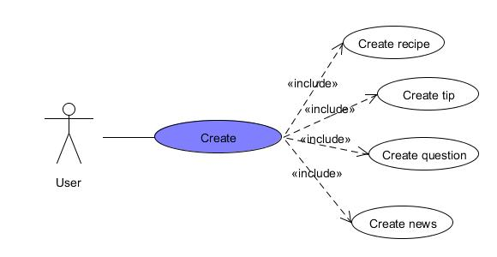

* + - 1. Create recipe

|  |  |  |  |  |
| --- | --- | --- | --- | --- |
| **USE CASE – Create Recipe SPECIFICATION** | | | | |
| Use-case No. | UC026 | Use-case Version | | 1.0 |
| Use-case Name | Create recipe | | | |
| Author | KienBT | | | |
| Date | 02/06/2012 | Priority | Normal | |
| **Actor:**  Authenticated User  **Summary:**  When user wants to post a recipe to sharing with other people.  **Goal**  User follows the form to post recipes easily and rapidly  **Triggers**  Move mouse to “Gửi bài” and click to “Gửi công thức” hyperlink  **Preconditions:**  Logged into website successfully.  **Post Conditions:**  Stay remain at current recipe page with a new recipe was posted.  **Main Success Scenario:**   |  |  |  | | --- | --- | --- | | Step | Actor Action | System Response | | 1 | Click to “ Gửi công thức” hyperlink | Navigate user to the page has form to user fills. | | 2 | Enter required fields |  | | 3 | Click to “ Chọn ảnh” button | Dialog opens to choose picture | | 4 | Click to “Lưu” button | Navigate user to page includes the recipe what has just posted. |   **Alternative Scenario:**  N/A  **Exceptions:**   |  |  |  | | --- | --- | --- | | Step | Actor Action | System Response | | 1 | Click to “ Gửi công thức” hyperlink | Navigate user to the page has form to user fills. | | 2 | Leave required fields blank |  | | 3 | Click to “ Gửi” button | Display a message “Bạn hãy sửa những lỗi bên dưới và thử lại”. |   **Relationships:**  Login function  **Business Rules:**  Must have main picture and description about dish | | | | |

* + - 1. Create tip

|  |  |  |  |  |
| --- | --- | --- | --- | --- |
| **USE CASE – Create tip SPECIFICATION** | | | | |
| Use-case No. | UC027 | Use-case Version | | 1.0 |
| Use-case Name | Create tip | | | |
| Author | KienBT | | | |
| Date | 02/06/2012 | Priority | Normal | |
| **Actor:**  Authenticated User  **Summary:**  When user wants to post a tip for collecting better ingredients or cooking more delicious.  **Goal**  User creates tip successfully  **Triggers**  Click to “Mẹo vặt” hyperlink  **Preconditions:**  Logged into website successfully.  **Post Conditions:**  Stay remain at current recipe page with a new tip was posted.  **Main Success Scenario:**   |  |  |  | | --- | --- | --- | | Step | Actor Action | System Response | | 1 | Click to “Gửi” button | Navigate user to the page has form to user fills. | | 2 | Enter required fields |  | | 3 | Click to “Chọn ảnh” button | Dialog opens to choose picture | | 4 | Click to “Gửi” button | Navigate user to page includes the tip what has just posted. |   **Alternative Scenario:**  N/A  **Exceptions:**   |  |  |  | | --- | --- | --- | | Step | Actor Action | System Response | | 1 | Click to “Gửi” button | Navigate user to the page has form to user fills. | | 2 | Leave required fields blank |  | | 3 | Click to “Gửi” button | Show error message “Bạn hãy sửa những lỗi bên dưới và thử lại.” |   **Relationships:**  Login function  **Business Rules:**  Description must be greater than 10 characters. | | | | |

* + - 1. Create news

|  |  |  |  |  |
| --- | --- | --- | --- | --- |
| **USE CASE – Create news SPECIFICATION** | | | | |
| Use-case No. | UC028 | Use-case Version | | 1.0 |
| Use-case Name | Create news | | | |
| Author | KienBT | | | |
| Date | 02/06/2012 | Priority | Normal | |
| **Actor:**  Authenticated User  **Summary:**  When user wants to post news related to cooking.  **Goal**  User posts news such as ingredients price or health news…  **Triggers**  Click to “Tin tức” hyperlink  **Preconditions:**  Logged into website successfully.  **Post Conditions:**  Stay remain at current recipe page with new news was posted.  **Main Success Scenario:**   |  |  |  | | --- | --- | --- | | Step | Actor Action | System Response | | 1 | Click to “ Gửi” button | Navigate user to the page has form to user fills. | | 2 | Enter required fields |  | | 3 | Click to “Chọn ảnh” button | Dialog opens to choose picture | | 4 | Click to “Gửi” button | Navigate user to page includes the tip what has just posted. |   **Alternative Scenario:**  N/A  **Exceptions:**   |  |  |  | | --- | --- | --- | | Step | Actor Action | System Response | | 1 | Click to “Gửi” button | Navigate user to the page has form to user fills. | | 2 | Leave required fields blank |  | | 3 | Click to “Chọn ảnh” button | Dialog opens to choose picture | | 4 | Click to “ Gửi” button | Show error message “Bạn hãy sửa những lỗi bên dưới và thử lại.” |   **Relationships:**  Login function  **Business Rules:**  Description must be greater than 10 characters. | | | | |

* + - 1. Create question

|  |  |  |  |  |
| --- | --- | --- | --- | --- |
| **USE CASE – Create question SPECIFICATION** | | | | |
| Use-case No. | UC029 | Use-case Version | | 1.0 |
| Use-case Name | Create question | | | |
| Author | KienBT | | | |
| Date | 02/06/2012 | Priority | Normal | |
| **Actor:**  Authenticated User  **Summary:**  When users want to ask something related to cooking.  **Goal**  User creates question for other users when he/she wants to ask something.  **Triggers**  Click to “Hỏi đáp” hyperlink  **Preconditions:**  Logged into website successfully.  **Post Conditions:**  Stay remain at current recipe page with new question was asked.  **Main Success Scenario:**   |  |  |  | | --- | --- | --- | | Step | Actor Action | System Response | | 1 | Click to “Gửi câu hỏi” hyperlink |  | | 2 | Enter required fields |  | | 3 | Click “Gửi” button | Stay remains current page with new question was posted |   **Alternative Scenario:**  N/A  **Exceptions:**   |  |  |  | | --- | --- | --- | | Step | Actor Action | System Response | | 1 | Click to “Gửi câu hỏi” hyperlink |  | | 2 | Click “Gửi” button | Display message “Câu hỏi phải ít nhất 10 ký tự” |   **Relationships:**  Login function  **Business Rules:**  Description must be greater than 10 characters. | | | | |

#### Question & Answer

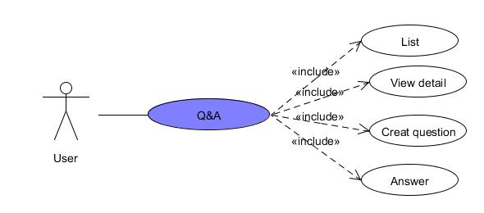

* + - 1. List Question

|  |  |  |  |  |
| --- | --- | --- | --- | --- |
| **USE CASE – List Question SPECIFICATION** | | | | |
| **Use-case No.** | UC033 | **Use-case Version** | | 1.0 |
| **Use-case Name** | List Question | | | |
| **Author** | ToanDX | | | |
| **Date** | 02/06/2012 | **Priority** | High | |
| **Actor:**  User  **Summary:**  This Question Page displays all questions of users. If user doesn’t find what they want, he/she can post a new question by clicks to “Gửi câu hỏi mới” hyperlink. Besides, all questions are displayed in question page will be displayed with question title, creator name, created time, number of vote up and vote down, number of views and answers. In default, Q&A will display 10 questions. User need click to “Xem thêm” to view more questions.  **Goal:**  Display Q&A page  **Triggers**  Click to “Hỏi đáp” menu bar.  **Preconditions:**  Access the website.  **Post Conditions:**  Stay remains at current page with Q&A page displayed.  **Main Success Scenario:**   |  |  |  | | --- | --- | --- | | Step | Actor Action | System Response | | 1 | Click to “Hỏi đáp” menu bar | Redirect user to Q&A page and displays questions. |   **Alternative Scenario:**  N/A  **Exceptions:**  N/A  **Relationships:**  N/A  **Business Rules:**  N/A | | | | |

* + - 1. View Detail

|  |  |  |  |  |
| --- | --- | --- | --- | --- |
| **USE CASE – View Question Detail SPECIFICATION** | | | | |
| **Use-case No.** | UC034 | **Use-case Version** | | 1.0 |
| **Use-case Name** | View Question Detail | | | |
| **Author** | ToanDX | | | |
| **Date** | 02/06/2012 | **Priority** | Normal | |
| **Actor:**  User  **Summary:**  When the users click on any question link, they will be redirected to corresponding question detail page. It contains question and its answers.  **Goal:**  Display question’s detail.  **Triggers**  Click to question’s detail hyperlink.  **Preconditions:**  Access the website.  **Post Conditions:**  Question and its answers will be displayed.  **Main Success Scenario:**   |  |  |  | | --- | --- | --- | | Step | Actor Action | System Response | | 1 | Click to question hyperlink | Redirect to question detail page |   **Alternative Scenario:**   |  |  |  | | --- | --- | --- | | Step | Actor Action | System Response | | 1 | User creates a new question and click to “Gửi” button. | Redirect to question detail page |   **Exceptions:**  N/A  **Relationships:**  Login use case, Create a New Question use case  **Business Rules:**  N/A | | | | |

* + - 1. Create Question

|  |  |  |  |  |
| --- | --- | --- | --- | --- |
| **USE CASE – Create New question SPECIFICATION** | | | | |
| **Use-case No.** | UC035 | **Use-case Version** | | 1.0 |
| **Use-case Name** | Create New Question | | | |
| **Author** | ToanDX | | | |
| **Date** | 02/06/2012 | **Priority** | Normal | |
| **Actor:**  User  **Summary:**  When users come to Q&A page and cannot find any question which suitable for their need, they can post a new question to find a solution for their problem.  **Goal:**  Create a new question.  **Triggers**  Click to “Gửi câu hỏi mới” hyperlink.  **Preconditions:**  Successfully logged into the system and accessed to question page.  **Post Conditions:**  Redirect to Question Detail page.  **Main Success Scenario:**   |  |  |  | | --- | --- | --- | | Step | Actor Action | System Response | | 1 | Click to “Gửi câu hỏi mới” hyperlink | Redirect user to Create new question page | | 2 | Enter required fields |  | | 3 | Click to “Gửi” button | Website will redirect to Question Detail page |   **Alternative Scenario:**  N/A  **Exceptions:**   |  |  |  | | --- | --- | --- | | Step | Actor Action | System Response | | 1 | Click to “Gửi câu hỏi mới” hyperlink | Redirect user to Create new question page | | 2 | Click to “Gửi” button | Display message “Bạn hãy sửa những lỗi bên dưới và thử lại.” |   **Relationships:**  Login use case, question page use case  **Business Rules:**  N/A | | | | |

* + - 1. Answer Question

|  |  |  |  |  |
| --- | --- | --- | --- | --- |
| **USE CASE – Answer Question SPECIFICATION** | | | | |
| **Use-case No.** | UC036 | **Use-case Version** | | 1.0 |
| **Use-case Name** | Answer Question | | | |
| **Author** | ToanDX | | | |
| **Date** | 02/06/2012 | **Priority** | Normal | |
| **Actor:**  User  **Summary:**  When open question page, the user can realize a question that he/she knows the answer or it is same problem with the user problem. The user can post an answer to propose a solution or showing empathy with the asker.  **Goal:**  Allow user to post an answer.  **Triggers**  Click to “Trả lời” button.  **Preconditions:**  Successfully logged in to the system and accessed to question detail page.  **Post Conditions:**  Stay remains at question detail page with new answer on top of answer area.  **Main Success Scenario:**   |  |  |  | | --- | --- | --- | | Step | Actor Action | System Response | | 1 | Click to the answer text box | “Trả lời” and “Bỏ qua” buttons appear | | 2 | Enter the content in reply box. |  | | 3 | Click to “Trả lời” button | The answer will be added to top of answer area with the content, creator, creator’s avatar and created time. |   **Alternative Scenario:**  N/A  **Exceptions:**   |  |  |  | | --- | --- | --- | | Step | Actor Action | System Response | | 1 | Click to the answer text box | “Trả lời” and “Bỏ qua” buttons appear | | 2 | The user leaves the content blank |  | | 3 | Click to “Trả lời” button | Nothing happen |     **Relationships:**  Login use case and question page use case  **Business Rules:**  N/A | | | | |

#### Search

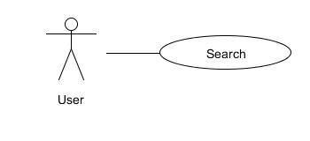

|  |  |  |  |  |
| --- | --- | --- | --- | --- |
| **USE CASE – Search Contents SPECIFICATION** | | | | |
| **Use-case No.** | UC042 | **Use-case Version** | | 1.0 |
| **Use-case Name** | Search Contents | | | |
| **Author** | ToanDX | | | |
| **Date** | 03/06/2012 | **Priority** | High | |
| **Actor:**  User  **Summary:**  Users can search for contents by some criteria in order to find contents suitable for their need. The search result will be filtered to support users find the right contents as quick as possible.  **Goal:**  Search for contents.  **Triggers**  Users enter search criteria and click search button  **Preconditions:**  Access the website  **Post Conditions:**  The page navigates to search result screen with the result displayed  **Main Success Scenario:**   |  |  |  | | --- | --- | --- | | Step | Actor Action | System Response | | 1 | Enter keyword to search text box |  | | 2 | Click to “Chọn danh mục” dropdown list | Show categories for user to choose | | 3 | Click to search icon | Display search result |   **Alternative Scenario:**  N/A  **Alternative Scenario – No result**   |  |  |  | | --- | --- | --- | | Step | Actor Action | System Response | | 1 | Enter keyword which no content has |  | | 2 | Clicks “Tìm kiếm” button | Display “Không tìm kết quả nào.” |   **Exceptions:**  N/A  **Relationships:**  N/A  **Business Rules:**  N/A | | | | |

#### Sort Content

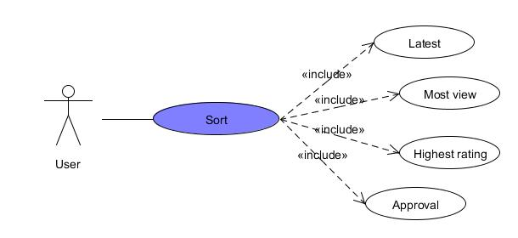

|  |  |  |  |  |
| --- | --- | --- | --- | --- |
| **USE CASE – Sort Content SPECIFICATION** | | | | |
| **Use-case No.** | UC044 | **Use-case Version** | | 1.0 |
| **Use-case Name** | Sort Content | | | |
| **Author** | ToanDX | | | |
| **Date** | 02/06/2012 | **Priority** | Normal | |
| **Actor:**  User  **Summary:**  Users will have the options to sort recipes by rating, number of comments and number of page views. Default will be “rating descending”.  **Goal:**  Sort a content base on user’s desired.  **Triggers**  Click to views/rating/new/approved hyperlink.  **Preconditions:**  Access the website  **Post Conditions:**  Stay remains at current page with contents sorted.  **Main Success Scenario:**   |  |  |  | | --- | --- | --- | | Step | Actor Action | System Response | | 1 | Click to new/views/comment/approved hyperlink. | Contents is sorted by new/views/comments descending and displayed. |   **Alternative Scenario:**  N/A  **Exceptions:**  N/A  **Relationships:**  N/A  **Business Rules:**  N/A | | | | |

#### Dictionary

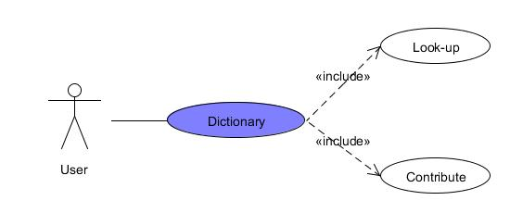

2.2.12.1 Look up

|  |  |  |  |  |
| --- | --- | --- | --- | --- |
| **USE CASE - Dictionary SPECIFICATION** | | | | |
| Use-case No. | UC046 | Use-case Version | | 1.0 |
| Use-case Name | Look-up | | | |
| Author | KienBT | | | |
| Date | 02/06/2012 | Priority | High | |
| **Actor:**  User  **Summary:**  User can look-up a strange word and see its meaning  **Goal**  User finds the meaning of a strange or new word.  **Triggers**  Click to “Xem đầy đủ” hyperlink  **Preconditions:**  Logged into website successfully.  **Post Conditions:**  N/A  **Main Success Scenario:**   |  |  |  | | --- | --- | --- | | Step | Actor Action | System Response | | 1 | Click to “Xem đầy đủ” hyperlink on the right of website | Show all words and meanings. |   **Alternative Scenario:**  N/A  **Exceptions:**  N/A  **Relationships:**  Login function  **Business Rules:**  N/A | | | | |

2.2.12.2 Contribute

|  |  |  |  |  |
| --- | --- | --- | --- | --- |
| **USE CASE - Contribute SPECIFICATION** | | | | |
| Use-case No. | UC047 | Use-case Version | | 1.0 |
| Use-case Name | Contribute | | | |
| Author | KienBT | | | |
| Date | 02/06/2012 | Priority | High | |
| **Actor:**  Authenticated User  **Summary:**  User can contribute a strange word and see its meaning  **Goal**  User sends a contribution for website.  **Triggers**  Click to “Thêm từ mới” hyperlink on the right of website.  **Preconditions:**  Logged into website successfully.  **Post Conditions:**  N/A  **Main Success Scenario:**   |  |  |  | | --- | --- | --- | | Step | Actor Action | System Response | | 1 | Click to “Từ” textbox, “Nghĩa” textbox and type the word |  | | 2 | Click “Gửi” | Display message “Thêm từ mới thành công. Ban quản trị sẽ kiểm tra độ chính xác trong thời gian sớm nhất.” |   **Alternative Scenario:**  N/A  **Exceptions:**   |  |  |  | | --- | --- | --- | | Step | Actor Action | System Response | | 1 | Leave textboxes blank |  | | 2 | Click “Tìm” button | Display message “Bạn hãy sửa những lỗi bên dưới và thử lại” |   **Relationships:**  Login function  **Business Rules:**  N/A | | | | |

## Software System Attributes

### Usability

GUI

* All the text, image text and help documents should be in Vietnamese.
* The interface should be elegant, simple and out-standing.
* All images must also provide alt attribute.

Usability for end-users

* Searching tool should be easy to use.
* The website must provide a help page to support novice users.
* Users can use main functionality of the system without logging in to the system.
* The system should remember information (but not confidential) that users have to provide regularly. For example: name, address…

Usability for admin and staff

* Website admin and shop’s staff should need no more than one day of training to be productive with the system.
* Detailed help must be available for the admin and staff, both in web pages and separate documentations.

Installation

* The system must be easy to deploy. Customer can deploy successfully and learn to configure, maintain the system within one day of training.
* The documentation for installation must be included. It describes detailed steps for installing or deploying the system. The customer can follow the steps without direct help from the developing team.

### Reliability

* Initial data must be collected carefully and correctly.
* The database must be backed up regularly and can be recovered if necessary.
* Have a good spam filter.
* Rating system must be reliable.
* Not conflict with other software.
* Rate of fault occurrence (ROFO): a number of 0.005 is acceptable. It means that it is acceptable to have 5 failures happen in each 1000 operational time units (e.g. 5 failures per 1000 hours of operation).
* Mean Time Between Failures (MTBF): 1 month.
* Mean Time To Repair (MTTR): immediately when admin finds out problem or website is attacked by someone. Average 1 day.
* Accuracy: precision of floating number should be rounded to 0.01. All currency units must be displayed (e.g. $, VND…)
* Maximum Bugs or Defect Rate: 5 bugs / KLOC.
* Bugs or Defect Rate
* Minor bugs: bugs related to GUI
* Significant bugs: bugs related to minor business logic
* Criticalbugs: function can’t execute correctly, completely loss of data, disconnect to the server

### Availability

* Systems have to run 24 hours 7 days
* Can be turned off when upgrading and must display an alternative maintenance page in such occasions
* Percentage of time available is about 95-97%. Because the system uses client/server protocol through Internet network, we cannot control cases of force majeure such as power failure, disconnected network…

### Security

* Privacy: the system should provide protection method for protecting user information from outside or from other users or software that is not part of the system. User password is also invisible for the system administrator.
* The system must provide methods to prevent common security attacks. E.g. SQL injection, D-Dos…
* Transformation of confidential information must be encrypted.
* The system must provide secure methods for users to recovery their password, including the interference of system’s admin.
* Secure information of customers should not be stored on customer’s machine.
* Utilize certain cryptographic techniques for database.
* Provide options for users to choose whether to share private information.
* Restrict communications between some areas of the program.
* Check data integrity for critical variables.
* Must use secure connection (SSL) for transferring sensitive data.

### Maintainability

Coding standards and naming conventions

* Output of the project must include coding standards and naming conventions documentations. Implementation code must be easy to maintain.
* All code must be clearly commented, including class, method documentations.
* If some components are reused, the documentations of those components must also be included.

Design

* The design of the system must be loosely coupled that chances on some module will not affect others.

Logging

* All errors should be logged, supporting for bug fixing and maintenance.
* All strange or sensitive situations should also be logged.

Email

* The system must provide an email address to receive customer feedback or send emails.

### Portability

Website can be used by any people with a browser and an Internet connection.

### Performance

Load time

* Every page should be completely displayed within: average 1.5 second and maximum 5 seconds.
* Searching should return and display the result within 2 seconds.
* Comments and rating and the like should affect immediately, without reloading the web page.
* Frequently accessed data must be cached.
* Reference data must be cached.

Mailing system

* Mail server should send emails within 1 minute after associated events happen.

Capacity

* The system should serve correctly and reasonably with at least 1000 online users at a moment.
* If the system is busy, it has to inform users about that.

Compatibility

* The system should provide elegant responses for nowadays common screen resolutions: 1024\*768, 1280\*800.
* The output must be compatible with all common browsers: Mozilla Firefox, Internet Explorer, Google Chrome, Apple Safari, and Opera.
* Information of the system can be accessed by searching bots.

# PART IV: SOFTWARE DESIGN DESCRIPTION

# Design Overview

This document describes the technical and UI design of the system. It includes the architectural design and the detailed design of common functions and business functions. It also includes the design of database model, and overall design of user interface.

The architectural design describes the overall architecture of the system, and the architecture of each main component and subsystem. It will describe the patterns being used, the role of each component and the role of the system in the working environment.

The detailed design describes static and dynamic structure for each component and function. It includes class diagrams, class explanations, and sequence diagrams of the main use cases. The detailed design uses notations of .NET framework 4.0 and C# 4.0 as they are the framework and language for developing the system.

The database design describes the relationship between entities, and details of each entity. It uses notations of SQL Server 2008 as it is the database server for developing the system.

The user interface design describes the layout of the system, and some design for the screens.

# System Architectural Design

## Overall System Architecture

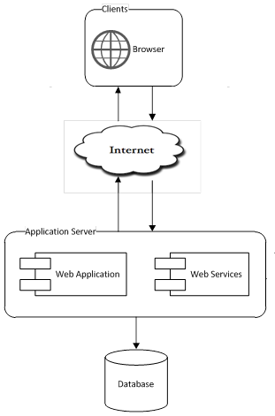

The system will use the Client-Server architectural patterns as the main architecture. It makes use of the Internet and common web protocols to deliver its services to the users.

The main entities of the above diagram will be described as following:

* **Database store:** this is the central data storage for the system. It may be running on a separate server to the Application Server, or in the same machine.
* **Application Server:** this is the server of the system running on IIS web server. It includes two main components: Web Application and Web Services. Web Application is responsible for creating web pages. It is developed using **ASP.NET MVC 3** framework. Web Services provides the system’s API to the world and some parts of the application.
* **Clients:** these include internet browsers running on personal computers, on mobile devices or on tablet. The web browsers will interact with the web application via normal protocols (HTTP, HTTPS…).

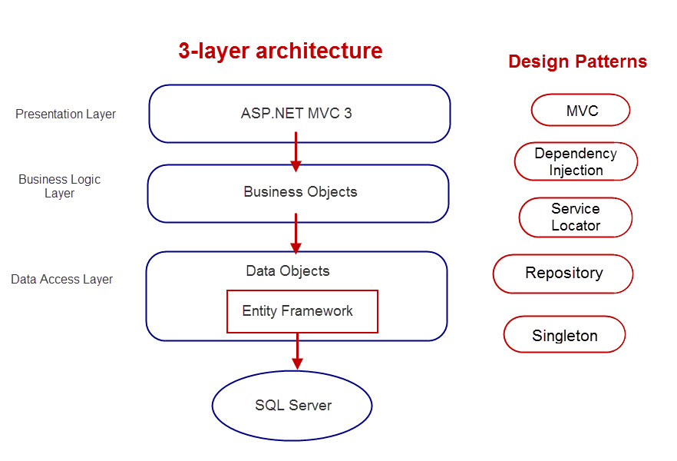

Patterns will be used throughout the project:

MVC, Dependency Injection, Service Locator, Repository, Singleton

## Web Application Architecture

The architecture for the CRS web application will be depicted as the following diagram:

### CRS.Common Component

This component contains common logic that can be used throughout the application. It includes for example mechanism for logging, caching, cryptography, and other utilities.

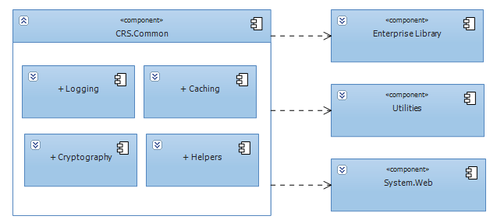

### CRS.Resources Component

This component contains static resources for the system. It includes localized strings and messages.

### CRS.Business Component

This component contains all business logic for the system. It includes object-relational mapping classes, business classes, data access layer, business interface…

The aim and challenge for the design is that this component will be application type independent. That is this component is not tied only to web application but can be used for other .NET application types if necessary.

All the services of this component will be used by dependent components via its interfaces.

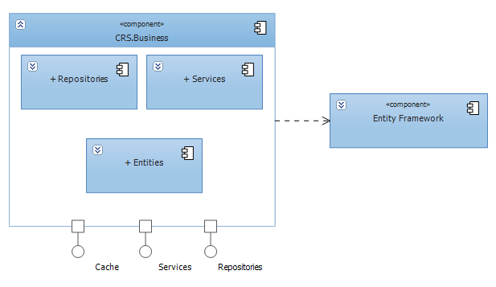

### CRS.Web Component

This component is responsible for delivering the front end to the users and accepting their inputs. It will be developed using ASP.NET MVC 3 framework. An MVC Application is designed and implemented using the following three attributes:

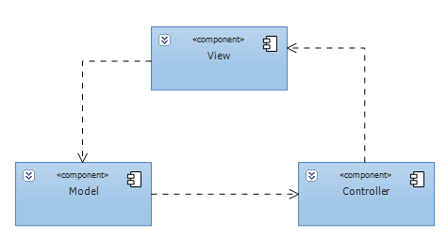

* **Model:** The model contains the core information for an application. This includes the data and validation rules as well as data access and aggregation logic.
* **View:** The view encapsulates the presentation of the application, and in ASP.NET this is typically the HTML markup.
* **Controller:** The controller contains the control-flow logic. It interacts with the Model and Views to control the flow of information and execution of the application.

The **CRS** application will make use another attribute: **View Model**. The view model encapsulates all the data properties that the view needs or provides. It is the view model that the view depends directly on, not the model. The model will be implemented by **CRS.Business** components, except those not related to business logics.



The overall architecture of CRS.Web component will be depicted as the following diagram:

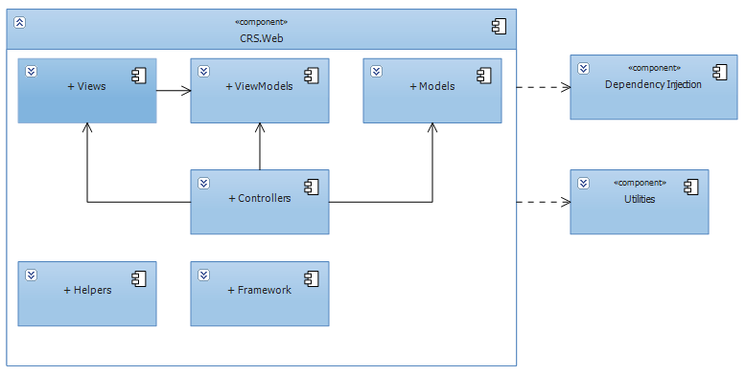

* **Helpers:** These are utilities classes specific for this component
* **Framework:** Contain the core framework to build web application

# Detailed Description of Component

## Comment

This part is the detailed design for the following use cases:

* Post a comment
* Edit a comment
* Delete a comment
* Report a comment
* Vote a comment

All contents (news, tips, and recipes) contain their own comment but the structure is the same. The following diagrams are drawn follow recipe comment.

### Class Diagram

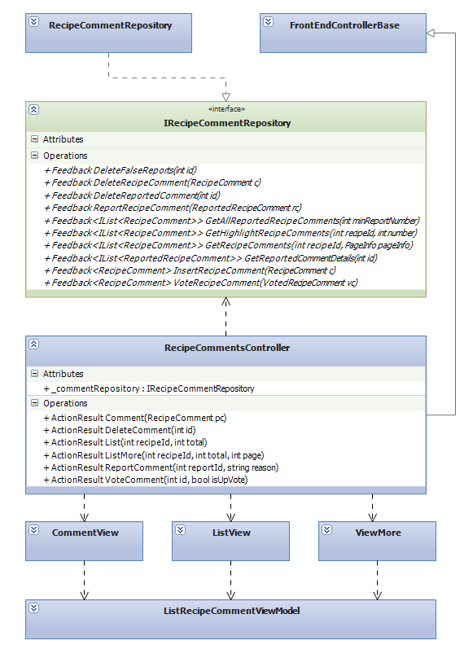

### Class Explanations

#### IRecipeCommentRepository interface

Outlines the methods that the data repository class (RecipeCommentRepository) will be able to perform. The data repository class will expand thisrepository pattern interface to include a full set of data access functions such as Select, Insert, Update, Delete.

Responsibilities:

* Delete comment
* Report comment
* Update vote status of a comment
* Get comments
* Get highlight comments
* Insert a new comment

#### RecipeCommentRepository class

Default implementation of IRecipeCommentRepository interface, contains the required code for accessing the MSSQL database

#### RecipeCommentsController class

The basic of responsibilities of RecipeCommentsController is to carry out the various use cases

Responsibilities:

* Allow all users to perform View Undeleted Comments Use Case
* Allow registered users to perform Insert A New Comment Use Case
* Allow registered users to perform Vote A Comment Use Case
* Allow registered users to Report A Comment Use Case
* Allow registered users users to perform Delete Their Own Comments Use Case

#### ListView class

Contain HTML markup and .NET code to render List Comments View screen

#### CommentView class

Contain HTML markup and .NET code to render Comment View screen

#### ListRecipeCommentViewModel class

Model type of ListView and CommentView

### Sequence Diagrams

#### 1.3.1 Create Comment

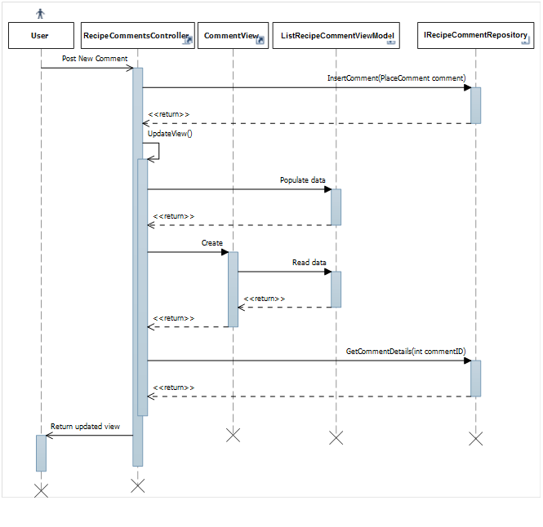

#### 1.3.2 Delete Comment

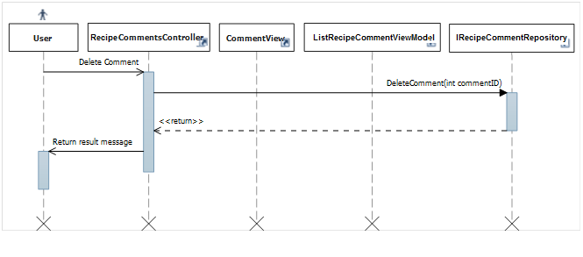

#### 1.3.3 Report Comment

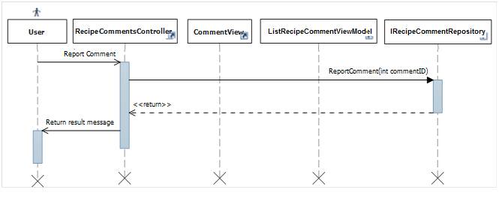

#### 1.3.4 View Comment List

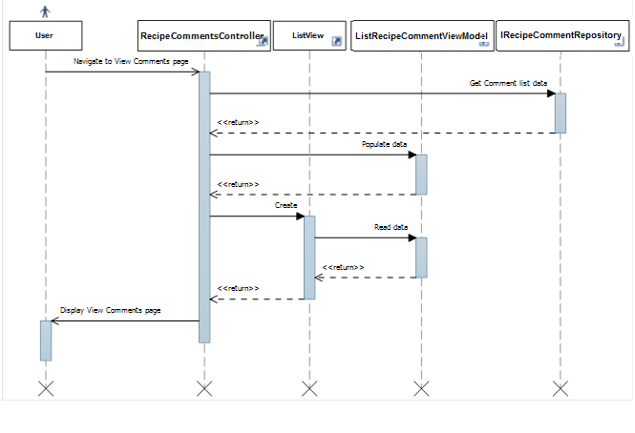

#### 1.3.5 Vote Comment

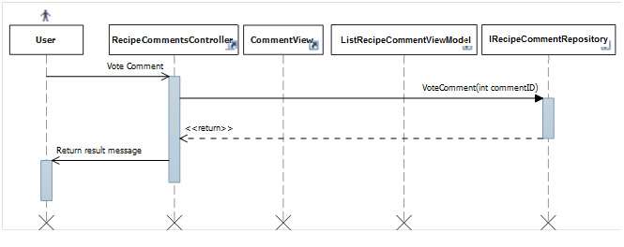

#### 1.3.6 Highlight Best Comment

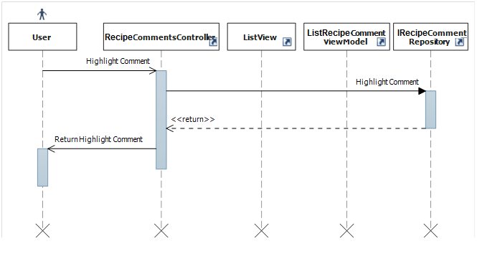

## Search Content

This part is the detailed design for the following use cases:

* Search Content (includes news, tips, recipes and all the contents)

### Class Diagram

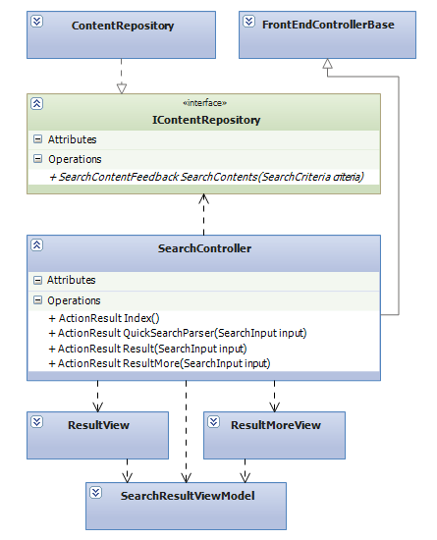

### Class Explanations

#### IContentRepository interface

Outlines the methods that the data repository class (ContentRepository) will be able to perform. The data repository class will expand this repository pattern interface to include Select data access functions

Responsibilities:

* Search contents (includes search on each type of content (news, tips, recipes) and search all contents)

#### ContentRepository class

Default implementation of IContentRepository interface, contains the required code for accessing the MSSQL database

#### SearchController class

The basic of responsibilities of RecipeCommentsController is to carry out the various use cases

Responsibilities:

* Allow all users to perform Search Content Use Case

#### ResultView class

Contain HTML markup and .NET code to render Search Result View screen

#### SearchResultViewModel class

Model type of ResultView

### Sequence Diagrams

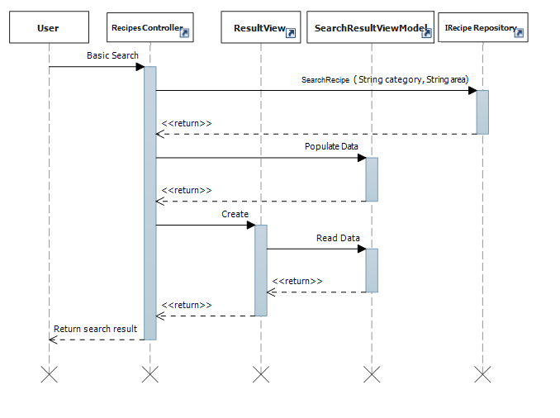

## Statistics

This part is the detailed design for the following use cases:

* Hot questions in month
* Top answer contributors
* Newest questions

### Class Diagram

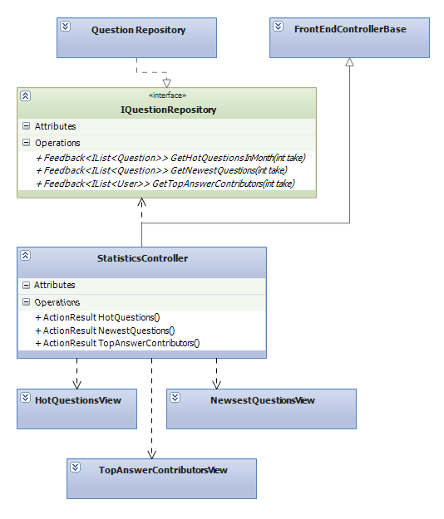

### Class Explanations

#### IQuestionRepository interface

Outlines the methods that the data repository class (QuestionRepository) will be able to perform. For statistical purposes, the data repository class will expand this repository pattern interface to include Select data access functions.

Responsibilities:

* Get list hot questions
* Get list top answer contributors
* Get list newest questions

#### QuestionRepository class

Default implementation of IQuestionRepository interface, contains the required code for accessing the MSSQL database

#### StatisticsController class

The basic of responsibilities of StatisticsControlleris to carry out the various use cases

Responsibilities:

* Allow all users to perform View Hot Questions In Month Use Case
* Allow all users to perform View Newest Questions Use Case
* Allow all users to perform View Top Answer Contributors Use Case

#### HotQuestionsView class

Contain HTML markup and .NET code to render Hot Questions View screen

#### NewestQuestionsView class

Contain HTML markup and .NET code to render Newest Questions View screen

#### TopAnswerContributorsView class

Contain HTML markup and .NET code to render Top Answer Contributors

### Sequence Diagrams

#### Hot Questions

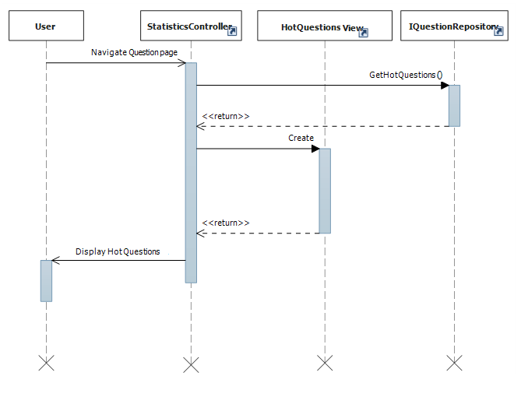

#### Newest Questions

#### Top Answer Contributors

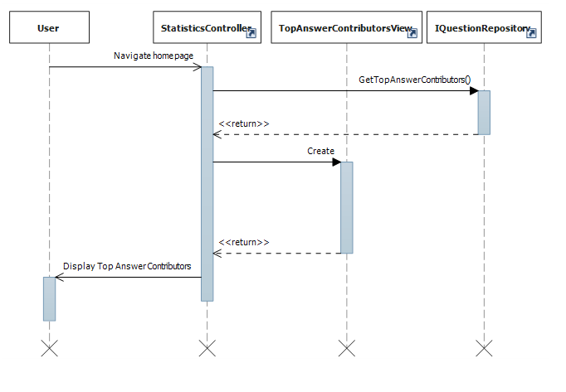

## Question

This part is the detailed design for the following use cases:

* Get Question List
* Get question’s details
* Insert a new question
* Update questions
* Report questions

### Class Diagram

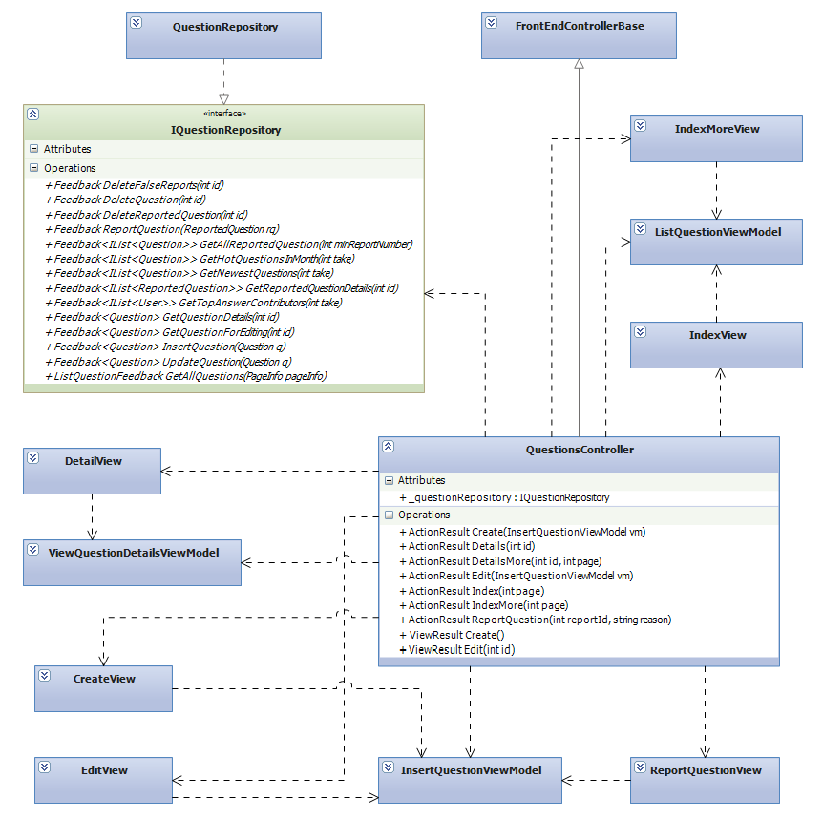

### Class Explanations

#### IQuestionRepository interface

Outlines the methods that the data repository class (QuestionRepository) will be able to perform. The data repository class will expand this repository pattern interface to include a full set of data access functions such as Select, Insert, Update, Delete.

Responsibilities:

* Get Question List
* Get question’s details
* Insert a new question
* Update questions
* Report questions

#### QuestionRepository class

Default implementation of IQuestionRepository interface, contains the required code for accessing the MSSQL database

#### QuestionsController class

The basic of responsibilities of QuestionsControlleris to carry out the various use cases

Responsibilities:

* Allow all users to performView Question List Use Case
* Allow all users to perform View Question’s Details Use Case
* Allow registered users to perform Insert A New Question Use Case
* Allow registered users to perform Update Questions Use Case
* Allow registered users to perform Report Questions Use Case

#### IndexView class

Contain HTML markup and .NET code to render Index View screen

#### DetailViewclass

Contain HTML markup and .NET code to render Detail View screen

#### CreateViewclass

Contain HTML markup and .NET code to render Create View screen

#### EditViewclass

Contain HTML markup and .NET code to render Edit View screen

#### ReportQuestionViewclass

Contain HTML markup and .NET code to render Report Question View screen

#### ListQuestionViewModelclass

Model type of IndexView

#### InsertQuestionViewModelclass

Model type of CreateView,EditView and ReportQuestionView

#### ViewQuestionDetailsViewModelclass

Model type of DetailView

### Sequence Diagrams

#### Create Question

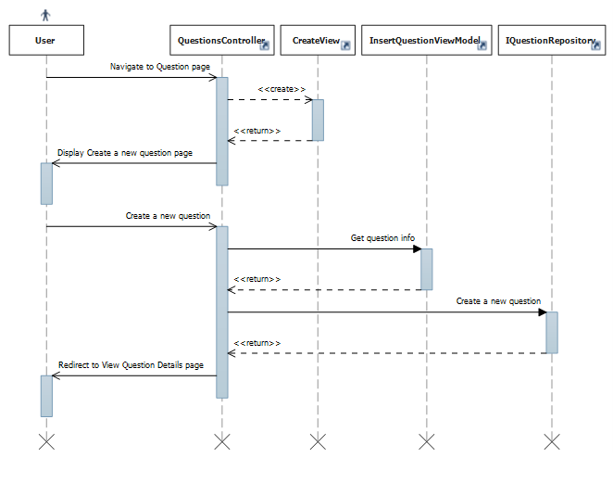

#### Edit Question



#### Get All Questions



#### Get Question Details



#### Report Question



#### Vote Question



## Answer

This part is the detailed design for the following use cases:

* Get answer list
* Reply question

### Class Diagram

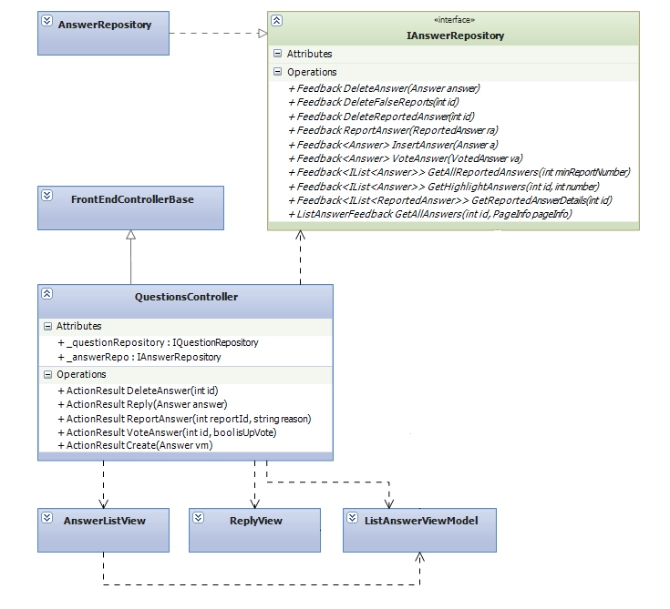



### Class Explanations

#### IAnswerRepository interface

Outlines the methods that the data repository class (AnswerRepository) will be able to perform. The data repository class will expand this repository pattern interface to include a set of data access functions such as Select, Insert, Delete.

Responsibilities:

* Get Answer list
* Vote answers
* Insert a newanswer
* Delete answers
* Get highlight answers

#### AnswerRepository class

Default implementation of IAnswerRepository interface, containsthe required code for accessing the MSSQL database

#### QuestionsController class

The basic of responsibilities of QuestionsControlleris to carry out the various use cases

Responsibilities:

* Allow all users to perform View Answer List Use Case
* Allow all users to perform View Highlight Answer Use Case
* Allow registered users to perform Insert A New Answer Use Case
* Allow registered users to perform Vote Answers Use Case
* Allow registered users to perform Delete Their OwnAnswer Use Case

#### AnswerListView class

Contain HTML markup and .NET code to render Answer List View screen

#### ReplyViewclass

Contain HTML markup and .NET code to render Reply View screen

#### ListAnswerViewModelclass

Model type of AnswerListView and ReplyView

### Sequence Diagrams

#### Get Answer List

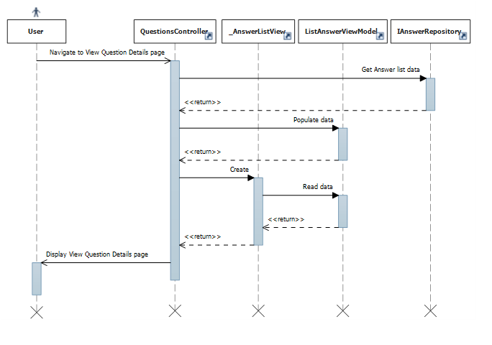

#### Reply

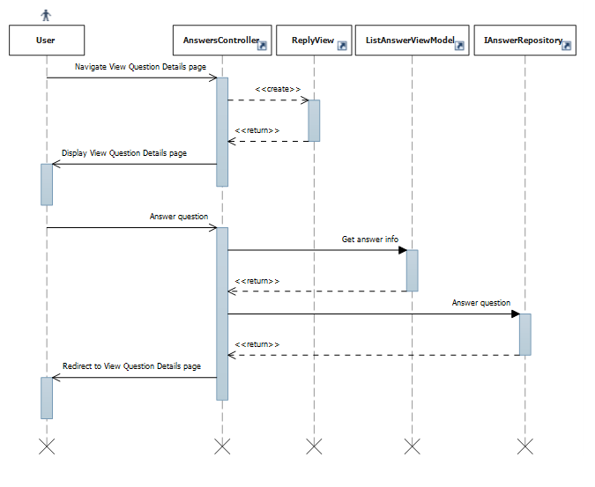

#### Report Answer

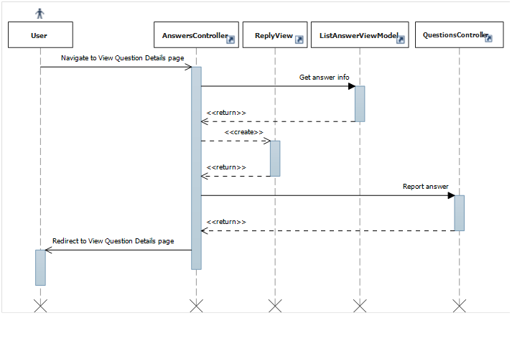

#### Vote Answer

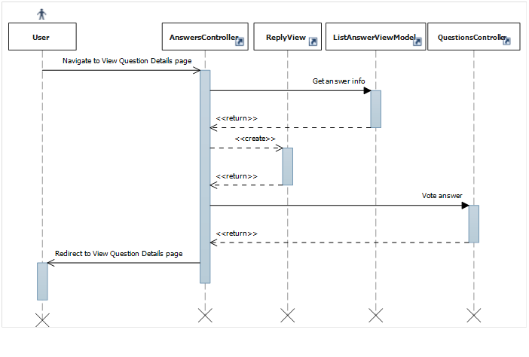

## Manage Categories

This part is the detailed design for the following use cases:

* View Categories list
* View Category ‘s details
* Create a new category
* Edit category
* Delete category

The following detailed design is follow Recipe categories but can be used for Tip categories as well

### Class Diagram

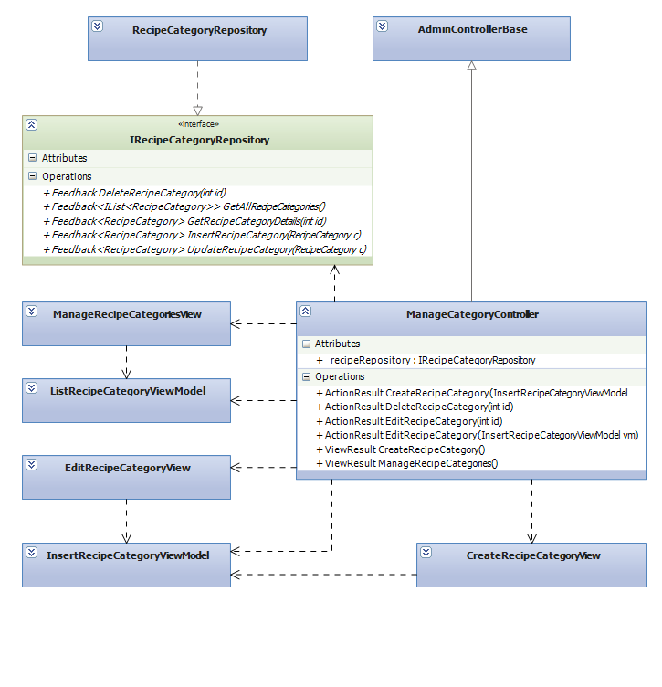

### Class Explanations

#### IRecipeCategoryRepository interface

Outlines the methods that the data repository class (RecipeCategoryRepository) will be able to perform. The data repository class will expand this repository pattern interface to include a full set of data access functions such as Select, Delete, Update, Insert.

Responsibilities:

* Insert a new category
* Update categories
* Get category’s detail
* Get all categories
* Delete categories

#### RecipeCategoryRepository class

Default implementation of IRecipeCategoryRepository interface, contains the required code for accessing the MSSQL database

#### ManageCategoriesController class

The basic of responsibilities of ManageCategoriesControlleris to carry out the various use cases

Responsibilities:

* Allow administrator and power users to perform Insert A New Category Use Case
* Allow administrator and power users to perform Update Categories Use Case
* Allow administrator and power users to perform View Category’s Detail Use Case
* Allow administrator and power users to perform View All Categories Use Case
* Allow administrator and power users to perform Delete Categories Use Case

#### ManageRecipeCategoriesView class

Contain HTML markup and .NET code to render Manage Recipe Categories View screen

#### CreateRecipeCategoryView class

Contain HTML markup and .NET code to render Create Recipe Category View screen

#### EditRecipeCategoryView class

Contain HTML markup and .NET code to render Edit Recipe Category View screen

#### InsertRecipeCategoryViewModel class

Model type of EditRecipeCategoryView and CreateRecipeCategoryView

#### ListRecipeCategoryViewModel class

Model type of ManageRecipeCategoryView

### Sequence Diagrams

#### Delete Category



#### Get All Categories



#### Insert Category



#### Edit Category



## Manage Spam Contents

This part is the detailed design for the following use cases:

* Delete False Content Reports
* Delete Reported Content
* Manage Reported Content

### Class Diagram



### Class Explanations

#### IContentRepository interface

Outlines the methods that the data repository class (ContentRepository) will be able to perform. The data repository class will expand this repository pattern interface to include a set of data access functions such as Select, Delete.

Responsibilities:

* Delete false content reports
* Delete reported content
* Get reported content

#### ContentRepository class

Default implementation of IContentRepository interface, contains the required code for accessing the MSSQL database

#### ManageContentsController class

The basic of responsibilities of ManageContentsControlleris to carry out the various use cases

Responsibilities:

* Allow administrator and power users to perform DeleteFalse Content Reports Use Case
* Allow administrator and power users to perform Delete Reported Content Use Case
* Allow administrator and power users to perform View Reported Content Use Case

#### ManageReportedContentView class

Contain HTML markup and .NET code to render Manage ReportedContent View screen

#### ListReportedContentViewModel class

Model type of ManageReportedContentView

### Sequence Diagrams

#### Delete False ContentReports

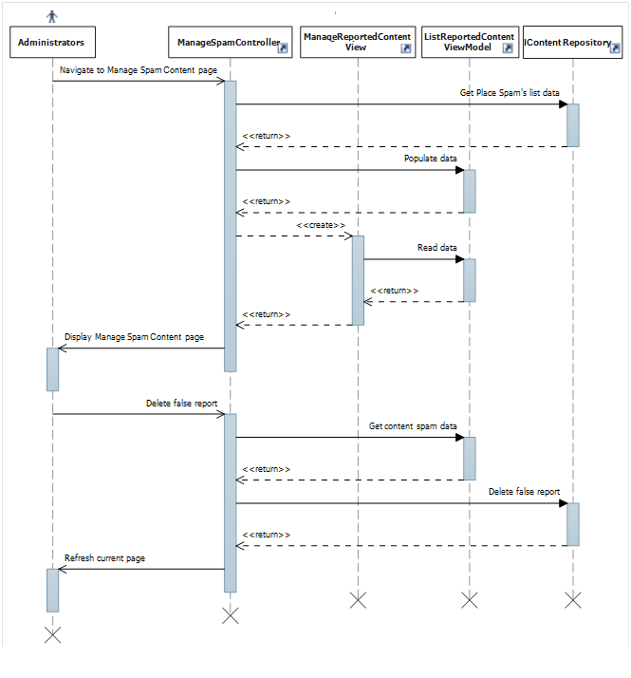

#### Delete Reported Content

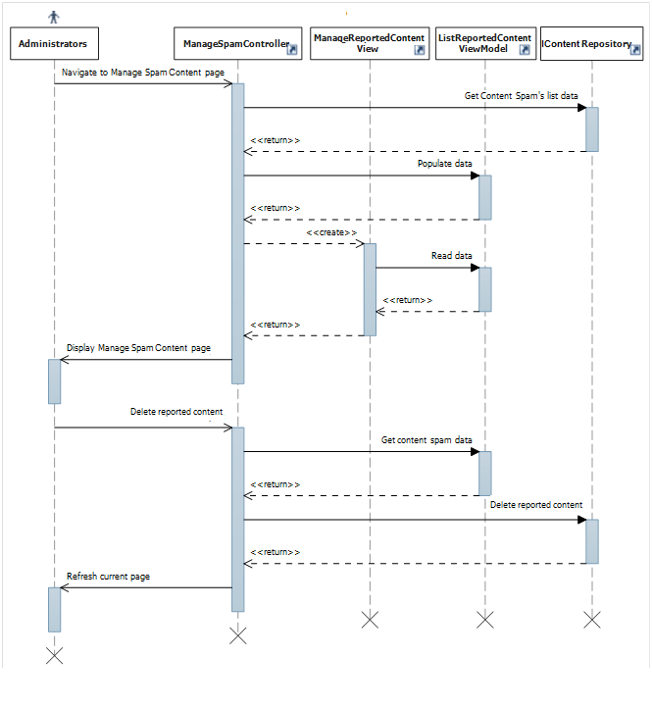

#### Manage Reported Content

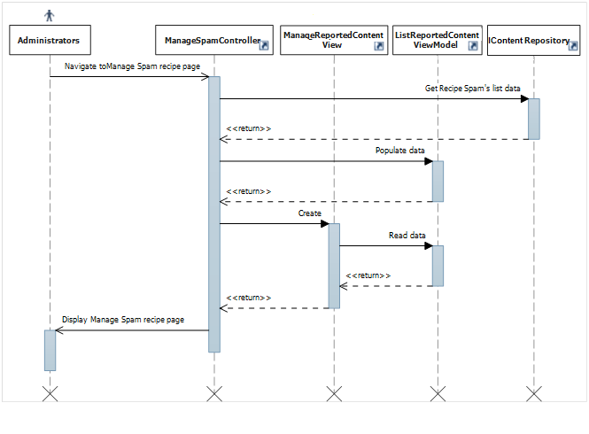

## Manage Spam Comments

This part is the detailed design for the following use cases:

* Delete False Comment Reports
* Delete Reported Comment
* Manage Reported Comment

### Class Diagram

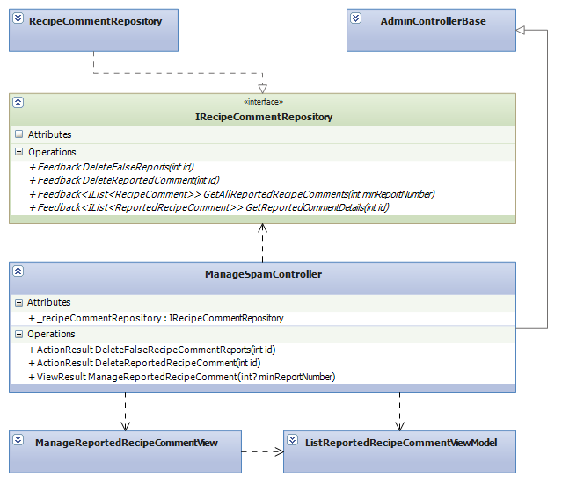

### Class Explanations

#### IRecipeCommentRepository interface

Outlines the methods that the data repository class (RecipeCommentRepository) will be able to perform. The data repository class will expand this repository pattern interface to include a set of data access functions such as Select, Delete.

Responsibilities:

* Delete false comment reports
* Delete reported comment
* Get reported comment

#### RecipeCommentRepository class

Default implementation of IRecipeCommentRepository interface, contains the required code for accessing the MSSQL database

#### ManagSpamController class

The basic of responsibilities of ManageSpamControlleris to carry out the various use cases

Responsibilities:

* Allow administrator and power users to perform Delete False Comment Reports Use Case
* Allow administrator and power users to perform Delete Reported Comment Use Case
* Allow administrator and power users to perform View Reported Comment Use Case

#### ManageReportedRecipeCommentView class

Contain HTML markup and .NET code to render Manage Reported Recipe Comment View screen

#### ListReportedRecipeCommentViewModel class

Model type of ManageReportedRecipeCommentView

### Sequence Diagrams

#### Delete False Comment Reports



#### Delete Reported Comment



#### Manage Reported Comment



## Manage Spam Answers

This part is the detailed design for the following use cases:

* DeleteFalseAnswerReports
* DeleteReportedAnswer
* ManageReportedAnswer

### Class Diagram

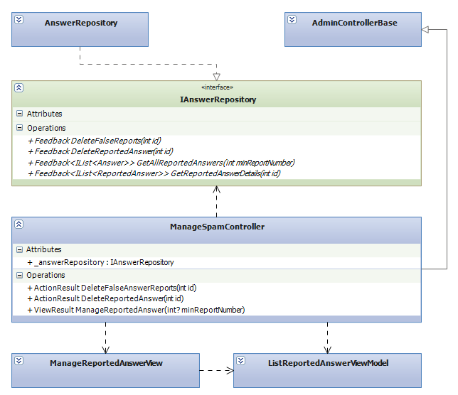

### Class Explanations

#### IAnswerRepository interface

Outlines the methods that the data repository class (AnswerRepository) will be able to perform. The data repository class will expand this repository pattern interface to include a set of data access functions such as Select, Delete.

Responsibilities:

* Delete false answer reports
* Delete reported answer
* Get reported answer

#### AnswerRepository class

Default implementation of IAnswerRepository interface, contains the required code for accessing the MSSQL database

#### ManagSpamController class

The basic of responsibilities of ManageSpamControlleris to carry out the various use cases

Responsibilities:

* Allow administrator and power users to perform Delete False Answer Reports Use Case
* Allow administrator and power users to perform Delete Reported Answer Use Case
* Allow administrator and power users to perform View Reported Answer Use Case

#### ManageReportedAnswerView class

Contain HTML markup and .NET code to render Manage Answer Comment View screen

#### ListReportedAnswerCommentViewModel class

Model type of ManageReportedRecipeCommentView

### Sequence Diagrams

#### DeleteFalseAnswerReports



#### DeleteReportedAnswer



#### ManageReportedAnswer



## Manager Users

This part is the detailed design for the following use cases:

* Edit user
* Ban user
* View user list



### Class Diagram

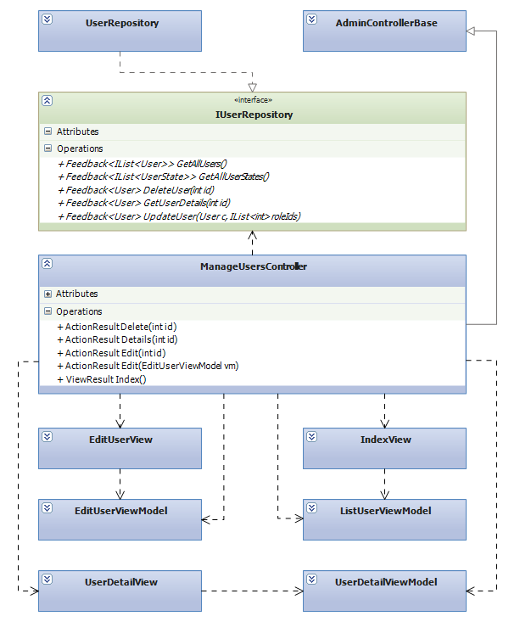

### Class Explanations

#### IUserRepository interface

Outlines the methods that the data repository class (UserRepository) will be able to perform. The data repository class will expand this repository pattern interface to include a set of data access functions such as Select, Update, Delete.

Responsibilities:

* Edit user
* Get user list

#### UserRepository class

Default implementation of IUserRepository interface, contains the required code for accessing the MSSQL database

#### ManageUsersController class

The basic of responsibilities of ManageUsersControlleris to carry out the various use cases

Responsibilities:

* Allow administrator and power users to perform View User List Use Case
* Allow administrator and power users to perform Edit User Use Case

#### EditUserView class

Contain HTML markup and .NET code to render Edit User View screen

#### IndexView class

Contain HTML markup and .NET code to render Index View screen

#### UserDetailsView class

Contain HTML markup and .NET code to render User Details View screen

#### ListUserViewModel class

Model type of IndexView

#### UserDetailsViewModel class

Model type of UserDetailsView

#### EditUserViewModel class

Model type of EditView

### Sequence Diagrams

#### EditUser



#### ViewUserDetails



#### ViewUserList



## Contents

### Class Diagram

This part is the detailed design for the following use cases:

* Get all contents
* Create a new content
* Edit contents
* Get contents by category
* Report contents
* Sort contents

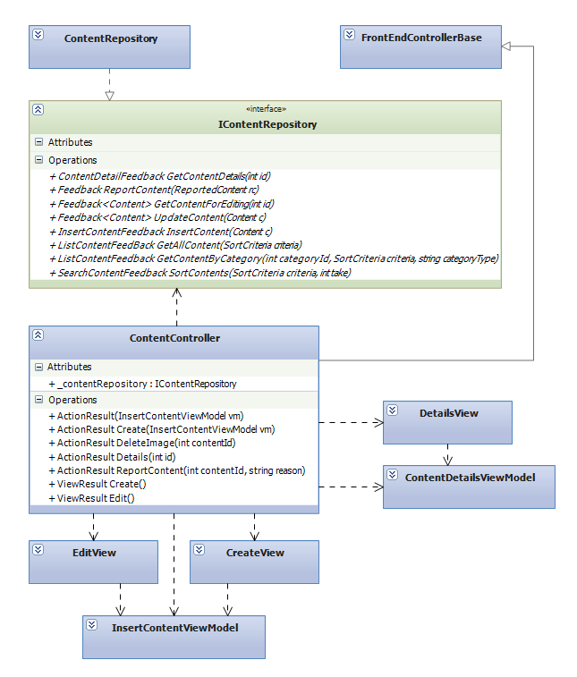

### Class Explanations

#### IContentRepository interface

Outlines the methods that the data repository class (ContentRepository) will be able to perform. The data repository class will expand this repository pattern interface to include a full set of data access functions such as Select, Update, Delete, Insert.

Responsibilities:

* Get all contents
* Create a new content
* Edit contents
* Get contents by category
* Report contents
* Sort contents

#### ContentRepository class

Default implementation of IContentRepository interface, contains the required code for accessing the MSSQL database

#### ContentController class

The basic of responsibilities of ContentControlleris to carry out the various use cases

Responsibilities:

* Allow all users to perform View Contents Use Case
* Allow registered users to perform View Contents by Category Use Case
* Allow registered users to perform Create A New Content Use Case
* Allow registered users to perform Edit Contents Use Case
* Allow registered users to perform Report Contents Use Case

#### EditView class

Contain HTML markup and .NET code to render Edit View screen

#### CreateView class

Contain HTML markup and .NET code to render Create View screen

#### DetailsView class

Contain HTML markup and .NET code to render Details View screen

#### InsertViewModel class

Model type of EditView and CreateView

#### ContentDetailsViewModel class

Model type of DetailsView

### Sequence Diagrams

#### Create Content

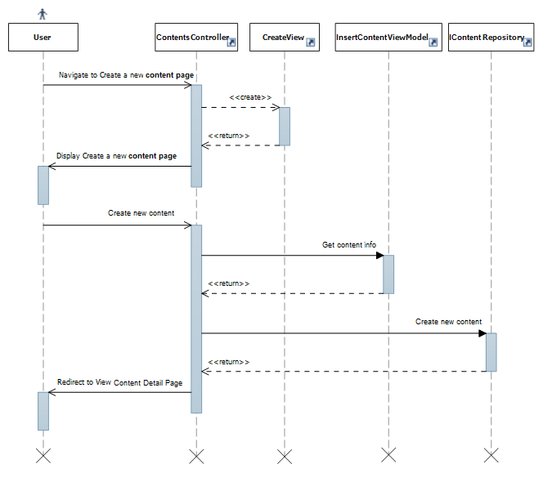

#### Edit Content

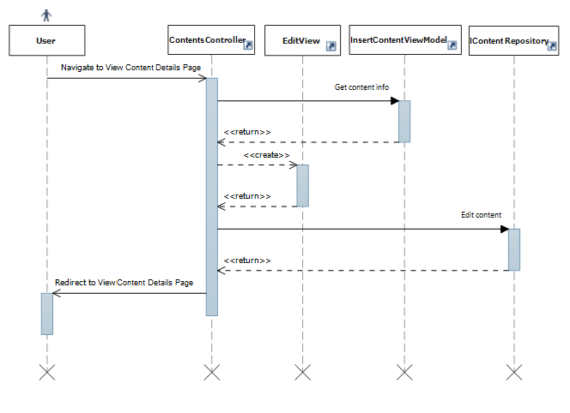

#### ReportContent

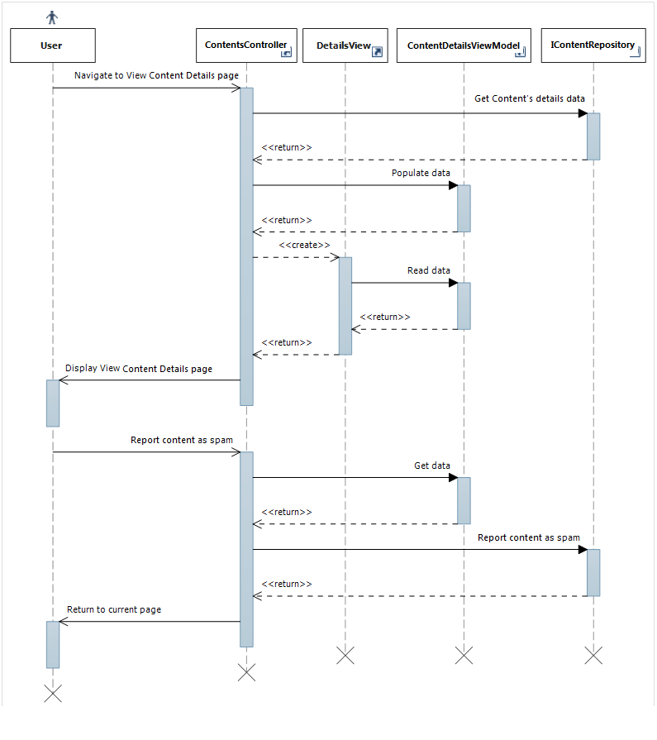

#### Rate Content

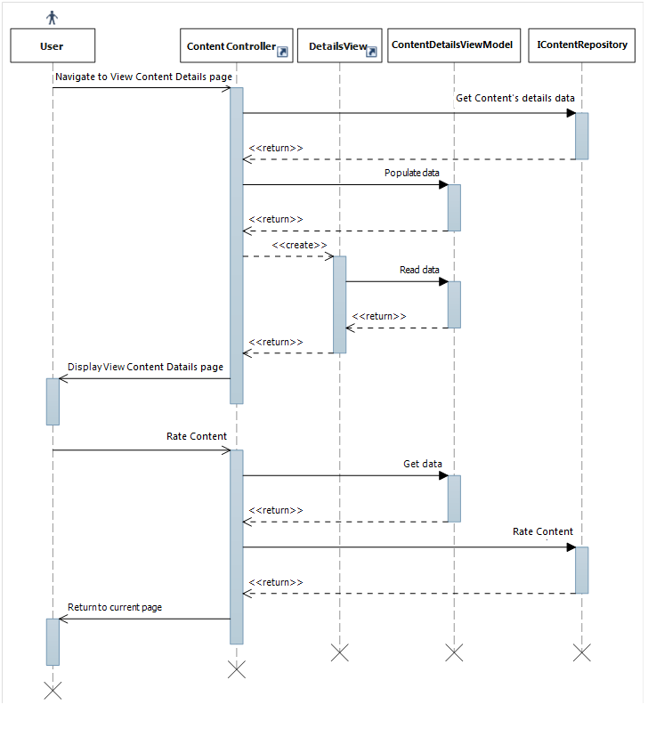

#### ViewContentDetails

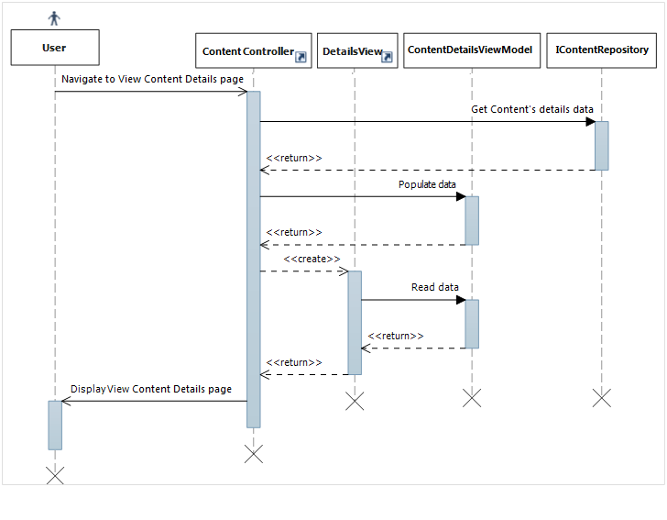

## Manage Spam Questions

This part is the detailed design for the following use cases:

* Delete False Question Reports
* Delete Reported Question
* Manage Reported Question

### Class Diagram

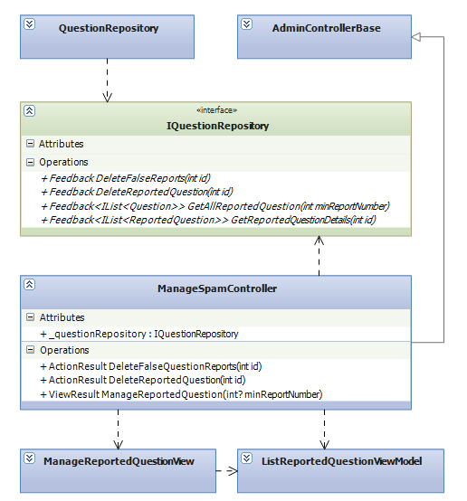

### Class Explanations

#### IQuestionRepository interface

Outlines the methods that the data repository class (QuestionRepository) will be able to perform. The data repository class will expand this repository pattern interface to include a set of data access functions such as Select, Delete.

Responsibilities:

* Delete false questionreports
* Delete reported question
* Get reported question

#### QuestionRepository class

Default implementation of IQuestionRepository interface, contains the required code for accessing the MSSQL database

#### ManageSpamController class

The basic of responsibilities of ManageSpamControlleris to carry out the various use cases

Responsibilities:

* Allow administrator and power users to perform Delete False Question Reports Use Case
* Allow administrator and power users to perform Delete Reported Question Use Case
* Allow administrator and power users to perform View Reported Question Use Case

#### ManageReportedQuestionView class

Contain HTML markup and .NET code to render Manage Reported Question View screen

#### ListReportedQuestionViewModel class

Model type of ManageReportedQuestionView

### Sequence Diagrams

#### DeleteFalse Question Reports



#### DeleteReported Question

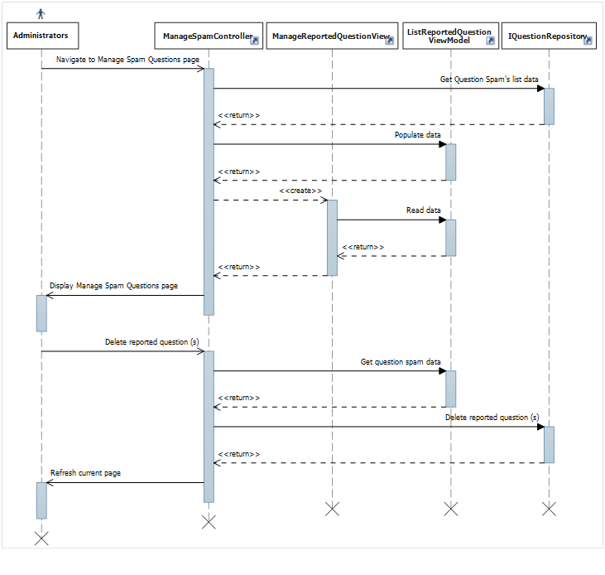

#### ManageReported Question

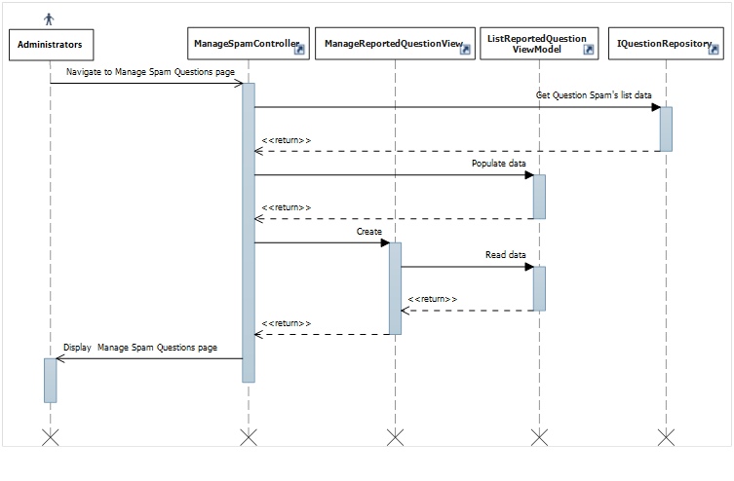

# Database Design

## Database Design

Refer to attached Database Design

## Tables

|  |  |
| --- | --- |
| Table Name | Description |
| Answers | Stores answers of questions |
| FavoriteRecipes | Stores favorite recipe of users |
| Locations | Stores geological information of a location |
| [News](#Tables/Categories) | Stores news |
| [News](#Tables/CategoryAlternatives)Comments | Stores comments of news |
| Permissions | Stores permission in the system |
| [Point](#Tables/FavoritePlaces)Configs | Stores how much point user can earn when contributed |
| [Questions](#Tables/FavoritePlaces) | Stores users questions |
| RatedRecipes | Stores rated recipes and by who |
| [RecipeCategories](#Tables/Permissions) | Stores recipe’s categories |
| [RecipeCategoryMapping](#Tables/PlaceComments) | Stores mapping of recipe’s categories and small recipe’s categories |
| [RecipeComments](#Tables/PlaceComments) | Stores comments of recipes |
| [Recipes](#Tables/PlaceResponses) | Stores recipes |
| [ReportedAnswers](#Tables/PlaceRevisions) | Stores reported answers |
| [ReportedNews](#Tables/Places) | Stores reported news |
| ReportedNewsComments | Stores reported news comments |
| RepotedQuestions | Stores reported questions |
| ReportedRecipeComments | Stores reported recipe’s comments |
| Reported­Recipes | Stores reported recipes |
| ReportedTipComments | Stores reported tip’s comments |
| ReportedTip | Stores reported tips |
| RolePermissions | Stores role’s permissions of the system |
| Roles | Stores role in the system |
| TipCategories | Stores tip’s categories |
| TipComments | Stores tips comments |
| Tips | Stores tips |
| Titles | Stores titles in the system |
| UpdateWords | Stores updated word from users |
| UserRoles | Stores users roles |
| Users | Stores information of users |
| User­States | Stores user account states |
| VisitorNumbers | Stores visitor numbers of contents |
| VisitorNumbers | Stores the number of visitors for each day |
| Voted­Answers | Stores voted answera and who has voted |
| Voted­NewsComments | Stores voted news comments and who has voted |
| Voted­RecipeComments | Stores voted recipes comments and who has voted |
| Voted­TipComments | Stores voted tips comments and who has voted |
| Voted­Tips | Stores voted tips and who has voted |
| Words | Stores keyword and meaning |

### Answers table

|  |  |  |  |  |  |  |
| --- | --- | --- | --- | --- | --- | --- |
| Table Name | Type | Null | Unique | P/F Key | Default | Description |
| Id | int |  |  | PK |  | Id of Answers  Identity 1 -1 |
| QuestionId | int |  |  | FK |  | Id of Question FK to Questions.id |
| ContentText | nvarchar |  |  |  |  | Answers content in text mode |
| UpVotes | int |  |  |  |  | Thumb up vote times |
| DownVotes | int |  |  |  |  | Thumb down vote times |
| Reports | int |  |  |  |  | Reported times |
| PostedBy | int |  |  | FK |  | Id of user posted the answer FK to Users.id |
| PostedDate | datetime |  |  |  |  | The posted date |
| UpdatedBy | int | x |  | FK |  | Id of user updated the answer FK to Users.id |
| LastUpdate | Datetime | X |  |  |  | The last updated date |
| isDeleted | bit |  |  |  |  | Flag to delete answer |

### 2.2 FavoriteRecipes table

|  |  |  |  |  |  |  |
| --- | --- | --- | --- | --- | --- | --- |
| Table Name | Type | Null | Unique | P/F Key | Default | Description |
| Id | int |  |  | PK |  | Id of Favorite recipe record  Identity 1 -1 |
| UserId | int |  |  | FK |  | User id who add a recipe to favorite list FK to Users.id |
| RecipeId | int |  |  | FK |  | Recipe id is added FK to Recipes.id |
| AddedDate | datetime |  |  |  |  | The added date |

### 2.3 Locations table

|  |  |  |  |  |  |  |
| --- | --- | --- | --- | --- | --- | --- |
| Table Name | Type | Null | Unique | P/F Key | Default | Description |
| Id | int |  |  | PK |  | Id of Locations  Identity 1 -1 |
| Name | Nvarchar(50) |  |  |  |  | Locations content |

### 2.4 News table

|  |  |  |  |  |  |  |
| --- | --- | --- | --- | --- | --- | --- |
| Table Name | Type | Null | Unique | P/F Key | Default | Description |
| Id | int |  |  | PK |  | Id of News  Identity 1 -1 |
| Title | nvarchar(100) |  |  |  |  | Title of news |
| TitleSearch | nvarchar(100) |  |  |  |  | Converted string of title to search function |
| TitleUrl | nvarchar(100) |  |  |  |  | Title’s url of news |
| ImageUrl | nvarchar(1000) |  |  |  |  | Images url |
| ContentText | nvarchar(255) |  |  |  |  | Content of news in text mode |
| ContentHtml | ntext |  |  |  |  | Content of news in html mode |
| Views | int |  |  |  |  | View times |
| Comments | int |  |  |  |  | Comment times |
| Reports | int |  |  |  |  | Reported times |
| PostedBy | int |  |  | FK |  | Id of user posted the news FK to Users.id |
| PostedDate | datetime |  |  |  |  | The posted date |
| UpdatedBy | int | x |  | FK |  | Id of user updated the news FK to Users.id |
| LastUpdate | Datetime | X |  |  |  | The last updated date |
| isDeleted | bit |  |  |  |  | Flag to delete news |

### 2.5 NewsComments table

|  |  |  |  |  |  |  |
| --- | --- | --- | --- | --- | --- | --- |
| Table Name | Type | Null | Unique | P/F Key | Default | Description |
| Id | int |  |  | PK |  | Id of news comment  Identity 1 -1 |
| NewsID | int |  |  | FK |  | News id is commented FK to News.id |
| ContentText | nvarchar(255) |  |  |  |  | Content of news comment in text mode |
| UpVotes | int |  |  |  |  | Thumb up vote times |
| DownVotes | int |  |  |  |  | Thumb down vote times |
| Reports | int |  |  |  |  | Reported times |
| PostedBy | int |  |  | FK |  | Id of user posted the news comment FK to Users.id |
| PostedDate | datetime |  |  |  |  | The posted date |
| UpdatedBy | int | x |  | FK |  | Id of user updated the news comment FK to Users.id |
| LastUpdate | Datetime | X |  |  |  | The last updated date |
| isDeleted | bit |  |  |  |  | Flag to delete news comment |

### 2.6 Permissions table

|  |  |  |  |  |  |  |
| --- | --- | --- | --- | --- | --- | --- |
| Table Name | Type | Null | Unique | P/F Key | Default | Description |
| Id | int |  |  | PK |  | Id of Permissions  Identity 1 -1 |
| Name | nvarchar(100) |  |  |  |  | Permissions name |
| Description | nvarchar(1000) | x |  |  |  | Description of permissions |

### 2.7 PointConfigs table

|  |  |  |  |  |  |  |
| --- | --- | --- | --- | --- | --- | --- |
| Table Name | Type | Null | Unique | P/F Key | Default | Description |
| Id | int |  |  | PK |  | Id of configuration Identity 1 -1 |
| [Key] | nvarchar(100) |  |  |  |  | Configuration content |
| Value | int |  |  |  |  | Configuration point value |
| Description | nvarchar(1000) | x |  |  |  | Description of configuration |

### 2.8 Questions table

|  |  |  |  |  |  |  |
| --- | --- | --- | --- | --- | --- | --- |
| Table Name | Type | Null | Unique | P/F Key | Default | Description |
| Id | int |  |  | PK |  | Id of questions  Identity 1 -1 |
| Title | nvarchar(100) |  |  |  |  | Title of questions |
| TitleUrl | nvarchar(100) |  |  |  |  | Title’s url of questions |
| ContentText | nvarchar(255) |  |  |  |  | Content of question in text mode |
| Views | int |  |  |  |  | Views times |
| Answers | int |  |  |  |  | Answer times of questions |
| Reports | int |  |  |  |  | Reported times |
| PostedBy | int |  |  | FK |  | Id of user posted the question FK to Users.id |
| PostedDate | datetime |  |  |  |  | The posted date |
| UpdatedBy | int | x |  | FK |  | Id of user updated the question FK to Users.id |
| LastUpdate | Datetime | X |  |  |  | The last update date |
| isDeleted | bit |  |  |  |  | Flag to delete question |

### 2.9 RatedRecipes table

|  |  |  |  |  |  |  |
| --- | --- | --- | --- | --- | --- | --- |
| Table Name | Type | Null | Unique | P/F Key | Default | Description |
| Id | int |  |  | PK |  | Id of rated recipes  Identity 1 -1 |
| RecipeID | int |  |  | FK |  | Recipe’s id is rated FK to Recipes.id |
| RatedBy | int |  |  | FK |  | Id of user rated the question FK to Users.id |
| RatedDate | datetime |  |  |  |  | The rated date |

### 2.10 RecipeCategories table

|  |  |  |  |  |  |  |
| --- | --- | --- | --- | --- | --- | --- |
| Table Name | Type | Null | Unique | P/F Key | Default | Description |
| Id | int |  |  | PK |  | Id of recipe’s categories  Identity 1 -1 |
| Name | nvarchar(50) |  |  |  |  | Name of recipe’s categories |
| NameUrl | nvarchar(50) |  |  |  |  | Name’s url of recipe’s categories |
| Description | nvarchar(100) | x |  |  |  | Description of recipe’s categories |
| isDeleted | bit |  |  |  |  | Flag to delete categories |

### 2.11 RecipeCategoryMapping table

|  |  |  |  |  |  |  |
| --- | --- | --- | --- | --- | --- | --- |
| Table Name | Type | Null | Unique | P/F Key | Default | Description |
| Id | int |  |  | PK |  | Id of mapping  Identity 1 -1 |
| RecipeCategoryId | int |  |  | FK |  | Recipe categories be mapped FK to RecipeCategories.id |
| RecipeSmallCategoryId | int |  |  | FK |  | Recipe’s small categories be mapped FK to RecipeSmallCategories.id |

### 2.12 RecipeComments table

|  |  |  |  |  |  |  |
| --- | --- | --- | --- | --- | --- | --- |
| Table Name | Type | Null | Unique | P/F Key | Default | Description |
| Id | int |  |  | PK |  | Id of recipes comment  Identity 1 -1 |
| RecipeId | int |  |  | FK |  | Recipe’s id is commented FK to Recipes.id |
| ContentText | nvarchar(4000) |  |  |  |  | Content of recipe’s comment |
| UpVotes | int |  |  |  |  | Thumb up vote times |
| DownVotes | int |  |  |  |  | Thumb down vote times |
| Reports | int |  |  |  |  | Reported times |
| PostedBy | int |  |  | FK |  | Id of user posted the recipes comment FK to Users.id |
| PostedDate | datetime |  |  |  |  | The posted date |
| UpdatedBy | int | x |  | FK |  | Id of user updated the recipes comment FK to Users.id |
| LastUpdate | Datetime | X |  |  |  | The last update date |
| isDeleted | bit |  |  |  |  | Flag to delete recipes comment |

### 2.13 Recipes table

|  |  |  |  |  |  |  |
| --- | --- | --- | --- | --- | --- | --- |
| Table Name | Type | Null | Unique | P/F Key | Default | Description |
| Id | int |  |  | PK |  | Id of recipes  Identity 1 -1 |
| Title | nvarchar(100) |  |  |  |  | Title of recipes |
| TitleSearch | nvarchar(100) |  |  |  |  | Converted string of title to search function |
| TitleUrl | nvarchar(100) |  |  |  |  | Title’s url of news |
| ImageUrl | nvarchar(1000) |  |  |  |  | Images url |
| Ingredients | nvarchar(1000) |  |  |  |  | Recipes ingredients |
| ContentText | nvarchar(255) |  |  |  |  | Content of recipes in text mode |
| ContentHtml | ntext |  |  |  |  | Content of recipes in html mode |
| MappingCategories | int |  |  | FK |  | Mapping categories id FK to RecipeCategoryMappings.id |
| RateTimes | int |  |  |  |  | Rate times of recipes |
| TotalRates |  |  |  |  |  | Total rate point of recipes |
| Views | int |  |  |  |  | View times |
| Comments | int |  |  |  |  | Comment times |
| Reports | int |  |  |  |  | Reported times |
| PostedBy | int |  |  | FK |  | Id of user posted the recipe FK to Users.id |
| PostedDate | datetime |  |  |  |  | The posted date |
| UpdatedBy | int | x |  | FK |  | Id of user updated the recipe FK to Users.id |
| LastUpdate | Datetime | X |  |  |  | The last updated date |
| IsApproved | bit |  |  |  |  | Flag to approve news |
| ApprovedBy | int |  |  | FK |  | Id of user approved the recipe FK to Users.id |
| isDeleted | bit |  |  |  |  | Flag to delete recipe |

### 2.14 [RecipeSmallCategories](#Tables/PlaceRevisions) table

|  |  |  |  |  |  |  |
| --- | --- | --- | --- | --- | --- | --- |
| Table Name | Type | Null | Unique | P/F Key | Default | Description |
| Id | int |  |  | PK |  | Id of [recipe’s small categories](#Tables/PlaceRevisions)  Identity 1 -1 |
| Name | nvarchar(50) |  |  |  |  | Name of [recipe’s small categories](#Tables/PlaceRevisions) |
| NameUrl | nvarchar(50) |  |  |  |  | Name’s url of [recipe’s small categories](#Tables/PlaceRevisions) |
| Description | nvarchar(100) | x |  |  |  | Description of [recipe’s small categories](#Tables/PlaceRevisions) |
| TipMappingId | int |  |  | FK |  | Mapped tip’s id FK to Tips.id |
| isDeleted | bit |  |  |  |  | Flag to delete [recipe’s small categories](#Tables/PlaceRevisions) |

### 2.15 [Reported](#Tables/Places)Answers table

|  |  |  |  |  |  |  |
| --- | --- | --- | --- | --- | --- | --- |
| Table Name | Type | Null | Unique | P/F Key | Default | Description |
| Id | int |  |  | PK |  | Id of [reported](#Tables/Places) answers  Identity 1 -1 |
| AnswerId | int |  |  | FK |  | Answer is reported FK to Answers.id |
| ReportedBy | int |  |  | FK |  | Reported users id FK to Users.id |
| ReportedDate | datetime |  |  |  |  | The reported time |
| Reason | nvarchar(100) | x |  |  |  | Report’s reason |
| IsIgnored | bit |  |  |  |  | Flag to ignore report |

### 2.16 ReportedNews table

|  |  |  |  |  |  |  |
| --- | --- | --- | --- | --- | --- | --- |
| Table Name | Type | Null | Unique | P/F Key | Default | Description |
| Id | int |  |  | PK |  | Id of [reported](#Tables/Places) news  Identity 1 -1 |
| NewsId | int |  |  | FK |  | News is reported FK to News.id |
| ReportedBy | int |  |  | FK |  | Reported users id FK to Users.id |
| ReportedDate | datetime |  |  |  |  | The reported time |
| Reason | nvarchar(100) | x |  |  |  | Report’s reason |
| IsIgnored | bit |  |  |  |  | Flag to ignore report |

### 2.17 ReportedNewsComments table

|  |  |  |  |  |  |  |
| --- | --- | --- | --- | --- | --- | --- |
| Table Name | Type | Null | Unique | P/F Key | Default | Description |
| Id | int |  |  | PK |  | Id of [reported](#Tables/Places) news comments  Identity 1 -1 |
| CommentId | int |  |  | FK |  | News comment is reported FK to NewsCommets.id |
| ReportedBy | int |  |  | FK |  | Reported users id FK to Users.id |
| ReportedDate | datetime |  |  |  |  | The reported time |
| Reason | nvarchar(100) | x |  |  |  | Report’s reason |
| IsIgnored | bit |  |  |  |  | Flag to ignore report |

### 2.18 ReportedQuestions table

|  |  |  |  |  |  |  |
| --- | --- | --- | --- | --- | --- | --- |
| Table Name | Type | Null | Unique | P/F Key | Default | Description |
| Id | int |  |  | PK |  | Id of [reported](#Tables/Places) questions  Identity 1 -1 |
| QuestionId | int |  |  | FK |  | Question is reported FK to Questions.id |
| ReportedBy | int |  |  | FK |  | Reported users id FK to Users.id |
| ReportedDate | datetime |  |  |  |  | The reported time |
| Reason | nvarchar(100) | x |  |  |  | Report’s reason |
| IsIgnored | bit |  |  |  |  | Flag to ignore report |

### 2.19 Reported­RecipeComments table

|  |  |  |  |  |  |  |
| --- | --- | --- | --- | --- | --- | --- |
| Table Name | Type | Null | Unique | P/F Key | Default | Description |
| Id | int |  |  | PK |  | Id of reported recipe’s comment  Identity 1 -1 |
| CommentId | int |  |  | FK |  | Recipe’s comment is reported  FK to RecipeComments.Id |
| ReportedBy | int |  |  | FK |  | User reported  FK to Users.Id |
| ReportedDate | datetime |  |  |  |  | The reported date |
| Reason | nvarchar(100) | x |  |  |  | Report’s reason |
| IsIgnored | bit |  |  |  |  | Flag to ignore report |

### 2.20 ReportedRecipes table

|  |  |  |  |  |  |  |
| --- | --- | --- | --- | --- | --- | --- |
| Table Name | Type | Null | Unique | P/F Key | Default | Description |
| Id | int |  |  | PK |  | Id of reported recipes  Identity 1 -1 |
| RecipeId | int |  |  | FK |  | Recipe is reported  FK to Recipes.Id |
| ReportedBy | int |  |  | FK |  | User reported  FK to Users.Id |
| ReportedDate | datetime |  |  |  |  | The reported date |
| Reason | nvarchar(100) | x |  |  |  | The reason why user reported |
| IsIgnored | bit |  |  |  |  | Flag to ignore report |

### 2.21 Reported­TipComments table

|  |  |  |  |  |  |  |
| --- | --- | --- | --- | --- | --- | --- |
| Table Name | Type | Null | Unique | P/F Key | Default | Description |
| Id | int |  |  | PK |  | Id of reported tip’s comment  Identity 1 -1 |
| CommentId | int |  |  | FK |  | Tip’s comment is reported  FK to TipComments.Id |
| ReportedBy | int |  |  | FK |  | User reported  FK to Users.Id |
| ReportedDate | datetime |  |  |  |  | The reported date |
| Reason | nvarchar(100) | x |  |  |  | Report’s reason |
| IsIgnored | bit |  |  |  |  | Flag to ignore report |

### 2.22 Reported­Tips table

|  |  |  |  |  |  |  |
| --- | --- | --- | --- | --- | --- | --- |
| Table Name | Type | Null | Unique | P/F Key | Default | Description |
| Id | int |  |  | PK |  | Id of reported tips  Identity 1 -1 |
| CommentId | int |  |  | FK |  | Tip is reported  FK to Tips.Id |
| ReportedBy | int |  |  | FK |  | User reported  FK to Users.Id |
| ReportedDate | datetime |  |  |  |  | The reported date |
| Reason | nvarchar(100) | x |  |  |  | Report’s reason |
| IsIgnored | bit |  |  |  |  | Flag to ignore report |

### 2.23 RolePermissions table

|  |  |  |  |  |  |  |
| --- | --- | --- | --- | --- | --- | --- |
| Table Name | Type | Null | Unique | P/F Key | Default | Description |
| Id | int |  |  | PK |  | Id of Role­Permissions  Identity 1 -1 |
| PermissionId | int |  |  | FK |  | Permission matches with role  FK to Permissions.Id |
| RoleId | int |  |  | FK |  | Role matches with permission  FK to Roles.Id |

### 2.24 Roles table

|  |  |  |  |  |  |  |
| --- | --- | --- | --- | --- | --- | --- |
| Table Name | Type | Null | Unique | P/F Key | Default | Description |
| Id | int |  |  | PK |  | Id of Roles  Identity 1 -1 |
| Name | nvarchar(100) |  |  |  |  | Name of Role |
| Description | nvarchar(1000) | x |  |  |  | Description of Role |

### 2.25 TipCategories table

|  |  |  |  |  |  |  |
| --- | --- | --- | --- | --- | --- | --- |
| Table Name | Type | Null | Unique | P/F Key | Default | Description |
| Id | int |  |  | PK |  | Id of [tip’s categories](#Tables/PlaceRevisions)  Identity 1 -1 |
| Name | nvarchar(50) |  |  |  |  | Name of [tip’s categories](#Tables/PlaceRevisions) |
| NameUrl | nvarchar(50) |  |  |  |  | Name’s url of [tip’s categories](#Tables/PlaceRevisions) |
| Description | nvarchar(100) | x |  |  |  | Description of [tip’s categories](#Tables/PlaceRevisions) |
| isDeleted | bit |  |  |  |  | Flag to delete [tip’s categories](#Tables/PlaceRevisions) |

### 2.26 TipComments table

|  |  |  |  |  |  |  |
| --- | --- | --- | --- | --- | --- | --- |
| Table Name | Type | Null | Unique | P/F Key | Default | Description |
| Id | int |  |  | PK |  | Id of tips comment  Identity 1 -1 |
| TipId | int |  |  | FK |  | Tip’s id is commented FK to Recipes.id |
| ContentText | nvarchar(4000) |  |  |  |  | Content of tip comment |
| UpVotes | int |  |  |  |  | Thumb up vote times |
| DownVotes | int |  |  |  |  | Thumb down vote times |
| Reports | int |  |  |  |  | Reported times |
| PostedBy | int |  |  | FK |  | Id of user posted the tips comment FK to Users.id |
| PostedDate | datetime |  |  |  |  | The posted date |
| UpdatedBy | int | x |  | FK |  | Id of user updated the recipes comment FK to Users.id |
| LastUpdate | Datetime | X |  |  |  | The last update date |
| isDeleted | bit |  |  |  |  | Flag to delete tips comment |

### 2.27 Tips table

|  |  |  |  |  |  |  |
| --- | --- | --- | --- | --- | --- | --- |
| Table Name | Type | Null | Unique | P/F Key | Default | Description |
| Id | int |  |  | PK |  | Id of tips  Identity 1 -1 |
| Title | nvarchar(100) |  |  |  |  | Title of news |
| TitleSearch | nvarchar(100) |  |  |  |  | Converted string of title to search function |
| TitleUrl | nvarchar(100) |  |  |  |  | Title’s url of tips |
| ImageUrl | nvarchar(1000) |  |  |  |  | Images url |
| ContentText | nvarchar(255) |  |  |  |  | Content of news in text mode |
| ContentHtml | ntext |  |  |  |  | Content of news in html mode |
| TipCategories | int |  |  | FK |  | Tip’s category FK to TipCategories.id |
| UpVotes | int |  |  |  |  | Thumb up vote times |
| DownVotes | int |  |  |  |  | Thumb down vote times |
| Views | int |  |  |  |  | View times |
| Comments | int |  |  |  |  | Comment times |
| Reports | int |  |  |  |  | Reported times |
| PostedBy | int |  |  | FK |  | Id of user posted the tips FK to Users.id |
| PostedDate | datetime |  |  |  |  | The posted date |
| UpdatedBy | int | x |  | FK |  | Id of user updated the tips FK to Users.id |
| LastUpdate | Datetime | X |  |  |  | The last updated date |
| isDeleted | bit |  |  |  |  | Flag to delete tips |

### 2.28 Titles table

|  |  |  |  |  |  |  |
| --- | --- | --- | --- | --- | --- | --- |
| Table Name | Type | Null | Unique | P/F Key | Default | Description |
| Id | int |  |  | PK |  | Id of title Identity 1 -1 |
| [Key] | nvarchar(100) |  |  |  |  | Title content |
| Value | int |  |  |  |  | Title point value |
| Description | nvarchar(1000) | x |  |  |  | Description of title |

### 2.29 UpdateWords table

|  |  |  |  |  |  |  |
| --- | --- | --- | --- | --- | --- | --- |
| Table Name | Type | Null | Unique | P/F Key | Default | Description |
| Id | int |  |  | PK |  | Id of Update words Identity 1 -1 |
| WordId | int |  |  | FK |  | Word’s id FK to Words.id |
| NewValue | nvarchar(100) |  |  |  |  | Word’s meaning content |
| UpdatedBy | int |  |  | FK |  | Id of user updated keyword FK to Users.id |
| UpdatedDate | datetime |  |  |  |  | The updated date |
| IsApproved | bit | x |  |  |  | Flag to approve updated word |
| ApprovedBy | int | x |  | FK |  | Id of user approved FK to Users.id |
| isDeleted | bit |  |  |  |  | Flag to delete updated word |

### 2.30 User­Roles table

|  |  |  |  |  |  |  |
| --- | --- | --- | --- | --- | --- | --- |
| Table Name | Type | Null | Unique | P/F Key | Default | Description |
| Id | int |  |  | PK |  | Id of User­Roles  Identity 1 -1 |
| UserId | int |  |  | FK |  | User matches with role  FK to Users.Id |
| RoleId | int |  |  | FK |  | Role matches with user  FK to Roles.Id |

### 2.31 Users table

|  |  |  |  |  |  |  |
| --- | --- | --- | --- | --- | --- | --- |
| Table Name | Type | Null | Unique | P/F Key | Default | Description |
| Id | int |  |  | PK |  | Id of Users  Identity 1 -1 |
| Username | nvarchar(30) |  |  |  |  | User’s name |
| Password | nvarchar(MAX) |  |  |  |  | Password of User |
| Ponit | Int |  |  |  |  | Point of User |
| [Level] | nvarchar(30) |  |  |  |  | User’s title |
| Email | nvarchar(100) |  |  |  |  | Email of User |
| AvatarUrl | nvarchar(1000) | x |  |  |  | User’s avatar image’s url |
| Birthday | Datetime | x |  |  |  | Birthday of user |
| Sex | nvarchar(20) | x |  |  |  | Sex of user |
| Hobbies | nvarchar(1000) | x |  |  |  | Hobbies of user |
| CookingExp | nvarchar(20) | x |  |  |  | User’s cooking experience |
| SocialNetworkUrl | nvarchar(1000) | x |  |  |  | Social network’s url of user |
| LocationId | int | x |  | FK |  | Location of User FK to Locations.Id |
| UserStateId | int |  |  | FK |  | State of User  FK to UserStates.Id |
| ResetPasswordKey | nvarchar(100) | x |  |  |  | Reset password key of User |
| LastLogin | datetime | x |  |  |  | Last login of User |
| FailedLoginAttempts | int |  |  |  |  | Failed Login times of User |
| LastLoginAttempted | datetime | x |  |  |  | Last Login Attempted of User |
| CreatedDate | datetime | x |  |  |  | The created date of User |
| LastUpdate | datetime | x |  |  |  | The last update date of User |
| IsDeleted | bit |  |  |  |  | Flag to delete User |
| TodayDate | datetime | x |  |  |  |  |
| TodayPoint | int | x |  |  |  |  |

### 2.32 User­States table

|  |  |  |  |  |  |  |
| --- | --- | --- | --- | --- | --- | --- |
| Table Name | Type | Null | Unique | P/F Key | Default | Description |
| Id | int |  |  | PK |  | Id of User­States  Identity 1 -1 |
| Name | nvarchar(50) |  |  |  |  | Name of User­State |
| Description | nvarchar(1000) | x |  |  |  | Description of User­State |

### 2.33 VisitorNumbers table

|  |  |  |  |  |  |  |
| --- | --- | --- | --- | --- | --- | --- |
| Table Name | Type | Null | Unique | P/F Key | Default | Description |
| Id | int |  |  | PK |  | Id of Visited­Places  Identity 1 -1 |
| Date | datetime |  |  |  |  |  |
| VisitorNumber | int |  |  |  |  |  |

### 2.34 Voted­Answers table

|  |  |  |  |  |  |  |
| --- | --- | --- | --- | --- | --- | --- |
| Table Name | Type | Null | Unique | P/F Key | Default | Description |
| Id | int |  |  | PK |  | Id of Voted­Answers  Identity 1 -1 |
| AnswerId | int |  |  | FK |  | Answer is voted  FK to Answers.Id |
| VotedBy | int |  |  | FK |  | User voted  FK to Users.Id |
| VotedDate | datetime |  |  |  |  | The voted date |
| IsUpVote | bit |  |  |  |  | Flag to vote up or vote down |

### 2.35 VotedNews­Comments table

|  |  |  |  |  |  |  |
| --- | --- | --- | --- | --- | --- | --- |
| Table Name | Type | Null | Unique | P/F Key | Default | Description |
| Id | int |  |  | PK |  | Id of Voted­Comments  Identity 1 -1 |
| CommentId | int |  |  | FK |  | News comment is voted  FK to NewsComments.Id |
| VotedBy | int |  |  | FK |  | User voted  FK to Users.Id |
| VotedDate | datetime |  |  |  |  | The voted date |
| IsUpVote | bit |  |  |  |  | Flag to vote up or vote down |

### 2.36 Voted­RecipeComments table

|  |  |  |  |  |  |  |
| --- | --- | --- | --- | --- | --- | --- |
| Table Name | Type | Null | Unique | P/F Key | Default | Description |
| Id | int |  |  | PK |  | Id of Voted­Comments  Identity 1 -1 |
| CommentId | int |  |  | FK |  | Recipe’s comment is voted  FK to RecipeComments.Id |
| VotedBy | int |  |  | FK |  | User voted  FK to Users.Id |
| VotedDate | datetime |  |  |  |  | The voted date |
| IsUpVote | bit |  |  |  |  | Flag to vote up or vote down |

### 2.37 VotedTipComments table

|  |  |  |  |  |  |  |
| --- | --- | --- | --- | --- | --- | --- |
| Table Name | Type | Null | Unique | P/F Key | Default | Description |
| Id | int |  |  | PK |  | Id of Voted­Comments  Identity 1 -1 |
| CommentId | int |  |  | FK |  | Tip’s comment is voted  FK to TipsComments.Id |
| VotedBy | int |  |  | FK |  | User voted  FK to Users.Id |
| VotedDate | datetime |  |  |  |  | The voted date |
| IsUpVote | bit |  |  |  |  | Flag to vote up or vote down |

### 2.38 VotedTips table

|  |  |  |  |  |  |  |
| --- | --- | --- | --- | --- | --- | --- |
| Table Name | Type | Null | Unique | P/F Key | Default | Description |
| Id | int |  |  | PK |  | Id of Voted­Tips  Identity 1 -1 |
| TipId | int |  |  | FK |  | Tip’s comment is voted  FK to Tips.Id |
| VotedBy | int |  |  | FK |  | User voted  FK to Users.Id |
| VotedDate | datetime |  |  |  |  | The voted date |
| IsUpVote | bit |  |  |  |  | Flag to vote up or vote down |

### 2.39 Words table

|  |  |  |  |  |  |  |
| --- | --- | --- | --- | --- | --- | --- |
| Table Name | Type | Null | Unique | P/F Key | Default | Description |
| Id | int |  |  | PK |  | Id of word Identity 1 -1 |
| [Key] | nvarchar(20) |  |  |  |  | Key content |
| Value | nvarchar(100) |  |  |  |  | Key’s meaning content |
| CreatedBy | int |  |  | FK |  | Id of user created keyword FK to Users.id |
| CreatedDate | datetime |  |  |  |  | The created date |
| IsApproved | bit | x |  |  |  | Flag to approve word |
| ApprovedBy | int | x |  | FK |  | Id of user approved FK to Users.id |
| isDeleted | bit |  |  |  |  | Flag to delete word |

# PART V: SOFTWARE TEST DOCUMENT

# Introduction

The testing for this project will consist of Unit, System/Integration (combined) and Acceptance test levels. It is hoped that there will be at least one full time independent test person for system/integration testing. Most testing will be done by the test manager with the development team’s participation.

Unit Testing will be done by the developers and will be approved by the implementing team leader. All unit test information (sample, output, data printouts, and defect information…) will be managed by developers and it must be showed when team required.

System/Integration Testing will be performed by the test manager and implementing team leader with assistance from the individual developers as required.

# Test Plan

## Features to be tested

The following is a list of areas to be focus on during testing of website

### Admin – Contents

Test all functions in Manage News, manage Recipes, Manage Tips, Manage Questions page includes: List, edit and delete.

### Admin – User

Test all functions in Manage Users, Manage Roles, Create a new Role page includes: List, create a new user, edit and update users.

### Admin – Categories

Test all functions in Manage Tip Categories, Create a new tip Category, Manage Recipe Categories, Create a new Recipe Category, Manage Small Recipe Categories, Create a new Small Recipe Category page includes: List, create a new category, edit and update categories.

### Admin – Approval

Test all functions in Approval Recipes, Unapproval Recipes page includes: List, edit approval.

### Admin – Dictionary

Test all functions in Approval Words, Unapproval Words and Approval Updated Words page includes: List, edit approval.

### Admin – Spam

* + 1. Reported News.

Test all functions in Manage Spam - Reported News includes: list all spam reports, confirm false report, delete spam entity, view spam report detail.

* + 1. Reported Recipes.

Test all functions in Manage Spam - Reported Recipes includes: list all spam reports, confirm false report, delete spam entity, view spam report detail.

* + 1. Reported Tips.

Test all functions in Manage Spam - Reported Tips includes: list all spam reports, confirm false report, delete spam entity, view spam report detail.

* + 1. Reported Questions.

Test all functions in Manage Spam - Reported Questions includes: list all spam reports, confirm false report, delete spam entity, view spam report detail.

* + 1. Reported Answers.

Test all functions in Manage Spam - Reported Answers includes: list all spam reports, confirm false report, delete spam entity, view spam report detail.

* + 1. Reported News Comment.

Test all functions in Manage Spam - Reported News Comment includes: list all spam reports, confirm false report, delete spam entity, view spam report detail.

* + 1. Reported Recipe Comment.

Test all functions in Manage Spam - Reported Recipe Comment includes: list all spam reports, confirm false report, delete spam entity, view spam report detail.

* + 1. Reported Tip Comment.

Test all functions in Manage Spam - Reported Tip Comment includes: list all spam reports, confirm false report, delete spam entity, view spam report detail.

### Users

Test all functions in Users includes: Login, Logout, Register, User info, Change user info, Change password, cumulation point.

### Homepage

Test all function in Homepage includes: list News, Tips, Recipes.

### Search

Test all functions in Search page includes: Quick Search.

### News

Test all functions in News page includes: list news, comment news, spam news, edit news.

### Recipes

Test all functions in Recipes page includes: list Recipes, comment Recipes, spam Recipes, edit Recipes, assess Recipes, certify Recipes.

### Tips

Test all functions in Tips page includes: list Tips, comment Tips, spam Tips, edit Tips, vote Tips.

### Dictionary

Test all functions in Dictionary page includes: list Dictionary, Add new word, edit word of dictionary.

### Q&A

Test all functions in Question & Answer includes: list all question, view question detail, create new question, post an answer, vote question, report question, vote answer, report answer, edit question, delete answer.

## Features not to be tested

The following is a list of the areas that will not be tested in this system:



### Admin – Statistics

Test all functions in Manage Roles page includes: List, create a new Role, edit and update roles.

### Network Connection & Security

With each user, it will be different. We only ensure that this system will affect to network.

### Performance

There wasn’t enough time so we can’t optimize source code and improve performance. We can only ensure the system work well but not at its best performance.

## Test Cases



### Admin – Contents

|  |  |  |  |  |  |  |  |
| --- | --- | --- | --- | --- | --- | --- | --- |
| **ID** | **Test Case Description** | **Test Case Procedure** | **Expected Output** | **Inter-test case Dependence** | **Result** | **Test date** | **Note** |
|  | **List Contents** |  |  |  |  |  |  |
|  | Steps 1. Login the system with Admin role. 2. Click "**Content**" tab in the left menu. | | | | | | |
|  | **Test Manage News** |  |  |  |  |  |  |
| [Content-1] | Test "**Manage News**" page | 1. Click **Manage News** tab in the left | Title pape: Manage News – Vuabep.vn  Display table have 4 column:  - Title: is hyberlink to news page.  - Posted by: is hyberlink user info of poster.  - Posted date: dd/mm/yy 00:00  - Edit button, Delete button |  | Pass | 19/06/12 |  |
| [Content-2] | Test Edit News successful. | 1. Click **Manage News** tab in the left.  2. Click 1 title hyberlink want to edit.  3. Input valid information in all textfield. 4. Click to "Lưu" button | 4. News is edited successful. |  | Pass | 19/06/12 |  |
| [Content-3] | Test Edit News unsuccessful. | 1. Click **Manage News** tab in the left.  2. Click 1 title hyberlink want to edit.  3. Input invalid information a textfield. 4. Click to "Lưu" button | 4. News is edited unsuccessful. |  | Pass | 19/06/12 |  |
| [Content-4] | Test Delete News | 1. Click **Manage News** tab in the left.  2. Click “**Delete**” button.  3. Click “Ok” button  4. Click “**Delete**” button.  5. Click “Cancel” button | 2. Display message: “Are you sure you want to delete this News?”  3. News is deleted, display message: “News has been deleted successfully”.  5. News isn’t deleted. |  | Pass | 19/06/12 |  |
|  | **Test Manage Recipes** | |  |  |  |  |  |
| [Content-5] | Test "**Manage Recipes**" page | 1. Click **Manage Reccipes** tab in the left | Title pape: Manage Recipes – Vuabep.vn  Display table have 4 column:  - Title: is hyberlink to Recipe page.  - Posted by: is hyberlink user info of poster.  - Posted date: dd/mm/yy 00:00  - Edit button, Delete button |  | Pass | 19/06/12 |  |
| [Content-6] | Test Edit Recipes successful. | 1. Click **Manage Reccipes** tab in the left.  2. Click 1 title hyberlink want to edit.  3. Input valid information in all textfield. 4. Click to "Lưu" button | 4. Recipe is edited successful. |  | Pass | 19/06/12 |  |
| [Content-7] | Test Edit Recipes unsuccessful. | 1. Click **Manage Reccipes** tab in the left.  2. Click 1 title hyberlink want to edit.  3. Input invalid information a textfield. 4. Click to "Lưu" button | 4. Recipe is edited unsuccessful. |  | Pass | 19/06/12 |  |
| [Content-8] | Test Delete Recipes | 1. Click **Manage Reccipes** tab in the left.  2. Click “**Delete**” button.  3. Click “Ok” button  4. Click “**Delete**” button.  5. Click “Cancel” button | 2. Display message: “Are you sure you want to delete this Recipe?”  3. News is deleted, display message: “Recipe has been deleted successfully”.  5. Recipe isn’t deleted. |  | Pass | 19/06/12 |  |
|  | **Test Manage Tips** | |  |  |  |  |  |
| [Content-9] | Test "**Manage Tips**" page | 1. Click **Manage Tips** tab in the left | Title pape: Manage Tips – Vuabep.vn  Display table have 4 column:  - Title: is hyberlink to tip page.  - Posted by: is hyberlink user info of poster.  - Posted date: dd/mm/yy 00:00  - Edit button, Delete button |  | Pass | 19/06/12 |  |
| [Content-10] | Test Edit tip successful. | 1. Click **Manage Tips** tab in the left.  2. Click 1 title hyberlink want to edit.  3. Input valid information in all textfield. 4. Click to "Lưu" button | 4. Tip is edited successful. |  | Pass | 19/06/12 |  |
| [Content-11] | Test Edit tip unsuccessful. | 1. Click **Manage Tips** tab in the left.  2. Click 1 title hyberlink want to edit.  3. Input invalid information a textfield. 4. Click to "Lưu" button | 4. Tip is edited unsuccessful. |  | Pass | 19/06/12 |  |
| [Content-12] | Test Delete tip | 1. Click **Manage Tips** tab in the left.  2. Click “**Delete**” button.  3. Click “Ok” button  4. Click “**Delete**” button.  5. Click “Cancel” button | 2. Display message: “Are you sure you want to delete this Tip?”  3. News is deleted, display message: “Tip has been deleted successfully”.  5. Tip isn’t deleted. |  | Pass | 19/06/12 |  |
|  | **Test Manage Questions** | |  |  |  |  |  |
| [Content-13] | Test "**Manage Questions**" page | 1. Click **Manage Questions** tab in the left | Title pape: Manage Questions – Vuabep.vn  Display table have 4 column:  - Title: is hyberlink to Questions page.  - Posted by: is hyberlink user info of poster.  - Posted date: dd/mm/yy 00:00  - Edit button, Delete button |  | Pass | 19/06/12 |  |
| [Content-14] | Test Edit question successful. | 1. Click **Manage Questions** tab in the left.  2. Click 1 title hyberlink want to edit.  3. Input valid information in all textfield. 4. Click to "Lưu" button | 4. Question is edited successful. |  | Pass | 19/06/12 |  |
| [Content-15] | Test Edit question unsuccessful. | 1. Click **Manage Questions** tab in the left.  2. Click 1 title hyberlink want to edit.  3. Input invalid information a textfield. 4. Click to "Lưu" button | 4. Question is edited unsuccessful. |  | Pass | 19/06/12 |  |
| [Content-16] | Test Delete question | 1. Click **Manage Questions** tab in the left.  2. Click “**Delete**” button.  3. Click “Ok” button  4. Click “**Delete**” button.  5. Click “Cancel” button | 2. Display message: “Are you sure you want to delete this Question?”  3. News is deleted, display message: “Question has been deleted successfully”.  5. Question isn’t deleted. |  | Pass | 19/06/12 |  |

### Admin – Users

|  |  |  |  |  |  |  |  |
| --- | --- | --- | --- | --- | --- | --- | --- |
| **ID** | **Test Case Description** | **Test Case Procedure** | **Expected Output** | **Inter-test case Dependence** | **Result** | **Test date** | **Note** |
|  | **List users** |  |  |  |  |  |  |
|  | Steps 1. Login the system with Admin role. 2. Click "**Users**" tab in the left menu. | | | | | | |
| [Users-1] | Test **Manage Users** page | Click "**Manage Users**" tab | **"Manage Users"** is highlighted by white color**. Manage Users** page is displayed with the folowing informations: - Title: Manage Users  - A table with 7 columns:  + Avarta + Username + Email + Point + User State + Last Login + Created Date - Buttons: refresh, first page, last page, previous page, next page - List of page - A label: Displaying items ... of ... |  | Pass | 19/06/12 |  |
|  | **View user's details** |  |  |  |  |  |  |
|  | Steps 1. Go to **Manage Users** page | | | | | | |
| [Users-8] | Test "**View User Details**" page | Click to an Username's hyperlink at **Manage Users** page | **View User Details** page will be displayed with the following informations: - Titile: View Details User  - Labels and values: Username, Email, Point, User State, Roles, Last logged in, Registed Date.  - 3 buttons: Edit, Delete and Back Check in DB: all informations are resemble values in Users, UserRoles and UserStates table. |  | Pass | 19/06/12 |  |
| [Users-9] | Back action | Click to "Back" button | Redirect to **Manage Users** page |  | Pass | 19/06/12 |  |
|  | **Edit user** |  |  |  |  |  |  |
|  | Steps 1. Go to **Manage Users** page 2. Click to an Username's hyperlink at **Manage Users** page | | | | | | |
| [Users-10] | Test "**Edit user**" page | Click to "Edit" button at **View User Details** page. | **Edit User** page will be displayed with the following informations: - Titile: Edit User - Labels: User Information, Tên đăng nhập, Email, Point (\*), User State. - Textfields: Email (is disabled), Tên đăng nhập ( is disabled), Point - DropDown List: User State - Checkboxes and Role values - 2 buttons: Save and Cancel Check in DB: all informations are resemble values in Users, UserRoles and UserStates table. |  | Pass | 19/06/12 |  |
| [Users-11] | Edit user successful | 1. Edit valid information 2. Click to "Save" button | Redirect to **Manage Users** page and Notification "User has been updated successfully" will be displayed at the below of title page. Check in DB: all edited informations are updated to Users, UserRoles and UserStates tables |  | Pass | 19/06/12 |  |
| [Users-12] | 1. Remove Point value 2. Click to "Save" button | Notification "Point là bắt buộc" with red color will be displayed beside Point textfield |  | Pass | 19/06/12 |  |
| [Users-13] | Remove Point value and input some characters to this textbox | Notification "The field Point must be a number." with red color will be displayed beside Point textfield |  | Pass | 19/06/12 |  |
|  | **Delete users** |  |  |  |  |  |  |
|  | Steps 1. Go to **Manage Users** page 2. Click to an email's hyperlink at **Manage Users** page | | | | | | |
| [Users-15] | Delete user successful | 1. Click to "Delete" button at **View User Details** page 2. Click "OK" | 1. Popup will appear with content: "Are you sure you want to delete this User?" 2. This user will be deleted.   Redirect to **Manage Users** page and Notification "User has been deleted successfully" will be displayed at the below of title page  Check in DB: IsDeleted attribute of this user is True |  | Pass | 19/06/12 |  |
| [Users-16] | Delete user unsuccessful | 1. Click to "Delete" button at **View User Details** page 2. Click "Cancel" | 1. Popup will appear with content: "Are you sure you want to delete this User?" 2. Popup will be closed.  Check in DB: IsDeleted attribute of this user is False |  | Pass | 19/06/12 |  |

### Admin – Categories

|  |  |  |  |  |  |  |  |  |  |
| --- | --- | --- | --- | --- | --- | --- | --- | --- | --- |
| **ID** | **Test Case Description** | **Test Case Procedure** | | **Expected Output** | **Inter-test case Dependence** | **Result** | **Test date** | **Note** | |
|  | **List categories** | |  |  |  |  |  | |  |
|  | Steps 1. Login the system with Admin role. 2. Click "**Categories**" tab in the left menu. | | | | | | | | |
| [Categories-1] | Test **Manage Tip Categories** page | Click " **Manage Tip Categories** " tab | | **"Manage Tip Categories"** is highlighted by white color**. Manage Tip Categories** page is displayed with the folowing informations: - Title: **Manage Tip Categories** - Add new record button - A table with 3 columns: + Name: contains tip category's name + Description: contains tip category's description + Blank column: contains Edit and Delete button with each row - Buttons: refresh, first page, last page, previous page, next page - List of page - A label: Displaying items ... of ... |  | Pass | 19/06/12 |  | |
| [Categories-2] | Test **Manage Recipe Categories** page | Click " **Manage Recipe Categories** " tab | | **"Manage Recipe Categories"** is highlighted by white color**. Manage Recipe Categories** page is displayed with the folowing informations: - Title: **Manage Recipe Categories** - Add new record button - A table with 3 columns: + Name: contains recipe category's name + Description: contains recipe category's description + Blank column: contains Edit and Delete button with each row - Buttons: refresh, first page, last page, previous page, next page - List of page - A label: Displaying items ... of ... |  | Pass | 19/06/12 |  | |
| [Categories-3] | Test **Manage Small Recipe Categories** page | Click " **Manage Small Recipe Categories** " tab | | **"Manage Small Recipe Categories"** is highlighted by white color**. Manage Small Recipe Categories** page is displayed with the folowing informations: - Title: **Manage Small Recipe Categories** - Add new record button - A table with 3 columns: + Name: contains small recipe category's name + Description: contains small recipe category's description + Blank column: contains Edit and Delete button with each row - Buttons: refresh, first page, last page, previous page, next page - List of page - A label: Displaying items ... of ... |  | Pass | 19/06/12 |  | |
|  | **Create a new Tip category** | | |  |  |  |  |  | |
|  | Steps 1. Go to **Manage Categories** page | | | | | | | | |
| [Categories-10] | Test "**Create a new Tip category**" page | Click to "Create a new record" button at **Manage Categories** page.  Or click "**Create a new Tip Category**" tab in the left | | **Create a new Tip Category** page will be displayed with the following informations: - Title: Create a Tip category - Labels: Tip Category information, Name(\*), Description  - Textfields: Name, Description  - 2 buttons: Save and Cancel |  | Pass | 19/06/12 |  | |
| [Categories-11] | Create a new Tip category successful | 1. Input valid information in 2 textfields 2. Click to "Save" button | | Redirect to **Manage Categorie**s page and Notification "Category has been inserted successfully" will be displayed at the below of title page. Check in DB:  - All inputed information are created in Categories table |  | Pass | 19/06/12 |  | |
| [Categories-12] | 1. Input valid information in Name textfield 2. Click to "Save" button | |  | Pass | 19/06/12 |  | |
| [Categories-13] | Create a new tip category unsuccessful | 1. Don't input Name textfiled 2. Click to "Save" button | | Message "Có lỗi xảy ra. Thực hiện tác vụ không thành công" displayed below title.  Notification “Name là bắt buộc” with red color will be displayed beside Name textfield |  | Pass | 19/06/12 |  | |
| [Categories-14] | 1. Input existed name in DB into Name textfiled 2. Click to "Save" button | | Notification "There is already a category with the same name" will be displayed at the below of title page. |  | Pass | 19/06/12 |  | |
| [Categories-15] | Cancel action | Click to "Cancel" button | | Redirect to **Manage Categories** page |  | Pass | 19/06/12 |  | |
|  | **Edit Tip category** |  | |  |  |  |  |  | |
|  | Steps 1. Go to **Manage Categories** page | | | | | | | | |
| [Categories-16] | Test **Edit Tip Category** page | Click to "Edit" button in any row at **Manage Categories** page | | **Edit Tip Category** page will be displayed with the following informations: - Titile: Edit a category - Labels: Category information, Name, Description.  - Textfields: Name, Description are filled information - 2 buttons: Save and Cancel |  | Pass | 19/06/12 |  | |
| [Categories-17] | Edit tip category successful | 1. Edit valid information in 3 textfields (Name mustn't existed in DB) 2. Click to "Save" button | | Redirect to **Manage Categories** page and Notification "Category has been updated successfully" will be displayed at the below of title page. Check in DB:  - All edited information are updated in Categories table |  | Pass | 19/06/12 |  | |
| [Categories-18] | 1. Edit valid information in Name textfield (Name mustn't existed in DB) and remove others textfield 2. Click to "Save" button | |  | Pass | 19/06/12 |  | |
| [Categories-19] | Edit tip category unsuccessful | 1. Remove value in Name textfiled 2. Click "Save" button | | Message "Có lỗi xảy ra. Thực hiện tác vụ không thành công" displayed below title.  Notification “Name là bắt buộc” with red color will be displayed beside Name textfield |  | Pass | 19/06/12 |  | |
| [Categories-20] | 1. Edit Name to be existed name in DB into Name textfiled 2. Click to "Save" button | | Notification "There is already a Category with the same name" will be displayed at the below of title page. |  | Pass | 19/06/12 |  | |
| [Categories-21] | Cancel action | Click to "Cancel" button | | Redirect to **Manage Categories** page |  | Pass | 19/06/12 |  | |
|  | **Delete Tip category** | | |  |  |  |  |  | |
|  | Steps 1. Go to **Manage Tip Categories** page | | | | | | | | |
| [Categories-22] | Delete tip category successful | 1. Click to "Delete" button in any row 2. Click to "OK" button | | 1. Popup will appear with content: "Are you sure you want to delete this Tip Category?" 2. This category will be deleted.   Notification "Tip Category has been deleted successfully" will be displayed at the below of title page  Check in DB: IsDeleted attribute of this category is True |  | Pass | 19/06/12 |  | |
| [Categories-23] | Delete tip category unsuccessful | 1. Click to "Delete" button in any row 2. Click to "Cancel" button | | 1. Popup will appear with content: "Are you sure you want to delete this Tip Category?" 2. Popup will be closed.  Check in DB: IsDeleted attribute of this category is False |  | Pass | 19/06/12 |  | |
|  | **Create a new Recipe category** | | |  |  |  |  |  | |
|  | Steps 1. Go to **Manage Recipe Categories** page | | | | | | | | |
| [Categories-24] | Test "**Create a new Recipe category**" page | Click to "Create a new record" button at **Manage Categories** page.  Or click "**Create a new Recipe Category**" tab in the left | | **Create a new Recipe Category** page will be displayed with the following informations: - Title: Create a Recipe category - Labels: Recipe Category information, Name(\*), Description  - Textfields: Name, Description  - 2 buttons: Save and Cancel |  | Pass | 19/06/12 |  | |
| [Categories-25] | Create a new Recipe category successful | 1. Input valid information in 2 textfields 2. Click to "Save" button | | Redirect to **Manage Categorie**s page and Notification "Recipe Category has been inserted successfully" will be displayed at the below of title page. Check in DB:  - All inputed information are created in Categories table |  | Pass | 19/06/12 |  | |
| [Categories-26] | 1. Input valid information in Name textfield 2. Click to "Save" button | |  | Pass | 19/06/12 |  | |
| [Categories-27] | Create a new Recipe category unsuccessful | 1. Don't input Name textfiled 2. Click to "Save" button | | Message "Có lỗi xảy ra. Thực hiện tác vụ không thành công" displayed below title.  Notification “Name là bắt buộc” with red color will be displayed beside Name textfield |  | Pass | 19/06/12 |  | |
| [Categories-28] | 1. Input existed name in DB into Name textfiled 2. Click to "Save" button | | Notification "There is already a category with the same name" will be displayed at the below of title page. |  | Pass | 19/06/12 |  | |
| [Categories-29] | Cancel action | Click to "Cancel" button | | Redirect to **Manage Categories** page |  | Pass | 19/06/12 |  | |
|  | **Edit Recipe category** | | | | | | | | |
|  | Steps 1. Go to **Manage Recipe Categories** page | | | | | | | | |
| [Categories-30] | Test **Edit Recipe Category** page | Click to "Edit" button in any row at **Manage Categories** page | | **Edit Recipe Category** page will be displayed with the following informations: - Titile: Edit a category - Labels: Category information, Name, Description  - Textfields: Name, Description are filled information - 2 buttons: Save and Cancel |  | Pass | 19/06/12 |  | |
| [Categories-31] | Edit recipe category successful | 1. Edit valid information in 3 textfields (Name mustn't existed in DB). 2. Click to "Save" button | | Redirect to **Manage Categories** page and Notification "Category has been updated successfully" will be displayed at the below of title page. Check in DB:  - All edited information are updated in Categories table |  | Pass | 19/06/12 |  | |
| [Categories-32] | 1. Edit valid information in Name textfield (Name mustn't existed in DB) and remove others textfield 2. Click to "Save" button | |  | Pass | 19/06/12 |  | |
| [Categories-33] | Edit recipe category unsuccessful | 1. Remove value in Name textfiled 2. Click "Save" button | | Message "Có lỗi xảy ra. Thực hiện tác vụ không thành công" displayed below title.  Notification “Name là bắt buộc” with red color will be displayed beside Name textfield |  | Pass | 19/06/12 |  | |
| [Categories-34] | 1. Edit Name to be existed name in DB into Name textfiled 2. Click to "Save" button | | Notification "There is already a Category with the same name" will be displayed at the below of title page. |  | Pass | 19/06/12 |  | |
| [Categories-35] | Cancel action | Click to "Cancel" button | | Redirect to **Manage Categories** page |  | Pass | 19/06/12 |  | |
|  | **Delete Recipe category** | | | | | | | | |
|  | Steps 1. Go to **Manage Recipe Categories** page | | | | | | | | |
| [Categories-36] | Delete Recipe category successful | 1. Click to "Delete" button in any row 2. Click to "OK" button | | 1. Popup will appear with content: "Are you sure you want to delete this Recipe Category?" 2. This category will be deleted.   Notification "Recipe Category has been deleted successfully" will be displayed at the below of title page  Check in DB: IsDeleted attribute of this category is True |  | Pass | 19/06/12 |  | |
| [Categories-37] | Delete Recipe category unsuccessful | 1. Click to "Delete" button in any row 2. Click to "Cancel" button | | 1. Popup will appear with content: "Are you sure you want to delete this Recipe Category?" 2. Popup will be closed.  Check in DB: IsDeleted attribute of this category is False |  | Pass | 19/06/12 |  | |
|  | **Create a new Small Recipe category** | | | | | | | | |
|  | Steps 1. Go to **Manage Recipe Categories** page | | | | | | | | |
| [Categories-38] | Test "**Create a new Small Recipe category**" page | Click to "Create a new record" button at **Manage Categories** page.  Or click "**Create a new Small Recipe Category**" tab in the left | | **Create a new Small Recipe Category** page will be displayed with the following informations: - Title: Create a Small Recipe category - Labels: Small Recipe Category information, Name(\*), Description  - Textfields: Name, Description  - 2 buttons: Save and Cancel |  | Pass | 19/06/12 |  | |
| [Categories-39] | Create a new Small Recipe category successful | 1. Input valid information in 3 textfields. 2. Click to "Save" button | | Redirect to **Manage Categorie**s page and Notification "Small Recipe Category has been inserted successfully" will be displayed at the below of title page. Check in DB:  - All inputed information are created in Categories table |  | Pass | 19/06/12 |  | |
| [Categories-40] | 1. Input valid information in Name textfield. 2. Click to "Save" button | |  | Pass | 19/06/12 |  | |
| [Categories-41] | Create a new Recipe category unsuccessful | 1. Don't input Name textfiled 2. Click to "Save" button | | Message "Có lỗi xảy ra. Thực hiện tác vụ không thành công" displayed below title.  Notification “Name là bắt buộc” with red color will be displayed beside Name textfield |  | Pass | 19/06/12 |  | |
| [Categories-42] | 1. Input existed name in DB into Name textfiled 2. Click to "Save" button | | Notification "There is already a category with the same name" will be displayed at the below of title page. |  | Pass | 19/06/12 |  | |
| [Categories-43] | Cancel action | Click to "Cancel" button | | Redirect to **Manage Categories** page |  | Pass | 19/06/12 |  | |
|  | **Edit Small Recipe category** | | | | | | | | |
|  | Steps 1. Go to **Manage Small Recipe Categories** page | | | | | | | | |
| [Categories-44] | Test **Edit Small Recipe Category** page | Click to "Edit" button in any row at **Manage Categories** page | | **Edit Small Recipe Category** page will be displayed with the following informations: - Titile: Edit a category - Labels: Small Recipe Category information, Name, Description  - Textfields: Name, Description are filled information - 2 buttons: Save and Cancel |  | Pass | 19/06/12 |  | |
| [Categories-45] | Edit Small recipe category successful | 1. Edit valid information in 3 textfields (Name mustn't existed in DB). 2. Click to "Save" button | | Redirect to **Manage Categories** page and Notification "Small Recipe Category has been updated successfully" will be displayed at the below of title page. Check in DB:  - All edited information are updated in Categories table. |  | Pass | 19/06/12 |  | |
| [Categories-46] | 1. Edit valid information in Name textfield (Name mustn't existed in DB) and remove others textfield 2. Click to "Save" button | |  | Pass | 19/06/12 |  | |
| [Categories-47] | Edit small recipe category unsuccessful | 1. Remove value in Name textfiled 2. Click "Save" button | | Message "Có lỗi xảy ra. Thực hiện tác vụ không thành công" displayed below title.  Notification “Name là bắt buộc” with red color will be displayed beside Name textfield |  | Pass | 19/06/12 |  | |
| [Categories-48] | 1. Edit Name to be existed name in DB into Name textfiled 2. Click to "Save" button | | Notification "There is already a Category with the same name" will be displayed at the below of title page. |  | Pass | 19/06/12 |  | |
| [Categories-49] | Cancel action | Click to "Cancel" button | | Redirect to **Manage Categories** page |  | Pass | 19/06/12 |  | |
|  | **Delete Small Recipe category** | | | | | | | | |
|  | Steps 1. Go to **Manage Small Recipe Categories** page | | | | | | | | |
| [Categories-50] | Delete Small recipe category successful | 1. Click to "Delete" button in any row 2. Click to "OK" button | | 1. Popup will appear with content: "Are you sure you want to delete this Small Recipe Category?" 2. This category will be deleted.   Notification "Small Recipe Category has been deleted successfully" will be displayed at the below of title page  Check in DB: IsDeleted attribute of this category is True |  | Pass | 19/06/12 |  | |
| [Categories-51] | Delete Small recipe category unsuccessful | 1. Click to "Delete" button in any row 2. Click to "Cancel" button | | 1. Popup will appear with content: "Are you sure you want to delete this Small Recipe Category?" 2. Popup will be closed.  Check in DB: IsDeleted attribute of this category is False |  | Pass | 19/06/12 |  | |

### Admin – Approval

|  |  |  |  |  |  |  |  |
| --- | --- | --- | --- | --- | --- | --- | --- |
| **ID** | **Test Case Description** | **Test Case Procedure** | **Expected Output** | **Inter-test case Dependence** | **Result** | **Test date** | **Note** |
|  | **List Approval** |  |  |  |  |  |  |
|  | Steps 1. Login the system with Admin role. 2. Click "**Approval**" tab in the left menu. | | | | | | |
| [Approval -1] | Test **Approval Recipes** | 1. Click **Approval Recipes** tab in left menu. | 1. Title pape: Approval Recipes – Vuabep.vn  Display table have 4 column:  - Title: is hyberlink to Recipe page.  - Posted by: is hyberlink user info of poster.  - Posted date: dd/mm/yy 00:00  - Approval button |  | Pass | 19/06/12 |  |
| [Approval -2] | Test Approval button | 1. Click **Approval Recipes** tab in left menu.  2. Click “Approval” button  3. Click “Cancel” button  4. Click “Approval” button  5. Click “Ok” button | 2. Message “Are you sure you want to approval this Recipe?” is displayed.  3. Message is closed.  5. Recipe is approved.  Message “Recipe has been approved successfully.” Is displayed. |  | Pass | 19/06/12 |  |
| [Approval -3] | Test **Unapproval Recipes** | 1. Click **Unapproval Recipes** tab in left menu. | 1. Title pape: Unapproval recipes – Vuabep.vn  Display table have 4 column:  - Title: is hyberlink to Recipe page.  - Posted by: is hyberlink user info of poster.  - Posted date: dd/mm/yy 00:00  - Unapproval button |  | Pass | 20/06/12 |  |
| [Approval -4] | Test Unapproval button | 1. Click **Unapproval Recipes** tab in left menu.  2. Click “Unapproval” button  3. Click “Cancel” button  4. Click “Unapproval” button  5. Click “Ok” button | 2. Message “Are you sure you want to unapproval this Recipe?” is displayed.  3. Message is closed.  5. Recipe is unapproved.  Message “Recipe has been unapproved successfully.” Is displayed. |  | Pass | 20/06/12 |  |
| [Approval -5] | Test Refresh button | Click to "Refresh" button | Current page will be displayed again with same content |  | Pass | 20/06/12 |  |
| [Approval -6] | Test First page button | Click to "First page" button when current displayed page is larger than 1 | First page will be displayed with content |  | Pass | 20/06/12 |  |
| [Approval -7] | Test Previous page button | Click to "Previous page" button when current displayed page is larger than 1 | Previous page of current page will be displayed with content |  | Pass | 20/06/12 |  |
| [Approval -8] | Test Next page button | Click to "Next page" button when current displayed page is smaller than max page | Next page of current page will be displayed with content |  | Pass | 20/06/12 |  |
| [Approval -9] | Test Last page button | Click to "Last page" button when current displayed page is smaller than max page | Last page will be displayed with content |  | Pass | 20/06/12 |  |
| [Approval -10] | Test index of page | Click to index page at the bottom | Index page will be displayed with content |  | Pass | 20/06/12 |  |

### Admin – Dictionary

|  |  |  |  |  |  |  |  |  |
| --- | --- | --- | --- | --- | --- | --- | --- | --- |
| **ID** | **Test Case Description** | **Test Case Procedure** | **Expected Output** | | **Inter-test case Dependence** | **Result** | **Test date** | **Note** |
|  | **List Approval** |  |  |  | |  |  |  |
|  | Steps 1. Login the system with Admin role. 2. Click "Dictionary" tab in the left menu. | | | | | | | |
| [Dictionary -1] | Test **Approve words** | 1. Click **Approval words** tab in left menu. | Title pape: Manage Dictionary – Vuabep.vn  **"Approve words"** tab is highlighted by white color**.**  Display table have 4 column:  - Word  - Meaning  - Create by: is hyberlink user info of poster.  - Created date: dd/mm/yy 00:00  - “Approval” and “Delete” button | |  | Pass | 20/06/12 |  |
| [Dictionary -2] | Test Approve button | 1. Click **Approve words** tab in left menu.  2. Click “Approval” button  3. Click “Cancel” button  4. Click “Approval” button  5. Click “Ok” button | 2. Message “Are you sure you want to approval this Word?” is displayed.  3. Message is closed.  5. Recipe is approved.  Message “Word has been approved successfully.” Is displayed. | |  | Pass | 20/06/12 |  |
| [Dictionary -3] | Test **Unapprove words** | 1. Click **Unapprove words** tab in left menu. | Title pape: Manage Dictionary – Vuabep.vn  **"Unapprove words"** tab is highlighted by white color**.**  Display table have 4 column:  - Word  - Meaning  - Create by: is hyberlink user info of poster.  - Created date: dd/mm/yy 00:00  - “Approval” and “Delete” button | |  | Pass | 20/06/12 |  |
| [Dictionary -4] | Test Unapproval button | 1. Click **Unapprove word** tab in left menu.  2. Click “Unapprove” button  3. Click “Cancel” button  4. Click “Unapprove” button  5. Click “Ok” button | 2. Message “Are you sure you want to unapproval this word?” is displayed.  3. Message is closed.  5. Recipe is unapproved.  Message “Words has been unapproved successfully.” Is displayed. | |  | Pass | 20/06/12 |  |
| [Dictionary -5] | Test **Approve Updated words** | 1. Click **Approve words** tab in left menu. | Title pape: Manage Dictionary – Vuabep.vn  **"Unapprove words"** tab is highlighted by white color**.**  Display table have 4 column:  - Word  - Meaning  - Create by: is hyberlink user info of poster.  - Created date: dd/mm/yy 00:00  - “Approval” and “Delete” button | |  | Pass | 20/06/12 |  |
| [Dictionary -6] | Test Approve button of **Approve Updated words** | 1. Click **Approve Updated word** tab in left menu.  2. Click “Approve” button  3. Click “Cancel” button  4. Click “Approve” button  5. Click “Ok” button | 2. Message “Are you sure you want to approval this Updated word?” is displayed.  3. Message is closed.  5. Recipe is unapproved.  Message “Words has been updated successfully.” Is displayed. | |  | Pass | 20/06/12 |  |
| [Dictionary -7] | Test Delete button of **Approve words, Unapprove words** and **Approve Updated words** | 1.Click **Approve words, Unapprove words** or **Approve Updated word**  2. Click “Delete” button.  3. Click “Cancel” button  4. Click “Delete” button.  5. Click “OK” button | 2. Display message: “Are you sure you want to delete this Word?”  “OK” and “Cancel” button  3. Message is closed.  5. Word is deleted  Display message: “Word has been deleted successfully. | |  | Pass | 20/06/12 |  |
| [Dictionary -8] | Test Refresh button | Click to "Refresh" button | Current page will be displayed again with same content | |  | Pass | 20/06/12 |  |
| [Dictionary -9] | Test First page button | Click to "First page" button when current displayed page is larger than 1 | First page will be displayed with content | |  | Pass | 20/06/12 |  |
| [Dictionary -10] | Test Previous page button | Click to "Previous page" button when current displayed page is larger than 1 | Previous page of current page will be displayed with content | |  | Pass | 20/06/12 |  |
| [Dictionary -11] | Test Next page button | Click to "Next page" button when current displayed page is smaller than max page | Next page of current page will be displayed with content | |  | Pass | 20/06/12 |  |
| [Dictionary -12] | Test Last page button | Click to "Last page" button when current displayed page is smaller than max page | Last page will be displayed with content | |  | Pass | 20/06/12 |  |
| [Dictionary -13] | Test index of page | Click to index page at the bottom | Index page will be displayed with content | |  | Pass | 20/06/12 |  |

### Admin – Spam

#### 3.6.1 Admin – Manage Reported News

|  |  |  |  |  |  |  |  |
| --- | --- | --- | --- | --- | --- | --- | --- |
| **ID** | **Test Case Description** | **Test Case Procedure** | **Expected Output** | **Inter-test case Dependence** | **Result** | **Test date** | **Note** |
|  | **List Reported News** | |  |  |  |  |  |
|  | Steps 1. Login the system with Admin role. 2. Click "Spam" tab in the left menu. | | | | | | |
| [Reported news-1] | Test **Manage Reported News** page | Click "Reported News" tab | **"Reported News"** tab is highlighted by white color**. Manage Reported News** page is displayed with the folowing informations: - Title: Manage Reported News - A label with content: "Display news with number of reports greater than or equal to:" - A text box with default value is "1" - A "Filter" button - A table with below columns:  + Title: name news displayed as hyperlink  + Posted By: contains comment's Poster name displayed as hyperlink  + Posted Date: contain comment's posted date  + Reports: contains number of spam reports belong to each comment, displayed as hyperlink  + Blank column: contains “Not Spam” and "Delete" button - At the end of table  + Buttons: first page, last page, previous page, next page  + List of page  + A label: Displaying items ... of ... |  | Pass | 20/06/12 |  |
|  | **View Report Detail (Reported News)** | |  |  |  |  |  |
|  | Steps 1. Login the system with Admin role. 2. Click "Spam" tab in the left menu. 3. Click "Reported news” tab | | | | | | |
| [Reported News-17] | View Report Detail | report number > 0 Click to report number hyperlink at column Reports | 1. Popup will appear with a table contains detail of all reports, has following columns: + Reported By: contains full name of the user who reported the comment + Reported Date: contains date which the comment got reported + Reason: contains report reason |  | Pass | 20/06/12 |  |
| [Reported News-18] | report number = 0 Click to report number hyperlink at column Reports | Display message: "No records to display." |  | Pass | 20/06/12 |  |
|  | **Delete Reported News** | |  |  |  |  |  |
|  | Steps 1. Login the system with Admin role. 2. Click "Spam" tab in the left menu. 3. Click "Reported News " tab | | | | | | |
| [Reported News-19] | Delete Reported News | 1. Click to "Delete" button in any row 2. Click "OK" | 1. Popup will appear with content: "Are you sure you want to delete this News?" 2. Chosen Comment will be disappear from Reported List.  3. Notification "Spam News and attached Reports has been deleted successfully " will be displayed |  | Pass | 21/06/12 |  |
| [Reported News-20] | Cancel | 1. Click to "Delete" button in any row 2. Click "Cancel" | 1. Popup will appear with content: "Are you sure you want to delete this News?" 2. Popup will be closed. |  | Pass | 21/06/12 |  |
|  | **Confirm Not Spam Report (Reported News)** | |  |  |  |  |  |
|  | Steps 1. Login the system with Admin role. 2. Click "Spam" tab in the left menu. 3. Click "Reported News" tab | | | | | | |
| [Reported News-21] | confirm Not Spam Report | Click to "Not Spam" button in any row | 2. Notification "Reports attached to chosen News has been deleted successfully" will be displayed |  | Pass | 21/06/12 |  |
|  | **Sort (Reported News)** | |  |  |  |  |  |
|  | Steps 1. Login the system with Admin role. 2. Click "Spam" tab in the left menu. 3. Click "Reported News" tab | | | | | | |
| [Reported News-22] | Sort by Posted Date | Increase Sort  Click to Posted Date title column | Reported News in table got sorted, older date then newer one |  | Pass | 21/06/12 |  |
| [Reported News-23] | Decrease Sort 1. Click to Posted Date title column 2. Click to Posted Date title column 2nd time | Reported News in table got sorted, newer date then older one |  | Pass | 21/06/12 |  |

#### 3.6.2 Admin – Manage Reported Recipes

|  |  |  |  |  |  |  |  |
| --- | --- | --- | --- | --- | --- | --- | --- |
| **ID** | **Test Case Description** | **Test Case Procedure** | **Expected Output** | **Inter-test case Dependence** | **Result** | **Test date** | **Note** |
|  | **List Reported Recipes** | |  |  |  |  |  |
|  | Steps 1. Login the system with Admin role. 2. Click "Spam" tab in the left menu. | | | | | | |
| [Reported Recipes -1] | Test **Manage Reported Recipes** page | Click "Reported Recipes" tab | **"Reported Recipes"** tab is highlighted by white color**. Manage Reported Recipes** page is displayed with the folowing informations: - Title: Manage Reported Recipes - A label with content: "Display Recipes with number of reports greater than or equal to:" - A text box with default value is "1" - A "Filter" button - A table with below columns:  + Title: name Recipes displayed as hyperlink  + Posted By: contains comment's Poster name displayed as hyperlink  + Posted Date: contain comment's posted date  + Reports: contains number of spam reports belong to each comment, displayed as hyperlink  + Blank column: contains “Not Spam” and "Delete" button - At the end of table  + Buttons: first page, last page, previous page, next page  + List of page  + A label: Displaying items ... of ... |  | Pass | 21/06/12 |  |
|  | **Filter (Reported Recipes)** | |  |  |  |  |  |
|  | Steps 1. Login the system with Admin role. 2. Click "Spam" tab in the left menu. 3. Click "Reported Recipes” tab | | | | | | |
| [Reported Recipes -11] | Test Filter Default Value | Click "Reported Recipes” tab | "1" is displayed in textbox all report Recipes has report number greater or equal 1 |  | Pass | 21/06/12 |  |
| [Reported Recipes -12] | Test Filter Button | Filter give valid result 1. Enter report number into textbox 2. Click "Filter" button | all report Recipes was displayed has report number greater or equal than enter value |  | Pass | 21/06/12 |  |
| [Reported Recipes -13] | Filter gives invalid result 1. Enter report number into textbox 2. Click "Filter" button | Display a message: "No records to display." |  | Pass | 21/06/12 |  |
| [Reported Recipes -14] | Filter give only 1 result 1. Enter report number, which only 1 place has, into textbox 2. Click "Filter" button | only 1 comment is displayed and has report number equal entered value |  | Pass | 21/06/12 |  |
| [Reported Recipes -15] | Test Client Validation | Enter negative value into textbox | Error Message: "Minimum Reports must be greater than or equal to [Entered Value]." |  | Pass | 21/06/12 |  |
| [Reported Recipes -16] | Entered value isn't numeric | Error Message: "The field Minimum Reports must be a number." |  | Pass | 25/06/2012 |  |
|  | **View Report Detail (Reported Recipes)** | |  |  |  |  |  |
|  | Steps 1. Login the system with Admin role. 2. Click "Spam" tab in the left menu. 3. Click "Reported Recipes” tab | | | | | | |
| [Reported Recipes -17] | View Report Detail | report number > 0 Click to report number hyperlink at column Reports | 1. Popup will appear with a table contains detail of all reports, has following columns: + Reported By: contains full name of the user who reported the comment + Reported Date: contains date which the comment got reported + Reason: contains report reason |  | Pass | 25/06/2012 |  |
| [Reported Recipes -18] | report number = 0 Click to report number hyperlink at column Reports | Display message: "No records to display." |  | Pass | 21/06/2012 |  |
|  | **Delete Reported Recipes** | |  |  |  |  |  |
|  | Steps 1. Login the system with Admin role. 2. Click "Spam" tab in the left menu. 3. Click "Reported Recipes " tab | | | | | | |
| [Reported Recipes -19] | Delete Reported Recipes | 1. Click to "Delete" button in any row 2. Click "OK" | 1. Popup will appear with content: "Are you sure you want to delete this Recipe?" 2. Chosen Comment will be disappears from Reported List.  3. Notification "Spam Recipes and attached Reports has been deleted successfully " will be displayed |  | Pass | 21/06/2012 |  |
| [Reported Recipes -20] | Cancel | 1. Click to "Delete" button in any row 2. Click "Cancel" | 1. Popup will appear with content: "Are you sure you want to delete this Recipe?" 2. Popup will be closed. |  | Pass | 21/06/2012 |  |
|  | **Confirm Not Spam Report (Reported Recipes)** | |  |  |  |  |  |
|  | Steps 1. Login the system with Admin role. 2. Click "Spam" tab in the left menu. 3. Click "Reported Recipes " tab | | | | | | |
| [Reported Recipes -21] | confirm Not Spam Report | Click to "Not Spam" button in any row | 2. Notification "Reports attached to chosen Recipes has been deleted successfully" will be displayed |  | Pass | 21/06/2012 |  |
|  | **Sort (Reported Recipes)** | |  |  |  |  |  |
|  | Steps 1. Login the system with Admin role. 2. Click "Spam" tab in the left menu. 3. Click "Reported Recipes" tab | | | | | | |
| [Reported Recipes -22] | Sort by Posted Date | Increase Sort  Click to Posted Date title column | Reported Recipes in table got sorted, older date then newer one |  | Pass | 21/06/2012 |  |
| [Reported Recipes -23] | Decrease Sort 1. Click to Posted Date title column 2. Click to Posted Date title column 2nd time | Reported Recipes in table got sorted, newer date then older one |  | Pass | 21/06/2012 |  |

#### 3.6.3 Admin – Manage Reported Tips

|  |  |  |  |  |  |  |  |
| --- | --- | --- | --- | --- | --- | --- | --- |
| **ID** | **Test Case Description** | **Test Case Procedure** | **Expected Output** | **Inter-test case Dependence** | **Result** | **Test date** | **Note** |
|  | **List Reported Tips** | |  |  |  |  |  |
|  | Steps 1. Login the system with Admin role. 2. Click "Spam" tab in the left menu. | | | | | | |
| [Reported Tips -1] | Test **Manage Reported Tips** page | Click "Reported Tips " tab | **"Reported Tips"** tab is highlighted by white color**. Manage Reported Tips** page is displayed with the folowing informations: - Title: Manage Reported Tips  A label with content: "Display Tips with number of reports greater than or equal to:" - A text box with default value is "1" - A "Filter" button - A table with below columns:  + Title: name Tips displayed as hyperlink  + Posted By: contains comment's Poster name displayed as hyperlink  + Posted Date: contain comment's posted date  + Reports: contains number of spam reports belong to each comment, displayed as hyperlink  + Blank column: contains “Not Spam” and "Delete" button - At the end of table  + Buttons: first page, last page, previous page, next page  + List of page  + A label: Displaying items ... of ... |  | Pass | 21/06/12 |  |
|  | **Filter (Reported Tips)** | |  |  |  |  |  |
|  | Steps 1. Login the system with Admin role. 2. Click "Spam" tab in the left menu. 3. Click "Reported Tips” tab | | | | | | |
| [Reported Tips -11] | Test Filter Default Value | Click "Reported Tips” tab | "1" is displayed in textbox all report Recipes has report number greater or equal 1 |  | Pass | 21/06/12 |  |
| [Reported Tips -12] | Test Filter Button | Filter give valid result 1. Enter report number into textbox 2. Click "Filter" button | all report Tips was displayed has report number greater or equal than enter value |  | Pass | 21/06/12 |  |
| [Reported Tips -13] | Filter gives invalid result 1. Enter report number into textbox 2. Click "Filter" button | Display a message: "No records to display." |  | Pass | 21/06/12 |  |
| [Reported Tips -14] | Filter give only 1 result 1. Enter report number, which only 1 place has, into textbox 2. Click "Filter" button | only 1 comment is displayed and has report number equal entered value |  | Pass | 21/06/12 |  |
| [Reported Tips -15] | Test Client Validation | Enter negative value into textbox | Error Message: "Minimum Reports must be greater than or equal to [Entered Value]." |  | Pass | 25/06/12 |  |
| [Reported Tips -16] | Entered value isn't numeric | Error Message: "The field Minimum Reports must be a number." |  | Pass | 21/06/12 |  |
|  | **View Report Detail (Reported Tips)** | |  |  |  |  |  |
|  | Steps 1. Login the system with Admin role. 2. Click "Spam" tab in the left menu. 3. Click "Reported Tips” tab | | | | | | |
| [Reported Tips -17] | View Report Detail | report number > 0 Click to report number hyperlink at column Reports | 1. Popup will appear with a table contains detail of all reports, has following columns: + Reported By: contains full name of the user who reported the comment + Reported Date: contains date which the comment got reported + Reason: contains report reason |  | Pass | 21/06/12 |  |
| [Reported Recipes -18] | report number = 0 Click to report number hyperlink at column Reports | Display message: "No records to display." |  | Pass | 21/06/12 |  |
|  | **Delete Reported Tips** | |  |  |  | Pass | 21/06/12 |
|  | Steps 1. Login the system with Admin role. 2. Click "Spam" tab in the left menu. 3. Click "Reported Tips " tab | | | | | | |
| [Reported Tips -19] | Delete Reported Recipes | 1. Click to "Delete" button in any row 2. Click "OK" | 1. Popup will appear with content: "Are you sure you want to delete this Tip?" 2. Chosen Comment will be disappears from Reported List.  3. Notification "Spam Tips and attached Reports has been deleted successfully " will be displayed |  | Pass | 25/06/12 |  |
| [Reported Tips -20] | Cancel | 1. Click to "Delete" button in any row 2. Click "Cancel" | 1. Popup will appear with content: "Are you sure you want to delete this Tip?" 2. Popup will be closed. |  | Pass | 21/06/12 |  |
|  | **Confirm Not Spam Report (Reported Tips)** | |  |  |  |  |  |
|  | Steps 1. Login the system with Admin role. 2. Click "Spam" tab in the left menu. 3. Click "Reported Tips " tab | | | | | | |
| [Reported Tips -21] | confirm Not Spam Report | Click to "Not Spam" button in any row | 2. Notification "Reports attached to chosen Tips has been deleted successfully" will be displayed |  | Pass | 21/06/12 |  |
|  | **Sort (Reported Tips)** | |  |  |  |  |  |
|  | Steps 1. Login the system with Admin role. 2. Click "Spam" tab in the left menu. 3. Click "Reported Tips " tab | | | | | | |
| [Reported Tips -22] | Sort by Posted Date | Increase Sort  Click to Posted Date title column | Reported Recipes in table got sorted, older date then newer one |  | Pass | 21/06/12 |  |
| [Reported Tips -23] | Decrease Sort 1. Click to Posted Date title column 2. Click to Posted Date title column 2nd time | Reported Recipes in table got sorted, newer date then older one |  | Pass | 21/06/12 |  |

#### 3.6.4 Admin – Manage Reported Questions

|  |  |  |  |  |  |  |  |  |  |  |  |  |
| --- | --- | --- | --- | --- | --- | --- | --- | --- | --- | --- | --- | --- |
| **ID** | **Test Case Description** | **Test Case Procedure** | | **Expected Output** | | **Inter-test case Dependence** | **Result** | **Test date** | | **Note** | | |
|  | **List Reported Questions** | | | |  |  |  | |  | |  |
|  | Steps 1. Login the system with Admin role. 2. Click "Spam" tab in the left menu. | | | | | | | | | | | |
| [Reported Questions-1] | Test **Manage Reported Question** page | | Click "Reported Questions" tab | **"Reported Questions"** tab is highlighted by white color**. Manage Reported Questions** page is displayed with the folowing informations: - Title: Manage Reported Question  A label with content: "Display question with number of reports greater than or equal to:" - A text box with default value is "1" - A "Filter" button - A table with below columns:  + Title: name Question displayed as hyperlink  + Posted By: contains comment's Poster name displayed as hyperlink  + Posted Date: contain comment's posted date  + Reports: contains number of spam reports belong to each comment, displayed as hyperlink  + Blank column: contains “Not Spam” and "Delete" button - At the end of table  + Buttons: first page, last page, previous page, next page  + List of page  + A label: Displaying items ... of ... | |  | Pass | 21/06/12 | |  | | |
|  | **Filter (Reported Questions)** | | |  | |  |  |  | |  | | |
|  | Steps 1. Login the system with Admin role. 2. Click "Spam" tab in the left menu. 3. Click "Reported Questions" tab | | | | | | | | | | | |
| [Reported Questions-11] | Test Filter Default Value | | Click "Reported Questions" tab | "1" is displayed in textbox all report questions has report number greater or equal 1 | |  | Pass | 21/06/12 | |  | | |
| [Reported Questions-12] | Test Filter Button | | Filter give valid result 1. Enter report number, which many places has, into textbox 2. Click "Filter" button | all report questions was displayed has report number greater or equal than enter value | |  | Pass | 21/06/12 | |  | | |
| [Reported Questions-13] | Filter give invalid result 1. Enter report number, which no place has, into textbox 2. Click "Filter" button | Display message "No records to display." | |  | Pass | 21/06/12 | |  | | |
| [Reported Questions-14] | Filter give only 1 result 1. Enter report number, which only 1 place has, into textbox 2. Click "Filter" button | only 1 question is displayed and has report number equal entered value | |  | Pass | 21/06/12 | |  | | |
| [Reported Questions-15] | Test Client Validation | | Enter negative value into textbox | Error Message: "Minimum Reports must be greater than or equal to [Entered Value]. " | |  | Pass | 21/06/12 | |  | | |
| [Reported Questions-16] | Entered value isn't numeric | Error Message: "Minimum Reports must be an integer." | |  | Pass | 21/06/12 | |  | | |
| [Reported Questions-17] | Test Server Validation | | turn off javascript in browser 1. Enter negative value into textbox 2. Click "Filter" button | Error Message: "Minimum Reports must be greater than or equal to [Entered Value]. " | |  | Pass | 21/06/12 | |  | | |
| [Reported Questions-18] | turn off javascript in browser 1. Entered value isn't numeric 2. Click "Filter" button | Error Message: "Minimum Reports must be an integer." | |  | Pass | 21/06/12 | |  | | |
|  | **View Report Detail (Reported Questions)** | | |  | |  |  |  | |  | | |
|  | Steps 1. Login the system with Admin role. 2. Click "Spam" tab in the left menu. 3. Click "Reported Questions" tab | | | | | | | | | | | |
| [Reported Questions-19] | View Report Detail | | report number > 0 Click to report number hyperlink at column Reports | 1. Popup will appear with a table contains detail of all reports, has following columns: + Reported By: contains full name of the user who reported the question + Reported Date: contains date which the question got reported + Reason: contains report reason | |  | Pass | 21/06/12 | |  | | |
| [Reported Questions-20] | report number = 0 Click to report number hyperlink at column Reports | Display message "No records to display." | |  | Pass | 21/06/12 | |  | | |
|  | **Delete Reported Questions** | | |  | |  |  |  | |  | | |
|  | Steps 1. Login the system with Admin role. 2. Click "Spam" tab in the left menu. 3. Click "Reported Places" tab | | | | | | | | | | | |
| [Reported Questions-21] | Delete Reported Place | | 1. Click to "Delete" button in any row 2. Click "OK" | 1. Popup will appear with content: "Are you sure you want to delete this Place?" 2. Chosen Place will be disappear from Reported List.  3. Notification "Spam Questions and attached Reports has been deleted successfully " will be displayed | |  | Pass | 21/06/12 | |  | | |
| [Reported Questions-22] | Cancel | | 1. Click to "Delete" button in any row 2. Click "Cancel" | 1. Popup will appear with content: "Are you sure you want to delete this Question?" 2. Popup will be closed. | |  | Pass | 21/06/12 | |  | | |
|  | **Confirm Not Spam Report (Reported Questions)** | | |  | |  |  |  | |  | | |
|  | Steps 1. Login the system with Admin role. 2. Click "Spam" tab in the left menu. 3. Click "Reported Questions" tab | | | | | | | | | | | |
| [Reported Questions-23] | confirm Not Spam | | 1. Click to "Not Spam" button in any row | 1. Popup will appear with content: "Are you sure you want to delete all reports belong to this question?" 2. Chosen Question will be disappear from Reported List.  3. Notification "Reports attached to chosen Question has been deleted successfully" will be displayed | |  | Pass | 21/06/12 | |  | | |
|  | **Sort (Reported Questions)** | | |  | |  |  |  | |  | | |
|  | Steps 1. Login the system with Admin role. 2. Click "Spam" tab in the left menu. 3. Click "Reported Questions" tab | | | | | | | | | | | |
| [Reported Questions-24] | Sort by Posted Date | | Increase Sort Click to Posted Date title column | Reported Comments in table got sorted, older date then newer one | |  | Pass | 21/06/12 | |  | | |
| [Reported Questions-25] | Decrease Sort 1. Click to Posted Date title column 2. Click to Posted Date title column 2nd time | Reported Comments in table got sorted, newer date then older one | |  | Pass | 21/06/12 | |  | | |

#### 3.6.5 Admin – Manage Reported Answers

|  |  |  |  |  |  |  |  |
| --- | --- | --- | --- | --- | --- | --- | --- |
| **ID** | **Test Case Description** | **Test Case Procedure** | **Expected Output** | **Inter-test case Dependence** | **Result** | **Test date** | **Note** |
|  | **List Reported Answers** | |  |  |  |  |  |
|  | Steps 1. Login the system with Admin role. 2. Click "Spam" tab in the left menu. | | | | | | |
| [Reported Answers-1] | Test **Manage Reported Answer** page | Click "Reported Answers" tab | **"Reported Answers"** tab is highlighted by white color**. Manage Reported Answers** page is displayed with the folowing informations: - Title: Manage Reported Answers  A label with content: "Display Answers with number of reports greater than or equal to:" - A text box with default value is "1" - A "Filter" button - A table with below columns:  + Answers: Answers displayed  + Posted By: contains comment's Poster name displayed as hyperlink  + Posted Date: contain comment's posted date  + Reports: contains number of spam reports belong to each comment, displayed as hyperlink  + Blank column: contains “Not Spam” and "Delete" button - At the end of table  + Buttons: first page, last page, previous page, next page  + List of page  + A label: Displaying items ... of ... |  | Pass | 21/06/12 |  |
|  | **Filter (Reported Answers)** | |  |  |  |  |  |
|  | Steps 1. Login the system with Admin role. 2. Click "Spam" tab in the left menu. 3. Click "Reported Answers" tab | | | | | | |
| [Reported Answers-11] | Test Filter Default Value | Click "Reported Answers" tab | "1" is displayed in textbox all report Answers has report number greater or equal 1 |  | Pass | 21/06/12 |  |
| [Reported Answers-12] | Test Filter Button | Filter give valid result 1. Enter report number, which many places has, into textbox 2. Click "Filter" button | all report answers was displayed has report number greater or equal than enter value |  | Pass | 21/06/12 |  |
| [Reported Answers-13] | Filter give invalid result 1. Enter report number, which no place has, into textbox 2. Click "Filter" button | Display messages "No records to display." |  | Pass | 21/06/12 |  |
| [Reported Answers-14] | Filter give only 1 result 1. Enter report number, which only 1 place has, into textbox 2. Click "Filter" button | only 1 answer is displayed and has report number equal entered value |  | Pass | 21/06/12 |  |
| [Reported Answers-15] | Test Client Validation | Enter negative value into textbox | Error Message: "Minimum Reports must be greater than or equal to [Entered Value]. " |  | Pass | 21/06/12 |  |
| [Reported Answers-16] | Entered value isn't numeric | Error Message: "Minimum Reports must be an integer." |  | Pass | 21/06/12 |  |
| [Reported Answers-17] | Test Server Validation | turn off javascript in browser 1. Enter negative value into textbox 2. Click "Filter" button | Error Message: "Minimum Reports must be greater than or equal to [Entered Value]. " |  | Pass | 21/06/12 |  |
| [Reported Answers-18] | turn off javascript in browser 1. Entered value isn't numeric 2. Click "Filter" button | Error Message: "Minimum Reports must be an integer." |  | Pass | 21/06/12 |  |
|  | **View Report Detail (Reported Answers)** | |  |  |  |  |  |
|  | Steps 1. Login the system with Admin role. 2. Click "Spam" tab in the left menu. 3. Click "Reported Answers" tab | | | | | | |
| [Reported Answers-19] | View Report Detail | report number > 0 Click to report number hyperlink at column Reports | 1. Popup will appear with a table contains detail of all reports, has following columns: + Reported By: contains full name of the user who reported the place + Reported Date: contains date which the placed got reported + Reason: contains report reason |  | Pass | 21/06/12 |  |
| [Reported Answers-20] | report number = 0 Click to report number hyperlink at column Reports | Display message "No records to display." |  | Pass | 21/06/12 |  |
|  | **Delete Reported Answers** | |  |  |  |  |  |
|  | Steps 1. Login the system with Admin role. 2. Click "Spam" tab in the left menu. 3. Click "Reported Places" tab | | | | | | |
| [Reported Answers-21] | Delete Reported Place | 1. Click to "Delete" button in any row 2. Click "OK" | 1. Popup will appear with content: "Are you sure you want to delete this Answer?" 2. Chosen Place will be disappear from Reported List.  3. Notification "Spam Answer and attached Reports has been deleted successfully " will be displayed |  | Pass | 21/06/12 |  |
| [Reported Answers-22] | Cancel | 1. Click to "Delete" button in any row 2. Click "Cancel" | 1. Popup will appear with content: "Are you sure you want to delete this Answer?" 2. Popup will be closed. |  | Pass | 21/06/12 |  |
|  | **Confirm False Report (Reported Answers)** | |  |  |  |  |  |
|  | Steps 1. Login the system with Admin role. 2. Click "Spam" tab in the left menu. 3. Click "Reported Answers" tab | | | | | | |
| [Reported Answers-23] | confirm False Report | 1. Click to "False Report" button in any row 2. Click "OK" | 1. Popup will appear with content: "Are you sure you want to delete all reports belong to this answer?" 2. Chosen Place will be disappear from Reported List.  3. Notification "Reports attached to chosen Answer has been deleted successfully" will be displayed |  | Pass | 21/06/12 |  |
| [Reported Answers-24] | Cancel | 1. Click to "False Report" button in any row 2. Click "Cancel" | 1. Popup will appear with content: "Are you sure you want to delete all reports belong to this answer?" 2. Popup will be closed. |  | Pass | 21/06/12 |  |
|  | **Sort (Reported Answers)** | |  |  |  |  |  |
|  | Steps 1. Login the system with Admin role. 2. Click "Spam" tab in the left menu. 3. Click "Reported Places" tab | | | | | | |
| [Reported Answers-25] | Sort by Created Date | Increase Sort 1. Click "Reported Places" tab 2. Click to Category title column | Reported Answers in table got sorted, older date then newer one |  | Pass | 21/06/12 |  |
| [Reported Answers-26] | Decrease Sort 1. Click "Reported Places" tab 2. Click to Category title column 3. Click to Category title column 2nd time | Reported Answers in table got sorted, newer date then older one |  | Pass | 21/06/12 |  |

#### 3.6.6 Admin – Manage Reported News Comments

|  |  |  |  |  |  |  |  |  |  |
| --- | --- | --- | --- | --- | --- | --- | --- | --- | --- |
| **ID** | **Test Case Description** | **Test Case Procedure** | **Expected Output** | **Inter-test case Dependence** | **Result** | **Test date** | | | **Note** |
|  | **List Reported News Comments** | |  |  | | |  |  |  |
|  | Steps 1. Login the system with Admin role. 2. Click "Spam" tab in the left menu. | | | | | | | | |
| [Reported news Comments-1] | Test **Manage Reported News Comment** page | Click "Reported News Comments" tab | **"Reported News Comments"** tab is highlighted by white color**. Manage Reported News Comment** page is displayed with the folowing informations: - Title: Manage Reported News Comments  - A label with content: "Display Comments with number of reports greater than or equal to:" - A text box with default value is "1" - A "Filter" button - A table with below columns:  + Comment: contains comment's content  + Posted By: contains comment's creator name displayed as hyperlink  + Posted Date: contain comment's created date  + Reports: contains number of spam reports belong to each comment, displayed as hyperlink  + Blank column: “Not spam” and "Delete" button - At the end of table  + Buttons: first page, last page, previous page, next page  + List of page  + A label: Displaying items ... of ... |  | Pass | 21/06/12 | | |  |
|  | **Filter (Reported News Comments)** | |  |  |  |  | | |  |
|  | Steps 1. Login the system with Admin role. 2. Click "Spam" tab in the left menu. 3. Click "Reported News Comments” tab | | | | | | | | |
| [Reported News Comments-11] | Test Filter Default Value | Click "Reported News Comments” tab | "1" is displayed in textbox all report News Comments has report number greater or equal 1 |  | Pass | 22/06/12 | | |  |
| [Reported News Comments-12] | Test Filter Button | Filter gives valid result 1. Enter report number into textbox 2. Click "Filter" button | all report News Comments was displayed has report number greater or equal than enter value |  | Pass | 22/06/12 | | |  |
| [Reported News Comments-13] | Filter give invalid result 1. Enter report number into textbox 2. Click "Filter" button | Display messages "No records to display." |  | Pass | 22/06/12 | | |  |
| [Reported News Comments-14] | Filter give only 1 result 1. Enter report number, which only 1 place has, into textbox 2. Click "Filter" button | only 1 comment is displayed and has report number equal entered value |  | Pass | 22/06/12 | | |  |
| [Reported News Comments-15] | Test Client Validation | Enter negative value into textbox | Error Message: "Minimum Reports must be greater than or equal to [Entered Value]." |  | Pass | 25/06/12 | | |  |
| [Reported News Comments-16] | Entered value isn't numeric | Error Message: "The field Minimum Reports must be a number." |  | Pass | 22/06/12 | | |  |
|  | **View Report Detail (Reported News Comments)** | |  |  |  |  | | |  |
|  | Steps 1. Login the system with Admin role. 2. Click "Spam" tab in the left menu. 3. Click "Reported news Comments tab | | | | | | | | |
| [Reported News Comments-19] | View Report Detail | report number > 0 Click to report number hyperlink at column Reports | 1. Popup will appear with a table contains detail of all reports, has following columns: + Reported By: contains full name of the user who reported the comment + Reported Date: contains date which the comment got reported + Reason: contains report reason |  | Pass | 22/06/12 | | |  |
| [Reported News Comments-20] | report number = 0 Click to report number hyperlink at column Reports | Display message: "No records to display." |  | Pass | 22/06/12 | | |  |
|  | **Delete Reported news Comment** | |  |  |  |  | | |  |
|  | Steps 1. Login the system with Admin role. 2. Click "Spam" tab in the left menu. 3. Click "Reported News Comments" tab | | | | | | | | |
| [Reported News Comments-21] | Delete Reported News Comment | 1. Click to "Delete" button in any row 2. Click "OK" | 1. Popup will appear with content: "Are you sure you want to delete this Comment?" 2. Chosen Comment will be disappear from Reported List.  3. Notification "Spam News and attached Reports has been deleted successfully " will be displayed |  | Pass | 22/06/12 | | |  |
| [Reported News Comments-22] | Cancel | 1. Click to "Delete" button in any row 2. Click "Cancel" | 1. Popup will appear with content: "Are you sure you want to delete this News?" 2. Popup will be closed. |  | Pass | 22/06/12 | | |  |
|  | **Confirm Not Spam Report (Reported News Comments)** | |  |  |  |  | | |  |
|  | Steps 1. Login the system with Admin role. 2. Click "Spam" tab in the left menu. 3. Click "Reported News Comments" tab | | | | | | | | |
| [Reported News Comments-23] | confirm Not Spam Report | Click to "Not Spam" button in any row | 2. Notification "Reports attached to chosen News has been deleted successfully" will be displayed |  | Pass | 22/06/12 | | |  |
|  | **Sort (Reported News Comments)** | |  |  |  |  | | |  |
|  | Steps 1. Login the system with Admin role. 2. Click "Spam" tab in the left menu. 3. Click "Reported News Comments" tab | | | | | | | | |
| [Reported News Comments-25] | Sort by Posted Date | Increase Sort  Click to Posted Date title column | Reported News Comments in table got sorted, older date then newer one |  | Pass | 22/06/12 | | |  |
| [Reported News Comments-26] | Decrease Sort 1. Click to Posted Date title column 2. Click to Posted Date title column 2nd time | Reported News Comments in table got sorted, newer date then older one |  | Pass | 22/06/12 | | |  |

#### 3.6.7 Admin – Manage Reported Recipe Comments

|  |  |  |  |  |  |  |  |
| --- | --- | --- | --- | --- | --- | --- | --- |
| **ID** | **Test Case Description** | **Test Case Procedure** | **Expected Output** | **Inter-test case Dependence** | **Result** | **Test date** | **Note** |
|  | **List Reported Recipe**  **Comments** | |  |  |  |  |  |
|  | Steps 1. Login the system with Admin role. 2. Click "Spam" tab in the left menu. | | | | | | |
| [Reported Recipe Comments-1] | Test **Manage Reported Recipe** **Comment** page | Click "Reported Recipe Comments" tab | **"Reported Recipe** **Comments"** tab is highlighted by white color**. Manage Reported Recipe** **Comment** page is displayed with the folowing informations: - Title: Manage Reported News Comments  - A label with content: "Display Comments with number of reports greater than or equal to:" - A text box with default value is "1" - A "Filter" button - A table with below columns:  + Comment: contains comment's content  + Posted By: contains comment's creator name displayed as hyperlink  + Posted Date: contain comment's created date  + Reports: contains number of spam reports belong to each comment, displayed as hyperlink  + Blank column: “Not spam” and "Delete" button - At the end of table  + Buttons: first page, last page, previous page, next page  + List of page  + A label: Displaying items ... of ... |  | Pass | 22/06/12 |  |
|  | **View Report Detail (Reported Recipe** **Comments)** | |  |  |  |  |  |
|  | Steps 1. Login the system with Admin role. 2. Click "Spam" tab in the left menu. 3. Click "Reported Recipe Comments tab | | | | | | |
| [Reported Recipe Comments-17] | View Report Detail | report number > 0 Click to report number hyperlink at column Reports | 1. Popup will appear with a table contains detail of all reports, has following columns: + Reported By: contains full name of the user who reported the comment + Reported Date: contains date which the comment got reported + Reason: contains report reason |  | Pass | 22/06/12 |  |
| [Reported Recipe Comments-18] | report number = 0 Click to report number hyperlink at column Reports | Display message: "No records to display." |  | Pass | 22/06/12 |  |
|  | **Delete Reported Recipe** **Comment** | |  |  |  |  |  |
|  | Steps 1. Login the system with Admin role. 2. Click "Spam" tab in the left menu. 3. Click "Reported News Comments" tab | | | | | | |
| [Reported Recipe Comments-19] | Delete Reported News Comment | 1. Click to "Delete" button in any row 2. Click "OK" | 1. Popup will appear with content: "Are you sure you want to delete this Comment?" 2. Chosen Comment will be disappear from Reported List.  3. Notification "Spam Recipe and attached Reports has been deleted successfully " will be displayed |  | Pass | 22/06/12 |  |
| [Reported Recipe Comments-20] | Cancel | 1. Click to "Delete" button in any row 2. Click "Cancel" | 1. Popup will appear with content: "Are you sure you want to delete this Recipe?" 2. Popup will be closed. |  | Pass | 22/06/12 |  |
|  | **Confirm Not Spam Report (Reported Recipe** **Comments)** | |  |  |  |  |  |
|  | Steps 1. Login the system with Admin role. 2. Click "Spam" tab in the left menu. 3. Click "Reported Recipe Comments" tab | | | | | | |
| [Reported Recipe Comments-21] | confirm Not Spam Report | Click to "Not Spam" button in any row | 2. Notification "Reports attached to chosen Recipe has been deleted successfully" will be displayed |  | Pass | 22/06/12 |  |
|  | **Sort (Reported Recipe Comments)** | |  |  |  |  |  |
|  | Steps 1. Login the system with Admin role. 2. Click "Spam" tab in the left menu. 3. Click "Reported Recipe Comments" tab | | | | | | |
| [Reported Recipe Comments-22] | Sort by Posted Date | Increase Sort  Click to Posted Date title column | Reported Recipe Comments in table got sorted, older date then newer one |  | Pass | 22/06/12 |  |
| [Reported Recipe Comments-23] | Decrease Sort 1. Click to Posted Date title column 2. Click to Posted Date title column 2nd time | Reported Recipe Comments in table got sorted, newer date then older one |  | Pass | 22/06/12 |  |

#### 3.6.8 Admin – Manage Reported Tips Comments

|  |  |  |  |  |  |  |  |
| --- | --- | --- | --- | --- | --- | --- | --- |
| **ID** | **Test Case Description** | **Test Case Procedure** | **Expected Output** | **Inter-test case Dependence** | **Result** | **Test date** | **Note** |
|  | **List Reported Tips** **Comments** | |  |  |  |  |  |
|  | Steps 1. Login the system with Admin role. 2. Click "Spam" tab in the left menu. | | | | | | |
| [Reported Tips Comments-1] | Test **Manage Reported Tips** **Comment** page | Click "Reported Tips Comments" tab | **"Reported Tips** **Comments"** tab is highlighted by white color**. Manage Reported Tips** **Comment** page is displayed with the folowing informations: - Title: Manage Reported Tips Comments  - A label with content: "Display Comments with number of reports greater than or equal to:" - A text box with default value is "1" - A "Filter" button - A table with below columns:  + Comment: contains comment's content  + Posted By: contains comment's creator name displayed as hyperlink  + Posted Date: contain comment's created date  + Reports: contains number of spam reports belong to each comment, displayed as hyperlink  + Blank column: “Not spam” and "Delete" button - At the end of table  + Buttons: first page, last page, previous page, next page  + List of page  + A label: Displaying items ... of ... |  | Pass | 22/06/12 |  |
|  | **View Report Detail (Reported Tips** **Comments)** | |  |  |  |  |  |
|  | Steps 1. Login the system with Admin role. 2. Click "Spam" tab in the left menu. 3. Click "Reported Tips Comments tab | | | | | | |
| [Reported Tips Comments-17] | View Report Detail | report number > 0 Click to report number hyperlink at column Reports | 1. Popup will appear with a table contains detail of all reports, has following columns: + Reported By: contains full name of the user who reported the comment + Reported Date: contains date which the comment got reported + Reason: contains report reason |  | Pass | 22/06/12 |  |
| [Reported Tips Comments-18] | report number = 0 Click to report number hyperlink at column Reports | Display message: "No records to display." |  | Pass | 22/06/12 |  |
|  | **Delete Reported Tips** **Comment** | |  |  |  |  |  |
|  | Steps 1. Login the system with Admin role. 2. Click "Spam" tab in the left menu. 3. Click "Reported Tips Comments" tab | | | | | | |
| [Reported Tips Comments-19] | Delete Reported Tips Comment | 1. Click to "Delete" button in any row 2. Click "OK" | 1. Popup will appear with content: "Are you sure you want to delete this Comment?" 2. Chosen Comment will be disappears from Reported List.  3. Notification "Spam Tips and attached Reports has been deleted successfully " will be displayed |  | Pass | 22/06/12 |  |
| [Reported Tips Comments-20] | Cancel | 1. Click to "Delete" button in any row 2. Click "Cancel" | 1. Popup will appear with content: "Are you sure you want to delete this Tips?" 2. Popup will be closed. |  | Pass | 22/06/12 |  |
|  | **Confirm Not Spam Report (Reported** Tips **Comments)** | |  |  |  |  |  |
|  | Steps 1. Login the system with Admin role. 2. Click "Spam" tab in the left menu. 3. Click "Reported Tips Comments" tab | | | | | | |
| [Reported Tips Comments-21] | confirm Not Spam Report | Click to "Not Spam" button in any row | 2. Notification "Reports attached to chosen Tips has been deleted successfully" will be displayed |  | Pass | 22/06/12 |  |
|  | **Sort (Reported Tips** **Comments)** | |  |  |  |  |  |
|  | Steps 1. Login the system with Admin role. 2. Click "Spam" tab in the left menu. 3. Click "Reported Tips Comments" tab | | | | | | |
| [Reported Tips Comments-22] | Sort by Posted Date | Increase Sort  Click to Posted Date title column | Reported Tips Comments in table got sorted, older date then newer one |  | Pass | 22/06/12 |  |
| [Reported Tips Comments-23] | Decrease Sort 1. Click to Posted Date title column 2. Click to Posted Date title column 2nd time | Reported Tips Comments in table got sorted, newer date then older one |  | Pass | 22/06/12 |  |

### Users

|  |  |  |  |  |  |  |  |
| --- | --- | --- | --- | --- | --- | --- | --- |
| **ID** | **Test Case Description** | **Test Case Procedure** | **Expected Output** | **Inter-test case Dependence** | **Result** | **Test date** | **Note** |
|  | **Login** |  |  |  |  |  |  |
|  | Steps: 1. Go to website | | | | | | |
| [Users-1] | Test **Login** page | Click to "Đăng nhập" button at the top of page | First panel includes: - Titile:"Đăng nhập" Second panel includes: - Labels: “Tên đăng nhập\*”, "Mật khẩu" - 2 textfields - Checkbox: "Tự động đăng nhập lần sau" - Button "Đăng nhập" - Hyperlink "Quên mật khẩu", "Đăng ký" - Text "Nếu bạn chưa có tài khoản, hãy đăng ký tại đây." |  | Pass | 16/07/12 |  |
| [Users-6] | Test **Forgot password** page | 1. Click to "Đăng nhập" button 2. Click to "Quên mật khẩu" hyperlink | 1. Display **Login** page 2. Display "Quên mật khẩu" page includes: - Title: “Lấy lại mật khẩu” - Label: "Email\*" - Textfield - Button: "Gửi mật khẩu mới" |  | Pass | 16/07/12 |  |
| [Users-7] | Test Forgot password email | 1. Go to "Quên mật khẩu" page  2. Input email and click to "Gửi mật khẩu mới" button | An email is sent to email includes: - From: no-reply@vuabep.vn - To: email - Subject: Xác nhận quên mật khẩu - Vuabep.vn - Content: "Xin chào" + Full Name + "Hãy nhấn vào đây (hyperlink) để thay đổi lại mật khẩu của bạn" |  | Pass | 16/07/12 |  |
| [Users-8] | Test **Reset password** page | Click to hyperlink in “Đổi mật khẩu” after user login successful. | Go to **Reset password** page includes: - Title: Đổi mật khẩu – Vuabep.vn - A panel including: + Title: Đổi mật khẩu + Labels: "Mật khẩu cũ\*", “Mật khẩu mới\*”, "Nhập lại mật khẩu mới (tối đa 6 ký tự)" + 3 textfields + Button: "Thay đổi” and “Hủy bỏ” |  | Pass | 16/07/12 |  |
| [Users-9] | Reset password successfully | 1. Input valid old password, new password and re-new password 2. Click to "Thay đổi" button 3. Log in with new password | 2. A panel will display including: - Message: "Thay đổi mật khẩu thành công" 3. Log in successfully |  | Pass | 16/07/12 |  |
| [Users-10] | Reset password unsuccessfully | Input password less than 6 characters | Display error message: "Mật khẩu phải từ 6 đến 50 ký tự." |  | Pass | 16/07/12 |  |
| [Users-11] | Input password more than 6 characters | Display error message: "Mật khẩu phải từ 6 đến 50 ký tự." |  | Pass | 16/07/12 |  |
| [Users-12] | Input old password, new password and re-password differently | Display error message:'Nhập lại mật khẩu' và 'Mật khẩu' phải giống nhau." |  | Pass | 16/07/12 |  |
| [Users-13] | Not input old password, new password and re-password | - Message: “Thay đổi mật khẩu không thành công.”  - Display error message:  + “Mật khẩu cũ là bắt buộc.”  + “Mật khẩu mới là bắt buộc.”  + “Nhập lại mật khẩu mới là bắt buộc.” |  | Pass | 16/07/12 |  |
|  | **Logout** |  |  |  |  |  |  |
|  | Steps: 1. Go to website | | | | | | |
| [Users-14] | Log out successfully | Click to "Thoát" button at the top of page | Redirect to Home page, require user to log in or register |  | Pass | 16/07/12 |  |
|  | **Register** |  |  |  |  |  |  |
|  | Steps: 1. Go to website | | | | | | |
| [Users-15] | Test **Register** page | Click to "Đăng ký thành viên" button at the top of page | A panel including: - Title: "Đăng ký tài khoản" - Labels: “Tên đăng nhập\*”, "Mật khẩu (tối thiểu 6 ký tự)", "Nhập lại mật khẩu", "Email (xác nhận đăng ký sẽ được gửi tới địa chỉ này), “Mã bảo vệ(image), “Nhập ký tự bảo vệ\*” - 5 textfields - Hyperlink "Quy định sử dụng dịch vụ", “Thay đổi (change image)” - Text "Bằng việc click vào nút “Đăng ký” bạn cũng đồng thời chấp thuận các điều khoản trong Quy định sử dụng dịch vụ" - Button "Đăng ký" |  | Pass | 16/07/12 |  |
| [Users-16] | Register successfully | 1. Go to **Register** page 2. Input valid information 3. Click to "Đăng ký" button | Display **Register Successfully** page. And email which contains hyperlink to activate account will be send immediately |  | Pass | 16/07/12 |  |
| [Users-17] | Register unsuccessfully | 1. Go to **Register** page 2. Don't input:  - “Tên đăng nhập” - “Mật khẩu \*”  - “Nhập lại mật khẩu\*”  - “Email\*” - “Nhập ký tự bảo vệ” 3. Click to "Đăng ký" button | Notification  -“Tên đăng nhập là bắt buộc”  - “Mật khẩu là bắt buộc.”  - “Nhập lại mật khẩu là bắt buộc”  - "Email là bắt buộc."  - “Ký tự nhập không đúng”  with red color will be displayed beside Email textfield |  | Pass | 16/07/12 |  |
| [Users-18] | 1. Go to **Register** page 2. Input invalid “Nhập ký tự bảo vệ” and input other valid information 3. Click to "Đăng ký" button | Notification "Ký tự nhập không đúng." with red color will be displayed beside Email textfield |  | Pass | 16/07/12 |  |
| [Users-19] | 1. Go to **Register** page 2. Input valid “Tên đăng nhập\*” and pasword less than 6 characters 3. Click to "Đăng ký" button | Notification  “Tên đăng nhập phải từ 6 đến 30 ký tự” and "Mật khẩu phải từ 6 đến 30 ký tự." with red color will be displayed beside "Mật khẩu" textfield |  | Pass | 16/07/12 |  |
| [Users-20] | 1. Go to **Register** page 2. Input valid “Tên đăng nhập\*” and pasword more than 30 characters 3. Click to "Đăng ký" button | Notification  “Tên đăng nhập phải từ 6 đến 30 ký tự” and "Mật khẩu phải từ 6 đến 30 ký tự." with red color will be displayed beside "Mật khẩu" textfield |  | Pass | 16/07/12 |  |
| [Users-21] | 1. Go to **Register** page 2. Input valid username, email.  Pasword and re-password are different 3. Click to "Đăng ký" button | Notification "'Nhập lại mật khẩu' và 'Mật khẩu' phải giống nhau." with red color will be displayed beside "Nhập lại mật khẩu" textfields |  | Pass | 16/07/12 |  |
| [Users-23] | Test welcome email | View email | Content: "Xin chào ... Cảm ơn bạn đã đăng ký tài khoản tại Vuabep.vn. |  | Pass | 16/07/12 |  |
| [Users-24] | Login after registering successfully | 1. Click to hyperlink in mailbox 2. Login with account activated below | 1. Browser is opened, go to website.  And a message will be displayed: "Đăng ký hoàn tất Tài khoản đã được kích hoạt thành công. Xin hãy đăng nhập" 2. Login successfully | Register successfully | Pass | 16/07/12 |  |
| [Users-25] | Login with account registered successfully but unactivated | Display error message: "Bạn hãy sửa những lỗi bên dưới và thử lại. •Tài khoản chưa được kích hoạt" | Register successfully | Pass | 16/07/12 |  |
|  | **User Profile** |  |  |  |  |  |  |
|  | Steps: 1. Logined to website successfully | | | | | | |
| [Users-26] | Test **User Info** page | Click to username hyperlink at the top of page or move the mouse to username click “Trang cá nhân” | Go to **User Info** page displayed including information:  -**Lables:** **Thông tin cá nhân, “Tham gia từ”, “Địa chỉ email”, “Điểm đóng góp”, “Hình đại diện(Dung lượng ảnh phải bé hơn 4 MB. Định dạng ảnh hỗ trợ: PNG JPG JPEG ).”, “Ngày sinh”, “Giới tính”, “Đang ở tại”, “Sở thích”, “Khả năng nấu nướng”, “Địa chỉ mạng xã hội thường dùng”.**  - Hyperlink  + Thống kê + Công thức + Mẹo vặt + Tin tức + Câu hỏi + Trả lời + Sổ tay + Thông tin cá nhân +Sửa thông tin |  | Pass | 16/07/12 |  |
| [Users-32] | Test all Hyperlink of User Info + Thống kê + Công thức + Mẹo vặt + Tin tức + Câu hỏi + Trả lời + Sổ tay + Thông tin cá nhân +Sửa thông tin | 1. Click to “**Trang cá nhân**”  2. Click hyberlink “**Thống kê**”  3. Click hyberlink “**Công thức**”  4. Click hyber link “**Mẹo vặt**”  5. Click hyberlink “**Tin tức**”  6. Click hyberlink “**Câu hỏi**”  7. Click hyberlink “**Trả lời**”  8. Click hyberlink “**Sổ tay**”  9. Click hyberlink “**Thông tin cá nhân**”  10. Click hyberlink “**Sửa thông tin**” | 2. Displayed lable “**Thống kê cá nhân**”  And table 2 columns “**Nội dung đã đóng góp**” và “**Số lượng**”.  **3. Display message:** **“Chưa đóng góp công thức nấu ăn nào” if user didn’t posted recipe. And Recipe is listed if user’s posted.**  **4.** **Display message: “Chưa đóng góp mẹo vặt nào” if user didn’t posted Tip. And Tip is listed if user’s posted.**  **5.** **Display message: “Chưa đóng góp tin tức nào” if user didn’t posted news. And the news was listed if user’s posted.**  **6.** **Display message: “Chưa đóng góp Câu hỏi nào” if user didn’t posted Questions. And the Question was listed if user’s posted.**  **7.** **Display message: “Chưa đóng góp câu trả lời nào” if user didn’t posted answers. And display table 5 columns: “Câu hỏi”, “Câu trả lời”, “Thích”, “Không thích”, “Thời gian trả lời” listed if user’s posted.**  **8.** **Display message: “Chưa thêm công thức nấu ăn nào vào sổ tay.” if the user does not add to“Sổ tay”. Display number recipe added, user can read, delete recipes added.**  9. Go to “**User Info**” page  10. Go to “**Change User Info**” page |  | Pass | 16/07/12 |  |
|  | **Change user info** |  |  |  |  |  |  |
|  | Steps: 1. Go to **User Info** page  2. Click “**Sửa thông tin”** | | | | | | |
| [Users-34] | Edit information successfully | 1. Input all field  2. Click “**Sửa đổi**” button | 2. Information’s changed is saved.  And displayed message:  “Thông tin cá nhân đã được cập nhật.” |  | Pass | 16/07/12 |  |
| [Users-37] | Edit avatar successfully | 1. Upload valid picture  2. Click “**Sửa đổi**” button | 2. Displayed message: “Thông tin cá nhân đã được cập nhận” and avarta is changed. |  | Pass | 16/07/12 |  |
| [Users-38] | Edit avatar unsuccessfully | Upload picture which size is larger than 4MB | Display error message "Dung lượng file phải nhỏ hơn 4MB" |  | Pass | 16/07/12 |  |
| [Users-39] | Upload picture which has extension type different than JPG, JPEG, PNG | Display error message "Chỉ hỗ trợ ảnh JPG, JPEG, PNG" |  | Pass | 16/07/12 |  |
|  | **Change password** |  |  |  |  |  |  |
|  | Steps: 1. Click “ Đổi mật khẩu” at the top of page  2. Go to **Change Password** page | | | | | | |
| [Users-41] | Change password successfully | Input valid info | Display message "Thay đổi mật khẩu thành công" |  | Pass | 16/07/12 |  |
| [Users-42] | Change password unsuccessfully | 1. Don't input anything 2. Click to "Thay đổi" button | Notification "Mật khẩu cũ là bắt buộc", Mật khẩu mới là bắt buộc.", "Nhắc lại mật khẩu mới là bắt buộc." with red color will be displayed beside each textfield |  | Pass | 16/07/12 |  |
| [Users-43] | 1. Input old password 2. Click to "Thay đổi" button | Notification "Mật khẩu mới là bắt buộc. ", "Nhắc lại mật khẩu mới là bắt buộc." with red color will be displayed beside "Mật khẩu mới" and "Nhập lại mật khẩu" textfields |  | Pass | 16/07/12 |  |
| [Users-44] | 1. Input old password and new password is less than 6 characters 2. Click to "Thay đổi" button | Notification "Mật khẩu mới phải từ 6 đến 30 ký tự.", "Nhắc lại mật khẩu mới là bắt buộc." with red color will be displayed beside "Mật khẩu mới" and "Nhập lại mật khẩu" textfields |  | Pass | 16/07/12 |  |
| [Users-45] | 1. Input old password and new password is more than 30 characters 2. Click to "Thay đổi" button | Notification "Mật khẩu mới phải từ 6 đến 30 ký tự.", "Nhắc lại mật khẩu mới là bắt buộc." with red color will be displayed beside "Mật khẩu mới" and "Nhập lại mật khẩu" textfields |  | Pass | 16/07/12 |  |
| [Users-46] | 1. Input old password, new password and re-new password is less than 30 characters 2. Click to "Thay đổi" button | Notification "Nhắc lại mật khẩu mới phải từ 6 đến 30 ký tự." with red color will be displayed beside "Nhập lại mật khẩu" textfields |  | Pass | 16/07/12 |  |
| [Users-47] | 1. Input old password, new password and re-new password is more than 30 characters 2. Click to "Thay đổi" button | Notification "Nhắc lại mật khẩu mới phải từ 6 đến 30 ký tự." with red color will be displayed beside "Nhập lại mật khẩu" textfields |  | Pass | 16/07/12 |  |
| [Users-48] | 1. Input old password, and new password and re-new password are different 2. Click to "Thay đổi" button | Notification "'Nhắc lại mật khẩu mới' và 'Mật khẩu mới' phải giống nhau." with red color will be displayed beside "Nhập lại mật khẩu" textfields |  | Pass | 16/07/12 |  |
| [Users-49] |  | 1. Input wrong old password, new password and re-new password are valid and different 2. Click to "Thay đổi" button | Display error message "Mật khẩu cũ không đúng" |  | Pass | 16/07/12 |  |
| [Users-50] | Cancel action | Click “Hủy bỏ” | Redirect to **User Profile** page |  | Pass | 16/07/12 |  |
| [Users-51] | Test Rank for User | 1. User have points = 0  2. User have points > 100  3. User have points > 500  4. User have points >1000  5. User have points >2000  6. User have points >3500  7. User have points > 6000  8. User have points > 10000 | 1. Rank of user: “Phụ bếp”  2. Rank of user: “Đầu bếp tập sự”  3. Rank of user: “Đầu bếp chính thức  4. Rank of user: “Đầu bếp trứ danh”  5. Rank of user: “Bếp phó”  6. Rank of user: “Bếp trưởng”  7. Rank of user: “Siêu đầu bếp”  8. Rank of user: “Vua đầu bếp” |  | Pass | 16/07/12 |  |
| [Users-52] | Test user point | 1. Register user  2. User is created a new recipe.  3. User is created a new tip.  4. User is created a new the news.  5. Max point per day: < 120, User is posted.  6. User has been spam. | 1. Starter point for every user is 10  2.Create a recipes: +30  3.Create a tip: +20  4. Create a news: +15  Max point per day: < 120  5. Display message:”Cảm ơn bạn đã đóng góp bài viết mới. Tuy nhiên bạn không được công thêm điểm vì bạn đã đạt số điểm tối đa cho phép một ngày  6. 1 time spam (any kind): - 25 |  | Pass | 16/07/12 |  |

### Home page

|  |  |  |  |  |  |  |  |
| --- | --- | --- | --- | --- | --- | --- | --- |
| **ID** | **Test Case Description** | **Test Case Procedure** | **Expected Output** | **Inter-test case Dependence** | **Result** | **Test date** | **Note** |
|  | **Test list News** | | |  |  |  |  |
|  | Steps: 1. Go to website | | | | | | |
| [Homepage-1] | Test **List News** of **Trang chủ** page | 1. Click to "**Trang chủ**" button at the top of page. | Go to Homepage:  Title page: Chuyên trang thông tin ẩm thực – vuabep.vn  - Tin Tức:  + Title: “Tin tức”  + List 5 the news to newer to older, list avarta news, title news, poster news, view news, posted date, number comment.  + Button to sort: “Mới nhất”, “Lượt xem”, “Bình luận” |  | Pass | 23/07/12 |  |
| [Homepage-2] | Display News | Click a news of homepage | Display News at **News** page. |  | Pass | 23/07/12 |  |
|  | **Test list Recipes** | | |  |  |  |  |
| [Homepage-4] | Test **Trang chủ** page | 1. Click to "**Trang chủ**" button at the top of page. | - Công thức nấu ăn  + Title: “Công thức nấu ăn”  + List 5 the recipe to newer from older, list avarta recipe, title recipe, poster recipe, view number, posted time, overview, vote number (number + “điểm/” + number + “lượt đánh giá)”, number comment.  + Button sort: “Mới nhất”, “Lượt xem”, “Bình luận”, “Đánh giá”, “Chứng nhận” |  | Pass | 23/07/12 |  |
| [Homepage-5] | Test sort **List Recipes** of **Trang chủ** page | Click “Mới nhất” | Recipe: List 5 the news to newer from older.  News: Display default sort is “Mới nhất”.  Tips: Display default sort is “Mới nhất”. |  | Pass | 23/07/12 |  |
| [Homepage-6] | Click “Lượt xem” | Recipe: List 5 the news has top 5 numbers view.  News: Display default sort is “Mới nhất”.  Tips: Display default sort is “Mới nhất”. |  | Pass | 23/07/12 |  |
| [Homepage-7] | Click “Bình luận” | Recipe: List 5 the news has top 5 numbers comment.  News: Display default sort is “Mới nhất”.  Tips: Display default sort is “Mới nhất”. |  | Pass | 23/07/12 |  |
| [Homepage-8] | Display Recipe | Click a Recipe of homepage | Display recipe at **Recipes** page. |  | Pass | 23/07/12 |  |
|  | **Test list Tips** | | |  |  |  |  |
| [Homepage-9] | Test **Trang chủ** page | 1. Click to "**Trang chủ**" button at the top of page. | - Mẹo vặt  + Title: “Mẹo vặt”  + List 5 Tips to newer from older, list avarta tip, title tip, poster recipe, view number, posted time, overview, vote number, number comment.  + Button sort: “Mới nhất”, “Lượt xem”, “Bình luận”, “Bình chọn” |  | Pass | 23/07/12 |  |
| [Homepage-10] | Test sort **List Tips** of **Trang chủ** page | Click “Mới nhất” | Tips: List 5 the news to newer from older.  News: Display default sort is “Mới nhất”.  Recipe: Display default sort is “Mới nhất”. |  | Pass | 23/07/12 |  |
| [Homepage-11] | Click “Lượt xem” | Tips: List 5 the news has top 5 numbers view.  News: Display default sort is “Lượt xem”.  Recipe: Display default sort is “Lượt xem”. |  | Pass | 23/07/12 |  |
| [Homepage-12] | Click “Bình luận” | Tips: List 5 the news has top 5 numbers comment.  News: Display default sort is “Bình luận”.  Recipe: Display default sort is “Bình luận”. |  | Pass | 23/07/12 |  |
| [Homepage-13] | Display Tips | Click a Tip of homepage | Display Tip at **Tips** page. |  | Pass | 23/07/12 |  |

### News

|  |  |  |  |  |  |  |  |  |  |  |
| --- | --- | --- | --- | --- | --- | --- | --- | --- | --- | --- |
| **ID** | **Test Case Description** | **Test Case Procedure** | | | **Expected Output** | **Inter-test case Dependence** | **Result** | | **Test date** | **Note** |
|  | **View News Page** | |  |  | |  |  |  | |  |
|  | Steps 1. Click "TIN TỨC" tab in the main menu. | | | | | | | | | |
| [News-1] | Test Display **News** page | Click "TIN TỨC" tab in the main menu | | | **"TIN TỨC"** tab is selected**. News** page is displayed with the following informations:  - "TIN TỨC" area contains:  + "GỬI TIN TỨC" hyperlink for posting new question  + list of 10 news, each news contains title, news avarta, poster, posted time, view number, overview news, number comment.  + if there are more then 10 news, there will be "xem thêm" label which display more questions when user click to it |  | Pass | 23/07/12 | |  |
| [News-2] | Test Display "Xem thêm" label | answer number < 10 | | | label is hidden |  | Pass | 23/07/12 | |  |
| [News-3] | answer number = 10 | | | label is hidden |  | Pass | 23/07/12 | |  |
| [News-4] | answer number > 10 | | | label is displayed |  | Pass | 23/07/12 | |  |
| [News-5] | Test Display More News | Click to "xem thêm" label | | | Display maximum 10 more news below current News |  | Pass | 23/07/12 | |  |
|  | **Create New News** | | | | |  |  |  | |  |
| [News-6] | Steps Click "GỬI TIN TỨC" hyperlink at right of page  Or click “GỬI TIN TỨC” of hyberlink “Gửi bài” at the top of page | | | | | | | | | |
| [News-7] | Test "Create News" page | Click "GỬI TIN TỨC" hyperlink | | | Title page: “Thêm tin tức mới – vuabep.vn”  Create News page is display with:  - Title: “Thêm tin tức mới” - label "Tiêu đề" with text box  - Lable “Hình đại diện” (Dung lượng ảnh phải bé hơn 4MB  Định dạng hỗ trợ: PNG JPG JPEG)  - Lable “Giới thiệu ngắn” with text box. - label "Nội dung" with html editor  - “Gửi” button  - “bỏ qua” to back **News** page |  | Pass | 23/07/12 | |  |
| [News-8] | Test news Title | 1. Leave title blank 2. Enter valid content and “Giới thiệu ngắn” 3. Click "Gửi" button | | | Display message "Tiêu đề là bắt buộc." |  | Pass | 23/07/12 | |  |
| [News-9] | 1. Enter title with length < max length (100) 2. Enter valid content and “Giới thiệu ngắn” 3. Click "Gửi" button | | | New News is created. User is redirected to View News Detail page of just created news |  | Pass | 23/07/12 | |  |
| [News-10] | 1. Enter title with length = max length (100) 2. Enter valid content and “Giới thiệu ngắn” 3. Click "Gửi" button | | | New News is created. User is redirected to View News Detail page of just created news |  | Pass | 23/07/12 | |  |
| [News-11] | 1. Enter title with length < min length (10) and > max length (100) 2. Enter valid content and “Giới thiệu ngắn”  3. Click "Gửi" button | | | Display message "Tiêu đề phải từ 10 đến 100 ký tự" |  | Pass | 23/07/12 | |  |
| [News-16] | Test news Content | 1. Enter valid title and “Giới thiệu ngắn” 2. Leave Content blank 3. Click "Gửi" button | | | Display message "Nội dung là bắt buộc." |  | Pass | 23/07/12 | |  |
| [News-17] | Test news avarta | 1. Enter valid content, title and overview.  2. Choose file image with size > size min () and < size max(4MB) and **PNG JPG JPEG**  3. Click "Gửi" button | | | New news is created. User is redirected to View News Detail page of just created news |  | Pass | 23/07/12 | |  |
| [News-18] | 1. Enter valid content, title and overview.  2. Choose file image with size < size min ()  3. Click "Gửi" button | | | Display message "Kích thước ảnh quá nhỏ." |  | Pass | 23/07/12 | |  |
| [News-19] | 1. Enter valid content, title and overview.  2. Choose file image with size > size max (4MB)  3. Click "Gửi" button | | | Display message "Kích thước ảnh quá lớn." |  | Pass | 23/07/12 | |  |
| [News-20] | 1. Enter valid content, title and overview.  2. Choose file image with file different **PNG JPG JPEG.**  3. Click "Gửi" button | | | Display message "Chỉ hỗ trợ định dạng ảnh PNG, JPD và JPEG." |  | Pass | 23/07/12 | |  |
| [News-21] | Test "Gửi" button | 1. Enter valid title 2. Enter valid content and “Giới thiệu ngắn” 3. Click "Gửi" button | | | New news is created. User is redirected to View News Detail page of just created news |  | Pass | 23/07/12 | |  |
| [News-22] | Test "Bỏ qua" button | 1. Enter valid title 2. Enter valid content and “Giới thiệu ngắn” 3. Click "Bỏ qua" button | | | Redirect to **News** page |  | Pass | 23/07/12 | |  |
|  | **View News Detail (with logged in)** | | | | | |  |  | |  |
|  | Steps 1. Log in 2. Click "TIN TỨC" tab in the main menu. 3. Click news's title hyperlink | | | | | | | | | |
| [News-23] | Test "News Detail" page | Click news's title hyperlink | | | **News Detail** page is displayed with the following informations:  - News area contains:  + News title  + News overview  + News content  + Posted date  + Poster name  + “Báo cáo vi phạm” is hyberlink.  + Lable: “Có” + number comment + “Bình luận” and Comment text area  + Thumb up symbol and vote up number for comment news.  + Up symbol and vote down number for comment news.  + flag symbol for report a comment News as spam  + if there are more than 10 Comment News, there will be "xem thêm" label which display more comment when user click to it.  + Lable: “Tin mới cập nhật”  + List 10 news is the top 10 news newer. |  | Pass | 23/07/12 | |  |
| [News-24] | Test display popup for report news | 1. Click to “Báo cáo vi phạm” | | | Popup a window contains:  - label with content "Lý do báo cáo vi phạm không bắt buộc phải nhập nhưng nếu bạn nêu rõ lý do vi phạm, Ban Quản Trị sẽ xử lý vi phạm dễ dàng và nhanh chóng hơn."  - a text area for user enter report reason  - "Báo cáo" button  - "Bỏ qua" button |  | Pass | 23/07/12 | |  |
| [News-25] | Test report news | 1. Click to “Báo cáo vi phạm” of news 2. Leave reason blank 3. Click to "Báo cáo" button 4. Click Ok | | | 1. A window popup 3. A notification is displayed with content: "Báo cáo vi phạm hoàn tất! Ban quản trị sẽ kiểm tra lại trong thời gian sớm nhất."  4. Close notification |  | Pass | 23/07/12 | |  |
| [News-26] | 1. Click to “Báo cáo vi phạm”  2. Enter reason < 100 characters 3. Click to "Báo cáo" button 4. Click Ok | | | 1. A window popup 3. A notification is displayed with content: "Báo cáo vi phạm hoàn tất! Ban quản trị sẽ kiểm tra lại trong thời gian sớm nhất." 4. Close notification |  | Pass | 23/07/12 | |  |
| [News-27] | 1. Click “Báo cáo vi phạm” of news  2. Enter reason = 100 characters 3. Click to "Báo cáo" button 4. Click Ok | | | 1. A window popup 3. A notification is displayed with content: "Báo cáo vi phạm hoàn tất! Ban quản trị sẽ kiểm tra lại trong thời gian sớm nhất." 4. Close notification |  | Pass | 23/07/12 | |  |
| [News-28] | 1. Click “Báo cáo vi phạm” of news 2. Enter reason > 100 characters 3. Click to "Báo cáo" button 4. Click Ok | | | Display message “Lý do không đài quá 100 ký tự." |  | Pass | 23/07/12 | |  |
| [News-29] | 1. Click “Báo cáo vi phạm” of news 2. Enter valid reason 3. Click to "Bỏ qua" button | | | 1. A window popup 3. Popup close |  | Pass | 23/07/12 | |  |
| [News-30] | Test comment number | post a new comment | | | answer number is increased by 1 |  | Pass | 23/07/12 | |  |
| [News-35] | Display "Chỉnh sửa thông tin" hyperlink | view your own news | | | "Chỉnh sửa thông tin" hyperlink is displayed |  | Pass | 23/07/12 | |  |
| [News-36] | view other user's news | | | "Chỉnh sửa thông tin" hyperlink is hidden |  | Pass | 23/07/12 | |  |
| [News-37] | Test "Chỉnh sửa thông tin" hyperlink | click to "Chỉnh sửa thông tin" hyperlink | | | redirect to edit News page |  | Pass | 23/07/12 | |  |
|  | **View News Detail (without logged in)** | | | | |  |  |  | |  |
|  | Steps 1. Click "TIN TỨC" tab in the main menu. 2. Click news's title hyperlink | | | | | | | | | |
| [News-38] | Test report News | 1. Click to “Báo cáo vi phạm” 2. Click "Ok" button | | | 1. Display popup with content: “Bạn cần đăng nhập để sử dụng chức năng này.  Click vào đây để đăng nhập.” 2. popup close |  | Pass | 23/07/12 | |  |
|  | **Sort News** | | | | | | |  | |  |
|  | Steps 1. Click "TIN TỨC" tab in the main menu. | | | | | | | | | |
| [News-39] | Test default sort news | Click "TIN TỨC" tab in the main menu. | | | List 10 news is the top 10 news newer. News sort with “Mới nhất” |  | Pass | 23/07/12 | |  |
| [News-40] | Test sort news with newer. | Click "Mới nhất" Button in the title of news page | | | List 10 News is the top 10 have the latest. |  | Pass | 23/07/12 | |  |
| [News-41] | Test sort news with view bumber | Click "Lượt xem" Button in the title of news page | | | List 10 news is the top 10 have the most view number. |  | Pass | 23/07/12 | |  |
| [News-42] | Test sort news with comment number. | Click "Bình luận" Button in the title of news page | | | List 10 News is the top 10 have the highest number comment. |  | Pass | 23/07/12 | |  |
|  | **Post a comment (without logged in)** | | | | | |  |  | |  |
|  | Steps 1. Click "TIN TỨC" tab in the main menu. 2. Click news's title hyperlink | | | | | | | | | |
| [News-45] | Test Post an comment | 1. Click to comment text area | | | Display message "Bạn phải đăng nhập để sử dụng chức năng này. Nếu bạn chưa có tài khoản, hãy đăng ký tại đây" |  | Pass | 23/07/12 | |  |
|  | **Display Comment News (with logged in)** | | | | | |  |  | |  |
|  | Steps 1. Log in 2. Click "TIN TỨC" tab in the main menu. 3. Click news's title hyperlink | | | | | | | | | |
| [News-46] | Test Display comment | Click news's title hyperlink | | | Each comment contains Poster avatar, poster name, posted date, comment's content comment are sorted by posted date, from newer to older |  | Pass | 23/07/12 | |  |
| [News-47] | Test Display Favorite comment | Click news's title hyperlink | | | 2 Comment have [vote up – vote down] highest, is displayed below “Bình luận được yêu thích” |  | Pass | 23/07/12 | |  |
| [News-48] | Test display comment's buttons | Move mouse to a comment of your own | | | vote up, vote down and "x" symbol are displayed |  | Pass | 23/07/12 | |  |
| [News-49] | Move mouse to an comment of other users | | | vote up, vote down and flag symbol are displayed |  | Pass | 23/07/12 | |  |
| [News-50] | Test vote comment | 1.Click to thumb up symbol | | | thumb up symbol turn into green, vote up number is increased by 1 |  | Pass | 23/07/12 | |  |
| [News-51] | 1. Click to thumb up symbol 2 .Click to thumb up symbol again | | | thumb up symbol turn into green, vote up number is increased by 1 after 1st click then stay remain |  | Pass | 23/07/12 | |  |
| [News-52] | 1.Click to thumb down symbol | | | Thumb down symbol turn into red, vote down number is increased by 1 |  | Pass | 23/07/12 | |  |
| [News-53] | 1.Click to thumb down symbol 2.Click to thumb down symbol again | | | Thumb down symbol turn into red, vote down number is increased by 1 after 1st click then stay remain |  | Pass | 23/07/12 | |  |
| [News-54] | 1. Click to thumb up symbol 2. Click to thumb down symbol | | | 1. Thumb up symbol turn into green, vote up number is increased by 1 2. Thumb up symbol turn back into gray, vote down symbol turn into red, vote up number is decreased by 1 and vote down number is increased by 1. |  | Pass | 23/07/12 | |  |
| [News-55] | 1. Click to thumb down symbol 2. Click to thumb up symbol | | | 1. Thumb down symbol turn into red, vote down number is increased by 1 2. Thumb down symbol turn back into gray, vote up symbol turn into green, vote down number is decreased by 1 and vote up number is increased by 1. |  | Pass | 23/07/12 | |  |
| [News-56] | Test display popup for report comment | 1. Click to flag symbol | | | Popup a window contains:  - label with content "Lý do báo cáo vi phạm không bắt buộc phải nhập nhưng nếu bạn nêu rõ lý do vi phạm, Ban Quản Trị sẽ xử lý vi phạm dễ dàng và nhanh chóng hơn."  - a text area for user enter report reason  - "Báo cáo" button  - "Bỏ qua" button |  | Pass | 23/07/12 | |  |
|  | **Display comment (without logged in)** | | | | |  |  |  | |  |
|  | Steps 1. Log in 2. Click "TIN TỨC" tab in the main menu. 3. Click news's title hyperlink | | | | | | | | | |
| [News-62] | Test vote comment | 1. Click to thumb up symbol 2. Click "Ok" button | | | 1. Display popup with content:  "Bạn cần đăng nhập để sử dụng chức năng này. Click vào đây để đăng nhập” 2. Popup close |  | Pass | 23/07/12 | |  |
| [News-63] | 1. Click to thumb down symbol 2. Click "Ok" button | | | 1. Display popup with content:  "Bạn cần đăng nhập để sử dụng chức năng này.  Click vào đây để đăng nhập." 2. popup close |  | Pass | 23/07/12 | |  |
| [News-64] | Test report news | 1. Click to flag symbol 2. Click "Ok" button | | | 1. Display popup with content:  "Bạn cần đăng nhập để sử dụng chức năng này.  Click vào đây để đăng nhập." 2. popup close |  | Pass | 23/07/12 | |  |
|  | **Edit News** | | | |  |  |  |  | |  |
|  | Steps 1. Log in 2. Click "TIN TỨC" tab in the main menu. 3. Click news's title hyperlink 4. Click to "Chỉnh sửa thông tin" hyperlink | | | | | | | | | |
| [News-65] | Test "Edit News" page | Click to "Chỉnh sửa thông tin" hyperlink | | | Title page: “Sửa tin tức mới – vuabep.vn”  Edit News page is display with:  - Title: “Thêm tin tức mới” - label "Tiêu đề" with text box  - Avarta news, button “Xóa” to delete avarta  - Lable “Giới thiệu ngắn” with text box. - label "Nội dung" with html editor  - “Gửi” button  - “bỏ qua” to back **News** page. |  | Pass | 23/07/12 | |  |
| [News-66] | Test edit news Title | 1. Leave title blank 2. Enter valid content and “Giới thiệu ngắn” 3. Click "Lưu" button | | | Display message "Tiêu đề là bắt buộc." |  | Pass | 23/07/12 | |  |
| [News-67] | 1. Enter title with length < max length (100) 2. Enter valid content and “Giới thiệu ngắn” 3. Click "lưu" button | | | New News is created. User is redirected to View News Detail page of just created news |  | Pass | 23/07/12 | |  |
| [News-68] | 1. Enter title with length = max length (100) 2. Enter valid content and “Giới thiệu ngắn” 3. Click "Lưu" button | | | New News is created. User is redirected to View News Detail page of just created news |  | Pass | 23/07/12 | |  |
| [News-69] | 1. Enter title with length < min length (10) and > max length (100) 2. Enter valid content and “Giới thiệu ngắn”  3. Click "Lưu" button | | | Display message "Tiêu đề phải từ 10 đến 100 ký tự" |  | Pass | 23/07/12 | |  |
| [News-74] | Test news Content | 1. Enter valid title and “Giới thiệu ngắn” 2. Leave Content blank 3. Click "Lưu" button | | | Display message "Nội dung là bắt buộc." |  | Pass | 23/07/12 | |  |
| [News-75] | Test news avarta | 1. Enter valid content, title and overview.  2. Click “Xóa” button | | | Display message: “Bạn có chắc muốn xóa hình ảnh này không?”  And button “OK” and “Cancel” |  | Pass | 23/07/12 | |  |
| [News-76] | Test edit news avarta when avarta is deleted | 1. Enter valid content, title and overview.  2. Choose file image with size > size min () and < size max(4MB) and **PNG JPG JPEG**  3. Click "Lưu" button | | | New news is created. User is redirected to View News Detail page of just created news |  | Pass | 23/07/12 | |  |
| [News-77] | 1. Enter valid content, title and overview.  2. Choose file image with size < size min ()  3. Click " Lưu " button | | | Display message "Kích thước ảnh quá nhỏ." |  | Pass | 23/07/12 | |  |
| [News-78] | 1. Enter valid content, title and overview.  2. Choose file image with size > size max (4MB)  3. Click " Lưu " button | | | Display message "Kích thước ảnh quá lớn." |  | Pass | 23/07/12 | |  |
| [News-79] | 1. Enter valid content, title and overview.  2. Choose file image with file different **PNG JPG JPEG.**  3. Click " Lưu " button | | | Display message "Chỉ hỗ trợ định dạng ảnh PNG, JPD và JPEG." |  | Pass | 23/07/12 | |  |
| [News-80] | Test " Lưu " button | 1. Enter valid title 2. Enter valid content and “Giới thiệu ngắn” 3. Click " Lưu " button | | | New news is created. User is redirected to View News Detail page of just created news |  | Pass | 23/07/12 | |  |
| [News-81] | Test "Bỏ qua" button | 1. Enter valid title 2. Enter valid content and “Giới thiệu ngắn” 3. Click "Bỏ qua" button | | | Redirect to **News** page |  | Pass | 23/07/12 | |  |

### Recipes

|  |  |  |  |  |  |  |  |  |  |  |
| --- | --- | --- | --- | --- | --- | --- | --- | --- | --- | --- |
| **ID** | **Test Case Description** | **Test Case Procedure** | | | **Expected Output** | **Inter-test case Dependence** | **Result** | | **Test date** | **Note** |
|  | **View Recipes Page** | |  |  | |  |  |  | |  |
|  | Steps 1. Click "CÔNG THỨC" tab in the main menu. | | | | | | | | | |
| [Recipes-1] | Test Display **Recipes** page | Click "CÔNG THỨC" tab in the main menu | | **"CÔNG THỨC"** tab is selected**. Recipes** page is displayed with the following informations:  - "CÔNG THỨC" area contains:  + "GỬI CÔNG THỨC" hyperlink for posting new recipes  + list of 10 news, each news contains title, news avarta, poster, posted time, view number, overview news, number comment, assessment: “Đánh giá” + 5 image star + “(“ + number point + “/” + number votes + “lượt đánh giá” | |  | Pass | | 10/08/12 |  |
|  | **Create New Recipes** | | | | |  |  | |  |  |
|  | Steps Click "GỬI CÔNG THỨC " hyperlink at right of page  Or click “GỬI CÔNG THỨC” of hyberlink “Gửi bài” at the top of page | | | | | | | | | |
| [Recipes-6] | Test "Create Recipes" page | Click "GỬI CÔNG THỨC " hyperlink | | Title page: “Thêm tin tức mới – vuabep.vn”  Create News page is display with:  - Title: “Thêm công thức nấu ăn mới” - label "Tiêu đề" with text box  - Lable and dropdownlist “Chuyên mục”.  - Lable “Hình đại diện” (Dung lượng ảnh phải bé hơn 4MB  Định dạng hỗ trợ: PNG JPG JPEG)  - Lable “Giới thiệu ngắn” with text box.  - Lable “Nguyên liệu” with text box - label "Nội dung" with html editor  - “Gửi” button  - “bỏ qua” to back **Recipes** page | |  | Pass | 10/08/12 | |  |
| [Recipes-7] | Test Recipes Title | 1. Leave title blank 2. Enter valid “Chuyên mục”, content and “Giới thiệu ngắn” 3. Click "Gửi" button | | Display message "Tiêu đề là bắt buộc." | |  | Pass | 10/08/12 | |  |
| [Recipes-8] | 1. Enter title with length < max length (100) 2. Enter valid “Chuyên mục”, content and “Giới thiệu ngắn” 3. Click "Gửi" button | | New recipe is created. User is redirected to View recipes Detail page of just created Recipe. | |  | Pass | 10/08/12 | |  |
| [Recipes-9] | 1. Enter title with length = max length (100) 2. Enter valid “Chuyên mục”, content and “Giới thiệu ngắn” 3. Click "Gửi" button | | New recipe is created. User is redirected to View Recipes Detail page of just created recipe | |  | Pass | 10/08/12 | |  |
| [Recipes-10] | 1. Enter title with length < min length (10) and > max length (100) 2. Enter valid “Chuyên mục”, content and “Giới thiệu ngắn”  3. Click "Gửi" button | | Display message "Tiêu đề phải từ 10 đến 100 ký tự" | |  | Pass | 10/08/12 | |  |
| [Recipes-11] | Test Recipes overview | 1. Leave “Giới thiệu ngắn” blank 2. Enter valid title, “Chuyên mục” and content 3. Click "Gửi" button | | Display message "Giới thiệu ngắn là bắt buộc." | |  | Pass | 10/08/12 | |  |
| [Recipes-12] | 1. Enter “Giới thiệu ngắn” with length > min length (10) and < max length (255) 2. Enter valid title, “Chuyên mục” and content 3. Click "Gửi" button | | New Recipe is created. User is redirected to View Recipes Detail page of just created Recipes | |  | Pass | 10/08/12 | |  |
| [Recipes-13] | 1. Enter “Giới thiệu ngắn” with length = max length (255) 2. Enter valid title, “Chuyên mục” and content 3. Click "Gửi" button | | New Recipe is created. User is redirected to View Recipes Detail page of just created Recipes | |  | Pass | 10/08/12 | |  |
| [Recipes-14] | 1. Enter “Giới thiệu ngắn”with length < min length (10) and > max length (255) 2. Enter valid title, “Chuyên mục” and content  3. Click "Gửi" button | | Display message "Giới thiệu ngắn phải từ 10 đến 255 ký tự" | |  | Pass | 10/08/12 | |  |
| [Recipes-15] | Test Recipes Content | 1. Enter valid title and “Giới thiệu ngắn” and “Chuyên Mục” 2. Leave Content blank 3. Click "Gửi" button | | Display message "Nội dung là bắt buộc." | |  | Pass | 10/08/12 | |  |
| [Recipes-16] | Test Recipes “Chuyên mục” | 1. Enter valid title, overview and content  2. Not select item in “Chuyên mục” dropdownlist | | Display message "Chuyên mục là bắt buộc." | |  | Pass | 10/08/12 | |  |
| [Recipes-17] | Test Recipes “Nguyên liệu” | 1. Leave “Nguyên liệu” blank 2. Enter valid title, “Chuyên mục”, overview and content 3. Click "Gửi" button | | Display message "Nguyên liệu là bắt buộc." | |  | Pass | 10/08/12 | |  |
| [Recipes-18] | 1. Enter “Nguyên liệu” with length > min length (10) and < max length (1000) 2. Enter valid title, “Chuyên mục”, overview and content 3. Click "Gửi" button | | New Recipe is created. User is redirected to View Recipes Detail page of just created Recipes | |  | Pass | 10/08/12 | |  |
| [Recipes-19] | 1. Enter “Nguyên liệu” with length = max length (1000) 2. Enter valid title, “Chuyên mục”, overview and content 3. Click "Gửi" button | | New Recipe is created. User is redirected to View Recipes Detail page of just created Recipes | |  | Pass | 10/08/12 | |  |
| [Recipes-20] | 1. Enter “Nguyên liệu” with length < min length (10) and > max length (255) 2. Enter valid title, “Chuyên mục”, overview and content  3. Click "Gửi" button | | Display message "Giới thiệu ngắn phải từ 10 đến 255 ký tự" | |  | Pass | 10/08/12 | |  |
| [Recipes-21] | Test Recipes avarta | 1. Enter valid title, “Chuyên mục”, “nguyên liệu”, overview and content  2. Choose file image with size > size min () and < size max(4MB) and **PNG JPG JPEG**  3. Click "Gửi" button | | New Recipe is created. User is redirected to View Recipes Detail page of just created news | |  | Pass | 10/08/12 | |  |
| [Recipes-22] | 1. Enter valid title, “Chuyên mục”, “nguyên liệu”, overview and content  2. Choose file image with size < size min ()  3. Click "Gửi" button | | Display message "Kích thước ảnh quá nhỏ." | |  | Pass | 10/08/12 | |  |
| [Recipes-23] | 1. Enter valid title, “Chuyên mục”, “nguyên liệu”, overview and content  2. Choose file image with size > size max (4MB)  3. Click "Gửi" button | | Display message "Kích thước ảnh quá lớn." | |  | Pass | 10/08/12 | |  |
| [Recipes-24] | 1. Enter valid title, “Chuyên mục”, “nguyên liệu”, overview and content  2. Choose file image with file different **PNG JPG JPEG.**  3. Click "Gửi" button | | Display message "Chỉ hỗ trợ định dạng ảnh PNG, JPD và JPEG." | |  | Pass | 10/08/12 | |  |
| [Recipes-25] | Test "Gửi" button | 1. Enter valid title 2. Enter valid title, “Chuyên mục”, “nguyên liệu”, overview and content  3. Click "Gửi" button | | New recipe is created. User is redirected to View recipes Detail page of just created recipes | |  | Pass | 10/08/12 | |  |
| [Recipes-26] | Test "Bỏ qua" button | 1. Enter valid title 2. Enter valid title, “Chuyên mục”, “nguyên liệu”, overview and content 3. Click "Bỏ qua" button | | Redirect to **Recipes** page | |  | Pass | 10/08/12 | |  |
|  | **View Recipes Detail (with logged in)** | | | | | |  |  | |  |
|  | Steps 1. Log in 2. Click "CÔNG THỨC" tab in the main menu. 3. Click news's title hyperlink | | | | | | | | | |
| [Recipes-27] | Test "Recipes Detail" page | Click recipes's title hyperlink | | **Recipes Detail** page is displayed with the following informations: - Recipes area contains:  + News title  + News overview  + News content  + Posted date  + Poster name  + Button “Thêm vào sổ tay”  + “Báo cáo vi phạm” is hyberlink.  + Lable: “Có” + number comment + “Bình luận” and Comment text area  + Thumb up symbol and vote up number for comment news.  + Up symbol and vote down number for comment news.  + flag symbol for report a comment Recipes as spam  + if there are more than 10 Comment Recipes, there will be "xem thêm" label which display more comment when user click to it.  + Lable: “Công thức cùng chuyên mục”  + List 5 Recipes with avarta recipes.  + Lable: “Công thức mới cập nhật”  + List 10 news is the top 10 recipes newer. | |  | Pass | 10/08/12 | |  |
| [Recipes-28] | Test “Thêm vào sổ tay” button when user is loged in. | 1. Click recipes's title hyperlink  2. Click “Thêm vào sổ tay” button  3. Click “OK” button | | 2. Recipe is added.  Display message: “Công thức nấu ăn đã được thêm vào sổ tay của bạn”.  3. Close message | |  | Pass | 10/08/12 | |  |
| [Recipes-30] | Test vote Recipes when user is logged in. | 1. Click 1 – 5 star to vote | | 1. User is voted 1- 5 point for recipe.  Display message:”Cảm ơn bạn đã đánh giá công thức nấu ăn này.”  Display average point of times vote: Average point + “điểm/” + number times vote + “Lượt đánh giá” | |  | Pass | 10/08/12 | |  |
| [Recipes-31] | Test vote Recipes when user without logged in. | 1. Click 1 – 5 star to vote  2.Click “OK” button | | 1. Display message: “Bạn cần đăng nhập để sử dụng chức năng này.  Click vào đây để đăng nhập.”  And button “OK”  2. Close message | |  | Pass | 10/08/12 | |  |
| [Recipes-38] | Test comment number | post a new comment | | answer number is increased by 1 | |  | Pass | 10/08/12 | |  |
| [Recipes-42] | Test display more Comment | Click to "xem thêm" label | | Display maximum 10 more comment below current comment | |  | Pass | 10/08/12 | |  |
| [Recipes-43] | Display "Chỉnh sửa thông tin" hyperlink | view your own recipes | | "Chỉnh sửa thông tin" hyperlink is displayed | |  | Pass | 10/08/12 | |  |
| [Recipes-44] | view other user's recipe | | "Chỉnh sửa thông tin" hyperlink is hidden | |  | Pass | 10/08/12 | |  |
| [Recipes-45] | Test "Chỉnh sửa thông tin" hyperlink | click to "Chỉnh sửa thông tin" hyperlink | | redirect to edit Recipes page | |  | Pass | 10/08/12 | |  |
|  | **View Recipes Detail (without logged in)** | | | | |  |  |  | |  |
|  | Steps 1. Click "CÔNG THỨC" tab in the main menu. 2. Click Recipes's title hyperlink | | | | | | | | | |
|  | **Sort Recipes** | | | | | | |  | |  |
|  | Steps 1. Click "CÔNG THỨC" tab in the main menu. | | | | | | | | | |
| [Recipes-47] | Test default sort recipes | Click "CÔNG THỨC" tab in the main menu. | | List 10 recipe is the top 10 news newer. Recipes sort with “Mới nhất” | |  | Pass | 10/08/12 | |  |
| [Recipes-48] | Test sort Recipes with newer. | Click "Mới nhất" Button in the title of news page | | List 10 Recipe is the top 10 have the latest. | |  | Pass | 10/08/12 | |  |
| [Recipes-49] | Test sort Recipes with view number | Click "Lượt xem" Button in the title of Recipes page | | List Recipes have the most view number. | |  | Pass | 10/08/12 | |  |
| [Recipes-50] | Test sort Recipes with comment number. | Click "Bình luận" Button in the title of news page | | List recipes have the highest number comment. | |  | Pass | 10/08/12 | |  |
| [Recipes-51] | Test sort Recipes with vote number. | Click "Đánh giá" Button in the title of news page | | List Recipes have the highest number vote. | |  | Pass | 10/08/12 | |  |
| [Recipes-52] | Test sort Recipes with approval. | Click "Chứng nhận" Button in the title of news page | | List Recipes is approved. | |  | Pass | 10/08/12 | |  |
|  | **Post a Comment Recipes (with logged in)** | | | | | | |  | |  |
|  | Steps 1. Log in 2. Click "CÔNG THỨC" tab in the main menu. 3. Click Recipes's title hyperlink | | | | | | | | | |
| [Recipes-53] | Test Post a comment | 1. Click to comment text area 2. Leave content blank 3. Click "Bình Luận" button | | Action does not happen. | |  | Pass | 10/08/12 | |  |
| [Recipes-54] | 1. Click to comment text area 2. Enter valid content 3. click "Bình Luận" button | | Recipes comment is post and put on top of answer list, created date is display as "vừa mới đây" | |  | Pass | 10/08/12 | |  |
|  | **Post a comment (without logged in)** | | | | | |  |  | |  |
|  | Steps 1. Click "CÔNG THỨC" tab in the main menu. 2. Click recipes's title hyperlink | | | | | | | | | |
| [Recipes-55] | Test Post a comment | 1. Click to comment text area | | Display message "Bạn phải đăng nhập để sử dụng chức năng này. Nếu bạn chưa có tài khoản, hãy đăng ký tại đây" | |  | Pass | 10/08/12 | |  |
|  | **Display Comment Recipes (with logged in)** | | | | | |  |  | |  |
|  | Steps 1. Log in 2. Click "CÔNG THỨC" tab in the main menu. 3. Click recipes's title hyperlink | | | | | | | | | |
| [Recipes-56] | Test Display comment | Click recipes's title hyperlink | | Each comment contains Poster avatar, poster name, posted date, comment's content comment are sorted by posted date, from newer to older | |  | Pass | 10/08/12 | |  |
| [Recipes-57] | Test Display Favorite comment | Click recipes's title hyperlink | | 2 Comment have [vote up – vote down] highest, is displayed below “Bình luận được yêu thích” | |  | Pass | 10/08/12 | |  |
| [Recipes-58] | Test display comment's buttons | Move mouse to a comment of your own | | vote up, vote down and "x" symbol are displayed | |  | Pass | 10/08/12 | |  |
| [Recipes-59] | Move mouse to an comment of other users | | vote up, vote down and flag symbol are displayed | |  | Pass | 10/08/12 | |  |
| [Recipes-66] | Test display popup for report comment | 1. Click to flag symbol | | Popup a window contains:  - label with content "Bạn có thể nhập lý do vi phạm để giúp ban quản trị xử lý nhanh chóng và dễ dàng hơn. "  - a text area for user enter report reason  - "Báo cáo" button  - "Bỏ qua" button | |  | Pass | 10/08/12 | |  |
|  | **Display comment (without logged in)** | | | | |  |  |  | |  |
|  | Steps 1. Log in 2. Click "CÔNG THỨC" tab in the main menu. 3. Click recipes's title hyperlink | | | | | | | | | |
| [Recipes-72] | Test vote comment | 1. Click to thumb up symbol 2. Click "Ok" button | | 1. Display popup with content:  "Bạn cần đăng nhập để sử dụng chức năng này.  Click vào đây để đăng nhập.” 2. Popup close | |  | Pass | 10/08/12 | |  |
| [Recipes-73] | 1. Click to thumb down symbol 2. Click "Ok" button | | 1. Display popup with content:  "Bạn cần đăng nhập để sử dụng chức năng này.  Click vào đây để đăng nhập." 2. popup close | |  | Pass | 10/08/12 | |  |
| [Recipes-74] | Test report news | 1. Click to flag symbol 2. Click "Ok" button | | 1. Display popup with content:  "Bạn cần đăng nhập để sử dụng chức năng này.  Click vào đây để đăng nhập." 2. popup close | |  | Pass | 10/08/12 | |  |
|  | **Edit Recipes** | | |  | |  |  |  | |  |
|  | Steps 1. Log in 2. Click "CÔNG THỨC" tab in the main menu. 3. Click recipes’s title hyperlink 4. Click to "Chỉnh sửa thông tin" hyperlink | | | | | | | | | |
| [Recipes-75] | Test "Edit Recipes" page | Click to "Chỉnh sửa thông tin" hyperlink | | Title page: “Sửa công thức mới – vuabep.vn”  Edit Recipes page is display with:  - Title: “Thêm Công thức nấu ăn mới” - label "Tiêu đề" with text box  - Avarta recipes, button “Xóa” to delete avarta  - Lable “Giới thiệu ngắn” with text box. - label "Nội dung" with html editor  - “Gửi” button  - “bỏ qua” to back **Recipes** page. | |  | Pass | 10/08/12 | |  |
| [Recipes-76] | Test edit Recipes Title | 1. Leave title blank 2. Enter valid content, “Nguyên liệu” and “Giới thiệu ngắn” 3. Click "Lưu" button | | Display message "Tiêu đề là bắt buộc." | |  | Pass | 10/08/12 | |  |
| [Recipes-77] | 1. Enter title with length < max length (100) 2. Enter valid content, “Nguyên liệu” and “Giới thiệu ngắn” 3. Click "lưu" button | | New Recipes is created. User is redirected to View Recipes Detail page of just created Recipes. | |  | Pass | 10/08/12 | |  |
| [Recipes-78] | 1. Enter title with length = max length (100) 2. Enter valid content, “Nguyên liệu” and “Giới thiệu ngắn” 3. Click "Lưu" button | | New Recipes is created. User is redirected to View Recipes Detail page of just created Recipes | |  | Pass | 10/08/12 | |  |
| [Recipes-79] | 1. Enter title with length < min length (10) and > max length (100) 2. Enter valid content, “Nguyên liệu” and “Giới thiệu ngắn”  3. Click "Lưu" button | | Display message "Tiêu đề phải từ 10 đến 100 ký tự" | |  | Pass | 10/08/12 | |  |
| [Recipes-80] | Test Edit recipes overview | 1. Leave “Giới thiệu ngắn” blank 2. Enter valid content, title and “Nguyên Liệu” 3. Click "Lưu" button | | Display message "Giới thiệu ngắn là bắt buộc." | |  | Pass | 10/08/12 | |  |
| [Recipes-81] | 1. Enter “Giới thiệu ngắn” with length > min length (10) and < max length (255) 2. Enter valid content, title and “Nguyên Liệu” 3. Click "Lưu" button | | New Recipes is created. User is redirected to View Recipes Detail page of just created Recipes | |  | Pass | 10/08/12 | |  |
| [Recipes-82] | 1. Enter “Giới thiệu ngắn” with length = max length (255) 2. Enter valid content, title, “Chuyên mục” and “Nguyên Liệu”  3. Click "Lưu" button | | New Recipes is created. User is redirected to View Recipes Detail page of just created Recipes | |  | Pass | 10/08/12 | |  |
| [Recipes-83] | 1. Enter “Giới thiệu ngắn” with length < min length (10) and > max length (255) 2. Enter valid content, title, “Chuyên mục” and “Nguyên Liệu”  3. Click "Lưu" button | | Display message "Giới thiệu ngắn phải từ 10 đến 255 ký tự" | |  | Pass | 10/08/12 | |  |
| [Recipes-84] | Test Edit Recipes “Nguyên Liệu” | 1. Leave “Nguyên Liệu” blank 2. Enter valid content, title, overview, “Chuyên mục”.  3. Click "Lưu" button | | Display message "Giới thiệu ngắn là bắt buộc." | |  | Pass | 10/08/12 | |  |
| [Recipes-85] | 1. Enter “Giới thiệu ngắn” with length > min length (10) and < max length (1000) 2. Enter valid content, title, overview, “Chuyên mục”.  3. Click "Lưu" button | | New Recipes is created. User is redirected to View Recipes Detail page of just created Recipes | |  | Pass | 10/08/12 | |  |
| [Recipes-86] | 1. Enter “Giới thiệu ngắn” with length = max length (1000) 2. Enter valid content, title, overview, “Chuyên mục”. 3. Click "Lưu" button | | New Recipes is created. User is redirected to View Recipes Detail page of just created Recipes | |  | Pass | 10/08/12 | |  |
| [Recipes-87] | 1. Enter “Giới thiệu ngắn”with length < min length (10) and > max length (1000) 2. Enter valid content, title, overview, “Chuyên mục”.  3. Click "Lưu" button | | Display message "Giới thiệu ngắn phải từ 10 đến 1000 ký tự" | |  | Pass | 10/08/12 | |  |
| [Recipes-88] | Test Recipes Content | 1. Enter valid title, overview, “Chuyên mục” and “Nguyên liệu” 2. Leave Content blank 3. Click "Lưu" button | | Display message "Nội dung là bắt buộc." | |  | Pass | 10/08/12 | |  |
| [Recipes-89] | Test Recipes avarta | 1. Enter valid content, title, overview, “Chuyên mục” and “Nguyên liệu”  2. Click “Xóa” button | | Display message: “Bạn có chắc muốn xóa hình ảnh này không?”  And button “OK” and “Cancel” | |  | Pass | 10/08/12 | |  |
| [Recipes-90] | Test edit Recipes avarta when avarta is deleted | 1. Enter valid content, title, overview, “Chuyên mục” and “Nguyên liệu”  2. Choose file image with size > size min () and < size max(4MB) and **PNG JPG JPEG**  3. Click "Lưu" button | | New Recipes is created. User is redirected to View Recipes Detail page of just created Recipes | |  | Pass | 10/08/12 | |  |
| [Recipes-91] | 1. Enter valid content, title, overview, “Chuyên mục” and “Nguyên liệu”.  2. Choose file image with size < size min ()  3. Click " Lưu " button | | Display message "Kích thước ảnh quá nhỏ." | |  | Pass | 10/08/12 | |  |
| [Recipes-92] | 1. Enter valid content, title, overview, “Chuyên mục” and “Nguyên liệu”  2. Choose file image with size > size max (4MB)  3. Click " Lưu " button | | Display message "Kích thước ảnh quá lớn." | |  | Pass | 10/08/12 | |  |
| [Recipes-93] | 1. Enter valid content, title, overview, “Chuyên mục” and “Nguyên liệu”  2. Choose file image with file different **PNG JPG JPEG.**  3. Click " Lưu " button | | Display message "Chỉ hỗ trợ định dạng ảnh PNG, JPD và JPEG." | |  | Pass | 10/08/12 | |  |
| [Recipes-94] | Test " Lưu " button | 1. Enter valid content, title, overview, “Chuyên mục”, “Nguyên liệu” and avarta 2. Click " Lưu " button | | New recipe is created. User is redirected to View recipes Detail page of just created news | |  | Pass | 10/08/12 | |  |

### Tips

|  |  |  |  |  |  |  |  |  |  |  |  |
| --- | --- | --- | --- | --- | --- | --- | --- | --- | --- | --- | --- |
| **ID** | **Test Case Description** | **Test Case Procedure** | | | **Expected Output** | **Inter-test case Dependence** | **Result** | | **Test date** | | **Note** |
|  | **View Tips Page** | |  |  | |  | |  | |  |  |
|  | Steps 1. Click "Mẹo vặt" tab in the main menu. | | | | | | | | | | |
| [Tips-1] | Test Display **Tips** page | Click "MẸO VẶT" tab in the main menu | | | **"MẸO VẶT"** tab is selected**. Tips** page is displayed with the following informations:  - "MẸO VẶT" area contains:  + "GỬI MẸO VẶT" hyperlink for posting new tips  + list of 10 tips, each tips contains title, news avarta, poster, posted time, view number, overview news, number like.  + if there are more then 10 tips, there will be "xem thêm" label which display more questions when user click to it |  | Pass | | | 01/08/12 |  |
|  | **Create New Tips** | | | | |  |  | | |  |  |
| [Tips -6] | Steps Click "GỬI MẸO VẶT" hyperlink at right of page  Or click “GỬI MẸO VẶT” of hyberlink “Gửi bài” at the top of page | | | | | | | | | | |
| [Tips -7] | Test "Create tips" page | Click "GỬI MẸO VẶT " hyperlink | | | Title page: “Thêm mẹo vặt mới – vuabep.vn”  Create tips page is display with:  - Title: “Thêm mẹo vặt mới” - label "Tiêu đề" with text box  - Lable “Chuyên mục” with dropdownlist  - Lable “Hình đại diện” (Dung lượng ảnh phải bé hơn 4MB  Định dạng hỗ trợ: PNG JPG JPEG)  - Lable “Giới thiệu ngắn” with text box. - label "Nội dung" with html editor  - “Gửi” button  - “bỏ qua” to back **News** page |  | | Pass | | 01/08/2012 |  |
| [Tips -8] | Test tips Title | 1. Leave title blank 2. Enter valid content, “Chuyên mục” and “Giới thiệu ngắn” 3. Click "Gửi" button | | | Display message "Tiêu đề là bắt buộc." |  | | Pass | | 01/08/2012 |  |
| [Tips -9] | 1. Enter title with length < max length (100) 2. Enter valid content, “Chuyên mục” and “Giới thiệu ngắn” 3. Click "Gửi" button | | | New tip is created. User is redirected to View tips Detail page of just created tips |  | | Pass | | 01/08/2012 |  |
| [Tips -10] | 1. Enter title with length = max length (100) 2. Enter valid content, “Chuyên mục” and “Giới thiệu ngắn” 3. Click "Gửi" button | | | New tip is created. User is redirected to View tips Detail page of just created tips |  | | Pass | | 01/08/2012 |  |
| [Tips -11] | 1. Enter title with length < min length (10) and > max length (100) 2. Enter valid content, “Chuyên mục” and “Giới thiệu ngắn”  3. Click "Gửi" button | | | Display message "Tiêu đề phải từ 10 đến 100 ký tự" |  | | Pass | | 01/08/2012 |  |
| [Tips -16] | Test Tips Content | 1. Enter valid title, overview and “Chuyên mục” 2. Leave Content blank 3. Click "Gửi" button | | | Display message "Nội dung là bắt buộc." |  | | Pass | | 01/08/2012 |  |
| [Tips -17] | Test Tips avarta | 1. Enter valid content, title, overview and “Chuyên mục”  2. Choose file image with size > size min () and < size max(4MB) and **PNG JPG JPEG**  3. Click "Gửi" button | | | New Tips is created. User is redirected to View Tips Detail page of just created Tips |  | | Pass | | 01/08/2012 |  |
| [Tips -18] | 1. Enter valid content, title, overview and “Chuyên mục”  2. Choose file image with size < size min ()  3. Click "Gửi" button | | | Display message "Kích thước ảnh quá nhỏ." |  | | Pass | | 01/08/2012 |  |
| [Tips -19] | 1. Enter valid content, title, overview and “Chuyên mục”.  2. Choose file image with size > size max (4MB)  3. Click "Gửi" button | | | Display message "Kích thước ảnh quá lớn." |  | | Pass | | 01/08/2012 |  |
| [Tips -20] | 1. Enter valid content, title, overview and “Chuyên mục”  2. Choose file image with file different **PNG JPG JPEG.**  3. Click "Gửi" button | | | Display message "Chỉ hỗ trợ định dạng ảnh PNG, JPD và JPEG." |  | | Pass | | 01/08/2012 |  |
| [Tips -21] | Test "Gửi" button | 1. Enter valid content, title, overview and “Chuyên mục”. 3. Click "Gửi" button | | | New Tip is created. User is redirected to View Tips Detail page of just created Tips |  | | Pass | | 01/08/2012 |  |
| [Tips -22] | Test "Bỏ qua" button | 1. Enter valid content, title, overview and “Chuyên mục”. 2. Click "Bỏ qua" button | | | Redirect to **Tips** page |  | | Pass | | 01/08/2012 |  |
|  | **View Tips Detail (with logged in)** | | | | | | |  | |  |  |
|  | Steps 1. Log in 2. Click "MẸO VẶT" tab in the main menu. 3. Click tips's title hyperlink | | | | | | | | | | |
| [Tips -23] | Test "tips Detail" page | Click tips's title hyperlink | | | **Tips Detail** page is displayed with the following informations:  Display breadcrumbs:  + Icon homepage: Redirect to Homepage,  + “Mẹo vặt”: Redirect to **Tips** page.  + Category of Tips: list tips same category.  - Tips area contains:  + Tips title  + Tips overview  + Tips content  + Posted date  + Poster name  + “Báo cáo vi phạm” is hyberlink.  + Lable: “Có” + number comment + “Bình luận” and Comment text area  + Thumb up symbol and vote up number for comment news.  + Up symbol and vote down number for comment news.  + flag symbol for report a comment News as spam  + if there are more than 10 Comment News, there will be "xem thêm" label which display more comment when user click to it.  + Lable: “Tin mới cập nhật”  + List 10 news is the top 10 news newer. |  | | Pass | | 01/08/2012 |  |
|  | Test breadcrumbs of Tips | 1. Click tips's title hyperlink  2. Click Icon homepage  3. Click tips's title hyperlink  4. Click “Mẹo vặt”  5. Click tips's title hyperlink  6. Click name category is displayed. | | | 2. Go to Homepage  4. Go to **Tips** page  6. List all tips same category. |  | | Pass | | 01/08/2012 |  |
| [Tips-24] | Test display popup for report tips | 1. Click to “Báo cáo vi phạm” | | | Popup a window contains:  - label with content "Bạn có thể nhập lý do vi phạm để giúp ban quản trị xử lý nhanh chóng và dễ dàng hơn."  - a text area for user enter report reason  - "Báo cáo" button  - "Bỏ qua" button |  | | Pass | | 01/08/2012 |  |
| [Tips -36] | Test comment number | post a new comment | | | comment number is increased by 1 |  | | Pass | | 01/08/2012 |  |
| [Tips -41] | Display "Chỉnh sửa thông tin" hyperlink | view your own Tips | | | "Chỉnh sửa thông tin" hyperlink is displayed |  | | Pass | | 01/08/2012 |  |
| [Tips -42] | view other user's tips | | | "Chỉnh sửa thông tin" hyperlink is hidden |  | | Pass | | 01/08/2012 |  |
| [Tips -50] | Test display popup for report comment | 1. Click to flag symbol | | | Popup a window contains:  - label with content "Bạn có thể nhập lý do vi phạm để ban Quản Trị xử lý vi phạm nhanh chóng và dễ dàng hơn."  - a text area for user enter report reason  - "Báo cáo" button  - "Bỏ qua" button |  | | Pass | | 01/08/2012 |  |
|  | **View Tips Detail (without logged in)** | | | | |  | |  | |  |  |
|  | Steps 1. Click "MẸO VẶT" tab in the main menu. 2. Click tips's title hyperlink | | | | | | | | | | |
| [Tips -56] | Test report Tips | 1. Click to “Báo cáo vi phạm” 2. Click "Ok" button | | | 1. Display popup with content: “Bạn cần đăng nhập để sử dụng chức năng này.  Click vào đây để đăng nhập.” 2. popup close |  | | Pass | | 01/08/2012 |  |
|  | **Sort Tips** | | | | | | | | |  |  |
|  | Steps 1. Click "MẸO VẶT" tab in the main menu. | | | | | | | | | | |
| [Tips -57] | Test default sort news | Click "TIN TỨC" tab in the main menu. | | | News sort with “Mới nhất” |  | | Pass | | 01/08/2012 |  |
| [Tips -58] | Test sort tips with newer. | Click "Mới nhất" Button in the title of tips page | | | List Tips have the latest. |  | | Pass | | 01/08/2012 |  |
| [Tips -59] | Test sort tips with view bumber | Click "Lượt xem" Button in the title of tips page | | | List tips have the most view number. |  | | Pass | | 01/08/2012 |  |
| [Tips -60] | Test sort tips with comment number. | Click "Bình luận" Button in the title of tips page | | | List tips have the highest number comment. |  | | Pass | | 01/08/2012 |  |
|  | **Post a Comment Tips (with logged in)** | | | | | | | | |  |  |
|  | Steps 1. Log in 2. Click "MẸO VẶT" tab in the main menu. 3. Click tips's title hyperlink | | | | | | | | | | |
| [Tips -61] | Test Post an comment | 1. Click to comment text area 2. Leave content blank 3. Click "Bình Luận" button | | | Action does not happen. |  | | Pass | | 01/08/2012 |  |
| [Tips -62] | 1. Click to comment text area 2. Enter valid content 3. click "Bình Luận" button | | | New comment is post and put on top of comment list, created date is display as "vừa mới đây" |  | | Pass | | 01/08/2012 |  |
|  | **Post a comment (without logged in)** | | | | | | |  | |  |  |
|  | Steps 1. Click "MẸO VẶT" tab in the main menu. 2. Click tips’s title hyperlink | | | | | | | | | | |
| [Tips -61] | Test Post an comment | 1. Click to comment text area | | | Display message "Bạn phải đăng nhập để sử dụng chức năng này. Nếu bạn chưa có tài khoản, hãy đăng ký tại đây" |  | | Pass | | 01/08/2012 |  |
|  | **Display Comment Tips (with logged in)** | | | | | | |  | |  |  |
|  | Steps 1. Log in 2. Click "MẸO VẶT" tab in the main menu. 3. Click tips's title hyperlink | | | | | | | | | | |
| [Tips -62] | Test Display comment | Click tips's title hyperlink | | | Each comment contains Poster avatar, poster name, posted date, comment's content comment are sorted by posted date, from newer to older |  | | Pass | | 02/08-12 |  |
| [Tips -63] | Test Display Favorite comment | Click tips's title hyperlink | | | 2 Comment have [vote up – vote down] highest, is displayed below “Bình luận được yêu thích” |  | | Pass | | 02/08-12 |  |
| [Tips -64] | Test display comment's buttons | Move mouse to a comment of your own | | | vote up, vote down and "x" symbol are displayed |  | | Pass | | 02/08-12 |  |
| [Tips -65] | Move mouse to an comment of other users | | | vote up, vote down and flag symbol are displayed |  | | Pass | | 02/08-12 |  |
| [Tips -66] | Test vote comment | 1.Click to thumb up symbol | | | thumb up symbol turn into green, vote up number is increased by 1 |  | | Pass | | 02/08-12 |  |
| [Tips -67] | 1. Click to thumb up symbol 2 .Click to thumb up symbol again | | | thumb up symbol turn into green, vote up number is increased by 1 after 1st click then stay remain |  | | Pass | | 02/08-12 |  |
| [Tips -68] | 1.Click to thumb down symbol | | | Thumb down symbol turn into red, vote down number is increased by 1 |  | | Pass | | 02/08-12 |  |
| [Tips -69] | 1.Click to thumb down symbol 2.Click to thumb down symbol again | | | Thumb down symbol turn into red, vote down number is increased by 1 after 1st click then stay remain |  | | Pass | | 02/08-12 |  |
| [Tips -70] | 1. Click to thumb up symbol 2. Click to thumb down symbol | | | 1. Thumb up symbol turn into green, vote up number is increased by 1 2. Thumb up symbol turn back into gray, vote down symbol turn into red, vote up number is decreased by 1 and vote down number is increased by 1. |  | | Pass | | 02/08-12 |  |
| [Tips -71] | 1. Click to thumb down symbol 2. Click to thumb up symbol | | | 1. Thumb down symbol turn into red, vote down number is increased by 1 2. Thumb down symbol turn back into gray, vote up symbol turn into green, vote down number is decreased by 1 and vote up number is increased by 1. |  | | Pass | | 02/08-12 |  |
| [Tips -72] | Test display popup for report comment | 1. Click to flag symbol | | | Popup a window contains:  - label with content "Bạn có thể nhập lý do vi phạm để ban Quản Trị xử lý vi phạm nhanh chóng và dễ dàng hơn."  - a text area for user enter report reason  - "Báo cáo" button  - "Bỏ qua" button |  | | Pass | | 02/08-12 |  |
|  | **Display comment (without logged in)** | | | | |  | |  | |  |  |
|  | Steps 1. Log in 2. Click "MẸO VẶT" tab in the main menu. 3. Click tips's title hyperlink | | | | | | | | | | |
| [Tips -78] | Test vote comment | 1. Click to thumb up symbol 2. Click "Ok" button | | | 1. Display popup with content:  "Bạn cần đăng nhập để sử dụng chức năng này.  Click vào đây để đăng nhập." 2. Popup close |  | | Pass | | 02/08-12 |  |
| [Tips -79] | 1. Click to thumb down symbol 2. Click "Ok" button | | | 1. Display popup with content:  "Bạn cần đăng nhập để sử dụng chức năng này.  Click vào đây để đăng nhập." 2. popup close |  | | Pass | | 02/08-12 |  |
| [Tips -80] | Test report news | 1. Click to flag symbol 2. Click "Ok" button | | | 1. Display popup with content:  "Bạn cần đăng nhập để sử dụng chức năng này.  Click vào đây để đăng nhập." 2. popup close |  | | Pass | | 02/08-12 |  |
|  | **Edit Tips** | | | |  |  | |  | |  |  |
|  | Steps 1. Log in 2. Click "TIN TỨC" tab in the main menu. 3. Click news's title hyperlink 4. Click to "Chỉnh sửa thông tin" hyperlink | | | | | | | | | | |
| [Tips -81] | Test "Edit Tips" page | Click to "Chỉnh sửa thông tin" hyperlink | | | Title page: “Sửa mẹo vặt – vuabep.vn”  Edit tips page is display with:  - Title: “Thêm mẹo vặt mới” - label "Tiêu đề" with text box  - Avarta tips, button “Xóa” to delete avarta  - Lable “Chuyên mục” and dropdownlist  - Lable “Giới thiệu ngắn” with text box. - label "Nội dung" with html editor  - “Gửi” button  - “bỏ qua” to back **tips** page. |  | | Pass | | 02/08-12 |  |
| [Tips -82] | Test edit Tips Title | 1. Leave title blank 2. Enter valid content and “Giới thiệu ngắn” 3. Click "Lưu" button | | | Display message "Tiêu đề là bắt buộc." |  | | Pass | | 02/08-12 |  |
| [Tips -83] | 1. Enter title with length < max length (100) 2. Enter valid content and “Giới thiệu ngắn” 3. Click "lưu" button | | | New Tip is created. User is redirected to View Tips Detail page of just created Tips |  | | Pass | | 02/08-12 |  |
| [Tips -84] | 1. Enter title with length = max length (100) 2. Enter valid content and overview. 3. Click "Lưu" button | | | New Tip is created. User is redirected to View Tip Detail page of just created Tips |  | | Pass | | 02/08-12 |  |
| [Tips -85] | 1. Enter title with length < min length (10) and > max length (100) 2. Enter valid content and overview.  3. Click "Lưu" button | | | Display message "Tiêu đề phải từ 10 đến 100 ký tự" |  | | Pass | | 02/08-12 |  |
| [Tips -90] | Test tips Content | 1. Enter valid title and “Giới thiệu ngắn” 2. Leave Content blank 3. Click "Lưu" button | | | Display message "Nội dung là bắt buộc." |  | | Pass | | 02/08-12 |  |
| [Tips -91] | Test tips avarta | 1. Enter valid content, title and overview.  2. Click “Xóa” button | | | Display message: “Bạn có chắc muốn xóa hình ảnh này không?”  And button “OK” and “Cancel” |  | | Pass | | 02/08-12 |  |
| [Tips -92] | Test edit tips avarta when avarta is deleted | 1. Enter valid content, title and overview.  2. Choose file image with size > size min () and < size max(4MB) and **PNG JPG JPEG**  3. Click "Lưu" button | | | New tip is created. User is redirected to View tips Detail page of just created tips |  | | Pass | | 02/08-12 |  |
| [Tips -93] | 1. Enter valid content, title and overview.  2. Choose file image with size < size min ()  3. Click " Lưu " button | | | Display message "Kích thước ảnh quá nhỏ." |  | | Pass | | 02/08-12 |  |
| [Tips -94] | 1. Enter valid content, title and overview.  2. Choose file image with size > size max (4MB)  3. Click " Lưu " button | | | Display message "Kích thước ảnh quá lớn." |  | | Pass | | 02/08-12 |  |
| [Tips -95] | 1. Enter valid content, title and overview.  2. Choose file image with file different **PNG JPG JPEG.**  3. Click " Lưu " button | | | Display message "Chỉ hỗ trợ định dạng ảnh PNG, JPD và JPEG." |  | | Pass | | 02/08-12 |  |
| [Tips -96] | Test " Lưu " button | 1. Enter valid title, content and “Giới thiệu ngắn” 2. Click " Lưu " button | | | New tip is created. User is redirected to View tips Detail page of just created tips |  | | Pass | | 02/08-12 |  |
| [Tips -97] | Test "Bỏ qua" button | 1. Enter valid title 2. Enter valid content and “Giới thiệu ngắn” 3. Click "Bỏ qua" button | | | Redirect to **Tips** page |  | | Pass | | 02/08-12 |  |

### Search

|  |  |  |  |  |  |  |  |
| --- | --- | --- | --- | --- | --- | --- | --- |
| **ID** | **Test Case Description** | **Test Case Procedure** | **Expected Output** | **Inter-test case Dependence** | **Result** | **Test date** | **Note** |
|  | **Quick Search** |  |  |  |  |  |  |
|  | Steps: 1. Go to website | | | | | | |
| [Search-1] | Test **Search** page | 1. Click to "Tìm kiếm" button at the top of page | Quick Search page is displayed with the folowing informations: - First panel contains : + Title: Tìm kiếm – Vuabep.vn  + Labels: "Nhập từ khóa tìm kiếm", "Chọn danh mục" + 1 textfields and  + 1 dropdownlist: Tất cả, Tin tức, công thức nấu ăn, Mẹo vặt. + Button: "Tìm kiếm" |  | Pass | 04/08/12 |  |
| [Search-2] | Test Suggest Search function | Input some characters which is contained in existed categories into "Nhập từ khóa tìm kiếm" textfield | Suggest categories which contains inputed characters |  | Pass | 04/08/12 |  |
| [Search-3] | Input some characters which isn't contained in any existed category into "Nhập từ khóa tìm kiếm" textfield | Don't display any suggestion, display message: “Không tìm thấy bài viết nào” |  | Pass | 04/08/12 |  |

### Dictionary

|  |  |  |  |  |  |  |  |
| --- | --- | --- | --- | --- | --- | --- | --- |
| **ID** | **Test Case Description** | **Test Case Procedure** | **Expected Output** | **Inter-test case Dependence** | **Result** | **Test date** | **Note** |
|  | **Test Dictionary(Logged in)** | | | |  |  |  |
|  | Steps: 1. Go to website | | | | | | |
| [Dictionary-1] | Test display Dictionary | Go to website | Dictionary is displayed right page.  -Title: “Từ điển nguyên liệu”  - A table with below columns:  + Tên: list 15 words, sort a-z.  + Tên gọi khác  - “Thêm từ mới” and “Xem đầy đủ” button |  | Pass | 15/08/12 |  |
| [Dictionary-2] | Test  “Thêm từ mới” button | Click “Thêm từ mới” button | - Title page: Thêm từ mới – Vuabep.vn  - Title: “Thêm từ mới”  - Lable “Từ” with textbox.  - Lable “nghĩa” with Textarea  - “Gửi” button and “Bỏ qua” button |  | Pass | 15/08/12 |  |
| [Dictionary-3] | Test Add a new word successful. | 1. Enter “Từ” and “Nghĩa” valid.  2. Click “Gửi” button | 2. Word is added successfully.  Display Message:”Thêm từ mới thành công. Ban quản trị sẽ kiểm tra độ chính xác trong thời gian sớm nhất.” |  | Pass | 15/08/12 |  |
| [Dictionary-4] | Test Add a new word unsuccessful. | 1.”Từ” or “Nghĩa” is blank.  2. Click “Gửi” button | 2. Display message:  -“Từ là bắt buộc” red is displayed below “Từ” textbox  -“Nghĩa là bắt buộc” red is displayed below “Nghĩa” textbox. |  | Pass | 15/08/12 |  |
| [Dictionary-5] | 1. Enter “Từ” is existed Database.  2. Enter “Nghĩa” valid.  3. Click “Gửi” button | Display message: “Đã có tên nguyên liệu này. Bạn hãy kiểm tra lại trước khi muốn thêm tên nguyên liệu mới.” |  | Pass | 15/08/12 |  |
| [Dictionary-6] | Test “Bỏ qua” button | Click “Thêm từ mới” button | Redirect to **Dictionary** page |  | Pass | 15/08/12 |  |
| [Dictionary-7] | Test “ Xem đầy đủ” button | Click “Xem đầy đủ” button | Go to **Dictionary** page  -Title page: “Từ điển nguyên liệu vùng miền – Vuabep.vn”  - Title: “Từ điển nguyên liệu vùng miền”  - A table with below columns:  + “Tên nguyên liệu” list all word.  + “Tên gọi khác” list all meaning word.  + 1 column have “Sửa” button. |  | Pass | 15/08/12 |  |
| [Dictionary-8] | Test edit dictionary word | 1. Click “Xem đầy đủ” button  2. Click “Sửa”  3. Click “Lưu” not change meaning word.  4. Delete word in “Nghĩa” textarea and click “Lưu” | 2. Go to “Sửa từ” page  Title page: “Sửa từ -Vuabep.vn”  -Title: “Sửa từ”  + Lable “Từ” and word want to edit.  + Lable “Nghĩa” with textarea.  + button “Lưu” and “Bỏ qua”  3. Display message: “Nghĩa mới phải khác nghĩa cũ”  4. Display message: “”Nghĩa là bắt buộc” |  | Pass | 15/08/12 |  |
|  | **Test Dictionary(without Logged in)** | | | |  |  |  |
| [Dictionary-9] | Test “Thêm từ mới” button | Click “Thêm từ mới” button of Dictionary | Display message:  Title message:  “Lời nhắn từ Vuabep.vn”  Content message: “Bạn phải đăng nhập để sử dụng chức năng này  Đăng nhập bằng tài khoản Vuabep.vn, hãy nhấn vào đây  Nếu bạn chưa có tài khoản, hãy đăng ký tại đây” |  | Pass | 16/08/12 |  |
| [Dictionary-10] | Test “Xem đầy đủ” button | Click “Xem đầy đủ” button of Dictionary | Display table Dictionary. |  | Pass | 16/08/12 |  |
| [Dictionary-11] | Test “Sửa” button of “Xem đầy đủ” | 1. Click “Xem đầy đủ” button of Dictionary  2. Click “Sửa” button | 2. Display message:  Title message:  “Lời nhắn từ Vuabep.vn”  Content message: “Bạn phải đăng nhập để sử dụng chức năng này  Đăng nhập bằng tài khoản Vuabep.vn, hãy nhấn vào đây  Nếu bạn chưa có tài khoản, hãy đăng ký tại đây” |  | Pass | 16/08/12 |  |

### Q&A

|  |  |  |  |  |  |  |  |  |  |
| --- | --- | --- | --- | --- | --- | --- | --- | --- | --- |
| **ID** | **Test Case Description** | **Test Case Procedure** | | | **Expected Output** | **Inter-test case Dependence** | **Result** | **Test date** | **Note** |
|  | **View Q&A Page** | |  |  | |  |  |  |  |
|  | Steps 1. Click "Hỏi Đáp" tab in the main menu. | | | | | | | | |
| [Q&A-1] | Test Display **Hỏi & Đáp** page | Click "Hỏi Đáp" tab in the main menu | | | **"Hỏi Đáp"** tab is selected**. Hỏi & Đáp** page is displayed with the following informations:  - "Hỏi & Đáp" area contains:  + "Gửi câu hỏi mới" hyperlink for posting new question  + list of 20 questions, each question contains title, poster, posted date, answer number, view number, + if there are more then 20 questions, there will be "xem thêm" label which display more questions when user click to it  - "Câu hỏi được quan tâm gần nhất" area contains 10 questions; each question contains title and view number  - "Thành viên trả lời nhiều nhất" area contains 10 most contributors; each user contains name and answer number |  | Pass | 15/08/12 |  |
| [Q&A-2] | Test Display Question | Click "Hỏi Đáp" tab in the main menu | | | Each Question contain:  Left Align:  - question's title in big size  - Poster name is hyperlink to link **User Info**  - Posted date  Right Align:  - answer number and label "lượt trả lời"  - view number and label "lượt xem". |  | Pass | 15/08/12 |  |
| [Q&A-3] | Test Display Hottest Question | Click "Hỏi Đáp" tab in the main menu | | | Display 10 hottest question, with highest view number on the right side Each question is displayed with:  - title in hyperlink  - question's view number |  | Pass | 15/08/12 |  |
| [Q&A-4] | Test Display Most Q&A Contributor | Click "Hỏi Đáp" tab in the main menu | | | Display 10 most contributors with highest answer number on the right side Each user is displayed with:  - full name in hyperlink  - user's answer number |  | Pass | 15/08/12 |  |
| [Q&A-5] | Test "Gửi câu hỏi mới" hyperlink | Click "Gửi câu hỏi mới" hyperlink | | | Redirect to Create Question Page |  | Pass | 15/08/12 |  |
| [Q&A-6] | Test View Number | 1. Click to question title hyperlink 2. Click "Hỏi Đáp" tab in the main menu | | | just clicked question's view number increased by 1 |  | Pass | 15/08/12 |  |
|  | **Create New Question** | | | |  |  |  |  |  |
|  | Steps Click "Gửi câu hỏi" hyperlink at right of page  Or click “Gửi câu hỏi” of hyberlink “Gửi bài” at the top of page | | | | | | | | |
| [Q&A-13] | Test "Create Question" page | Click "Gửi câu hỏi" hyperlink | | | Create Question page is display with:  -Title: “Thêm câu hỏi mới” - label "Tiêu đề" with text box - label "Nội dung" with html editor  - “Gửi” button  - “bỏ qua” to back **Hỏi & Đáp** page |  | Pass | 13/08/12 |  |
| [Q&A-14] | Test Question Title | 1. Leave title blank 2. Enter valid content 3. Click "Gửi" button | | | Display message "Tiêu đề là bắt buộc." |  | Pass | 13/08/12 |  |
| [Q&A-16] | 1. Enter title with length < max length (100) 2. Enter valid content 3. Click "Gửi" button | | | New question is created. User is redirected to View Question Detail page of just created question |  | Pass | 13/08/12 |  |
| [Q&A-17] | 1. Enter title with length = max length (100) 2. Enter valid content 3. Click "Gửi" button | | | New question is created. User is redirected to View Question Detail page of just created question |  | Pass | 13/08/12 |  |
| [Q&A-18] | 1. Enter title with length > max length (100) 2. Enter valid content  3. Click "Gửi" button | | | Display message "Nhập không quá 100 ký tự." |  | Pass | 13/08/12 |  |
| [Q&A-20] | Test Question Content | 1. Enter valid title 2. Leave Content blank 3. Click "Gửi" button | | | Display message "Nội dung là bắt buộc." |  | Pass | 13/08/12 |  |
| [Q&A-22] | Test "Gửi" button | 1. Enter valid title 2. Enter valid content 3. Click "Gửi" button | | | New question is created. User is redirected to View Question Detail page of just created question |  | Pass | 13/08/12 |  |
| [Q&A-23] | Test "Bỏ qua" button | 1. Enter valid title 2. Enter valid content 3. Click "Thoát" button | | | Redirect to Q&A page |  | Pass | 13/08/12 |  |
|  | **View Question Detail (with logged in)** | | | |  |  |  |  |  |
|  | Steps 1. Log in 2. Click "Hỏi Đáp" tab in the main menu. 3. Click question's title hyperlink | | | | | | | | |
| [Q&A-24] | Test "Question Detail" page | Click question's title hyperlink | | | **Question Detail** page is displayed with the following informations:  - question area contains:  + question content  + Posted date  + Poster name  + "Trả lời" label and text area  + thumb up symbol and vote up number for a comment questions.  + up symbol and vote down number for a comment questions.  + flag symbol for report a comment question as spam  + a label contains number of answers belong to current viewing question in format: "Có" + Answer Number + "câu trả lời"   + if there are more than 20 answers, there will be "xem thêm" label which display more answers when user click to it  - "Câu hỏi được quan tâm gần đây" area contains 10 questions; each question contains title and view number  - "Thành viên trả lời nhiều nhất" area contains 10 most contributors; each user contains name and answer number |  | Pass | 13/08/12 |  |
| [Q&A-25] | Test display popup for report question | 1. Click to “Báo cáo vi phạm” | | | Popup a window contains:  - label with content "Lý do báo cáo vi phạm không bắt buộc phải nhập nhưng nếu bạn nêu rõ lý do vi phạm, Ban Quản Trị sẽ xử lý vi phạm dễ dàng và nhanh chóng hơn."  - a text area for user enter report reason  - "Báo cáo" button  - "Bỏ qua" button |  | Pass | 13/08/12 |  |
| [Q&A-30] |  | 1. Click to flag symbol 2. Enter valid reason 3. Click to "Bỏ qua" button | | | 1. A window pop up 3. Popup close |  | Pass | 13/08/12 |  |
| [Q&A-36] | Display "sửa" hyperlink | view your own question | | | "sửa" hyperlink is displayed |  | Pass | 13/08/12 |  |
| [Q&A-37] | view other user's question | | | "sửa" hyperlink is hidden |  | Pass | 13/08/12 |  |
| [Q&A-38] | Test "sửa" hyperlink | click to "sửa" hyperlink | | | redirect to edit question page |  | Pass | 13/08/12 |  |
|  | **View Question Detail (without logged in)** | | | | |  |  |  |  |
|  | Steps 1. Click "Hỏi & Đáp" tab in the main menu. 2. Click question's title hyperlink | | | | | | | | |
| [Q&A-39] | Test report question | 1. Click to “Báo cáo vi phạm” 2. Click "Ok" button | | | 1. Display popup with content:  "Bạn cần đăng nhập để sử dụng chức năng này.  Click vào đây để đăng nhập. “  2. popup close |  | Pass | 13/08/12 |  |
|  | **Post an answer (with logged in)** | | | | | | |  |  |
|  | Steps 1. Log in 2. Click "Hỏi Đáp" tab in the main menu. 3. Click question's title hyperlink | | | | | | | | |
| [Q&A-40] | Test Post an answer | 1. Click to answer text area 2. Leave content blank 3. Click "Bình Luận" button | | | Action does not happen. |  | Pass | 13/08/12 |  |
| [Q&A-41] | 1. Click to answer text area 2. Enter valid content 3. click "Bình Luận" button | | | New answer is post and put on top of answer list, created date is display as "vừa mới đây" |  | Pass | 13/08/12 |  |
|  | **Post an answer (without logged in)** | | | | | |  |  |  |
|  | Steps 1. Click "Hỏi & Đáp" tab in the main menu. 2. Click question's title hyperlink | | | | | | | | |
| [Q&A-42] | Test Post an answer | 1. Click to answer text area | | | Display message "Bạn phải đăng nhập để sử dụng chức năng này. Nếu bạn chưa có tài khoản, hãy đăng ký tại đây" |  | Pass | 13/08/12 |  |
|  | **Display answers (with logged in)** | | | | | |  |  |  |
|  | Steps 1. Log in 2. Click "Hỏi & Đáp" tab in the main menu. 3. Click question's title hyperlink | | | | | | | | |
| [Q&A-43] | Test Display answers | Click question's title hyperlink | | | Each answer contains Poster avatar, poster name, posted date, answer's content answers are sorted by posted date, from newer to older |  | Pass | 13/08/12 |  |
| [Q&A-44] | Test Display Favorite answers | Click question's title hyperlink | | | 2 Answers have [vote up – vote down] highest, is displayed below “Trả lời được yêu thích” |  | Pass | 13/08/12 |  |
| [Q&A-45] | Test display answer's buttons | Move mouse to an answer of your own | | | vote up, vote down and "x" symbol are displayed |  | Pass | 13/08/12 |  |
| [Q&A-46] | Move mouse to an answer of other users | | | vote up, vote down and flag symbol are displayed |  | Pass | 13/08/12 |  |
| [Q&A-47] | Test vote answer | 1.Click to thumb up symbol | | | thumb up symbol turn into green, vote up number is increased by 1 |  | Pass | 13/08/12 |  |
| [Q&A-48] | 1. Click to thumb up symbol 2 .Click to thumb up symbol again | | | thumb up symbol turn into green, vote up number is increased by 1 after 1st click then stay remain |  | Pass | 13/08/12 |  |
| [Q&A-49] | 1.Click to thumb down symbol | | | thumb down symbol turn into red, vote down number is increased by 1 |  | Pass | 13/08/12 |  |
| [Q&A-50] | 1.Click to thumb down symbol 2.Click to thumb down symbol again | | | thumb down symbol turn into red, vote down number is increased by 1 after 1st click then stay remain |  | Pass | 13/08/12 |  |
| [Q&A-51] | 1. Click to thumb up symbol 2. Click to thumb down symbol | | | 1. thumb up symbol turn into green, vote up number is increased by 1 2. thumb up symbol turn back into gray, vote down symbol turn into red, vote up number is decreased by 1, vote down number is increased by 1. |  | Pass | 13/08/12 |  |
| [Q&A-52] | 1. Click to thumb down symbol 2. Click to thumb up symbol | | | 1. thumb down symbol turn into red, vote down number is increased by 1 2. thumb down symbol turn back into gray, vote up symbol turn into green, vote down number is decreased by 1, vote up number is increased by 1. |  | Pass | 13/08/12 |  |
| [Q&A-53] | Test display popup for report answer | 1. Click to flag symbol | | | Popup a window contains:  - label with content "Lý do báo cáo vi phạm không bắt buộc phải nhập nhưng nếu bạn nêu rõ lý do vi phạm, Ban Quản Trị sẽ xử lý vi phạm dễ dàng và nhanh chóng hơn."  - a text area for user enter report reason  - "Báo cáo" button  - "Bỏ qua" button |  | Pass | 13/08/12 |  |
|  | **Display answers (without logged in)** | | | | |  |  |  |  |
|  | Steps 1. Log in 2. Click "Hỏi & Đáp" tab in the main menu. 3. Click question's title hyperlink | | | | | | | | |
| [Q&A-59] | Test vote answer | 1. Click to thumb up symbol 2. Click "Ok" button | | | 1. display popup with content:  "Bạn cần đăng nhập để sử dụng chức năng này.  Click vào đây để đăng nhập. “ 2. Popup close |  | Pass | 13/08/12 |  |
| [Q&A-60] | 1. Click to thumb down symbol 2. Click "Ok" button | | | 1. display popup with content:  "Bạn cần đăng nhập để sử dụng chức năng này.  Click vào đây để đăng nhập. " 2. popup close |  | Pass | 13/08/12 |  |
| [Q&A-61] | Test report answer | 1. Click to flag symbol 2. Click "Ok" button | | | 1. display popup with content:  "Bạn cần đăng nhập để sử dụng chức năng này.  Click vào đây để đăng nhập. " 2. popup close |  | Pass | 13/08/12 |  |
|  | **Edit Question** | | | |  |  |  |  |  |
|  | Steps 1. Log in 2. Click "Hỏi Đáp" tab in the main menu. 3. Click question's title hyperlink 4. Click to "Chỉnh sửa thông tin" hyperlink | | | | | | | | |
| [Q&A-62] | Test "Edit Question" page | Click to "Chỉnh sửa thông tin" hyperlink | | | Edit Question page is display with: - label "Tiêu đề" and text box contains question's title - label "Nội dung" and html editor contains question's content  - “Lưu” button  - Lable “Bỏ qua” to back to **Hỏi Đáp** page |  | Pass | 13/08/12 |  |
| [Q&A-63] | Test Question Title | 1. Leave title blank 2. Click "Lưu" button | | | Display message "Tiêu đề là bắt buộc." |  | Pass | 13/08/12 |  |
| [Q&A-64] | Turn off javascript 1. Leave title blank 2. Click "Lưu" button | | | Display message "Tiêu đề là bắt buộc." |  | Pass | 13/08/12 |  |
| [Q&A-65] | 1. Edit title with length < max length (100) 2. Click "Lưu" button | | | Question is saved with new information. User is redirected to View Question Detail page of just edited question |  | Pass | 13/08/12 |  |
| [Q&A-66] | 1. Edit title with length = max length (100) 2.Click "Lưu" button | | | Question is saved with new information. User is redirected to View Question Detail page of just edited question |  | Pass | 13/08/12 |  |
| [Q&A-67] | 1. Edit title with length > max length (100) | | | Display message "Nhập không quá 100 ký tự." |  | Pass | 13/08/12 |  |
| [Q&A-68] | Test Question Content | 1. Leave Content blank 2. Click "Lưu" button | | | Display message "Nội dung là bắt buộc." |  | Pass | 13/08/12 |  |
| [Q&A-69] | Test "Lưu" button | 1. Edit question information 2. Click "Lưu" button | | | New question is created. User is redirected to View Question Detail page of just created question |  | Pass | 13/08/12 |  |
| [Q&A-70] | Test "Bỏ qua" button | 1. Edit question information 2. Click "Bỏ qua" button | | | Redirect to Question Detail page |  | Pass | 13/08/12 |  |

## Checklists



### Checklist of Validation

|  |  |  |  |
| --- | --- | --- | --- |
| Question | Yes | No | N/A |
| 1. Does a failure of validation on every field cause a sensible user error message? |  | x |  |
| 2. Is the user required to fix entries which have failed validation tests? |  |  | X |
| 3. Have any fields got multiple validation rules and if so are all rules being applied? | x |  |  |
| 4. If the user enters an invalid value and clicks on the OK button (i.e. does not TAB off the field) is the invalid entry identified and highlighted correctly with an error message? |  | x |  |
| 5. Is validation consistently applied at screen level unless specifically required at field level? | x |  |  |
| 6. For all numeric fields check whether negative numbers can and should be able to be entered. | x |  |  |
| 7. For all numeric fields check the minimum and maximum values and also some mid-range values allowable? |  | x |  |
| 8. For all character/alphanumeric fields check the field to ensure that there is a character limit specified and that this limit is exactly correct for the specified database size? |  |  | X |
| 9. Do all mandatory fields require user input? | x |  |  |
| 10. If any of the database columns don't allow null values then the corresponding screen fields must be mandatory. (If any field which initially was mandatory has become optional then check whether null values are allowed in this field.) | x |  |  |

### Submission Checklist

|  |  |  |  |  |
| --- | --- | --- | --- | --- |
| Question | | Yes | No | N/A |
| TABLES AND FIGURES | | | | |
| 1 | Does every table column, including the stub column, have a heading? | x |  |  |
| 2 | Are all tables referred to in text? | x |  |  |
| 3 | Are the elements in the figures large enough to remain legible after the figure has been reduced to the width of a journal column or page? |  |  | x |
| 4 | Is lettering in a figure no smaller than 8 points and no larger than 14 points ? |  | x |  |
| 5 | Are the figures being submitted in a file format acceptable to the publisher ? |  |  | x |
| 6 | Has the figure been prepared at a resolution sufficient to produce a high-quality image? |  |  | x |
| 7 | Are all figures numbered consecutively with Arabic numerals? |  | x |  |
| 8 | Are all figures and tables mentioned in the text and numbered in the order in which they are mentioned? | x |  |  |
| REFERENCES | | | | |
| 1 | Are references cited both in text and in the reference list? |  |  | x |
| 2 | Do the text citations and reference list entries agree both in spelling and in date? |  |  | x |
| 3 | Are journal titles in the reference list spelled out fully? |  | x |  |
| 4 | Are the references (both in the parenthetical text citations and in the reference list) ordered alphabetically by the authors’ surnames? |  | x |  |
| 5 | Are inclusive page numbers for all articles or chapters in books provided in the reference list? |  | x |  |
| 6 | Are references to studies included in your meta-analysis preceded by an asterisk? |  | x |  |
| FORMAT | | | | |
| 1 | Have you checked the journal’s website for instructions to authors regarding specific formatting requirements for submission? |  | x |  |
| 2 | Is the entire manuscript—including quotations, references, author note, content footnotes, and figure captions—double-spaced? Is the manuscript neatly prepared? |  | x |  |
| 3 | Are the margins at least 1 in. (2.54 cm)? |  |  | x |
| 4 | Are the title pages, abstracts, references, appendices, content footnotes, tables, and figures on separate pages (with only one table or figure per page)? Are the figure captions on the same page as the figures? Are manuscript elements ordered in sequence, with the text pages between the abstract and the references? |  |  | x |
| 5 | Are all pages numbered in sequence, starting with the title page? | x |  |  |
| PARAGRAPHS AND HEADINGS | | | | |
| 1 | Is each paragraph longer than a single sentence but not longer than one manuscript page? |  |  | x |
| 2 | Do the levels of headings accurately reflect the organization of the paper? | x |  |  |
| 3 | Do all headings of the same level appear in the same format? | x |  |  |

# Test Result

|  |  |  |  |  |  |
| --- | --- | --- | --- | --- | --- |
| **Module code** | **Pass** | **Fail** | **Untested** | **N/A** | **Number of test cases** |
| **Total** | 617 | 10 | 0 | 0 | 627 |
| **Admin: Content** | 21 | 0 | 0 | 0 | 21 |
| **Admin: Users** | 16 | 0 | 0 | 0 | 16 |
| **Admin: Approval** | 10 | 0 | 0 | 0 | 10 |
| **Admin: Dictionary** | 13 | 0 | 0 | 0 | 13 |
| **Admin: Categories** | 45 | 6 | 0 | 0 | 51 |
| **Admin: Manage Reported News** | 22 | 1 | 0 | 0 | 23 |
| **Admin: Manage Reported Recipes** | 22 | 1 | 0 | 0 | 23 |
| **Admin: Manage Reported Tips** | 22 | 1 | 0 | 0 | 23 |
| **Admin:** Manage Reported **Questions** | 25 | 0 | 0 | 0 | 25 |
| **Admin: Manage Reported Answers** | 26 | 0 | 0 | 0 | 26 |
| **Admin: Reported News Comments** | 26 | 0 | 0 | 0 | 26 |
| **Admin: Reported Recipes Comments** | 23 | 0 | 0 | 0 | 23 |
| **Admin: Reported Tips Comments** | 22 | 1 | 0 | 0 | 23 |
| **Users** | 51 | 0 | 0 | 0 | 51 |
| **Homepage** | 13 | 0 | 0 | 0 | 13 |
| **News** | 81 | 0 | 0 | 0 | 81 |
| **Recipes** | 95 | 0 | 0 | 0 | 95 |
| **Tips** | 97 | 0 | 0 | 0 | 97 |
| **Search** | 3 | 0 | 0 | 0 | 3 |
| **Dictionary** | 11 | 0 | 0 | 0 | 11 |
| **Q&A** | 70 | 0 | 0 | 0 | 70 |

# PART VI: SOFTWARE USER’S MANUAL

# Installation Guide

## Setting up the environment at server side

The following software must be installed into the server machine:

* Windows Server 2008 operating system
* Internet Information Services (IIS) 7.5
* SQL Server 2008 R2
* .NET Framework 4.0

## Deployment at server side

### Prepare deployment package

* Extract the deployment package to a folder on the server
* For example: D:\Temp\CRS\_Deployment\_Package

### Deploy Database

* Open Microsoft SQL Server Management Studio (SSMS)
* Create a database named CRS

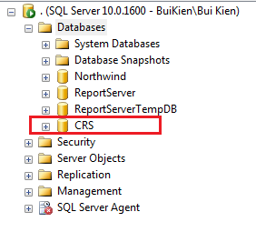

* Open file <deployment\_package>\Database\Schemas\Database Schemal.sql in SSMS
* Change working database in SSMS to CRS

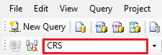

* Press F5 to run the script. Data tables should be created for CRS database

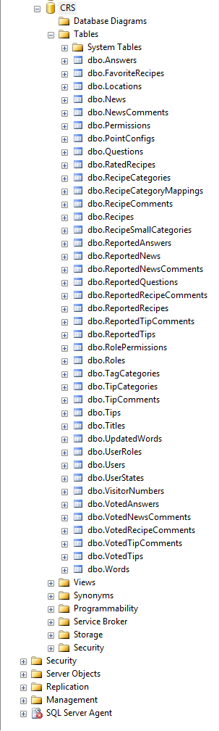

* Open file <deployment\_package>\Database\Data\CRS\_Reference data.sql in SSMS
* Press F5 to run the script. Reference data should be inserted to CRS database. For example the following is data of Permissions table:

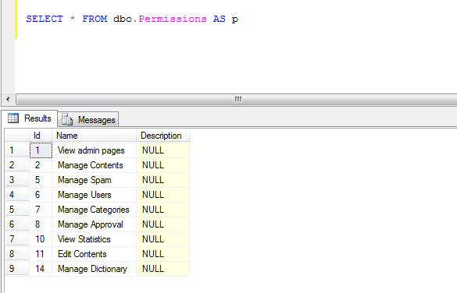

* The database contains one user with login account: kientt/19001789. This user has full privileges to the system.

### Deploy web application

* Register ASP.NET with IIS: open command line tool with admin privilege, change working folder to C:\Windows\Microsoft.NET\Framework64\v4.0.30319

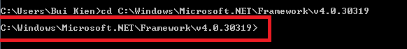

* Type aspnet\_regiis –i and press enter to register ASP.NET 4.0 to IIS

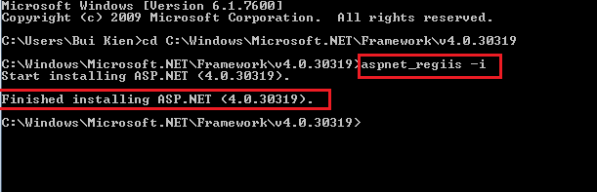

* Open IIS by opening start menu, type iis and press enter

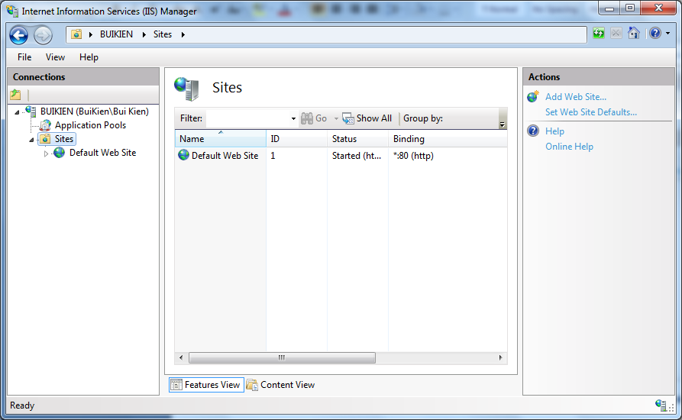

* Select Application Pools menu on the left menu bar, then select DefaultAppPool, click on Advanced Settings menu on the right bar, then open Identity window, choose Built-in account as LocalSystem:

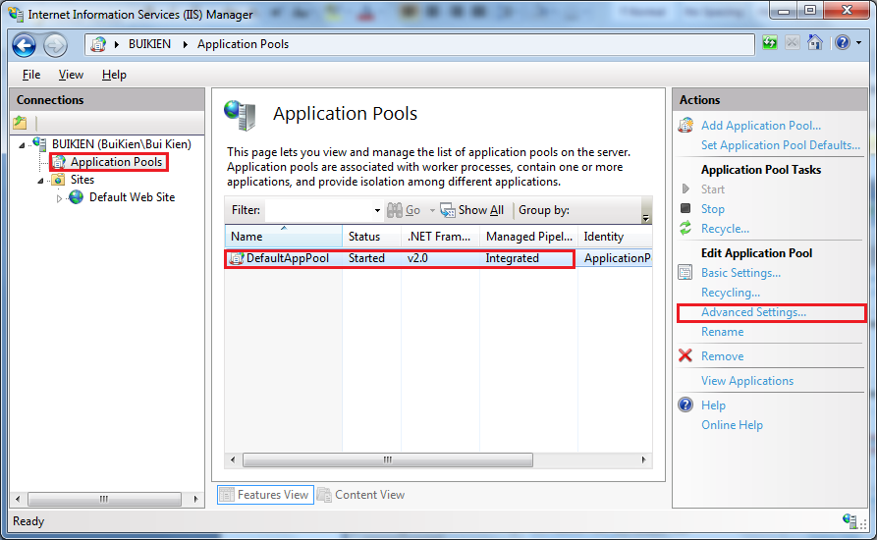

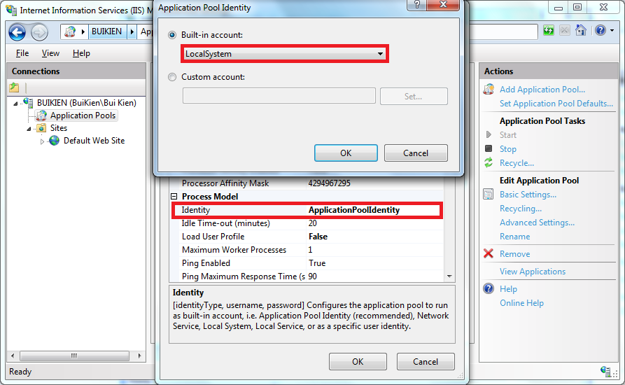

* Copy contents of<deployment\_package>\Web folder to another working folder. This folder will be the physical path of the web app. For example: E:\Study\CRS\CRS.Web

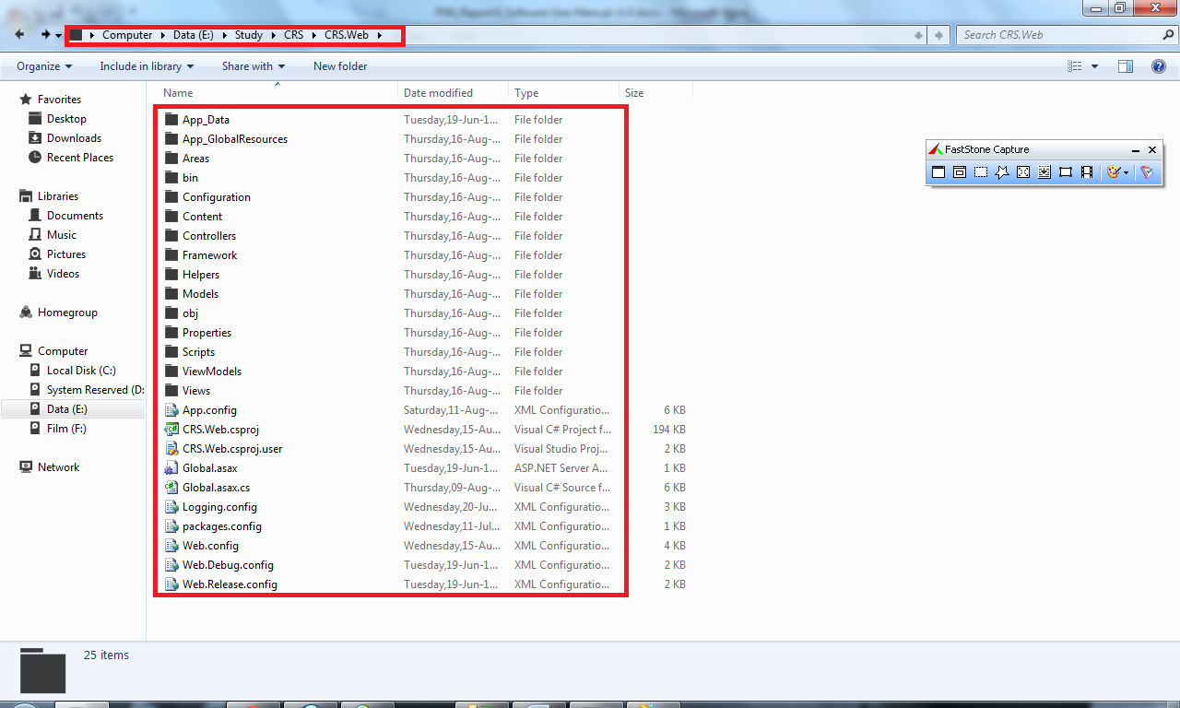

* Test the application by entering localhost/crs/ in to address bar of the browser. The application should show up:

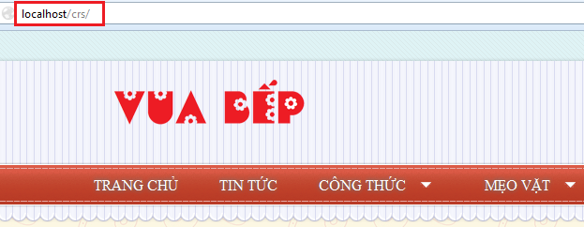

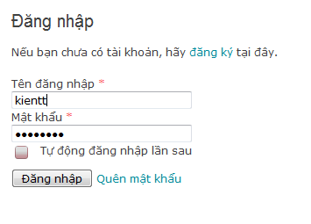

### 2.4 Change Configurations

#### 2.4.1 Change logging config

* Open file Logging.config in the application physical path
* Change the log files for errors and general to an absolute file path or relative file path to the application

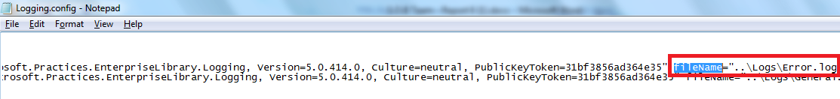

#### 2.4.2 Change system config

* Open file AppSettings.config in the application physical path

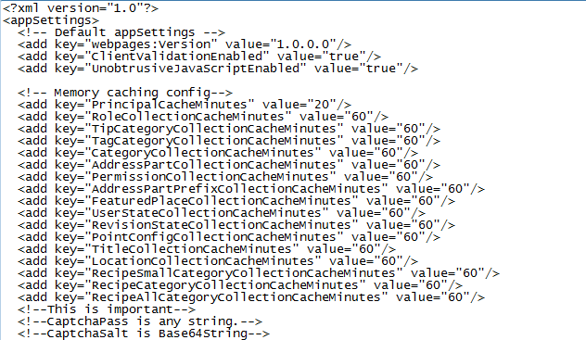

# User’s Guide

## Register

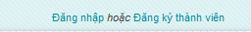

Click mouse to “Đăng ký thành viên” hyperlink.

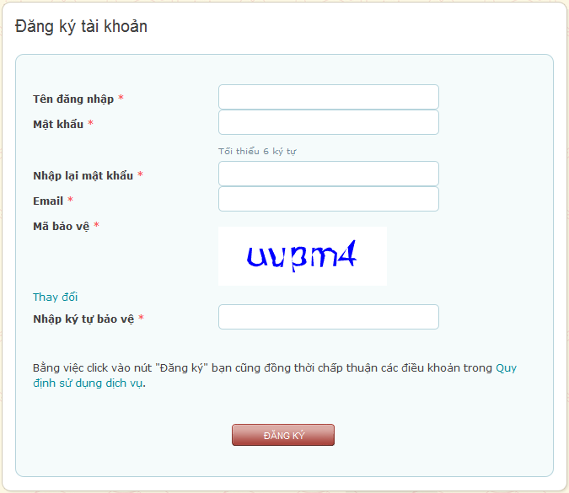

Fill all required information

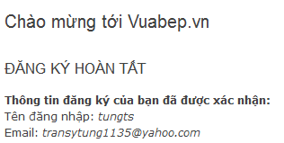

Successful message will be displayed.

## Login



Click mouse to “Đăng nhập” hyperlink.

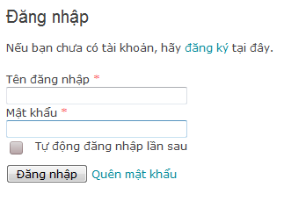

Enter user account and password correctly and then click to “Đăng nhập” button. If you want browser will automatically login in the next time.

## Forgot Password



If user is already has an account but forgets password. User can click to “Quên mật khẩu” hyperlink.

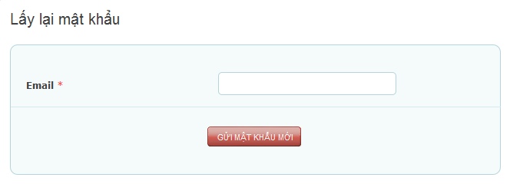

Enter user’s account email and then click to “Gửi mật khẩu mới”. System will send to user a new password to email.

## View Profile

### Method 1

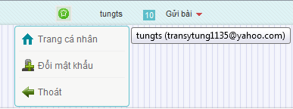

Click to username and then click to “Trang cá nhân” hyperlink

### Method 2

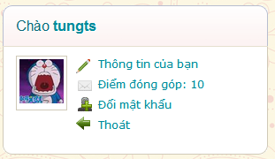

Click to “Thông tin của bạn” hyperlink on the right of website.

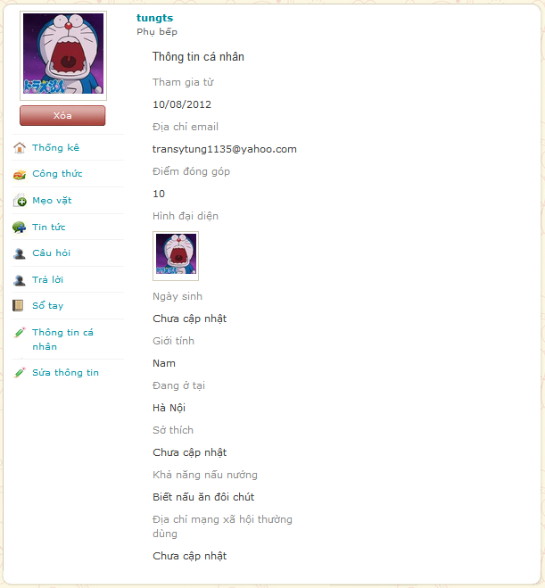

* Thông kê: Statistic your contribution.
* Công thức, mẹo vặt, tin tức, câu hỏi and trả lời: View your contribution in each category and include hyperlink to navigate to corresponding contribution.
* Sổ tay: View your favorite contents were added by you.
* Sửa thông tin: Edit your information

## Menu bar



Menu bar contains hyperlinks to main function such as “Trang chủ”, “Tin tức”, “Công thức”, “Mẹo vặt”, “Hỏi đáp”, Tìm kiếm”.

****

And if user is Admin or Power User, menu bar has “Admin” hyperlink.

## Sort bar



### 6.1 Recipes

* Click to “Công thức” hyper link.
* 
* Mới nhất: Sort by the newest recipes are posted.
* Lượt xem: Sort by the most view recipes
* Bình luận: Sort by the most comment recipes.
* Đánh giá: Sort by user’s rating.
* Chứng nhận: Sort by approved recipes by cooking experts.

### 6.2 News

Click to “Tin tức” hyperlink

* 
* Mới nhất: Sort by the newest news is posted.
* Lượt xem: Sort by the most view news
* Bình luận: Sort by the most comment news.

### 6.3 Tips

* Click to “Mẹo vặt” hyper link
* 
* Mới nhất: Sort by the newest tips are posted.
* Lượt xem: Sort by the most view tips
* Bình luận: Sort by the most comment tips.
* Bình chọn: Sort by user’s rating

## View detail

### Recipe

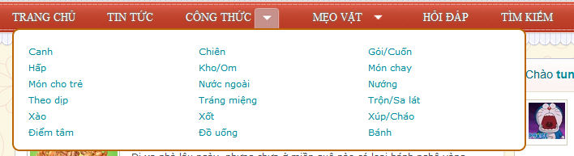

Click to arrow beside “Công thức” hyper link to show categories of recipes.

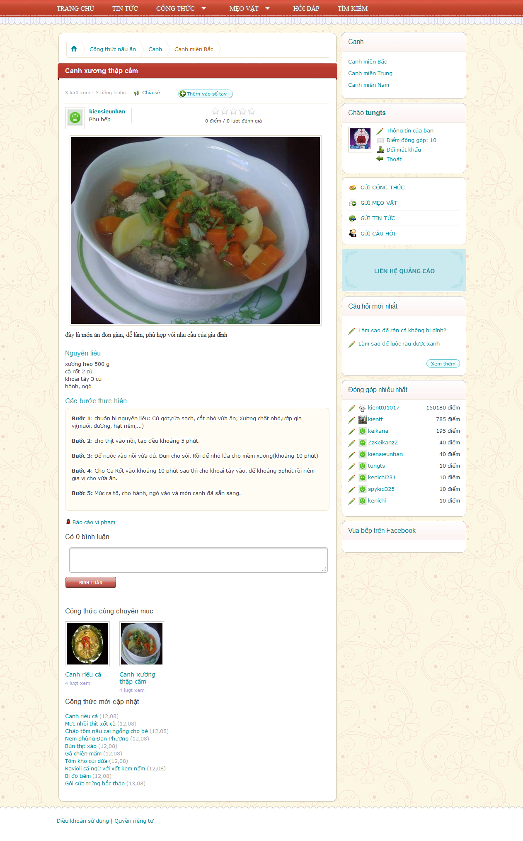

* Chia sẻ: Click to “Chia sẻ”



* Click to social network user want to share.
* Rating bar: Click to star (1->5) to rate for this recipe.

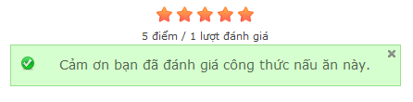

* Click to “Like” button to share user’s like on Facebook.
* Click to “G+” button to share user like on Google+
* Click to “Thêm vào sổ tay” to add this recipe to “Sổ tay”.
* Click to “Bình luận” textbox to leave a comment and then click to “Bình luận” button to post comment

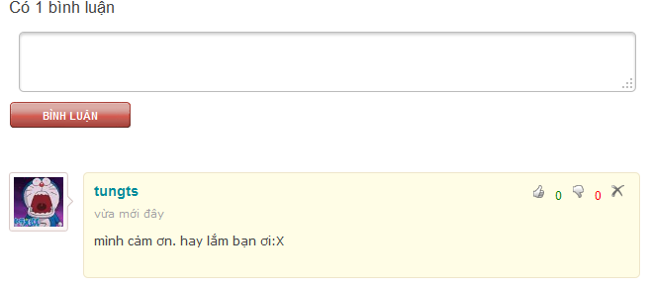

* Click thumb up or thumb down button to rate comment (you can’t rate your own comment). Click “X” button to delete.

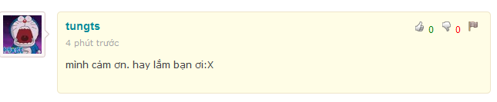

* Click “Flag” button to report if this comment has bad content or spam.

### Tips

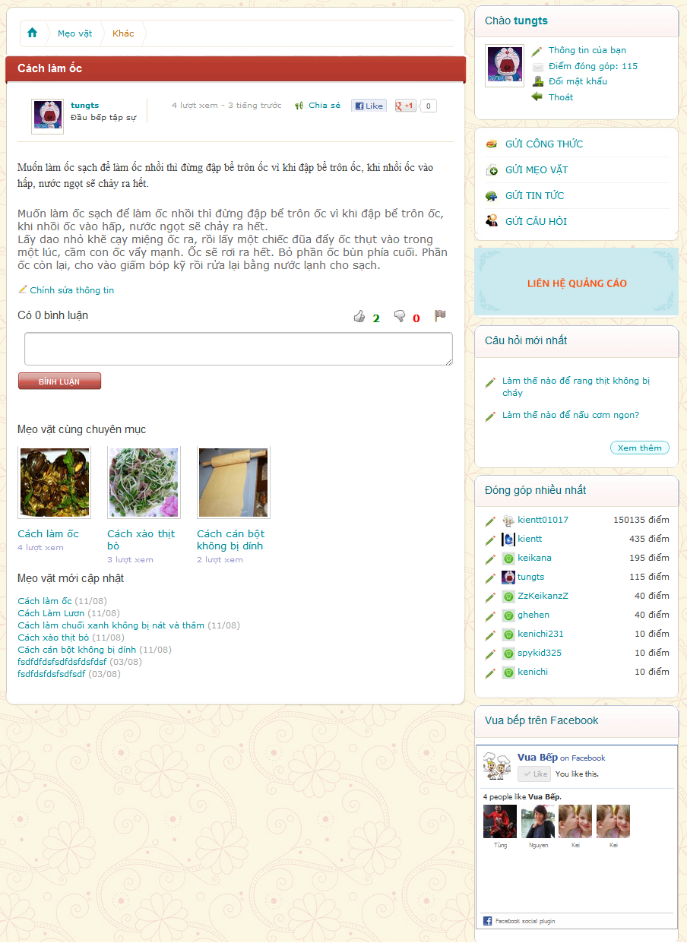



Click thumb up or thumb down button to rate comment (you can’t rate your own comment). Click “X” button to delete.



Click “Flag” button to report if this comment has bad content or spam.

### Question/Answer

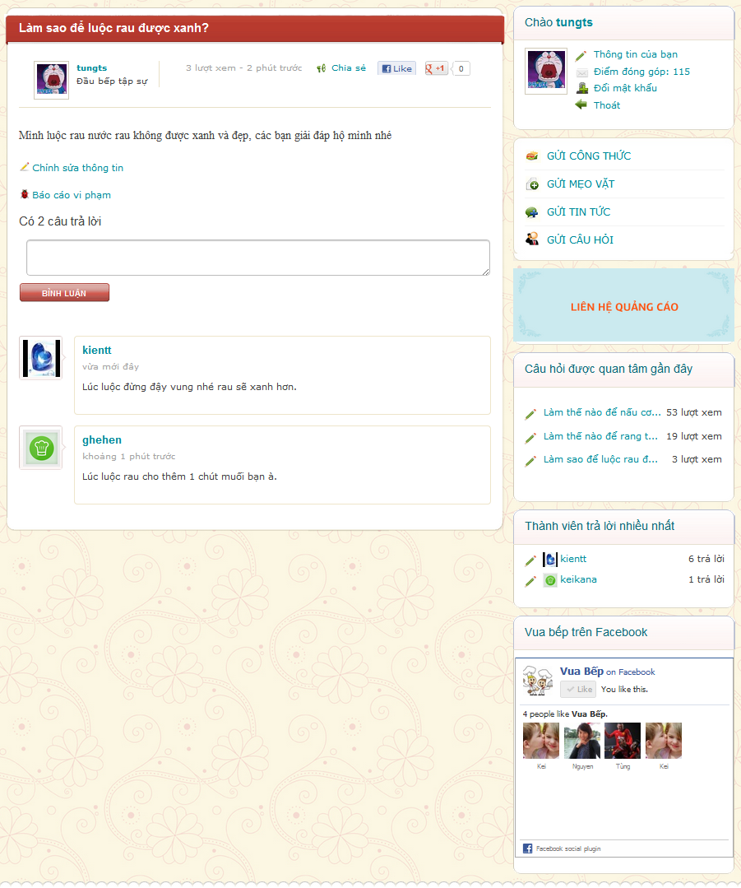

## Search



* Click to “Tìm kiếm” hyperlink on menu bar

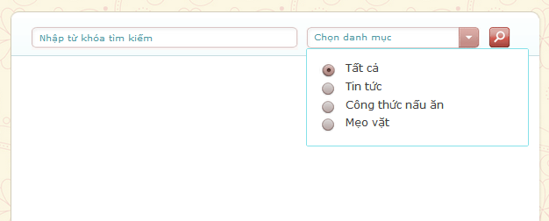

* User enters keyword and then click to “Chọn danh mục” dropdown list choose category to search. After that, user clicks to search icon to search.

## Right Menu

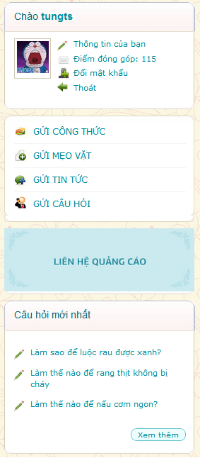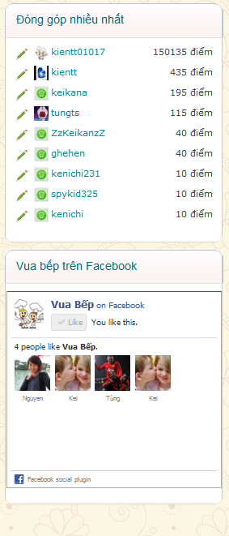

* Right menu contain user menu, create menu, banner, latest question, top user and facebook plugin.
* User can use hyperlink at right menu to quick access.

## Create

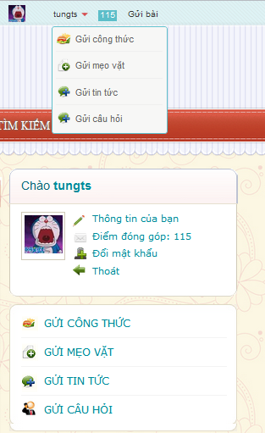

* User has two ways to access create function.
* Click to “Gửi công thức” to create new recipe

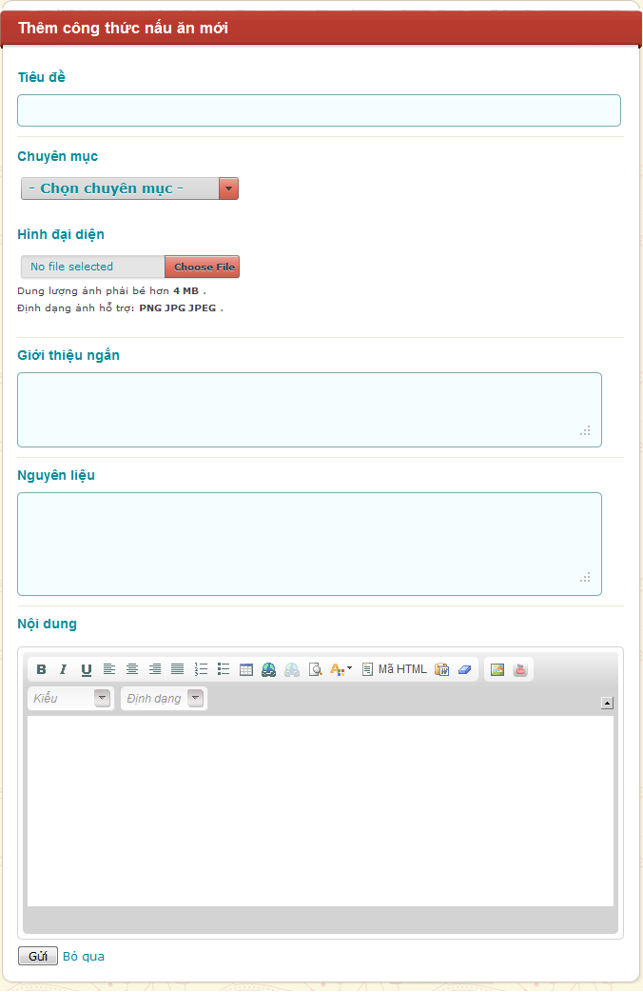

* Click to “Chọn chuyên mục” drop down list to choose category for recipe .Click to “Choose file” button to choose image from user’s computer.
* Fill all information and then click to “Gửi” button to create or “Bỏ qua” to cancel.
* Create function is the same for “Gửi mẹo vặt” and “Gửi tin tức”.
* Click to “Gửi câu hỏi” hyperlink.

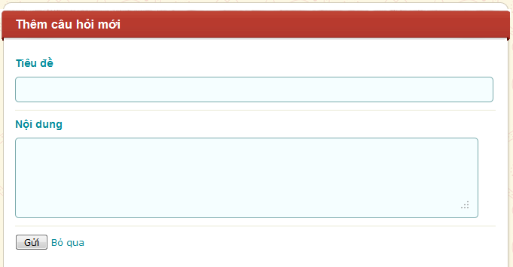

Fill all information and then click to “Gửi” button to submit or “Bỏ qua” hyperlink to dismiss.

## Dictionary

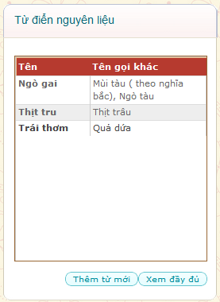

* Click to “Xem đầy đủ” to view full list of word

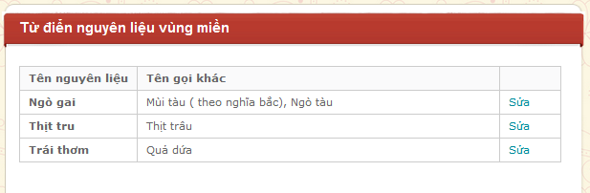

* Click to “Sửa” to edit word

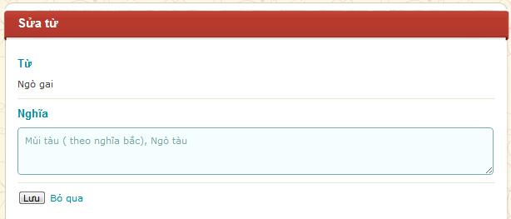

* Edit in “Nghĩa” textbox and then click to “Lưu” button to save or “Bỏ qua” hyperlink to dismiss.



* Click to “Thêm từ mới” button to create new word.

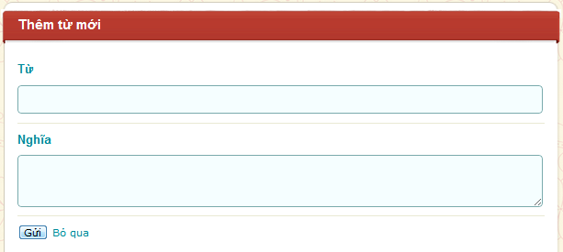

* Fill all information and then click to “Gửi” button to send or “Bỏ qua” hyperlink to dismiss



* When user in “Xem đầy đủ” page. Use “Ctrl + F” on keyboard to open search function of web browser.



Or



* Will appear, user can type to search word.

# Administrator’s Guide

Click to “Admin” hyperlink on Menu bar



## Manage Contents

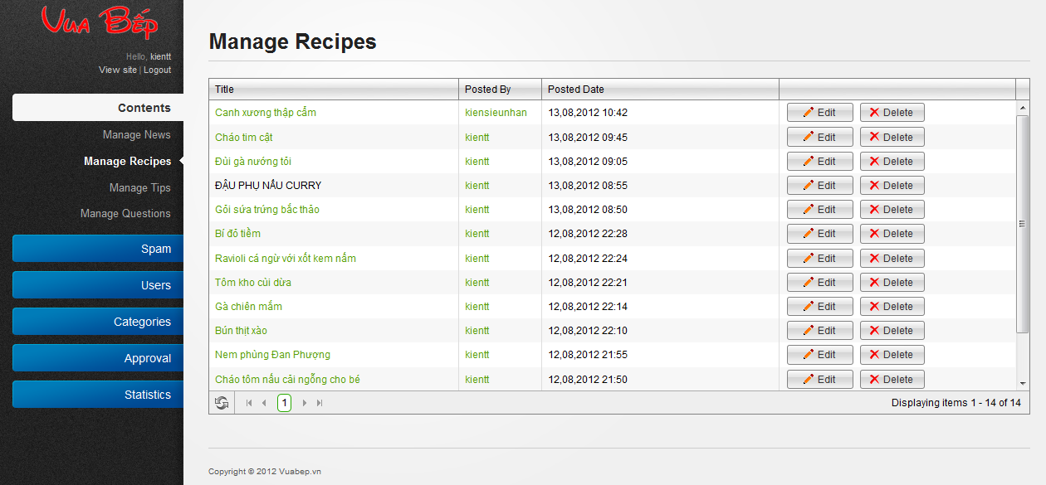

* Click to “Edit” button, system will navigate admin to edit content

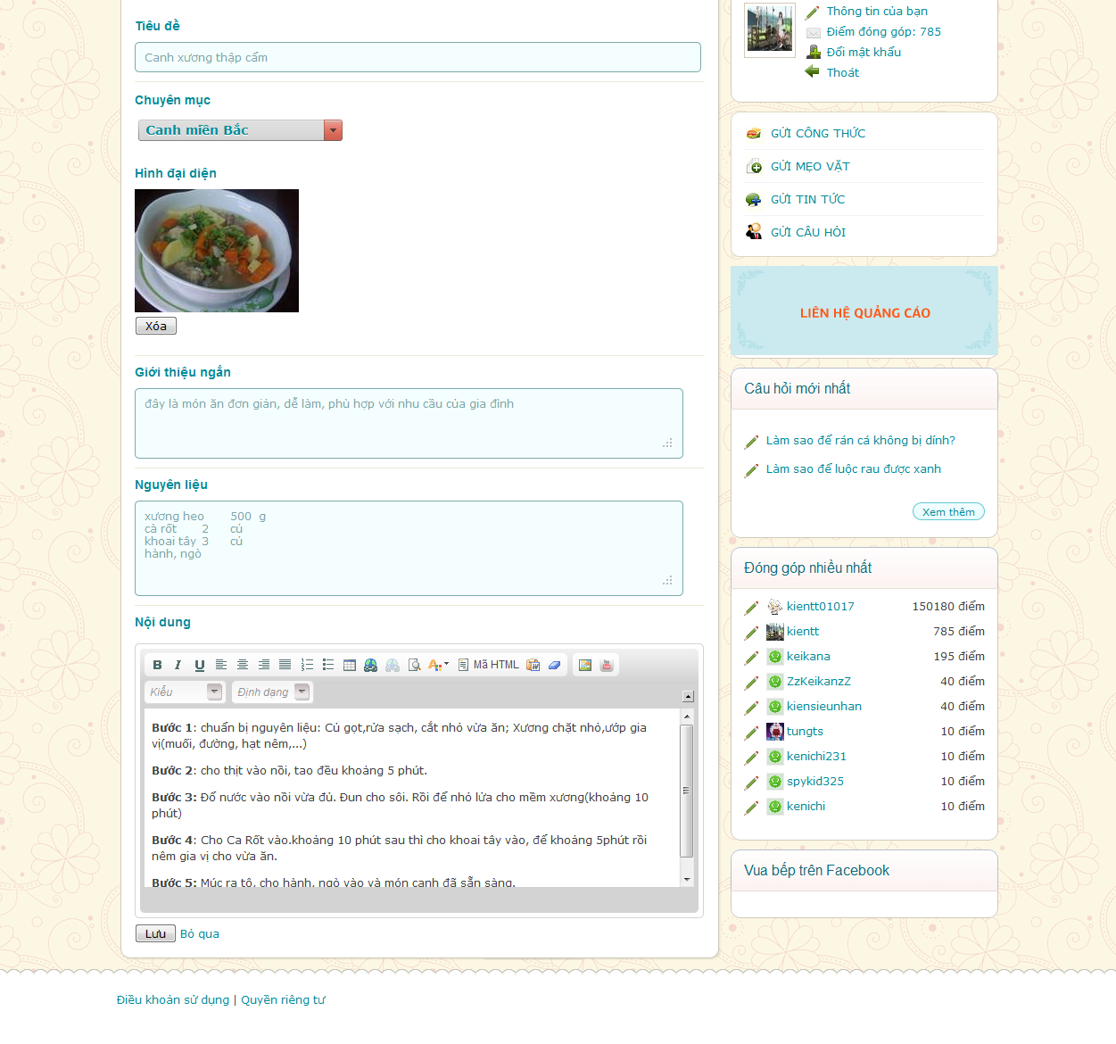

* After edit content, click to “Lưu” button to save.
* Click to “Delete” button to delete this content, system will ask to confirm.
* 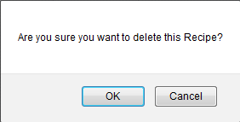
* Click “OK” button to delete this content, click “Cancel” to back to manage contents page.

## Manage Spam

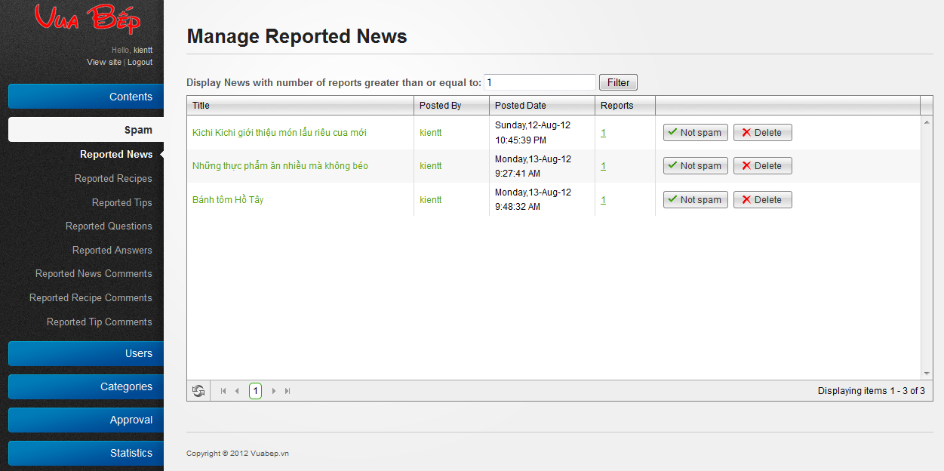

* Click to Spam to show sub-menu.
* Click “Reported” to view reported content and then click to “Not spam” button to delete this report.
* Click to “Delete” button, system will ask to confirm.



* Click “OK” button to delete this content, click “Cancel” to back to manage contents page.

## User

### Manage User

**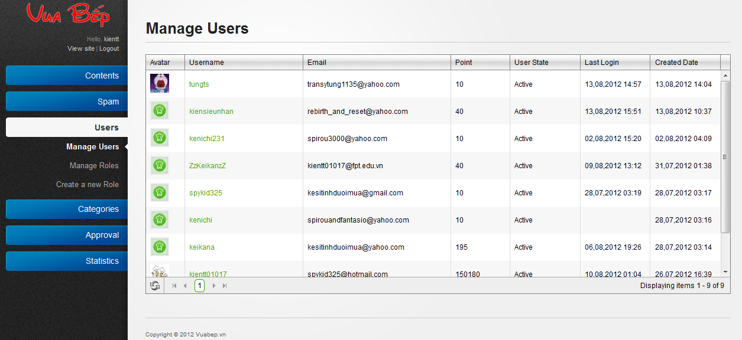**

* Click to username to edit or delete user.

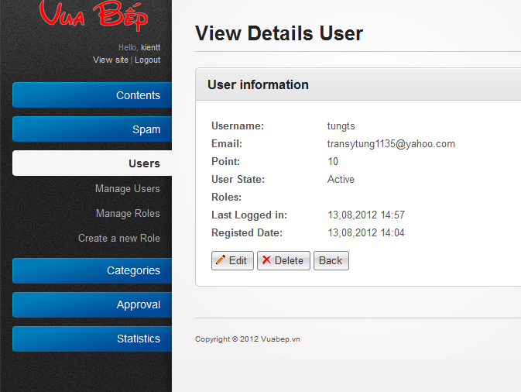

* Click “Edit” button to edit user information

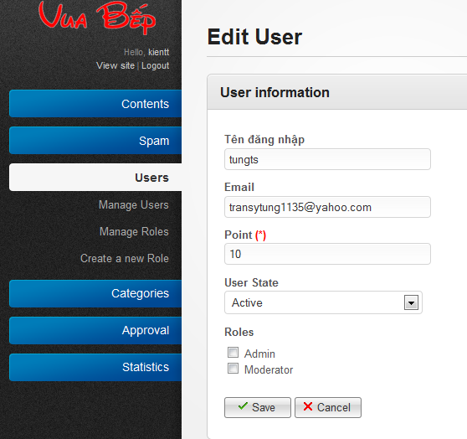

* Click to “Save” button to save. Click to “Cancel” to back to previous page.

### Manage Roles

**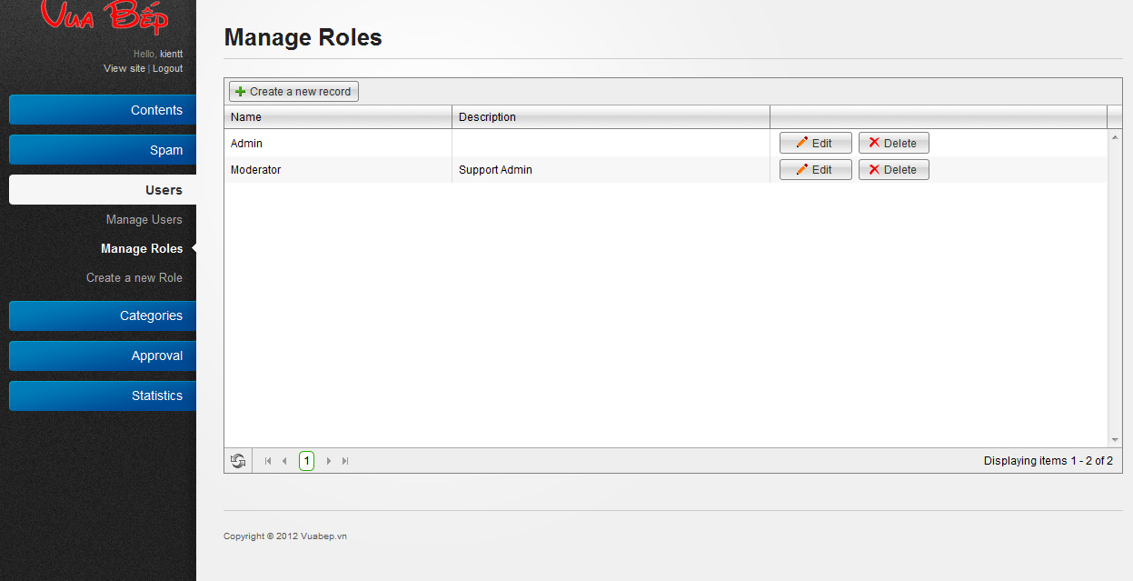**

* Click to “Create a new record” to create new role.

**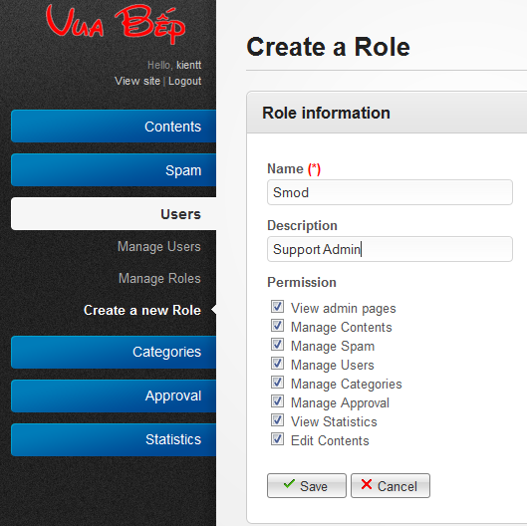**

* Click to “Save” button to save new record.

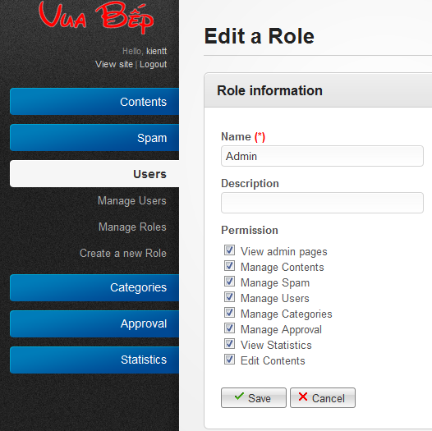

* Click to “Edit” button to edit role and then click to “Save” button to save.
* Click to “Delete” button to delete record.

## Categories

4.1 Manage Tip Categories & Recipe Categories

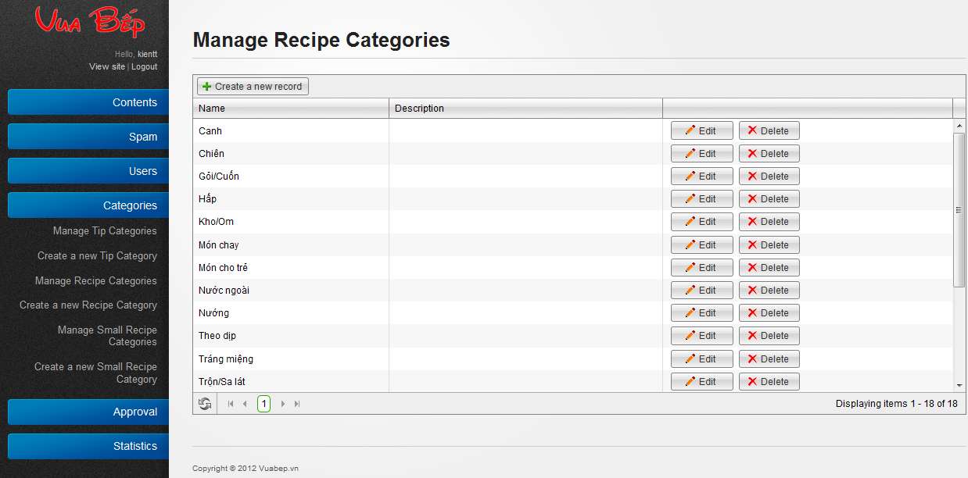

* Manage Tip Categories, Manage Recipe Categories are show all each categories.
* Click to “Delete” button to delete a category.
* Click to “Edit” button to edit a category.

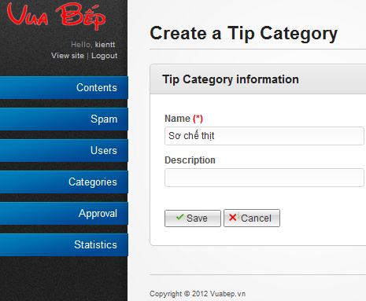

* Edit content of category and then click “Save” button to save or “Cancel” button to dismiss.

### Create new Tip & Recipe categories

* Click to “Add new record” button to create new category.
* 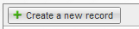
* Fill information and then click to “Save” button to save or “Cancel” to dismiss.

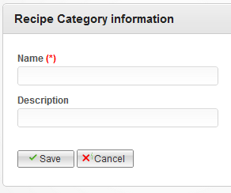

### Manage Small Recipe category

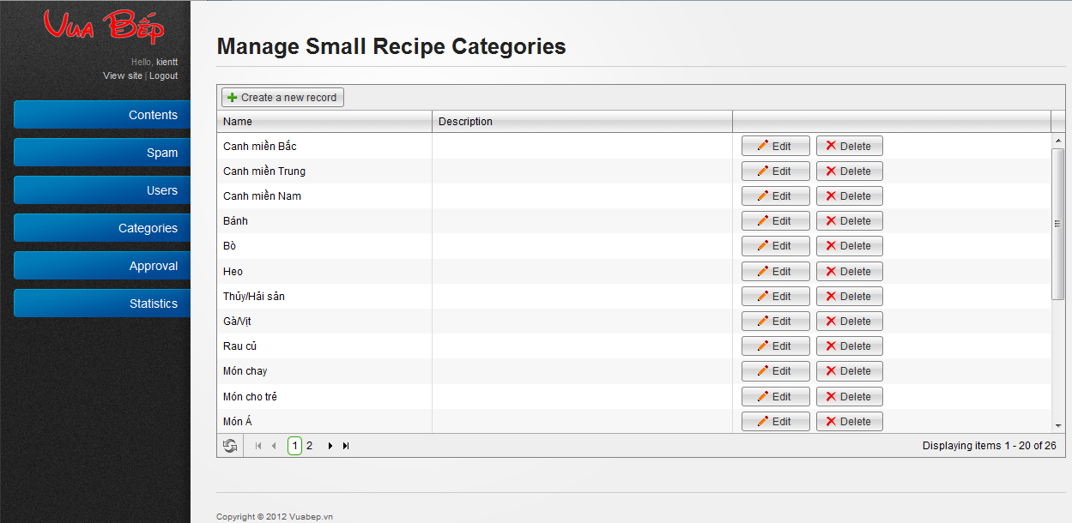

* Click to “Delete” button to delete a category.
* Click to “Edit” button to edit a category.

**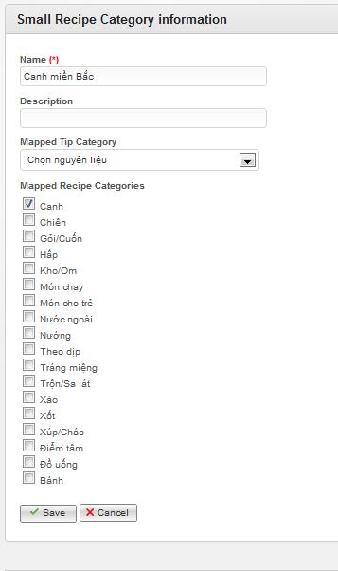**

* Edit information and then click “Save” button to save or “Cancel” button to dismiss.

### Create Small Recipe Categories

* Click to “Add new record” button to create new category.
* 
* Fill information and then click to “Save” button to save or “Cancel” to dismiss.

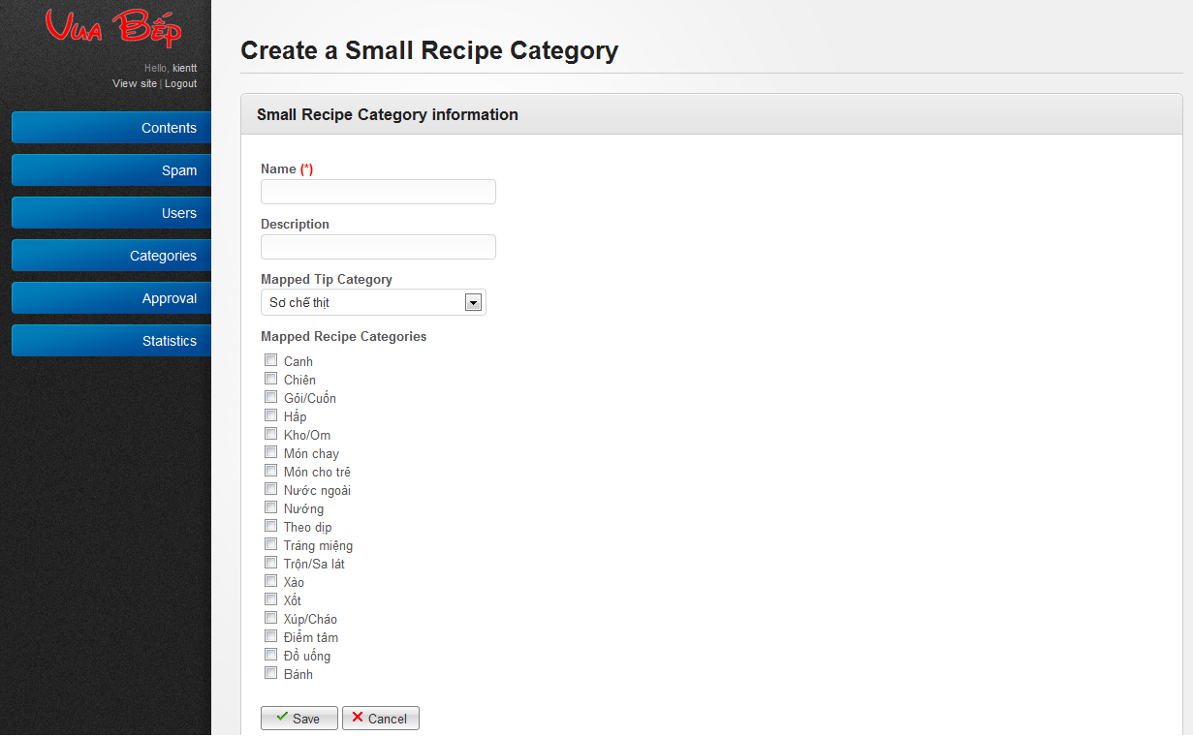

## Approval

### Approve recipes

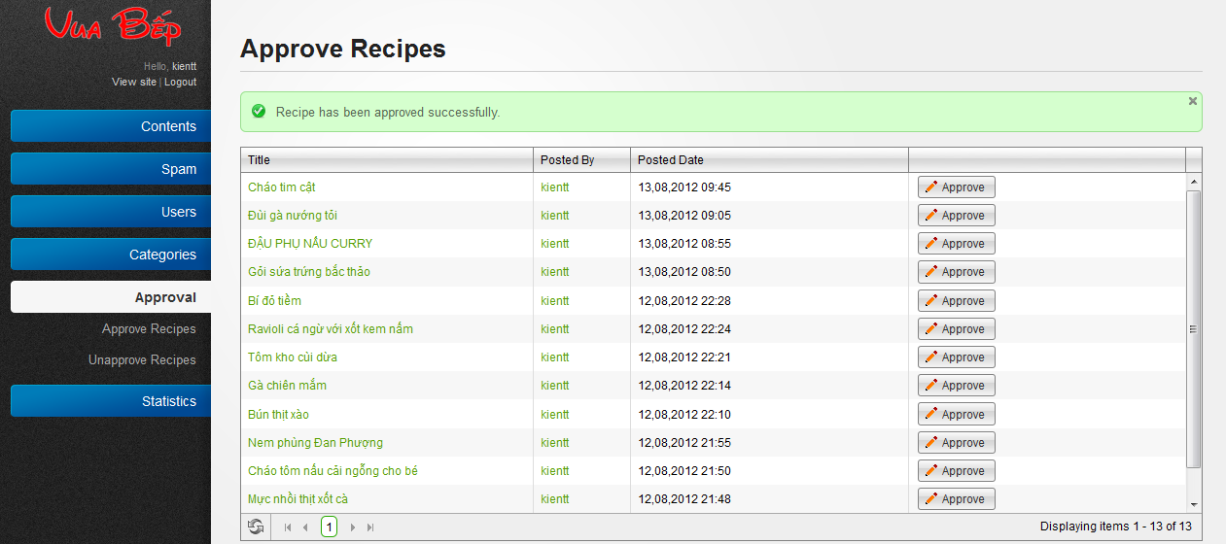

* Click to “Approve” to approve a recipe.

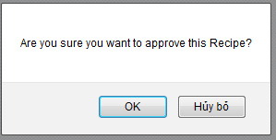

* Click “Ok” button to complete action or “Hủy bỏ” button to dismiss.

### Unapprove recipes

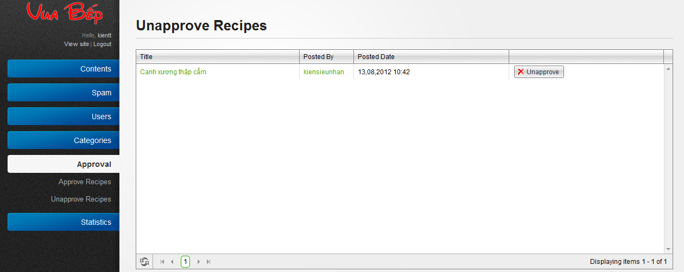

* Click to “Unapprove” button to unapproved recipe.

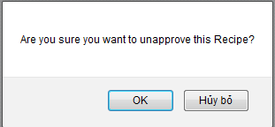

* Click “Ok” button to complete action or “Hủy bỏ” button to dismiss.

## Dictionary

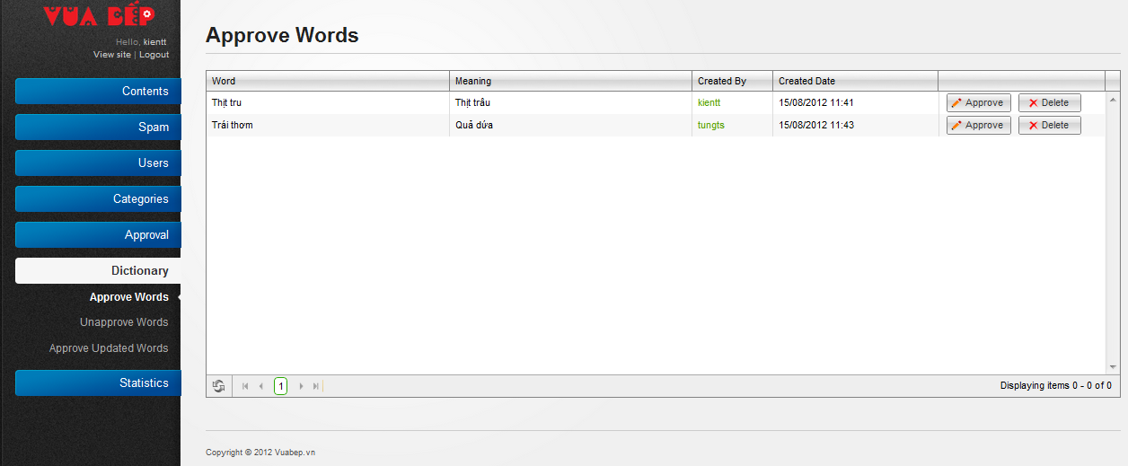

* Click to “Approve” button to approve a word

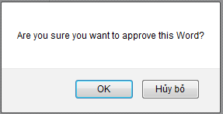

* Click to “OK” button to complete action or “Hủy bỏ” to dismiss
* Click to “Delete” to delete word.

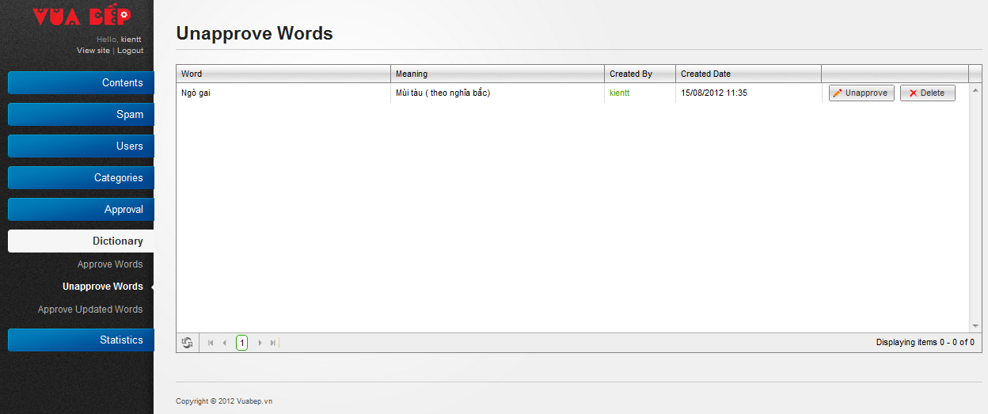

* Click to “Unapprove” button to unapproved word.

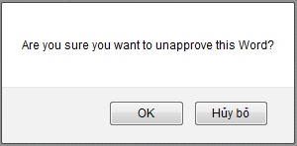

* Click “Ok” button to complete action or “Hủy bỏ” button to dismiss
* Click to “Delete” to delete word.

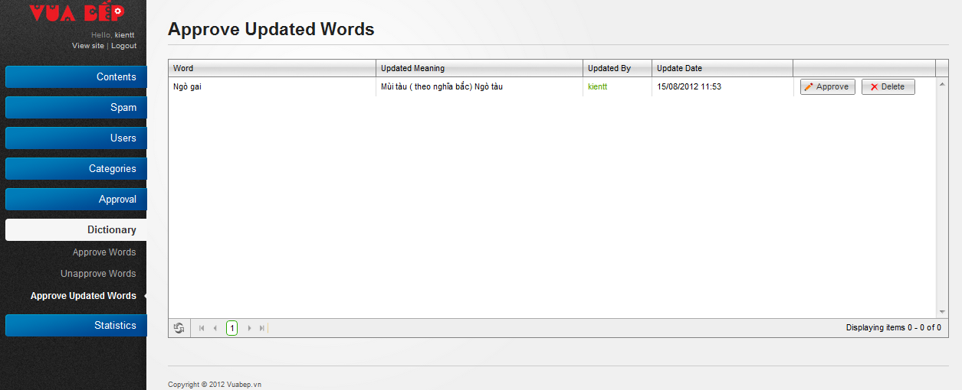

* Click to “Approve” button to approve an update word



* Click to “OK” button to complete action or “Hủy bỏ” to dismiss
* Click to “Delete” to delete word.

# PART VII: REFERENCE

1. <http://en.wikipedia.org/wiki/Vietnamese_cuisine>
2. Wikipedia Iterative and incremental development

[http://en.wikipedia.org/wiki/Iterative\_and\_incremental\_development](http://en.wikipedia.org/wiki/Iterative_and_incremental_development%20)

1. .NET Naming Guidelines

[http://msdn.microsoft.com/en-us/library/ms229002.aspx](http://msdn.microsoft.com/en-us/library/ms229002.aspx%20)

1. FxCop rules and Code Analysis for Managed Code Warnings

[http://msdn.microsoft.com/en-us/library/ee1hzekz.aspx](http://msdn.microsoft.com/en-us/library/ee1hzekz.aspx%20)

1. ITPro portal Top ten software development risks

[http://www.itproportal.com/2010/06/14/top-ten-software-development-risks](http://www.itproportal.com/2010/06/14/top-ten-software-development-risks%20)

1. Wikipedia Project management

<http://en.wikipedia.org/wiki/Project_management>

1. Wikipedia, 2011, 'Use case'

<<http://en.wikipedia.org/wiki/Use_case>>

1. Jeff Atwood, 2011, 'Suggested Edits and Edit Review' blog, February 5th, Stack Exchange

<<http://blog.stackoverflow.com/2011/02/suggested-edits-and-edit-review>>

1. Microsoft, ' ASP.NET MVC Framework '

<http://www.asp.net/mvc/whatisaspmvc>

1. MSDN, ' UML Class Diagrams: Guidelines ',

<http://msdn.microsoft.com/en-us/library/dd409416.aspx>

1. MSDN, ' UML Sequence Diagrams: Guidelines '2011

<http://msdn.microsoft.com/en-us/library/dd409389.aspx>

1. Wikipedia, ' Dependency Injection ',

<http://en.wikipedia.org/wiki/Dependency_injection>